(BC/CH 495) Spring 2018
Directed Research for Biochemistry

BC 495 Research (3) Research project (approximately 10 hours per week) performed in Chaminade or other research laboratory under supervision of a practicing research scientist. Offered annually. Prerequisites: BC 360/L. Materials intensive fee applies. Pending Academic Council Approval.4. Sample Syllabus

Biochemistry 495 Directed Senior Research

1. Meetings and Faculty

1.1. Meetings
Meeting times to be announced via email from Dr Kawakami and will be held once a week for an hour and additional times. Student attendance at a weekly meeting with the course coordinator is required, these meetings may be held in a group or individualized format.

1.2. Faculty

Coordinator Dr Joel Kawakami (jkawakam@chaminade.edu)
Office: Henry 4 Tel: (808) 739-8576
Research Mentors

Dr Helen Turner (hturner@chaminade.edu)Obesity and Immunology
Dr Michael Dohm (mdohm@chaminade.edu) Environmental Toxicology
Dr Joel Kawakami (jkawakam@chaminade.edu)Cancer Drug Design
Dr Alexander Stokes (astokes@hawaii.edu)Cardiovascular Biology
Dr Abby Collier (acollier@hawaii.edu) Pediatric Pharmacology
Dr Joan Kuh (joan.kuh@chmainade.edu)Liver Disease
Dr. Hank Trapido Rosenthal (rosenthl@hawaii.edu) Marine Microbiology
Dr. Claire Wright (Claire.wright@chaminade.edu)
Reproductive Tissue Biology
Dr. David Carter (david.carter@chmainade.edu)Forensic Taphonomy

1.2. Office Hours.
Office hours with Dr Kawakami are by appointment.

2. The Course.

2.1. Overview.
Directed Senior Research is a culmination of the course of study in chemistry/biochemistry. The steps that are follow here are quite similar to steps taken by biomedical scientists in a wide variety of research labs, from generating ideas and research proposals to collection and analysis of data and finally to the presentation of results to other scientists (including those at granting agencies) through a written publication and or a public presentation. The weekly meetings with the facilitator, Dr Kawakami, will be used to review project progress and to perform exercises that aim to increase knowledge of topical issues in the realms of biomedical/biochemical discovery, scientific ethics and recent technical advances.

The course has three components:
- #1. Hands-on Laboratory Research Project
You may complete this on or off-campus. Off-campus internships are typically during the summer prior to your registration in BC495. Students who complete this component off campus are still required to perform course components #2 and #3 below. If you wish to perform on campus research you must be accepted by a research mentor from the list above by the end of week 2 of the semester. You should aim to spend at least 10 hours per week on your research project. Be aware that this is a minimum and the nature of biochemistry research means that it is sometimes time-consuming and unpredictable.

- #2: Weekly class meetings and assignments, including a final research paper.
- #3: Poster presentation to faculty and staff in week 13 of the semester.

2.3. Learning Outcomes.
Successful completion of this course should provide students with the following learning outcomes:

- Demonstration of the ability to organize and perform biological/biochemical research using the scientific method.
- Demonstration of the ability to complete a library search of biological/biochemical literature and utilizing SciFinder database.
- Demonstration of understanding problems involved in conducting research in biochemistry.
- Demonstration of the ability to critically analyze data.
- Demonstration of competency in using biological/biochemical techniques and instruments.
- Completion of writing up research as a scientific paper formatted for submission to a peer-reviewed journal.
- Completion and presentation of a poster documenting the research project for an audience of peers and professional scientists.

3. Requirements and Grading

3.1. Grading Scheme
Attendance and participation in weekly meetings 100 points
Final Poster Presentation 200 points
Final written paper 100 points
Written assignments 100 Points

A Excellent >90% 450 points or more B Good >80% 400-449 points
C Average >70% 350-399 points
D Below Average >60% 300-349 points
F Failure <60% 299 points or less

Student attendance at a weekly meeting with the course coordinator is required, these meetings may be held in a group or individualized format.
Attendance/participation: 20% (100 points). Attendance at weekly meeting with the course coordinator (either in group or individually) as well as participation/engagement during these meetings will be calculated as 20% of the grade. Ten points will be allocated per meeting of which 5 are for attendance and 5 will be allocated on the basis of student participation and engagement. The instructor will provide a rubric for the allocation of these points.

A poster documenting your literature research project which you are required to present in our mini-symposium. A single sheet poster will be required. The poster will include title, authors and affiliations, abstract, background, methods, results and data, discussion, literature cited and acknowledgements. PowerPoint templates for poster design are recommended and will be provided on request by Dr Kawakami. At the mandatory poster presentation session you should be prepared to give a brief oral presentation of your poster and answer questions from faculty and your peers. This will be held on campus in week 13 of the semester. The date of this symposium will be announced in class.
All research papers or essays should be formatted in accordance with the guidelines for submission to the Journal of Biological Chemistry (see http://www.jbc.org/site/misc/ifora.xhtml) and Journal of Organic Chemistry (see http://pubs.acs.org/paragonplus/submission/loceah/joceah_authguide.pdf).

Required elements of the paper are:
- Title page: title of your research project, your name, course and date of submission.
- Abstract: standard abstract form that presents your research (including results) in less than 200 words.
- Introduction: a review of literature, hypothesis and rationale of your research project. What is known about your area of interest and about your specific question(s)? What is not known? Where does your work fit in and contribute?
- Methods and Materials: a detailed description of techniques, instruments, experimental and control groups and flow-charts if needed.
- Results: data tables, figures, photographs and brief narrative of each.
- Discussion and Conclusion: a careful analysis of results, error analysis and proposals for additional work.
- Literature Cited: provides a complete list of work cited. Comply with the style of the Journal of Biological Chemistry.
- *The research must comply with the Chaminade University Writing Across the Disciplines standards.
- * The research paper must be submitted as hard copy by no later than the end of week fourteen to Dr Kawakami and as a PDF emailed to jkawakam@chaminade.edu by the same deadline.

3.4. How to keep a laboratory notebook
- Completely number pages before recording data/writing in it.
- Use permanent ink.
- Include a complete Table of Contents at the beginning; all experiments should be dated and page numbers indicated. Include your mathematical calculations.
- Cross out errors—do not erase or use Liquid Paper.
- If data for a given experiment is to be collected periodically, leave sufficient space to enter the data over time. A data table might be appropriate in this case.
- Record data directly and do not tear pages out.
- The notebook is the property of the supervising investigator and should be surrendered to them upon completion of the project.

4. Policies.

- Late assignments will not be accepted without prior written approval from the instructor.
- Students using cell phones in class will be asked to leave and will be marked as absent.
- All other academic polices specified by the University Catalog and Student Handbook apply to this course.
- Students performing research at off-campus locations are required to perform all applicable safety trainings prior to starting work
- Details of the course may be subject to change.

Class Schedule

Week 1 Orientation and Overview

Homework: Key Scientific Questions Written Exercise
250 words “What is the most important question scientists should be addressing today?”
Due to Dr. Kawakami (hard copy) by the beginning of week 2.

Week 2 Discussion of Key Scientific Questions Written Exercise
Name of Research Project Supervisor due to Dr. Kawakami with project title.

Homework: How do we know what we know? Exercise
Prepare 10 minute white board presentation on the assigned question.

Week 3: Discussion of How do we know what we know? Presentations

Homework: Prepare project hypothesis with you research supervisor.

Week 4: Research hypothesis and experimental plan discussion
Be prepared to discuss the work you are planning to do or have done in the lab

Week 5: What makes a good project? Exercise and group discussion

Week 6: Role models: the PhD, MD-PhD and postdoctoral experience
External panel discussion
Homework: prepare project abstract and methods section for poster and paper

Week 7: Review of Research Progress
Homework: “Bad apples” exercise
Prepare 10 min whiteboard presentation on you assigned scientific misconduct case

Week 8: “Bad apples” Research Ethics discussion
Homework: first drafts of paper and poster

Weeks 9-12 Paper and Poster preparation

Week 13: Poster Symposium, also email poster copy to (jkawakam@chaminade.edu)
Week 14: Paper due by the end of this week to Dr Kawakami
(hard copy and email PDF to jkawakam@chaminade.edu)

WHAT DOES SUCCESS LOOK LIKE?
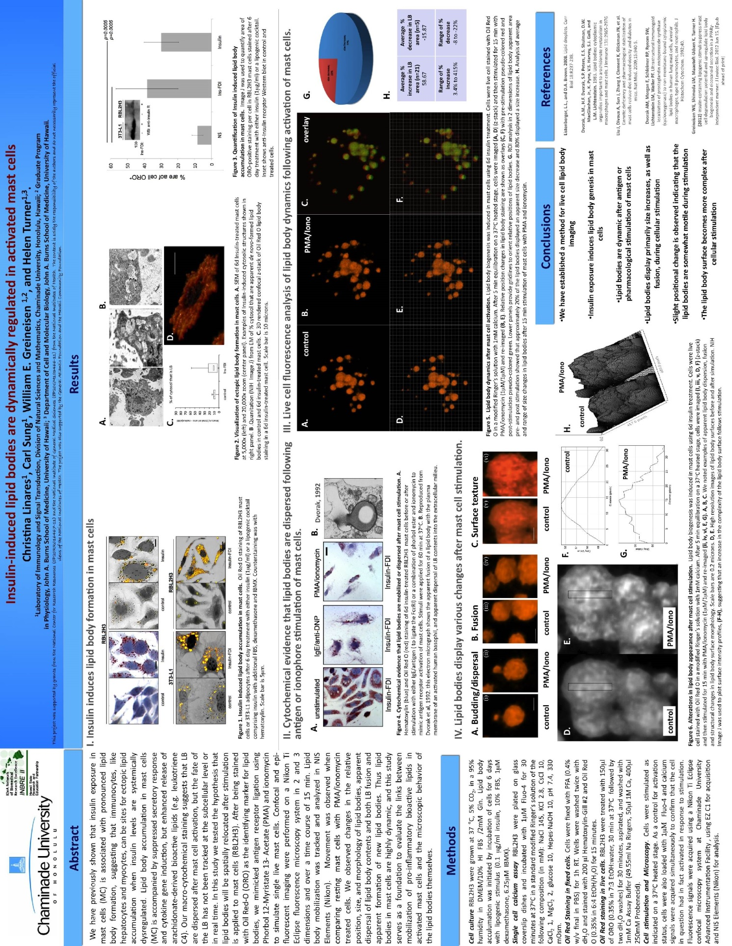
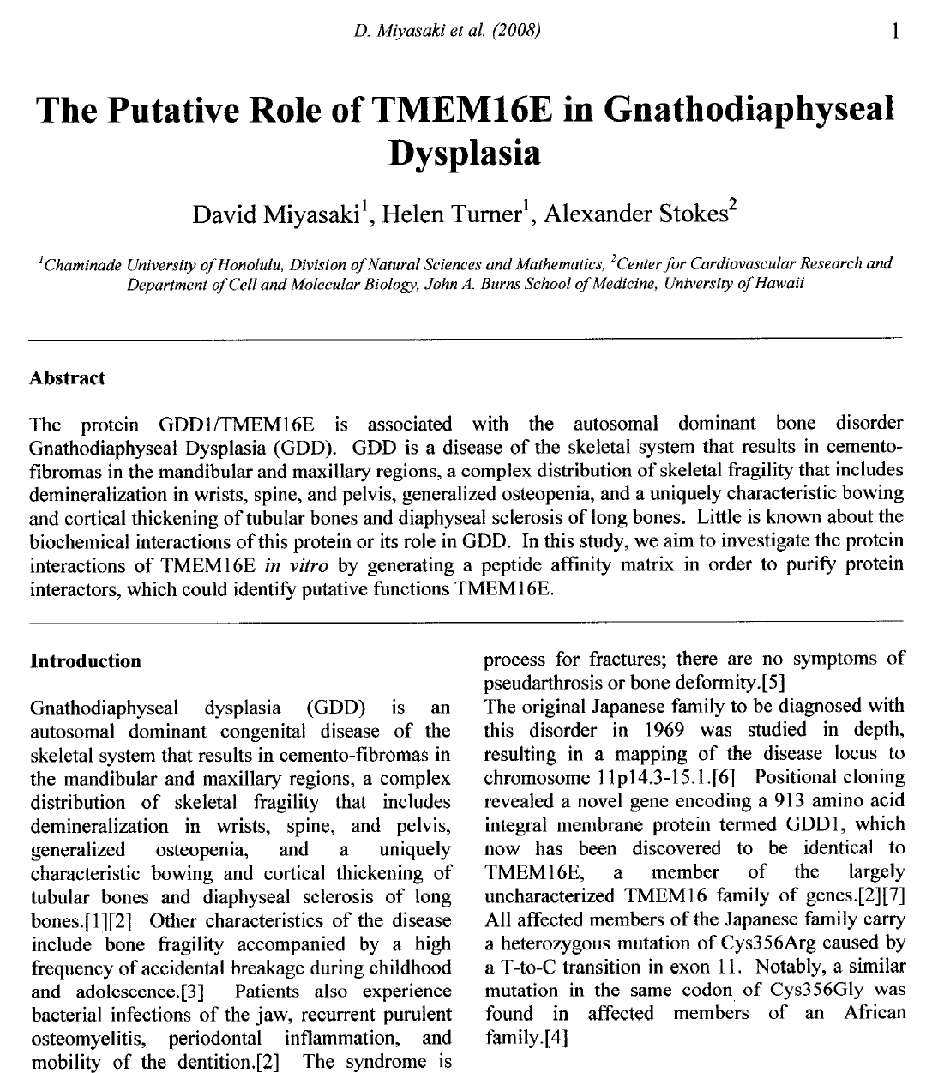

XI. Additional Departmental and University Polices

1. Electronic Devices
Use of music devices and cell phones is prohibited during all Natural Science and Mathematics classes at Chaminade, unless specifically permitted by your instructor. Use of cellphones and music devices in laboratories is a safety issue. In addition, use of cellphones and music devices in any class is discourteous and may lead to suspicion of academic misconduct. Students who cannot comply with this rule will be asked to leave class and may be subject to laboratory safety violation fines. You will be asked to leave class and marked absent if you do not comply. This will negatively affect your grade. Please refer any questions to the Dean of Natural Sciences and Mathematics.

2. ADAA Statement
2.1 Pursuant to several federal and state laws, including the Americans with Disabilities Act of 1990, as amended by the ADA Amendments Act of 2008, and Section 504 of the Rehabilitation Act of 1973, all qualified students with disabilities are protected from discrimination on basis of disability and are eligible for reasonable accommodations or modifications in the academic environment to enable them to enjoy equal access to academic programs, services, or activities. If a student would like to determine if they meet the criteria for accommodations, they should contact the Counseling Center at 808-735-4845 for further information.

3. Attendance & Tardiness

3.1 Students are expected to attend regularly all courses for which they are registered. Students should notify their instructors when illness or other extenuating circumstances prevents them from attending class and make arrangements to complete missed assignments. Notification may be done by emailing the instructor’s Chaminade email address, calling the instructor’s campus extension or by leaving a message with the instructor’s division office (Natural Science and Math 1 (808) 440-4204). It is the instructor’s prerogative to modify deadlines of course requirements accordingly. Any student who stops attending a course without officially withdrawing may receive a failing grade.

3.2 Unexcused absences equivalent to more than a week of classes may lead to a grade reduction for the course. Any unexcused absence of two consecutive weeks or more may result in being withdrawn from the course by the instructor, although the instructor is not required to withdraw students in that scenario. Repeated absences put students at risk of failing grades.

3.3. Tardiness
[At the Discretion of Instructor]

4. Policy on Make-Up Tests
[At the Discretion of Instructor]

5. Policy on Communication
5.1 The University provides a Chaminade email address for all students. Official Chaminade communications will be sent to the students’ Chaminade email address and instructors will use only this email to communicate with students. It is the responsibility of the student to check their email frequently. Report email-related problems to the Helpdesk at 808-735-4855 or helpdesk@chaminade.edu.

6. Laboratory Safety Information
The following guidelines are established to provide instructions in maintaining safety for students, staff, and faculty while using any of the science laboratories at Chaminade University. The Division of Natural Sciences and Mathematics (NSM), along with the University Environmental Safety Office are responsible for enforcing the regulations set forth in the current Student Handbook. Queries should be addressed to: Dean of Natural Sciences and Mathematics (808) 440-4204; Environmental Safety Officer (808) 739-4811

7. Title IX Declaration
Chaminade University of Honolulu recognizes the inherent dignity of all individuals and promotes respect for all people. Sexual misconduct, physical and/or psychological abuse will NOT be tolerated at CUH. If you have been the victim of sexual misconduct, physical and/or psychological abuse, we encourage you to report this matter promptly. As a faculty member, I am interested in promoting a safe and healthy environment, and should I learn of any sexual misconduct, physical and/or psychological abuse, I must report the matter to the Title IX Coordinator. Should you want to speak to a confidential source you may contact the following:
• Chaminade Counseling Center| 808 735-4845.
• Any priest serving as a sacramental confessor or any ordained religious leader serving in the sacred confidence role.

8. Academic Honesty
Students are expected to have read and to abide by the “Student Rules of Conduct” which are available in your copy of Chaminade University’s Student Handbook. Cheating in the form of plagiarism, collusion, deception and will not be tolerated and will negatively affect your grade.

9. The instructor may modify elements of this syllabus according to the operational needs of the class.

