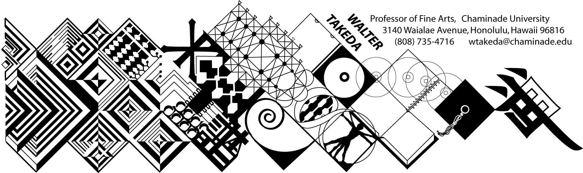
ART 202 Spr 2018
Survey of Art II
Tues/Thurs 8:30-9:20 am in Henry 227
Walter Takeda
Office Hrs: afternoons
or appointment E205

COURSE DESCRIPTION: Art 202 is a general survey course, with no prerequisites, that may be used to fulfill CUH's general education fine arts requirement or used as a liberal arts elective.

The material covers a survey of Western art, sculpture, and architecture from the Renaissance to present. In this age of frequent travel, you will undoubtedly have opportunity to visit many of the areas covered. Study of these cultures will result in a deeper understanding of this rich human legacy.

COURSE OUTCOMES: Student Learning Outcomes linked to Program Learning Outcomes:
The student will understand the historical and theoretical influences as well as the interdisciplinary forces that shape the history of art. The student, in the papers, will research and apply this knowledge of those influences.

More specifically, upon successful completion of this course, the student will demonstrate an:
- Understanding of the placement of art within its historical context;
- Ability to recognize important aspects of a style, country, or movement;
- Ability to use this understanding and ability to contextualize a given piece of art or artistic movement.
These outcomes are all linked to Program Learning Outcome #4.

This class presents material in chronological order; you are expected to do parallel reading in your text. At the beginning of each class, a pool of slides will be shown of previous critical material. As much as possible, these works will be from the text. After each class, keep a list of this pool of slides, correctly spelled as to artist, title of work and school or style. Use this "mini-review" to good advantage; cramming for THIS class is a poor idea.
Before each exam is a thorough review of the material. Audiotaping this review helps many students. Review slides will be placed on e-College for you to download well before the exam. Other material will also be placed on e-College.

COURSE REQUIREMENTS:

Examinations will include objective questions (multiple choice, true/false), slide identification (artist, title, school), and a written comparative analysis (paper) between two works. Your ability to recognize artists and/or styles not in the review pool will take the test beyond mere rote memory; this will be an assessment tool to gauge important goals of this course. These goals include your ability to place art in historical context, recognize important aspects of a style or movement, and recognize individual styles of artists. As such, additional quizzes (which may not count to the grade) may be administered.

A comparative analysis paper is also required; a handout to this effect will be distributed later.

MAKEUP EXAMS are a serious matter. Students will notify the instructor BEFORE the exam (at wtakeda@chaminade.edu or leave a message at 735-4716) then bring in a verifiable excuse, such as a service station invoice, doctor's slip, etc. It is the student's responsibility to abide by these two conditions and the instructor's prerogative to refuse a makeup. The makeup will be scheduled by the instructor, normally at 7:30 am which will produce no time conflicts. If the student is again absent, he or she will be given a zero. In fairness to other students, a different makeup exam will be administered; if it is at all possible to take the test on time, make every effort to do so rather than risk a more different exam. THERE IS ABSOLUTELY NO EXTRA CREDIT IN THIS COURSE!

GRADING POLICY: A:100-90, B: 89-80, C: 79-70, D: 69-60. Please note that this scale may be different from other instructors. Each exam, including the final, will be equally weighted.

COURSE SCHEDULE:
The instructor reserves the right to adjust the schedule and contents of this syllabus, such as exam times or grading criteria or any other changes. Any announced change made in class is the student's responsibility.

The student is obligated to abide by the conditions of this syllabus as may be amended, the Chaminade catalog, and the Chaminade student handbook, and cannot claim ignorance of these conditions as an excuse for noncompliance with the requirements herein set.

TUESDAY THURSDAY
Jan 16 | Intro; historical overview; Proto-Renaissance | Jan 18 | Proto-Renaissance; Brunelleschi and the triumph of the Renaissance
Jan 19 | Italian Renaissance artists of 15thC | Jan 21 | Ital. Ren. Artists continued
Jan 23 | Int’l Gothic to Early Flemish | Jan 25 | High Renaissance: daVinci, Raphael
Jan 30 | Michelangelo | Feb 1 | Mannerism, Venetian, French Ren.
Feb 6 | FIRST EXAM REVIEW | Feb 8 | FIRST EXAM
Feb 13 | German painting; Italian Baroque | Feb 15 | Spanish and Flemish Baroque
Feb 20 | Dutch Realism | Feb 22 | Dutch Realism
Feb27 | 17thC French ptg; Versailles | Mar 1 | Rococo
Mar 6 | Neoclassicism | Mar 8 | SECOND EXAM REVIEW
Mar 13 | SECOND EXAM | Mar 15 | Romanticism
Mar 20 | Romanticism cont. to Realism | Mar 22 | Impressionism
Mar 27 | SPRING BREAK | Mar 29 | SPRING BREAK
Apr 3 | Impressionism to Post-Impress. | Apr 5 | Post-Impressionism continued
Apr 10 | Cubism | Apr 12 | Fauve, Dada, Surrealism
Apr 17 | European Expressionism to Action | Apr 19 | Pop to Post-Modern art
May 1 | Internat. Style to Post-Modern arch. | May 3 | FINAL REVIEW
Tuesday  May 8 | FINAL EXAM – same room 8:30

Dont forget: Deadline to withdraw or go credit/no credit, not made clear on the CU website.

