
AR 103/ID 216
VisDes/DesPrinc
Spring’18 Eiben108
-02: TR 11:30-12:50
-01: 10:00-11:20
office hrs E212

COURSE DESCRIPTION: ID 216 is a pre-major studio course for all ID candidates or may serve as a fine arts general education requirement. Students produce projects on the elements and principles of design.
COURSE OUTCOMES: Upon successful completion of this course, the student will demonstrate an:
- Understanding and appreciate the purpose of design;
- Understand the evolvement of creative activity, both rejection and enhancement;
- Practice increasing refinement of visual ideas
- For E+ID students, this course addresses CIDA Standards 8 and 11– Design Elements & Principles. They must understand and make effective use these Elements & Principles here and apply them in future E+ID courses.

COURSE REQUIREMENTS INCLUDE THE FOLLOWING:

ATTENDANCE IS MANDATORY! Students must be on time and stay the full period. Instructions are at the beginning of class. Anything over two unexcused absences (e.g. a tardy, leaving early) will result in a lower grade for the ENTIRE COURSE. Any 3 combination of tardies or early leaving will constitute a full absence. All excused absences must fulfill two requirements: 1. the student will e-mail the instructor before the absence and 2, upon return, some evidence (doctor's slip, service station invoice) MUST be produced.
ADOBE ILLUSTRATOR AND PHOTOSHOP will be used to do projects; No matter what your major, it may be advantageous to list this fact on your job resume - a more than working knowledge of these well-known programs.
If you are lacking computer skills, this may not be your course. Unless you have these programs at home, you will have to listen carefully and work diligently in class, where these programs installed. Download all the materials on Canvas immediately. The instructor may provide added instructions and handouts. BY NEXT CLASS, load them onto your electronic devices before class to avoid screen clutter – A flash drive is recommended over any cloud service – downloading takes valuable class time especially if the entire class is downloading from Canvas at one time! Before each class start time, email me with an attachment of a quiz that is to be found in every project subfolder; if you fail to do that, points will be deducted from that project. If you cannot finish during class time, you will have to come into the classroom when it is unoccupied, which will be a pain, or you will have to rent these expensive programs from Adobe. This is why attendance is so crucial, hand the penalties so heavy. Good students go over the handouts thoroughly before coming to class.
In future, it would be a great advantage to know these popular programs. Another benefit is that there are no need for books and traditional art materials.
DUE DATES and TIMES: Designated deadlines for projects are absolute – no excuses! A pink slip in your future is exponentially more horrific than an F in a project. You must submit your project (usually an Adobe Illustrator file, .ai, and a .jpeg version) via e-mail to me only at wtakeda@chaminade.edu. Make sure – open your mail’s “sent items” folder to verify that it was transmitted along with attachments. Never delete these “sent items” till the course is over. This is your responsibility. If there is a question, you must provide a screen capture as proof: open the verifying e-mail; press “Print Screen” on keyboard; open a Word Document; click “Paste” and e-mail this. As your work on a project for several days there is no excuse for lateness - turning in incomplete work is better than a zero.
PRESENTATIONS by the student and critique by the class may be conducted on the Design Principle projects. A poor presentation detracts from the project grade; so take it seriously - prepare explanations, methodology, etc. Your professional growth must include ability to articulate and persuade an audience.
GRADING POLICY: Grading is a subjective matter and all the more so in the artistic area. A mere compliance with the minimal requirements of the project results in a C. There is nothing wrong with a C - it denotes adequate work if correctly fulfilling the basic requirements. Any higher grade requires more creativity within the assignment’s parameters, a higher degree of execution, greater aesthetic quality, excellent presentation, etc.
Grading criteria: A=100-90, B= 89-80, C= 79-70, D= 69-60, F= 59 or below
Late Penalties: Principles projects are twice the value of Elements projects. Logo is weightier still.
Any project sent or submitted after the start of class deadline will suffer a deduction, even if by1 minute. A project may be submitted before midnight on that deadline day with a 10% deduction, a full letter grade drop. Nothing will be accepted thereafter (zero for project) unless above verifiable proof is submitted; same prior notification rule applies.

THE FOLLOWING COURSE SCHEDULE may be changed. The student, if absent, is still responsible for any verbal changes of assignments and due dates stated in class; check with classmates.
Remember that quizzes may precede the Intro to new projects at the beginning of class- read handouts beforehand to pass quizzes; wrong answers will be deducted from your Project grade.

Schedule
DATE | TUESDAY | date | THURSDAY
Jan16 | Intro to Illustrator; work on value proj | 18 | Work on value proj
23 | ** intro to line/shape project (Size Variation) | 25 | Work line/shape project (SizeVar)
30 | ** intro, work on Shapes in Container project | Feb 1 | Work shapes within container proj
Feb 6 | ** intro, finish color A; due before next class# | 8 | Work color B proj (SizeVar)
13 | ** texture intro; work texture (Size ar) | 15 | work on texture proj (SizeVar)
20 | ** intro, work on space illusion | 22 | Work space illusion project
27 | ** intro focal point by isolation | Mar 1 | Work on focal point by isolation
Mar 6 | ** intro, work on transition | 8 | Work on transition
13 | ** intro, work on Unity (Photoshop) | 15 | Work on Unity
20 | work on unity; #due before next class# | 22 | Intro, work on Asymmetric balance
27 | SPRING BREAK | 29 | SPRING BREAK ***
Apr 3 | work asymm balance- #due before next class# | 5 | Intro, work on Room Alteration Proj
10 | work on Room proj; #due before next class# | 12 | Work on logo: creative ideas
17 | Logo section 2 Creative Ideas | 19 | Work on logo creative ideas
24 | ** Work on logo Variations | 26 | Work on logo: Variations
May 1 | ** Finalize & render in Illustrator | May3 | Finish Illustrator final logo

** The deadline before start of class (e-mailed projects) of the project previously worked on.
For example, before 10a.m. Tuesday Jan 22, an e-mail submission should have been sent on the
Value Project.
**Turn in the project worked on previously before class (deduction otherwise).
(Remember the deadline to withdraw from class or go credit/no credit.)
The student is responsible for reading, comprehending and abiding by the terms and directions of this syllabus as may be amended in class, and cannot claim ignorance of its contents or verbal amendments as an escuse.

SYLLABUS SUPPLEMENT – Specific Class Policies and their Penalties
(You are responsible for the material herein as much as in the syllabus proper)

ABSENCES should not be taken lightly.
- If LATE, roll will already have been taken at the start of class. It is your responsibility to make your presence known to the instructor so that he can mark you late and not absent. If you are chronically late, 3 “lates” will equal one unexcused absence against you.
- Three or more unexcused absences may result in a full letter grade drop on your final class grade.
POSSIBLE QUIZZES: Last semester’s experience necessitates this, as students did not heed my suggestions to download all the folders at the beginning of the semester; much time was lost downloading from Canvas during class, and my time lost going over material they should have read regarding each project. I will not take kindly if I see anyone downloading from Canvas!

LATE PROJECT SUBMISSIONS:
above Absence policy is independent of these late project submission policies.
Deadlines are before class after workdays on that project. Again, note the syllabus schedule - the double asterisk (**) before a class means that the previous project is due before the start of class.
Always save onto your laptop, flash drive, or other device/method – not on the classroom desktops. This way, you can email the project, finished or not, from your home, and avoid a penalty.
If the ‘before class’ deadline is not met, you have until midnight of that deadline date to submit, at a 10% penalty in grade. So a submission of 1 minute after class starts till midnight that day has the same 10% penalty.
Thus, if you are absent, make a decision which would be a worse penalty: the late submission or an incomplete work submitted on time. Nothing will be accepted after the midnight deadline.

FILENAMES OF PROJECT SUBMISSIONS - GENERALLY REQUIRED ON 3 PLACES: Projects will be submitted as an Illustrator file (.ai) and a .jpeg file conversion of the .ai file. Later there will be Photoshop files (.psd).
- You will be provided with a template for most projects; on that template will be a layer where you will type your section and name. As there are more than 1 section, it will expedite my printing and grading your projects.
- Both files are to be submitted as 2 attachments on 1 e-mail. DON’T send 2 emails – 1 for each!
- The filename of both will be your section (01 or 02 followed by LastnameFirstname as follows:
01 TakedaWalter Do not add anything before or after. -5% on first offense, more if you
continue to forget.
- To convert your Illustrator file to .jpeg, go to “File > Export” – you cannot use “Save As”
- When you get to this window, you MUST check “Use Artboards” -5% on first offense, more if you continue.
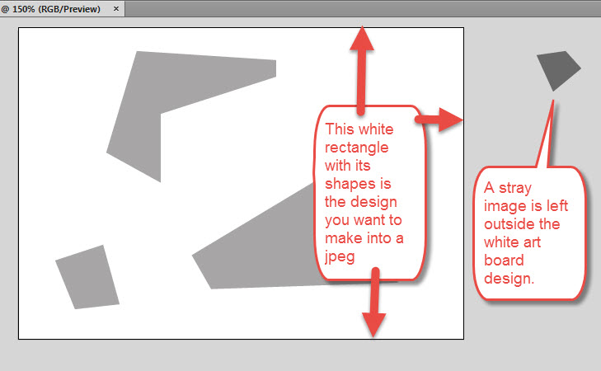
Use Arboards was checked, so the proper margins of the original Artboard appears. The forgotten stray object to the right outside of the artboard is correctly not included in the jpeg.

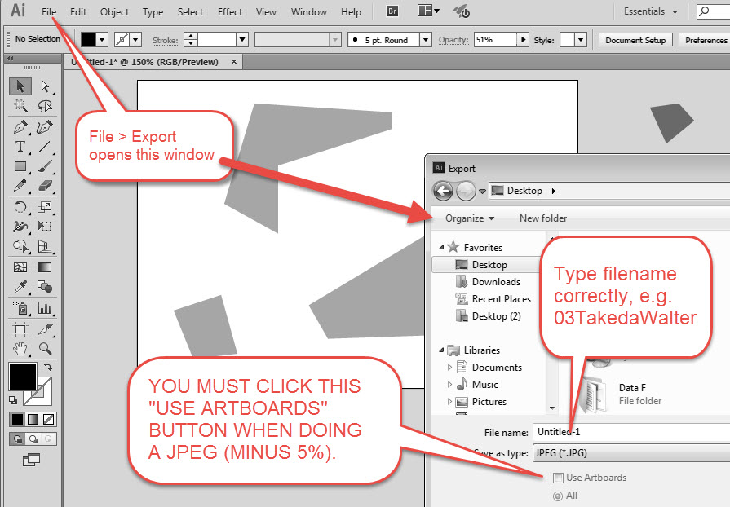

An .ai Illustrator file is a vector image, so it must be converted to a raster (pixel-based) image. Thus it must be “Exported” (converted), not “Saved As.”
LATER PROJECTS IN PHOTOSHOP:
Save As (jpeg) will flatten all your Photoshop layers into one. If you wish to further alter the image with its separate layers, save it as a Photoshop (.psd) file.

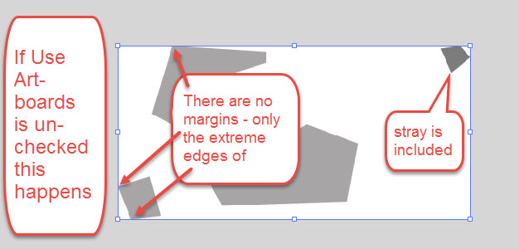
Use Artboards was not checked, so the jpeg image made will only include up to the extreme horizontal and vertical points of all the objects, even the stray outside of the artboard.

Double check your Color Mode on the next window – Do not leave at professional printing CMYK mode.
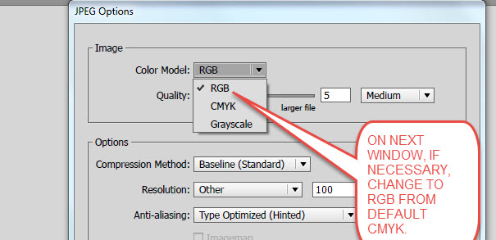

CLASSROOM WORKTIME
Maximize your time in class on working on the Adobe programs.
Only work on the project scheduled for that day. Find time later in a studio when there is no class and catch up on a late project. Ask the instructor if it is OK to work in a class in progress.
Do not be texting or doing other work during this time, or being on social media. Some projects have phases that can be worked out at home – such as gathering objects on Google Images for the Logo.

