Philosophy/Psychology/Religion 463
Death and Dying (Online)
Spring 2017-2018
Instructor: Dr. Thomas (Toby) Yos
- Meeting Dates: January 16 – May 10
- Office Hours: Visit My (virtual) Office anytime
- E-mail: thomas.yos@adjunct.chaminade.edu or through Canvas Inbox on blue, left-hand menu.

Required Texts:
Tuesdays with Morrie by Mitch Albom
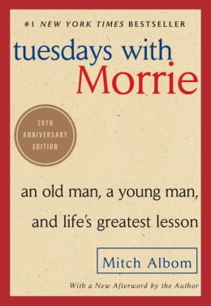
TUESDAYS WITH MORRIE
REQUIRED |By ALBOM
- EDITION: 97
- PUBLISHER: PENG RAND
- ISBN: 9780767905923
To Comfort Always (2nd edition) by Linda Norlander
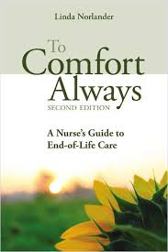
TO COMFORT ALWAYS
REQUIRED |By NORLANDER
- EDITION: 2ND 14
- PUBLISHER: SIGMA THET
- ISBN: 9781938835506
Have a Little Faith by Mitch Albom
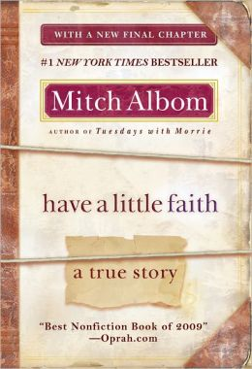
HAVE A LITTLE FAITH
REQUIRED |By ALBOM
- EDITION: 09
- PUBLISHER: HACHETTE B
- ISBN: 9781401310462

Man's Search for Meaning by Viktor E. Frankl

MAN'S SEARCH FOR MEANING
REQUIRED |By FRANKL
- EDITION: 06
- PUBLISHER: PENG RAND
- ISBN: 9780807014271

Catalogue Description - PH/PSY/RE 463 Death and Dying: This course is a psychological, philosophical, theological, ethical, biological, and social inquiry into the nature of death. It examines issues including life after death, assisted suicide, right to die, relationship of the medical system and right to life, bereavement, death system, and Eastern approaches to death.

General Education Learning Outcomes for Interdisciplinary Courses from Student Handbook:
Students who successfully complete the General Education Core program will:
1. Demonstrate the ability to approach particular areas of human culture and experience utilizing a variety of disciplinary perspectives
2. Demonstrate the ability to transcend disciplinary boundaries in articulating approaches to the ultimate questions of meaning in human experience

Course Learning Outcomes:
In order that the students may have a better understanding of what they will learn in PH/PSY/RE 463, the following outcomes are provided. Through the course, the student will:
1. Demonstrate a deeper understanding of cross-cultural issues surrounding Death and Dying through written reflections and participation in class discussion.
2. Clarify one's own thoughts on Death and Dying and demonstrate this increased clarity through written reflections and class discussions.
3. Be an active and caring member of a classroom community of inquiry and demonstrate this through responses to classmates' discussion postings.
4. Strengthen one's thinking, inquiry, and writing skills and demonstrate this through written reflections and class discussions.

Assignments:
- Discussion Postings: Each week you must make a total of 5 quality postings on that week's discussion boards. 15 weeks of Discussion Postings X 10 points = 150 points
- Online Material Quizzes: Each week you must take a quiz which assesses whether or not you have gone through and understood all of that weeks online content. 15 Online Material Quizzes X 10 points = 150 points
- Book Reflections: Each week you must read approximately 50 pages and submit a one page written reflection on your reading. 14 Book Reflections X 10 points = 140 points
- Extended Reflection: You must submit an approximately 5 page long Extended Reflection. 1 Extended Reflection X 50 points = 50 points
Course Grade: The number of points that you earn will determine your final grade for the course.
If you earn 441-490 points (90-100%), you will get a grade of “A” for the course.
If you earn 392-440 points (80-89%), you will get a grade of “B” for the course.
If you earn 343-391 points (70-79%), you will get a grade of “C” for the course.
If you earn 294-342 points (60% to 69%), you will get a grade of “D” for the course.
If you earn 293 points or below (59% and below), you will get a grade of “F” for the course.

Due Date: There is a strict weekly due date of 11:59 p.m. each Sunday night for all weekly discussion postings. There is a suggested time-line for submitting all other assignments on the Course Schedule. The last day to submit all book reflections, the extended reflection, online material quizzes, and discussion postings is Thursday, May 10.
A NOTE ON PLAGIARISM: Plagiarism is strictly prohibited. Plagiarism will, at the very least, result in failure of the assignment. Additionally, Plagiarism may lead to failure of the course, or suspension or dismissal from the university. For more information on this go to bottom of the Module tab, open the "Writing Papers" Module, and visit Plagiarism: Why You Should NOT Do It
Got Questions?
About the content, structure, or expectations of this course? Visit My (virtual) Office and ask your question.
About more personal matters? Feel free to send me an e-mail.
About technical, computer stuff? Check out the "Canvas Orientation for Students" on your Dashboard or use the ? Help button on your blue, left-hand Canvas menu.

For more information about each kind of assignment and for the course schedule please go to the Canvas Modules tab, then to Syllabus and Assignment Descriptions, and to the corresponding assignment tabs.

