

PAR 205: ACTING I Fall, 2017

THR 305: ACTING II
Bro. Gary E. Morris, S.M. Tu/Th, 2:30-3:50pm
Office: Ching 105A Ching 101—The Loo Theater
Phone: 440-4246
Office Hours: T. Th.1:00-2:30 PM (also by appointment)
MW.F. By appointment
E-mail address: gmorris@chaminade.edu



Course Description
The course aims to develop an appreciation of theater and the acting process. The student will develop a basic understanding of the acting process through improvisation, exercises, various reading and writing assignments—all given practical exploration when applied to scene and monologue work. Acting skills of relaxation and concentration are combined with script analysis, line interpretation and character development to produce short performances that are worthy of the craft of acting.

THR 305—advanced development of the above

Outcomes
By the end of the semester, students will be able:
- To possess fundamental knowledge and practice of the vocal and physical tools required for acting
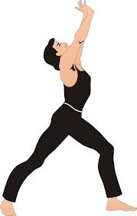
- To introduce the acting student to some of the basic skills used in the creation of character, and the choices that lead characters to action.

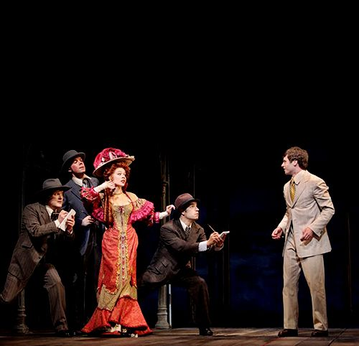
- Through the use of neutral scenes, individual monologues, and scene study students will leave the class with an understanding of objectives, obstacles, character analysis, blocking, movement, and transitions
.

- To recognize connections between life and acting and build acting technique upon those connections.


- To understand and to competently use the terminology and vocabulary of the art of acting

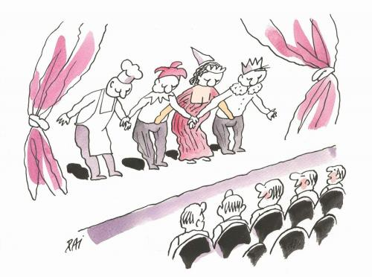

- To become more focused and informed as a theater audience

- To develop the ability to evaluate acting in a theatrical production



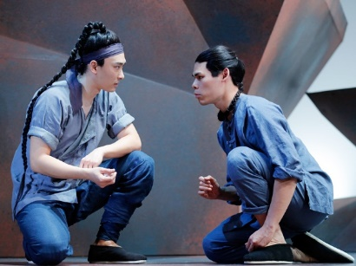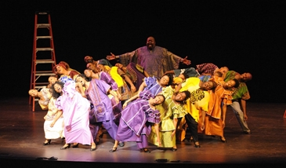
- To read and understand a range of theatrical literature representing different cultures and traditions of acting



- To respond actively and imaginatively in classroom by engaging in active participation in exercises and activities, discussion, interpreting, analyzing and critical thinking.


- To present monologues, readings or scenes/short plays in front of an audience with confidence and evidence of proper preparation and rehearsal.

THR 305—advanced development of the above

Texts—No required textbook; use of play scripts, monologues and other published material

Supplemental Materials
Play scripts, articles and other materials and resources will be placed in the Sullivan Library on reserve for this class. Specific information will be given out as the materials are available.

Expectations and Policies 
- Attendance ON TIME and participation at all class sessions. This is very important, as group work on scenes and play production demands that all be present and participating.
- Reading all assigned materials and being prepared for classroom activities, in class and scheduled rehearsals and performances.
- Memorizing all selections/scenes by specified dates.
- Writing two short reflective essays on acting assignments
- Writing one acting analysis of a character in a play script.
- Writing one review of a professional acting performance from a play on DVD
- Attend and review two live theatrical productions (the spring CUH production and one community-based production)
- Maintain a detailed and efficient acting journal 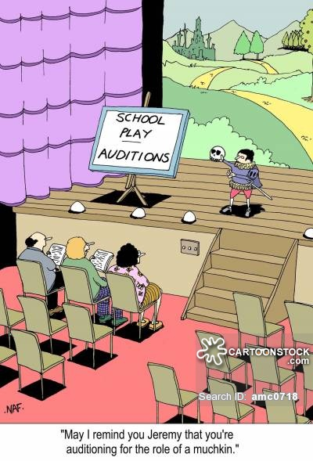

Extra Credit
The following are extra credit options for the class:
- Seeing and reviewing an additional production/performance; up to 25 points E.C.
- Presenting an additional memorized and staged monologue or scene; up to 25 points E.C.
- Actively participate as a performer or in a running crew (costumes and props, scenery, or sound and lighting) for the CUH Drama Department’s spring production this semester; up to 100 points E.C.. The fall production will be the comedy Beyond Therapy by Christopher Durang, with performances November 3,4,5,8,9,10,11,12. Roles available for 4m and 2w. Auditions after Labor Day weekend in the Loo theatre. Information will be provided in class about signing up for acting auditions and crew positions.
- 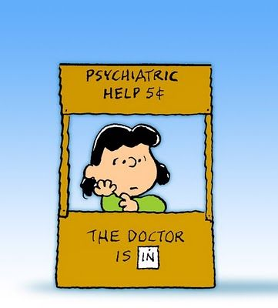

Student Conduct

- Note: All portable cellular phones, headsets, earphones, i-Pods, MP-3 players (and their ilk) and other non-academic, non-essential technological distractions must remain turned off and in bags or packs during each entire class session.
- Laptop computers are allowed with permission, and ONLY for work pertaining to this class. Violators lose this privilege.
- No one may leave the room during the class except in an emergency. Take care of bathroom needs, business and communications before or after class.
- Plagiarism will not be tolerated. All students are expected to follow the CUH policy regarding use of technology and plagiarism (see online Student Handbook, or the online CUH General Catalogue).



Grading:
The class grade is determined through a point system. Points are earned on the preparation and presentation of selections, monologues and scenes, short quizzes, the writing assignments (play attendance/reviews, short reflection papers and acting journal); classroom attendance and participation; and any extra credit done for this class. The following scale of the total points will be used to determine grades: 90-100% is an A; 80-89% is a B; 70-79% is a C; 60-69% is a D; 59% and below is an F.

Grade Value Assignments: Performances/scene work 50%
Written work 20%
Final Performance/Exam 20%
Class Participation/Attendance 10%



Writing Requirements
All written assignments handed into the professor for this class must meet the following criteria:
- The papers must be word-processed or typed, double-spaced, in black ink, using appropriate paper, fonts and standard margins.
- All written work must meet the standard writing requirements set forth by CUH and will be evaluated using a template designed to meet these requirements.
- All writing assignments must be handed in during the class on the assigned dates unless permission from the professor to hand in a tardy assignment is given in advance.
- Production Reviews (with programs, ticket stubs attached) are due the week following the attendance at the production. Late reviews will not be accepted.

Attendance Policy
Attendance is taken at every class session. Contributing to and participating in classroom activities are expected. Attendance is extremely important for this class. Because of the tightness of class schedule, work missed due to absence may not be made up. Because of other studentt’s ability to fully participate. We will be relying on each other to be prepared and present. The final grade will be lowered by 10% after three unexcused absence, and excessive absences will affect the final grade for the course. Absences are only deemed excused by the teacher, and in advance (except with a doctor’s note for sickness).
It is the student’s responsibility to notify the professor in writing concerning all excused absences.



Class Structure 

We will approach our learning of basic acting skills in three parts:

Part I: Developing the Actor's Instrument
Observation, Concentration, Sensory Awareness, Emotional Awareness, Imagination, Listening, Relaxation, Voice

Part II: The Actor as Detective
Given Circumstances, Environment, Objectives, Actions, Obstacles, Structure, Characterization.

Part III: Putting It All Together
Applying what we've learned to texts (interpretive readings, monologues, scenes.)
You will be assigned individual and ensemble exercises throughout all three parts. Rehearsal outside of class is mandatory.

A more detailed schedule of assignments and classroom activities will follow soon.

Final Exam Scenes are scheduled for 1:15-3:15pm on Wednesday, December 13th in the Loo Theatre.



