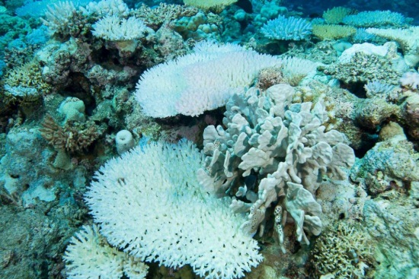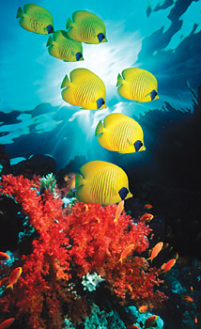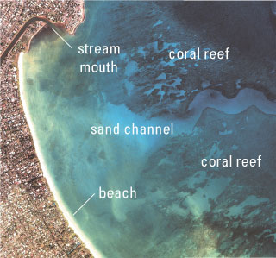

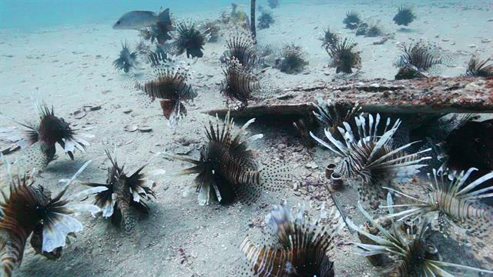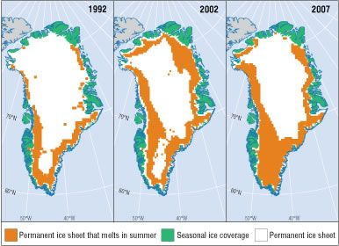

Marine Environmental Science: ENV 115

Lecture Syllabus
Fall 2017

How inappropriate to call this planet Earth when it is quite clearly Ocean.
Arthur C. Clarke

There's nothing wrong with enjoying looking at the surface of the ocean itself, except that when you finally see what goes on underwater, you realize that you've been missing the whole point of the ocean. Staying on the surface all the time is like going to the circus and staring at the outside of the tent.

Dave Barry

It is said by the Eldar that in water there lives yet the echo of the Music of the Ainur more than in any substance that is in this Earth; and many of the Children of Ilúvatar hearken still unsated to the voices of the Sea, and yet know not for what they listen.
J.R.R. Tolkien, The Silmarillion

For most of history, man has had to fight nature to survive; in this century he is beginning to realize that, in order to survive, he must protect it.
Jacques-Yves Cousteau

The scientific community is no private club. In principle, and in its best and broadest sense of the words, scientific inquiry can be undertaken by anyone on almost any subject matter.
W. Quine and J. Ullian

Instructor: Dr. Gail Grabowsky (“Dr. Gail”)

Address: Wesselkamper, rm 108
Environmental Studies
Chaminade University
3140 Waialae Ave
Honolulu, HI 96816

Phone: Office: 735-4834 (ext. 4834 if calling from on campus); cell: (808) 387-9319 (no calls after 9:00 PM please)

E-mail address: ggrabows@chaminade.edu

Office hours: MF: 3:00-5:00; Tu 11:30-2:30; Or by appointment

Course Description: This course introduces students to the scientific causes and consequences of the current major marine environmental issues. Topics include: effects of climate change on ocean ecosystems, marine pollution, marine debris, oil spills, fisheries exploitation, fisheries by-catch, marine alien species, coastal development and coral reef degradation. The course focuses on making students aware of the material causes and consequences of each issue as well as the role of science in elucidating and devising solutions to each issue.

Course Learning Outcomes: When you have completed this course you should:
Know what science is and how scientific research is conducted
Understand the basic concepts in oceanography and marine biology
Know the characteristics of the major marine zones
Know the names and ecological roles of a number of marine organisms that occur in Hawaiian waters
Know the physical causes of each of the major marine environmental issues
Understand the causal network of events that lead to the occurrence of each issue
Know the actual and projected physical consequences of each issue
Understand the detrimental effect(s) of each issue on marine ecosystems and human welfare
Be familiar with some of the specific mechanisms diverse indigenous people of the Pacific employ(ed) in gathering ocean resources that may be considered sustainable practices
Demonstrate an understanding of the connections between academic work and real-life situations

Course Requirements: Your grade in this course will be based on the following. Each of the items/activities listed below will be described to you in writing or orally in class.

Course Grading: Based solely on the following in the following proportions:
- Two Lecture Exams 40% (20% each)
- Final Exam 20%
- Marine Zone Presentation 20%
- Notable Marine Places and Issues Presentation 20%

The points that each contributes to your grade in this course is as follows:
Lecture Exams 200 points (100 points each)
Final Exam 100

Marine Zone Presentation 100
Notable Marine Places and Issues Presentation 100
500 points total
Grading Procedures:
Grades will be assigned to written exams using a curve with the mean score for the class being a B- and the score immediately below the mean being a C+. This will be explained in detail in class. The first two lecture exams will cover the material from the start of class up until the first exam and the material after the first exam up until the second exam, respectively. These exams will have a variety of types of questions on them. The final exam is cumulative, multiple choice and covers the lecture material for the entire semester. A review sheet will be handed out before every exam.

Texts:
Required: You should purchase this textbook.

Castro, P. & M. E. Huber. Marine Biology. 10th Edition. McGraw Hill. 2013. [ISBN:9781259168505]

Supplemental Texts: A number of readings in this course will come from the documents and publications listed below. Still other readings may come from documents not on the list below which become known to me or relevant during the course. I will provide you hard copies or e-copies through Google Drive.

“U.S. Ocean Action Plan: The Bush Administrations Response to the U.S. Commission on Ocean Policy.” 2005.
Boesch, D. F. et al. “Marine Pollution in the United States.” 2001. Pew Oceans Commission.
Carlton, J.T. “Introduced Species in U.S. Coastal Waters.” 2001. Pew Oceans Commission.
Congressional Quarterly Global Rersearch. 2007. “Oceans in Crisis: Can the Loss of Biodiversity be Halted?” (1)10 pp.237-264. www.globalresearch.com.
Dayton, P. K., S. Thrush and F.C. Coleman. “Ecological Effects of Fishing in Marine Ecosystems of the United States.” 2002. Pew Oceans Commission.
Global Coral Reef Monitoring Network. 2008. Status of Coral Reefs of the World. Clive Wilkinson editor.
International Panel on Climate Change (IPCC). 2014. Climate Change 2014 Synthesis Report.
International Program on the State of the Ocean. 2012. “The Ocean in Crisis.”
Mora, C., Andrefouet, S., Costello, M.J. et al. 2006. “Coral reefs and the global network of marine protected areas.” Ecology: 312: 1750-1751.
Poepoe, K.K., P.K. Bartram and A. M. Friedlander. 2003(?). “The use of traditional Hawaiian knowledge in the contemporary management of marine fisheries.” Putting Fishers’ Knowledge to Work: Conference Proceedings, pp. 328-339.
U.S. Commission on Ocean Policy. 2004. “An Ocean Blueprint for the 21st Century.” http://www.oceancommission.gov

Marine Zone and Notable Marine Places and Issues Presentations:
These presentations will both count towards your lecture grade. The particular protocols, requirements and grading criteria for each will be described in class and with a handout. The date of the presentations are indicated on the syllabus.

Extra Credit Options:
Throughout the course Dr. Gail will be making numerous environmental service-learning outings available to you. You may also find environmental service opportunities on your own. Those that Dr. Gail organizes or brings to your attention will typically be on Saturdays or after school. For every service-learning activity that you participate in, that entails 4-5 hours of work, will receive +5 extra credit points.
Also, periodically throughout the course there will be talks and presentations you may attend that pertain to the course material. Dr. Gail will let you know when these opportunities arise OR you may discover them and bring them to the class’s attention. You can earn +2 extra credit points towards a lecture exam for each talk you attend with content related to the course content.
In order for all talks and service activities to count for extra credit you MUST have them approved by Dr. Gail PRIOR TO the event and you MUST document your presence (if Dr. Gail is not also in attendance) with a photograph of yourself participating AND give Dr. Gail the name and phone number of the person in charge or speaker/presenter. If there are any handouts from the event bring them as evidence of your attendance as well. You may earn up to 30 extra credit points from service activities and 10 from attending talks/presentations.

Attendance:
While I dearly hope that you can make every class…, since you are adults now, you are free to miss any lecture class you choose… but KNOW that there may be some consequences should you choose to exercise this option: your grade could (and most likely WILL) suffer. I believe that students who have missed a lot of classes ALWAYS would have done better if they had not missed classes. There simply is no substitute for being in class when it comes to understanding the material. I can give you a fishing pole, but I cannot make you fish.
If you miss a lecture exam or lab your absence must be excused if it is not to formally effect your grade. Excused absences occur when you bring in a doctor’s note, a funeral announcement for a family member, notice of participation in athletic events, etc. Unexcused absences occur when you were working, surfing, sleeping, cramming for an exam in another class, etc. Unexcused absences from lab will negatively affect your grade. For each unexcused lab absence you will lose 20 points (the equivalent of one full grade for your formal lab write up). I am a scientist; I require hard evidence if an absence is to be excused. If your car breaks down on the way to lab take a picture and make SURE I can verify the date and time of the breakdown and it will be an excused absence, ☺, however, no evidence; no excused absence.

Classroom Atmosphere:
I value a very open, yet courteous class atmosphere. Express your ideas! Ask your questions! (The only dumb question is the one in which you ask yourself if you should ask your question.) Respect the thoughts and ideas and opinions of others – really think about what others say. Let them fully express their thoughts and ideas and then you do the same. The thing I value most from my college days are all the wonderful, valuable, diverse ways of looking at and understanding the world that I was exposed to. Be an open vessel – take ideas in! You will learn as much from each other as you do from me.

If you are handicapped under the Americans with Disabilities Act:
Chaminade will provide assistance for any student with documented disabilities. Any student who believes he/she may need accommodations in this class must contact Dr. June Yasuhara (735-4845), at the Counseling Center (office is next to security), in order to determine if you meet the requirements for a documented disability in accordance with the Americans with Disabilities Act. Please contact Dr. Yasuhara as soon as possible so that accommodations can be implemented in a timely fashion.

Reminders of Important University-Wide Policies:
The following policies are summarized from the Student Handbook. Please be sure that you have reviewed these and other policies that your Handbook contains.

Academic Honesty:
Students are responsible for promoting academic honesty at Chaminade by not participating in or facilitating others’ participation in any act of academic dishonesty, and by reporting incidences of academic dishonesty (such as theft of tests, records, and other confidential materials, altering grades, and/or plagiarism) to their instructors.

Freedom of Expression:
Students are free to take reasoned exception to the views offered in a particular course of study. They may be required to know thoroughly the specific bodies of knowledge or interpretations or theories set forth by the professor, but are free to reserve judgment as to the truth or falsity of them.

Students are expected to maintain the standards of academic performance articulated in course syllabi, supplemental readings, assignments and Academic and Student Affairs policies. The instructor is considered the normal and competent judge of academic work. Students have an appeals process in the rare case of unjust grading and evaluation by the procedure detailed in the Academic Grievance section of the Student Handbook.

This syllabus and course schedule are living documents: they are free to change. I try to adhere as closely as possible to them for your convenience, but there will be times in which we will take longer on a particular topic or add or delete a topic to enhance the course. I like to be able to react to you as the course proceeds and go with the flow a bit in order to make the course experience sort of custom fit to you!
You are responsible for all of the information in this document: losing it or not reading it do not make you exempt from knowing what’s in it!
Use it to keep you organized and aware of important dates and how your grade is determined.

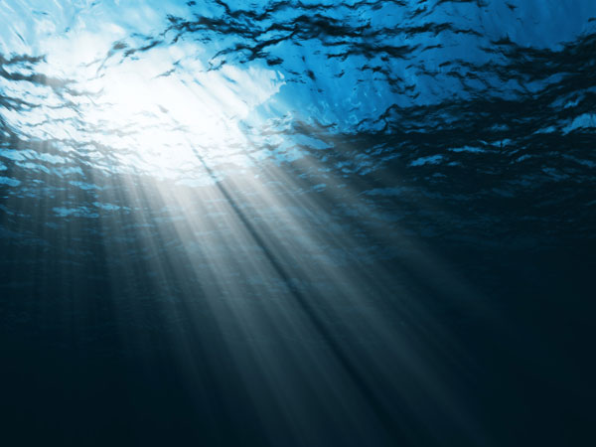

Marine Environmental Science

Course Schedule
Fall 2017
Part I

Ocean Environments & Inhabitants

WEEK OF TOPIC ACTIVITIES
8/28 – 9/1 Course Intro; Marianist Values; Science Chapter 1 in textbook
9/5 – 9/8 Marine Geology Chapter 2 in the textbook
9/11 – 9/15 Special Properties of Water; Seawater Chemistry Chapter 3 in the textbook
9/18 – 9/22 Oceanography
9/25 – 9/29 History of Life; Marine Biodiversity Chpts 4 & 6 in the textbook
10/2 – 10/6 Introduction to Ecology; Marine Ecosystems Chpts 7, 8 & 9 in the textbook
10/10 10/10: Exam I 10/10: Exam I
(NO CLASS on 10/12 – Dr. Gail at Coral Reef meeting all day)
10/16 – 10/20 Ecology Wrap-Up; Larvae Chapter 10 in the textbook
10/19: Marine Zone Presentations

Part II

Threats to Our Oceans

WEEK OF TOPIC ACTIVITIES
10/23 – 10/27 Coral Reef Threats; Coastal Development Outside Readings (provided in e-copy)
10/30 – 11/3 Marine Pollution; Marine Debris Outside Readings (provided in e-copy)
11/6 – 11/9 Eutrophication and Non-Point Source Pollution Outside Readings (provided in e-copy)
11/13 – 11/17 Fisheries: Recreational Near Shore Outside Readings (provided in e-copy)
11/20 – 11/22 Fisheries: Commercial Outside Readings (provided in e-copy)
11/20: Exam II 11/20: Exam II
11/27 – 12/1 Aquaculture; Introduced Species
12/4 – 12/8 Issues Summary; Solutions to Marine Threats Outside Readings (provided in e-copy)
12/5: Notable Marine Places & Issues Presentations Chapter 18 in the textbook

Important Dates You Should Know:

- Final Exam: Thursday, December 14th from 3:30 – 5:30 PM in our classroom.

