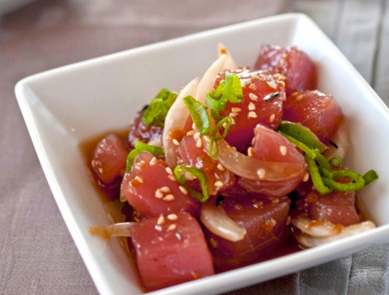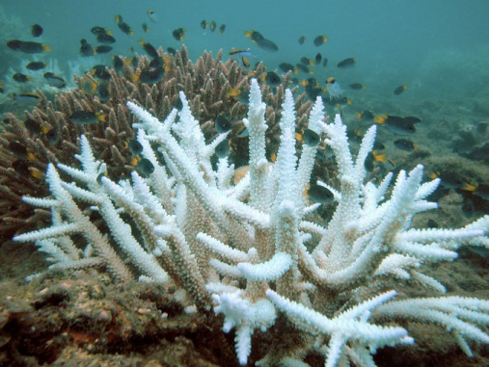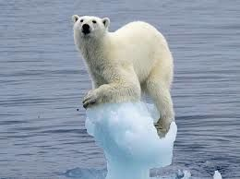
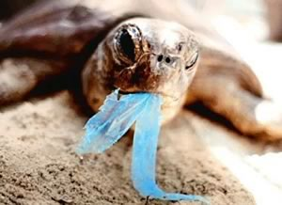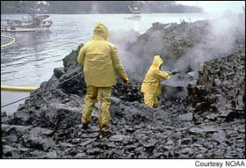

Marine Environmental Science Laboratory: ENV 115L

Course Syllabus
Summer II 2017

Human alteration of earth is substantial and growing.
Peter M. Vitousek et al.
Science 1997

Not unlike the lobster, we humans tend not to notice changes in our “water” so long as they happen gradually. For an American, dropping into the “hot pot” of Haiti or Burkina Faso creates a shock of realization: the entire planet is in the same pot, and while their are local spots hotter than others, our “pot” is warming worldwide.
Thom Hartmann
The Last Hours of Ancient Sunlight

Instructor: Dr. Gail Grabowsky (“Dr. Gail”)

Address: Wesselkamper Science Center, room 108
Environmental Studies
Chaminade University
3140 Waialae Ave
Honolulu, HI 96816

Phone: 735-4834 (ext. 834 if calling from on campus)

E-mail address: ggrabows@chaminade.edu

Office hours: WF: After class until 5:00 or by appointment
Course Description: This course introduces students to the scientific methodologies used to determining and studying the current major marine environmental issues. Issues studied include: global warming, marine pollution, marine debris, oil spills, fisheries exploitation, fisheries by-catch, marine alien species, coastal development and coral reef degradation. Laboratory exercises are conducted in the field and on the Chaminade campus. Students taking this course will be engaged in field science activities.

Course Learning Outcomes: When you have completed this course you should:
Know what science is and how scientific research is conducted
Be familiar with and experienced at reading the primary scientific literature
Know the basic units used in making scientific measurements
Be able to competently collect, record, analyze, present and interpret scientific data
Be able to write up a scientific research report
Be able to properly collect, identify and preserve marine biological specimens
Be able to identify particular marine organisms and their behaviors in the field
Be comfortable conducting field measurements in a variety of types of marine habitats
Be able to document the physical effects of a number of the major marine environmental issues
Be able to document some of the detrimental effect(s) marine environmental issues have on marine ecosystems

Course Requirements: Your grade in this course will be based on the following. Each of the items/activities listed below will be described to you in writing or orally in class.

- Laboratory worksheets, homework, etc. 50%
- Hawaiian Invertebrate/Vertebrate Organism Exposé 20%
- Marine environmental issue Journal Article Critique 20%
- Attendance 10%

Course Grading: The proportion that each of the above contributes to your grade in this course is as follows:

Lab worksheets, etc. 250 points
Hawaiian Invertebrate/Vertebrate Organism Exposé 100

Journal Article Critique 100
Attendance 50
500 points total

Laboratory worksheets, formal labs and Journal Article Critique will be graded on effort, correctness (when there is a correct response etc.) thoughtfulness and organization. Effort in general manifests itself as neatness, completeness, thoroughness, calories expended per unit time(!), timeliness, correct spelling, any extra creative things you do above-and-beyond what is expected, etc. Correctness means do your statements jive with corresponding scientific knowledge, do your conclusions follow from the evidence before you, did you calculate an equation correctly, interpret a graph accurately, make a table that illustrates your data properly, etc. Thoughtfulness can show up in many ways, perhaps you really think things through, trying to consider all the variables or you worked hard to tie pieces of evidence together, maybe you consider something that may be important that everyone else ignores. By being “thoughtful” I don’t mean that you look out for other people (i.e. are kind) I mean that you have done some thinking, really reflected upon a topic, have given it some time, have analyzed it, etc. thoroughly. Organization pertains to the design of your presentation. Did you present the material, answers, ideas, etc. is a way that is understandable, efficient and follows existing protocol (if they exist and/or are explained prior to the assignment).

Texts:
Required: None.

Supplemental Texts: We will do a number of laboratory activities that do not come from a specific lab book per se as well as custom-designed labs. These have been put together by Dr. Gail and/or her colleagues. There will also be some quantitative on-line “dry labs.” All lab-related documents will be made available to you in your Google Drive folder.

Things You’ll Need for Class:
- A Lab Coat! Buy this at the office right next to our laboratory: Henry Hall Lab 4. You can buy the “disposable” one that lasts the entire semester for $5 I believe. You must also ALWAYS WEAR COVERED SHOES INTO LAB OR YOU WILL NOT BE ABLE TO PARTICIPATE FOR THE DAY AND WILL RECEIVE A ZERO FOR THAT LAB!
- Snorkel Gear: It is NOT a pre-requisite that you be able to snorkel/swim to take this class but you will have the opportunity to do so in lab if you are able. I have JUST purchased WONDERFUL masks and snorkels that you may check-out for each lab. If you own your own gear that is great. If you check out the gear be sure to treat it like your own and rinse it after each lab when we are done. You all WILL need to buy or borrow a pair of fins as you must wear fins when we snorkel.
- Shoes that can get wet: Be sure you have something for your feet that you can cross wet basalt rocks in! These will get wet.
- Water Bottle: Bring this to all labs that occur in the field.
- Sunscreen/hat/etc.: To protect you when we are in the field.
- A love of the field and getting dirty, wet or cold: Guys this is a marine course so you will have/get to go outside! Be ready to be hot/cold, dirty etc. and prepare accordingly. Bring sunscreen if you need it, a towel, a wetsuit, etc. if you’d like and have a mind to be IN nature!

You are responsible for all of the information in this document:
Losing it or not reading it, are not excuses for not knowing what’s in it!!!

NOTE!
ALL course handouts and readings outside of the textbook are available IN COLOR in your ENV 115/115L Google Drive folder

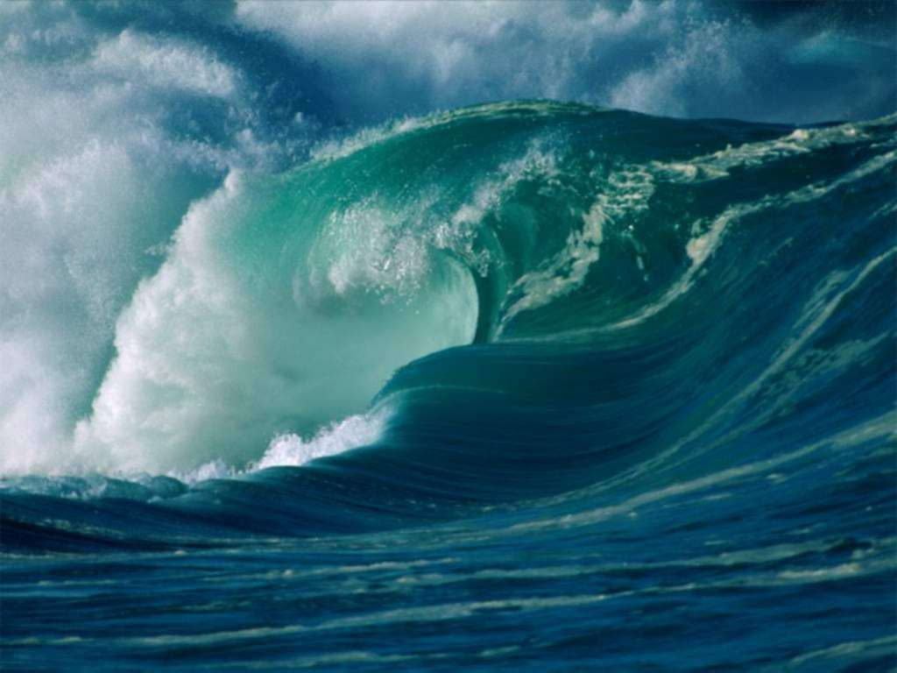

Marine Environmental Science Laboratory

Course Schedule

DATE LAB TOPIC ACTIVITIES
7/5 Course Intro and Mechanics; Who are we?! Course Intro; Review syllabi
Background Knowledge Probe
7/7 Take-Home Ocean Literacy On-line Quizzes Bring Proof you took quizzes! Quiz results due
Blue Planet Series: “Ocean World” in lab 7/7!; Choose critters for Exposes
______

7/12 Current Marine Issues Around the World Share a marine issue of concern to you
7/12 LAB STARTS AT 11:00!
Coral common names Quiz!
7/14 The big picture: survey the ocean from above Diamond Head Hike; Lab handout & worksheet;
______ Inverts other-than coral Quiz!
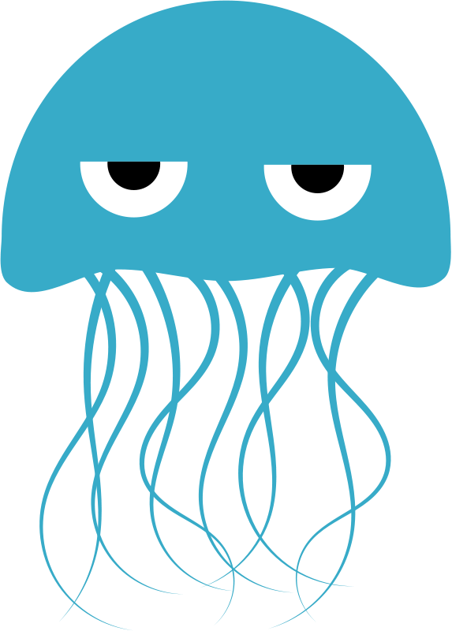

7/19 Hawaiian Organism Exposé Presentations Natural history of Hawaiian marine critters
Bony fish Quiz!
7/21 Marine plants = limu and their classification Diamond Head; Need snorkel gear!; Draw
______ Sharks, marine mammals, reptiles, birds Quiz!!!

726 Blue Planet: “Open Ocean” & “Seasonal Seas” LAB STARTS AT 11:00! Take notes!

7/28 Marine Ecology LAB STARTS AT 11:00! Waikiki Aquarium;
______ Lab handout & worksheet

8/2 Fish count OR coral survey (conditions dictate!) Ala Moana/Waikiki MLCD; Need snorkel gear!

Lab handout & worksheet
8/4 Choose journal articles & Tuna Big Data Lab Brief fieldtrip to the Library to choose articles;
______ Guest presenter: Dr. Mark Speck

8/9 Real issues in the research literature Journal Article Critiques
& “The End of the Line”

8/11 A healthy reef Hanauma Bay; Need snorkel gear!
______

Dates we snorkel: 7/21, 8/2, 811
Dates we are going somewhere outside of lab but are NOT going in the water: 7/14, 7/28

NOTE: If on any day we are scheduled to go into the water the conditions are dangerous (due to water conditions or the presence of dangerous sea creatures) Dr. Gail will revise the lab and we will stay dry!

