Marine Environmental Science Lecture: ENV 115

Course Syllabus
Summer II 2017

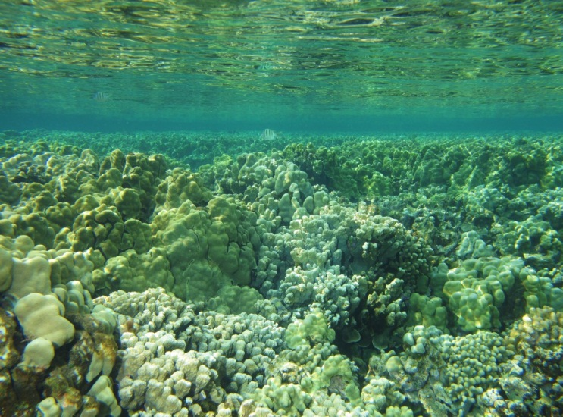

O ke au i kahuli wela ka honua
At the time when the earth became hot
O ke au i kahuli lole ka lani
At the time when the heavens turned about
O ke au i kuka‘iaka ka la
At the time when the sun was darkened
E ho‘omalamalama i ka malama
To cause the moon to shine
NOTE!
ALL course handouts and readings outside of the textbook are available IN COLOR in your ENV 115/115L Google Drive folder
O ke au o Makali‘i ka po
The time of the rise of the Pleiades
O ka walewale ho‘okumu honua ia
The slime, this was the source of the earth
O ke kumu o ka lipo, i lipo ai
The source of the darkness that made darkness
O ke kumu o ka Po, i po ai
The source of the night that made night
O ka lipolipo, o ka lipolipo
The intense darkness, the deep darkness
O ka lipo o ka la, o ka lipo o ka po
Darkness of the sun, darkness of the night
Po wale ho–‘i
Nothing but night
Hanau ka po
The night gave birth
Hanau Kumulipo i ka po, he kane
Born was Kumulipo in the night, a male
Hanau Po‘ele i ka po, he wahine
Born was Po‘ele in the night, a female
Hanau ka ‘Uku-ko‘ako‘a, hanau kana, he ‘Ako‘ako‘a, puka
Born was the coral polyp, born was the coral, came forth…
Lines excerpted from the Hawaiian Kumulipo origin chant

The scientific community is no private club. In principle, and in its best and broadest sense of the words, scientific inquiry can be undertaken by anyone on almost any subject matter.
W. Quine and J. Ullian

Instructor: Dr. Gail Grabowsky (“Dr. Gail”)

Address: Wesslekamper Science Center, room 108
Environmental Studies
Chaminade University
3140 Waialae Ave
Honolulu, HI 96816

Phone: 735-4834 (ext. 834 if calling from on campus)

E-mail address: ggrabows@chaminade.edu

Office hours: TTh: after class until 5:00 or by appointment

Course Description: This course introduces students to the scientific causes and consequences of the current major marine environmental issues. Topics include: effects of global warming on ocean ecosystems, marine pollution, marine debris, oil spills, fisheries exploitation, fisheries by-catch, marine alien species, coastal development and coral reef degradation. The course focuses on making students aware of the material causes and consequences of each issue as well as the role of science in devising solutions to each issue.

Course Learning Outcomes: When you have completed this course you should:
Know what science is and how scientific research is conducted
Understand the basic concepts in oceanography and marine biology
Know the characteristics of the major marine zones
Know the names and ecological roles of a number of marine organisms that occur in Hawaiian waters
Know the physical causes of each of the major marine environmental issues
Understand the causal network of events that lead to the occurrence of each issue
Know the actual and projected physical consequences of each issue
Understand the detrimental effect(s) of each issue on marine ecosystems and human welfare
Be familiar with some of the specific mechanisms diverse indigenous people of the Pacific employ(ed) in gathering ocean resources that may be considered sustainable practices
Experience the role of environmental service in living in the Marianist tradition and in ameliorating marine environmental issues

Course Requirements: Your grade in this course will be based on the following. Each of the items/activities listed below will be described to you in writing or orally in class.

- Two lecture exams 50% (25% each)
- Marine Zone Presentations (teams) 25%
- Notable Marine Places and Issues Presentations (solo) 25%

Course Grading: The proportion that each of the above contributes to your grade in this course is as follows:
Exams 200 points (100 points each)

Marine Zone Presentations 100
Notable Marine Places and Issues Presentations 100
TOTAL: 400

Grading Procedures: Grades will be assigned to written exams using a curve with the mean score for the class being a B- and the score immediately below the mean being a C+. This will be explained in detail in class.

The Marine Zone Presentation and the Notable Marine Places and Issues Presentation count towards your lecture grade. The particular protocols, requirements and grading criteria for these assignments will be described in class and/or with a handout by Dr. Gail as each assignment approaches. The dates that each will be given are indicated on the syllabus. These may be group or solo presentations, depending upon the size of the class and the material covered.

Extra Credit Options: Periodically throughout the course there will be talks you may attend that pertain to the course material. I will let you know when these opportunities arise. If you choose to attend you will earn +2 extra credit points towards a lecture exam. If you participate in any ocean-related service activities during the period the course is running you may receive extra credit for them (+5 for every ½ day service activity).

Texts:
Required: You should purchase these in the bookstore.

Castro, P. & M. E. Huber. Marine Biology. 10th Edition. McGraw Hill. 2016. [ISBN 0072852909]

Supplemental Texts: A number of readings in this course, particularly in the second half, will come from other sources. I will provide hard copies or e-copies of all non-textbook readings to you.

Reminders of Important University-Wide Policies:
The following policies are summarized from the Student Handbook. Please be sure that you have reviewed these and other policies that your Handbook contains.

Attendance:
Students are expected to attend all classes. The University assumes you are mature enough to be responsible for your behavior.

I must report any absence of two weeks or more to the Office of the Associate Provost and the Registrar.

You should notify me when illness prevents you from attending class and make arrangements to complete the missed assignments. Depending on your circumstances, I may modify deadlines of course requirements. Anyone who stops attending a course without officially withdrawing, may receive a failing grade.

Classroom Deportment:
- You are expected to be punctual; unexcused tardiness [being five or more minutes late to class] will be considered an absence
- Radios, tape decks, headsets, televisions, and other personal audiovisual equipment not pertinent to the class are prohibited during class.
- Beepers and cellular telephones are also prohibited during class except in extenuating circumstances for which you have received my approval in advance.
- And finally, I expect you to follow the University’s “dress code” requiring footwear and appropriate shirts to be worn during all classes (I want no unnecessary “distractions” during class!)

Academic Honesty:
Students are responsible for promoting academic honesty at Chaminade by not participating in or facilitating others’ participation in any act of academic dishonesty, and by reporting incidences of academic dishonesty (such as theft of tests, records, and other confidential materials, altering grades, and/or plagiarism) to their instructors.

Freedom of Expression:
Students are free to take reasoned exception to the views offered in a particular course of study. They may be required to know thoroughly the specific bodies of knowledge or interpretations or theories set forth by the professor, but are free to reserve judgment as to the truth or falsity of them.

Students are expected to maintain the standards of academic performance articulated in course syllabi, supplemental readings, assignments and Academic and Student Affairs policies. The instructor is considered the normal and competent judge of academic work. Students have an appeals process in the rare case of unjust grading and evaluation by the procedure detailed in the Academic Grievance section of the Student Handbook.

If you are handicapped under the Americans with Disabilities Act:
Chaminade will provide assistance for any student with documented disabilities. You must contact the Counseling Center (office is next to security) in order to determine if you meet the requirements for documentation as being disabled under ADA.

Title IX Statement:
Chaminade University of Honolulu recognizes the inherent dignity of all individuals and promotes respect for all people. Sexual misconduct, physical and/or psychological abuse will NOT be tolerated at CUH. If you have been the victim of sexual misconduct, physical and/or psychological abuse, we encourage you to report this matter promptly. As a faculty member, I am interested in promoting a safe and healthy environment, and should I learn of any sexual misconduct, physical and/or psychological abuse, I must report the matter to the Title IX Coordinator.

Classroom Atmosphere:
I value a very open, yet courteous class atmosphere. Express your ideas! Ask your questions! (The only dumb question is the one in which you ask yourself if you should ask your question.) Respect the thoughts and ideas and opinions of others – really think about what others say. Let them fully express their thoughts and ideas and then you do the same. The thing I value most from my college days are all the wonderful, valuable, diverse ways of looking at and understanding the world that I was exposed to. Be an open vessel – take ideas in! You will learn as much from each other as you do from me.

You are responsible for all of the information in this document:
losing it or not reading it, are not excuses for not knowing what’s in it!!!

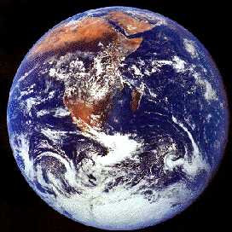
NOTE!
ALL course handouts and readings outside of the textbook are available IN COLOR in your ENV 115/115L Google Drive folder

Marine Environmental Science Lecture

Course Schedule
Summer II 2017

Part I

Ocean Inhabitants & Environments

WEEK TOPIC ACTIVITIES
7/5 – 7/7 Science & Indigenous Knowledge; Ocean Geology Chpts 1& 2 in the textbook

7/10 – 7/14 Seawater; Oceanography Chpts 3, 4, 6
NO CLASS 7/13 Work on Marine Zone Presentations!

7/17 – 7/21 Marine Biodiversity; Marine Ecosystems; Chpts 7, 8, 9 & 10
7/20: Marine Zone Presentations Chpts 11-16
Healthy Oceans Wrap-Up; Catch up!; Review Sheet for Exam I

Part II

Threats to Our Oceans

WEEK TOPIC ACTIVITIES
7/24 – 7/28 7/25: Exam I; Issues Overview; Coral Reef Threats; Chpts 17 & 18; Outside Readings
Climate Change & Handouts

7/31 – 8/4 8/3: Notable Marine Places & Issues Presentations
Marine Pollution; Marine Debris, Coastal Devel Outside Readings & Handouts

8/7 – 8/11 Introduced Species; Fisheries & Aquaculture; Outside Readings & Handouts
Solutions to Marine Threats
8/10: Exam II

