Spring 2017: Biology 320 Genetic Control & Patterning

Instructors:
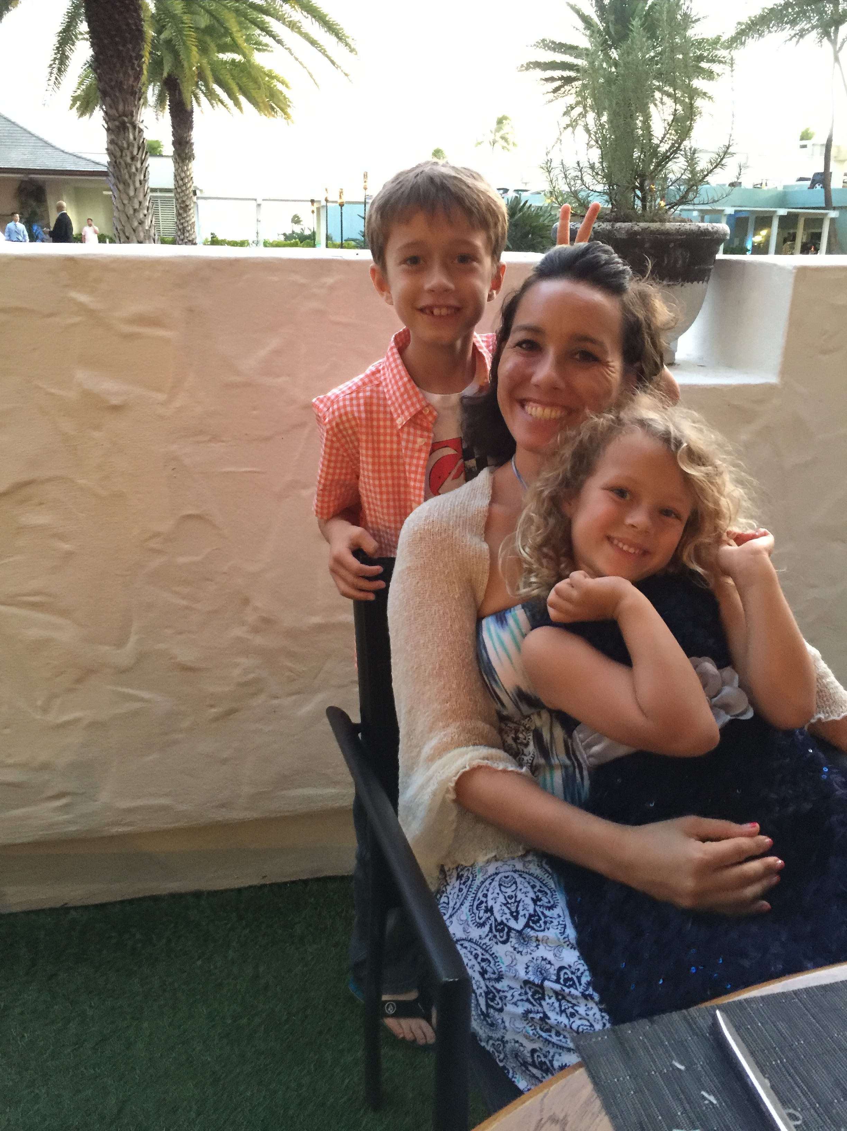
Dr. Henry Trapido-Rosenthal,PhD Dr. Jolene Tarnay Cogbill, PhD
henry.trapido-rosenthal@chaminade.edu jolene.cogbill@chaminade.edu

Class Meetings: M, W, F 9:30 – 10:20am, CTCC 253

Office Hours: Cogbill - WSC 102, M,W, F 10:30-11:30 or by appointment
Trapido-Rosenthal - WSC 101 when the door is open
Required Text: Scott F. Gilbert, Developmental Biology, 10th ed., Sinauer Associates, Inc.

*Concurrent registration in BI 320L required.

Course Description:
This course focuses on the genetic control and patterning of organisms. Specifically, cellular and
molecular processes that govern the production of an embryo and the patterning of individual
tissues and organs in a manner that is consistent with their physiological functionality. The effect of exogenous stimuli on body patterning in both physiological and pathophysiological situations will also be addressed.

General Course Objectives:
- Describe the concepts of cellular induction, specification, commitment and differentiation.
- Describe how & why the processes of gametogenesis and fertilization are the first major steps in the formation of the early body plan.
- Describe the genes & signal transduction pathways involved in major embryonic developmental processes including gene patterning, cleavage, gastrulation, organogenesis, and neurulation.
- Be able to use at least one invertebrate and one vertebrate example to illustrate and describe the various stages of embryonic development.
- Be able to explain how concepts in developmental biology can overlap with other sciences, such as stem cell research, cancer research, evolutionary sciences or neurosciences

Specific Student Objectives:

- At the end of the course, you will be able to answer the following essential questions:
Student Learning Outcomes | Linkage to Biology Program Learning Outcomes
How does a single cell give rise to a complex organism with many cell types, tissues and organs? | #2) ability to visualize, statistically evaluate, validate and  interpret scientific data, and to communicate science  effectively both orally and in writing.  #3) The ability to acquire and comprehend information from  published scientific literature & to employ computational  resources in the resolution of biological problems.  #4) An understanding of the chemical and physical principles  that unite all life forms, and of biological organization  at the molecular, cellular, tissue, organ, organism and  systems level.  #7) An understanding of the entry requirements, career  pathways and progression for the major post-graduate  fields of research, education and health professions.
How is the temporal and spatial organization of tissues and organs determined?
How does the regulation of gene expression influence morphognesis?
What are the different germ layers, where do they originate from and what organs/systems arise from each?

What are the hallmarks of the following key developmental processes:
    - Axis formation
    - Embryonic pattern formation
    - Gametogenesis
    - Fertilization
    - Orgnaogenesis
    - Neurulation

Grading

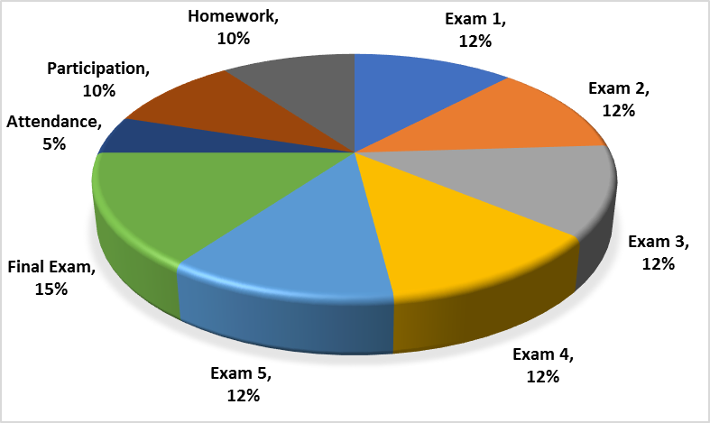
*Extra credit opportunities may be available during the course of regular lectures or may be written into the exams.

Attendance/Participation:
- Presence in class is mandatory & necessary in order for a student to fully grasp concepts. Students are expected to attend regularly all courses for which they are registered. Students should notify their instructors when illness or other extenuating circumstances prevents them from attending class and make arrangements to complete missed assignments. Notification may be done by emailing the instructor’s Chaminade email address, calling the instructor’s campus extension or by leaving a message with the instructor’s division office (Natural Science and Math 1 (808) 440-4204). It is the instructor’s prerogative to modify deadlines of course requirements accordingly. Any student who stops attending a course without officially withdrawing may receive a failing grade.
- Unexcused absences equivalent to more than a week of classes may lead to a grade reduction for the course. Any unexcused absence of two consecutive weeks or more may result in being withdrawn from the course by the instructor, although the instructor is not required to withdraw students in that scenario. Repeated absences put students at risk of failing grades.
- If you miss a class it is YOUR responsibility to ask the instructor or your classmates for the information that you missed and to pick up any handouts that may have been distributed.
- It is highly suggested that students bring their text books with them to class as there may be in class activities that will require the use of the text.

Makeup exams and extra credit:
- Makeup exams and quizzes are generally not given. If there is an insurmountable problem please come talk to me to see what arrangements can be made.

Departmental and University Polices:
- Music Devices and Cellular Phones: Use of music devices and cell phones is prohibited during all Natural Science and Mathematics classes at Chaminade, unless specifically permitted by your instructor. Use of cellphones and music devices in laboratories is a safety issue. In addition, use of cellphones and music devices in any class is discourteous and may lead to suspicion of academic misconduct. Students who cannot comply with this rule will be asked to leave class and may be subject to laboratory safety violation fines. You will be asked to leave class and marked absent if you do not comply. This will negatively affect your grade. Please refer any questions to the Dean of Natural Sciences and Mathematics.
- ADA Accomodations: Pursuant to several federal and state laws, including the Americans with Disabilities Act of 1990, as amended by the ADA Amendments Act of 2008, and Section 504 of the Rehabilitation Act of 1973, all qualified students with disabilities are protected from discrimination on basis of disability and are eligible for reasonable accommodations or modifications in the academic environment to enable them to enjoy equal access to academic programs, services, or activities. If a student would like to determine if they meet the criteria for accommodations, they should contact the Counseling Center at 808-735-4845 for further information Students with special needs who meet criteria for the Americans with Disabilities Act (ADA) provisions must provide written documentation of the need for accommodations from CUH Couseling Center (Dr. June Yasuhara, 735-4845) by the end of the third week of classes. Failure to provide written documentation will prevent your instructor from making necessary accommodations.
- Policy on Communication : The University provides a Chaminade email address for all students. Official Chaminade communications will be sent to the students’ Chaminade email address and instructors will use only this email to communicate with students. It is the responsibility of the student to check their email frequently. Report email-related problems to the Helpdesk at 808-735-4855 or helpdesk@chaminade.edu.
- Title IX Declaration: Chaminade University of Honolulu recognizes the inherent dignity of all individuals and promotes respect for all people. Sexual misconduct, physical and/or psychological abuse will NOT be tolerated at CUH. If you have been the victim of sexual misconduct, physical and/or psychological abuse, we encourage you to report this matter promptly. As a faculty member, I am interested in promoting a safe and healthy environment, and should I learn of any sexual misconduct, physical and/or psychological abuse, I must report the matter to the Title IX Coordinator. Should you want to speak to a confidential source you may contact the following: Chaminade Counseling Center| 808 735-4845;
Any priest serving as a sacramental confessor or any ordained religious leader serving in the sacred confidence role.
- Academic Honesty: Students are expected to have read and to abide by the “Student Rules of Conduct” which are available in your copy of Chaminade University’s Student Handbook. Cheating in the form of plagiarism, collusion, deception and will not be tolerated and will negatively affect your grade.

Because Chaminade is an academic community with high professional standards, its teaching function is seriously disrupted and subverted by academic dishonesty. Dishonesty includes, but is not limited to, cheating, which includes giving/receiving unauthorized assistance during an examination; obtaining information about an examination before it is given, using inappropriate/unallowed sources of information during an examination; altering answers after an examination has been submitted; and altering the records on any grade. (Refer to the Chaminade University catalog for further information).

Tentative Course Outline: Every effort has been made to insure that the material in this syllabus is accurate and complete. The instructor reserves the right to make any changes in the contents of this syllabus that she deems necessary or desirable.

Week Dates Topic Assignment Lead Instructor
1 Jan 18 Review: History, Life Cycle, Fate Maps,
Cell Lineages, Homologies, Topology Chp 1 Dr Trapido-Rosenthal
20 Review: Differential Gene Expression Chp 2 Dr Cogbill

2 23 Review: Differential Gene Expression Chp 2 Dr Cogbill
25 Review: Cell-Cell Communication Chp 3 Dr Cogbill
27 Fertilization: Sea Urchins Chp 4 Dr Trapido-Rosenthal

3 30 Fertilization: Mammals Chp 4 Dr Trapido-Rosenthal
Feb 1 Early Development: Cleavage, Gastrulation,
Axis Formation Chp 5 Dr Cogbill
3 Early Development: Invertebrates Chp 5/6 Dr Cogbill

4 6 Early Development: Invertebrates Chp 6 Dr Cogbill
8 Exam 1
10 Early Development: Deuterostome Invertebrates Chp 7 Dr Trapido-Rosenthal

5 13 Early Development: Deuterostome Invertebrates Chp 7 Dr Trapido-Rosenthal
15 Early Development: Deuterostome Invertebrates Chp 7 Dr Trapido-Rosenthal
17 Early Development: Deuterostome Invertebrates Chp 7 Dr Trapido-Rosenthal

6 20 President’s Day -NO CLASSES
22 Early Development: Amphibians Chp 8 Dr Cogbill
24 Early Development: Fish Chp 8 Dr Cogbill

7 27 Early Development: Birds Chp 9 Dr Cogbill
Mar 1 Early Development: Mammals Chp 9 Dr Cogbill
3 Exam 2

8 6 Ectoderm Chp 10 Dr Trapido-Rosenthal
8 Ectoderm Chp 10 Dr Trapido-Rosenthal
10 Ectoderm Chp 11 Dr Trapido-Rosenthal

9 13 Ectoderm Chp 11 Dr Trapido-Rosenthal
15 Mesoderm Chp 12 Dr Trapido-Rosenthal
17 Mesoderm and Endoderm Chp 12/13 Dr Trapido-Rosenthal

10 20-24 Spring Break – NO CLASSES

11 27 Prince Kuhio Day – NO CLASSES
29 Mesoderm and Endoderm Chp 13 Dr Trapido-Rosenthal
31 Exam 3

12 Apr 3 Tetrapod Limb Development Chp 14 Dr Cogbill
5 Tetrapod Limb Development Chp 14 Dr Cogbill
7 Tetrapod Limb Development/ Chp 14/15 Dr Cogbill
Sex Determination:environmental

13 10 Sex Determination: chromosomal Chp 15 Dr Cogbill
12 The Germ Line Chp 17 Dr Cogbill
14 Good Friday – NO CLASSES Chp 17 Dr Cogbill

14 17 The Germ Line Chp 17 Dr Cogbill
19 Exam 4
21 Postembryonic Development Chp 16 Dr Trapido-Rosenthal

15 24 Postembryonic Development Chp 16 Dr Trapido-Rosenthal
26 Development and the Environment Chp 19 Dr Trapido-Rosenthal
28 Development and the Environment Chp 19 Dr Trapido-Rosenthal
16 1 Development and the Environment Chp 19 Dr Trapido-Rosenthal
3 Development and the Environment Chp 19 Dr Trapido-Rosenthal
5 Exam 5

17 8-11 Finals Exam Week

