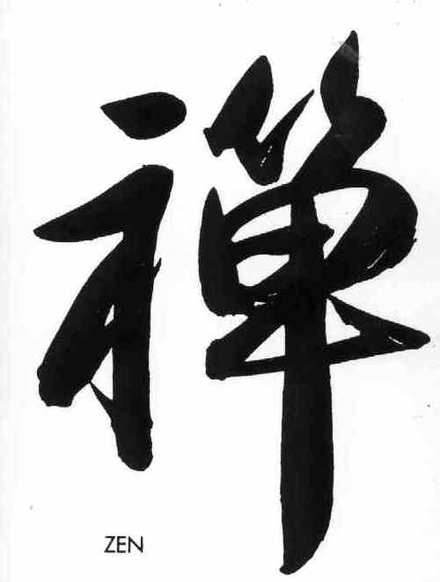
CHAMINADE UNIVERSITY OF HONOLULU
RE 461 ZEN: SELF, BEING AND TIME (3)
Spring Day: January 17 – May 5 , 2017
COURSE SYLLABUS

Instructor: Clark Ratliffe Classroom: Behavioral Science 101
Class Time: Tues. 2:30PM-5:20PM Office Hours: by appointment
Emails: clark.ratliffe@chaminade.edu Phone: (808) 386-5645
clark@diamondsangha.org
COURSE OVERVIEW

REQUIREMENTS
Description: A general survey of the historical development of Zen Buddhism in the East and the West will introduce students to this popular subject for many Westerners. Meditation experiences will illustrate the meaning and practice of Zen. Analytical discussion and comparison of concepts such as self, being, and time will provide students with the opportunity to understand this tradition from their own faith background. Students will also practice zazen.

Prerequisites: RE 103, RE 205, or RE 211. Fulfills Global Awareness course requirement. This course may not be used to satisfy the 300-level Religious Studies General Education Core requirement. Offered annually.

Orientation: In this course, students will:
- Examine the essential foundations of Zen Buddhism through its major schools;
- Participate in a variety of class exercises and activities to explore the important elements of applied Zen Buddhism;
- Identify the nature and meaning of purposeful living as applied by Buddhists and Christians to social issues such as peace and justice.

Required Texts:
Aitken, R. Taking the Path of Zen. North Point Press: CA.1982. ISBN: 0-86547-080-4.
Loy, David R. Money, Sex, War, Karma. Wisdom Publications: MA. 2008. ISBN: 0-86171-558-6

COURSE OBJECTIVES

COURSE OBJECTIVES

Student Learning Outcomes
By the end of this course, students will be able to:
- Articulate the meaning of Zen teaching and meditation (PLO 2);
- Analyze the influence of Zen in Eastern and Western society (PLO 2,6);
- Differentiate historical background and practice of the major schools of Zen Buddhism;
- Examine one’s own experience in Zen meditation, sitting and working (PLO 2,6);
- Apply Zen teaching to make a difference in communities through service or research (PLO 4);
- Explore the basic similarities between Zen and one’s own faith

Learning Outcome Assessment:
Student’s work will be evaluated for:
- knowledge of the subject matter from textbooks, discussions, videos, research and outside class activities;
- critical application and accuracy of content;
- thoroughness of answers in reflective assignments and essays;
- continuing development of understanding.

STUDENT REQUIREMENTS

Students With Disabilities: It is the student’s responsibility to self-identify, with appropriate documentation, to the Director of Personal Counseling in order to receive accommodations.

Regular Participation (20%): Because class participation is the primary mechanism by which course content is gained in this class, students are expected to attend all scheduled classes.
Attendance guidelines:
- Roll will be taken every class session and points will be deducted for each class you miss. If you are not present during the taking of attendance, you will be counted absent.
- If you are absent from 3 (20% of the course) classes your grade will be lowered by one letter grade; if you are absent 5 (1/3rd of the course) or more classes you will fail the course.
- No absences will be excused except in the cases of (i) an emergent medical situation or severe illness; or (ii) a death in the student’s immediate family.
- All requests for special accommodations, e.g., medical, athletic, or learning-related, will be considered and may require the appropriate paperwork.

Participation also involves:
  - Completion of the readings and turning in reading reflection papers at the start of class.
  - Answering questions and participating actively in class discussions.
  - Listening respectfully without cross-talking or interrupting others.
  - Finally, as being fully present in this moment is at the heart of Zen practice please plan to turn off or silence you cell phones at the start of class.

Reading Reflections (25%): Of the 12 readings assigned over the semester you are to choose 6 of them on which to write a short reflection. This is intended to help and encourage students to be prepared for full participation in class discussions. A fill-in-able MS Word document will be provided for your convenience. If, for some reason you don’t have access to Word you may turn in a double spaced, about one page in length document, and should include the following information:

- Student name
- Reading reflection number (1, 2, 3…) and chapter title.
- Discuss one or more statements or concepts in the reading that you:
  - found interesting and why, and/or
  - didn’t understand but want to understand, and/or
  - agreed or disagreed with and why, and/or
  - would like to learn more about and why.
- Your response to the “For Discussion” question/s.

Reflection on Zen Meditation Orientation (10%): Zazen (Zen meditation) is the heart and soul of Zen and is far more important than any of the lecture content of this class. We will start every class with a little zazen and you are encouraged try this meditation regularly throughout the semester. For these reasons the “field trip” to the Palolo Zen Center where you will learn to do zazen is mandatory. You may not miss this class for any reason whatsoever.

In a short reflection paper address the following questions/issues:
- What were your general impressions of the temple and what you experienced at the orientation.
- Describe what it was like for you during the actual zazen periods. What was hardest for you? Can you conceive of any potential positive benefits?
- Describe in what way a meditation such as zazen either could or could never play a role in your life. Why/why not?

Project (20%): There is one research paper or project required for this course. It will be on a topic of your choosing in consultation with the instructor. The aim is that the topic of this paper or project is personally meaningful to you and reflects your personal aspirations and spiritual motivations as they relate to your life and this course. It may be on a particular luminary in Zen history, an idea or subject that is important to you and can be related in some way to this course and its’ objectives. For instance, comparing ideas in Zen with ones in your own spiritual tradition or life that either contrast or are similar. Perhaps applying zen to a treasured activity in your life ie: Zen and the Art of Basketball, Yoga, Cooking - whatever. It may also be a substantial experiential project rather than formal paper research. In past semesters students have done things like make a video of how zen could operate in their life (surfing, hiking, writing). Last semester a student filmed his daily reaction to trying to do 14 days of daily meditation. Another did a video diary of her “zen-like” reflections at the end of her morning run. The instructor will entertain any reasonable proposal to fulfill this assignment. A student came to the Palolo Zen Temple for zazen every Sunday for about half the semester.

If you choose the paper option, it will be 5-10 double spaced pages. There will be an introduction in which the subject and scope of the paper is clearly stated. In the introduction will be a statement of why this subject is important to you and what you intend to accomplish in the paper. The body of the paper will then fulfill the goals delineated in the introduction. The liberal use of headings can help guide your thinking and the reader through the ideas you are presenting. The conclusion summarizes what was accomplished in the paper. You will be graded on accuracy of concepts and ideas, depth of reflection, insightfulness of analysis and the clarity of your organization and writing.

If, on the other hand, you are doing an experiential project that involves another medium (such as making a video) there may be little or no writing involved at all. This will be determined in consultation with the instructor.

Service Learning & Its’ Reflection Paper (10%): Students will do a service learning activity that is specific to the Zen context of this course. In Zen the word “samu” means “work ceremony” and is an important part of Zen training. In Zen “work” is considered another form of meditation. At the Palolo Zen Center there are Samu days (where the work is done in silence) and Work Parties (where talking socially during work is allowed). The possible choices of dates are the following Sundays (you must have attended the Orientation to Zen at the temple before you can attend): If you are unable to attend any of these dates let me know and other activities can be substituted including various other Service Learning activities sponsored by Chaminade.

- 1/29 (Samu)
- 2/19 (Work Party)
- 3/19 (Samu)
- 4/23 (Work Party)

The schedule for the Samu and Work Party are a little different, but both start at 9am and go till 12 or 1 (including lunch). Each morning consists of a little zazen, a brief talk on work, samu, and then lunch. Each student will attend one Samu or Work Party.

Objectives of this Service Learning to be addressed in the reflection paper
Write a paper reflecting on what was learned from this experience. Include the following:

- Describe how the experience of zazen acquired in this class includes everyday activity.
- Describe in what ways Zen practice (a solitary activity) contributes to the service of people.
- Share how work and service could contribute to your process of discovering meaning in your life.
- Articulate what new insights you developed about Zen during the activity.
- Critically review how Zen relates to Marianist values.

Presentation of Chapter discussion (5%): Each student will do a brief presentation on one of the chapters in the Money, Sex, War, Karma book which we will discuss most weeks. Each chapter takes a very broad topic, such as war, and puts it in a Zen/Buddhist context. Focus on that and propose something particular that we can take up in a class discussion. Please deliver the information succinctly, and be conscientious about time. Using PowerPoint for this presentation can be very helpful but is not required.

Project Presentation (10%): Due week 15 (last day of class). Each student will do a 20 minute presentation (usually using PowerPoint again) of the results of your project.

GRADING

Grade Calculation:
- Zen Temple Orientation 10%
- Attendance & Participation 25%
- Reading Reflections 25%
- Orientation and Reflection 10%
- Project 20%
- Project presentation 5%
- Chapter presentation 5%

Your grade is calculated using the following scale:
A: 90-100%; B: 80-89%; C: 70-79%; D: 63-69%; F: 0-62%

It is not my intention that anyone experiences anxiety in this course over grades. Every student starts the class with an A. If you come and actively participate in class, do the assignments with a good faith effort you will keep your A. There are no right or wrong answers to specific content in this course. Zen is a practice and is approached in this course with a free flow of ideas and experiences. One of the hallmarks of Zen practice is to be present – utterly and totally. That is all I ask of you.

SYLLABUS CALENDAR

Date |  | Content | Homework
Class 1  Jan. 17 |   1. Searching for… meaning, fulfillment. | Introduction: What is Zen?  Introduction to the course and each other.  What Zen is… What it isn’t.  Introduction to the Ten Oxherding Pictures | For Discussion:  1. Why are you taking this class?  2. What is your current perception of what Zen is?
Class 2  Jan. 24 | 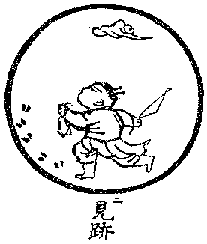  2. The hint of a path is found. | The Still Point: Zazen  Field Trip: 2:30-5:20 PM  Orientation to Zen Practice at  Honolulu Diamond Sangha  2747 Waiomao Road Honolulu, HI 96816  For directions see: http://diamondsangha.org/finding-the-honolulu-diamond-sangha/ | Readings:  Aitken pp 115-132  Due next week:  Required reflection on the meditation
Class 3  Jan. 31 |   3. Catching a glimpse of who you really are. | Overview of Zen Buddhist History  Early Foundations  Various Schools  Movement through time and place  Types of Zen  The Ten Oxherding Pictures  Discussion Activity  Dukkha  Self-construction of the self | Readings:  1. Aitken, pp 56-66  2. Loy, Suffering of Self: pg15-23  Reading Reflection Questions:  1. What is dukkha and what are the three types?  2. What does it mean that there is no inside and no outside self?  3. “Buddha” means to be awake. What does awake mean in Zen?  Service Learning Opportunity:  Samu Sunday at Zendo: 1/25  Due:  Reading reflection 1.  Reflection on field trip (required)
Class 4  Feb. 7 |   4. When catching a wild Ox you are in for a wild ride. | More Foundations  The Sutras  Three Treasures  The Ten Precepts  Discussion Activity  Group work on Precepts | Readings:  Aitken, p 67-88  Reading Reflection Questions:  1. What does it mean to you to “take refuge in the Sangha?”  2. What are the ten precepts and in what fundamental ways do they differ from the 10 Commandments?  Service Learning Opportunity:  Work Party Sunday at Zendo: 2/8  Due: Reading reflection 2.
Class 5  Feb. 14 |   5. Living every moment fully as it really is! | Work Practice  Samu  Practice in daily life  Dealing with difficult people  “Cutting wood, carrying water…”  Discussion Activity  Can money buy happiness?  Money as a reality symbol  Monetary self-worth/affirmation | Readings:  Ratliffe article, Samu Tales pdf  Loy, Lack of Money pp 26-30  For Discussion:  1. When the monk said “Zazen not Zen” what did he mean?  2. What does Loy say is the 4th function of money.  Due: Reading reflection 3.
Class 6  Feb. 21 |  | Body Practice  Purification  Oryoki  Being-Awareness  Mindfulness practices  Discussion Activity  Consciousness as a commodity  What is our attention  What is the nature of a distraction | Readings:  1. Loy, Consciousness Commodified, pp 95-102  Reading Reflection Questions:  1. Discuss “A structured thought is more than a link.”  2. Advertising penetrates the mind with desire and belief. What do you think of this?  3. Which is more worrisome: weapons of mass destruction or weapons of mass distraction?  Due: Reading reflection 4.
Class 7  Feb. 28 |  | Art Practice  Buddhist Statues and Pictures Gardens in a Zen Monastery  Caligraphy  Discussion Activity  Enso painting  What is the nature of past, present and future in Zen?  Why do we try to escape the present? | Readings:  1. Loori, Painting Spring  2. Loy, Trapped in Time  Reading Reflection Questions:  1. How is “eternal life” different for a Buddhist vs a Christian?  2. What is the difference between the now that I have and the now that I am?  Due: Reading reflection 5.
Class 8  March 7 |  | Tradition  Gathas and Prayers  Sutra chanting  Bowing  Discussion Activity  Zazen and enlightenment are not enough  What the Buddha would do is what you will do.  What will you do to address the suffering in the world? | Readings:  1. Loy, What Would the Buddha Do, pp 79-85  Reading Reflection Questions:  1. Is being mindful and aware enough?  2. How is addressing the suffering of the world a Zen activity?  3. Enlightenment is not about some higher reality – so what is it about?  Due: Reading reflection 6.
Class 9  March 14 |  | Tradition cont.  Positions on sex  Marriage (including same sex)  Abortion  Women rights or lack of  Discussion Activity  The Buddhist/Zen perspective on sexual orientation.  What is sexual misconduct  Cultural and lay and monastic differences | Readings:  1. Loy, What’s Wrong with Sex, pp 65-77  Reading Reflection Questions:  1. What is sexual misconduct in Zen?  2. Discuss some of the links between sex, spiritual practice, parenthood, contraception.  Due: Reading reflection 7.  Service Learning Opportunity:  Samu Sunday at Zendo: 3/15
NO CLASS  March 21 |   6. In harmony there is no effort. | SPRING BREAK
Class 10  March 28 |   7. Returning to your true home. Where is that? | Right Action  Arhat and Bodhisattva Ideal  Activism  Jobs  Responsibility  Discussion Activity  Interdependence of everything  Cause and effect of suffering | Readings:  1. Loy, How to Drive Your Karma, pp 53-63  Reading Reflection Questions:  1. Describe what interdependence is.  2. Do you think that karma means everything is predetermined?  3. Discuss whether or not karma is an elaborate punishment/reward system.  Due: Reading reflection 8.
Class 11  April 4 |  | Right Action cont.  Pacifism  Vegetarianism  War  Discussion Activity  What is the lure of war?  Why do we like it?  When is it okay to kill or not?  Where to draw the line…Is there a line? | Readings:  1. Loy, Why We Love War  Reading Reflection Questions:  1. What in us finds war agreeable?  2. What is the Buddhist alternative to the good vs evil world view?  3. Is it really possible or even right to be a pacifist?  Service Learning Opportunity:  Work Party Sunday at Zendo: 4/5  Due: Reading reflection 9.
Class 12  April 11 | 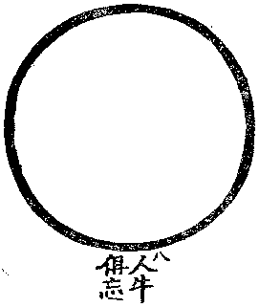  8. All opposites come together and fill the universe. | Koan Study  What is a koan? What they aren’t  History  Purpose  How they are used  Hakuin Zenji’s Song of Zazen  Discussion Activity  Language and emptiness  Ideas in Hakuin’s poem | Readings:  1. Aitken, pp 95-113  2. Loy, Second Buddha pp 45-52  Reading Reflection Questions:  1. How does doing zazen “wipe away beginningless crimes?”  2. Discuss “this very place is the Lotus Land, this very body the Buddha” and contrast with the Christian ideas of Heaven and God.  3. Nagarjuna says nirvana is what?  Due: Reading reflection 10.
Class 13  April 18 |  | Zen and the Environment  Self/Other problem and our environment  Alienation to where and who we are  Discussion Activity  Is global warming only a political issue?  What does it mean to be comfortable? Where does it come from? | Readings:  1. Loy, Healing Ecology, pp 103-111  Reading Reflection Questions:  1. What is the distinction between ourselves and our environment?  2. How are Zen realization and ecology connected?  Due: Reading reflection 11.
Class 14  April 25 | 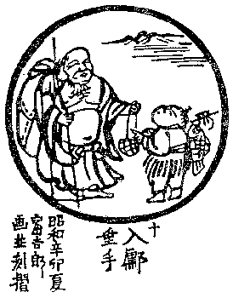  10. Final enlightenment is nothing special. Just whole and complete the way you are. | Zen and the Environment cont.  Karma of food issues  Discussion Activity  Vegetarianism and not killing  Morality and ethics of GMO foods | Reading:  1. Loy, Karma of Food, pp 113-126  Reading Reflection Questions:  1. Should a “good” Buddhist be a vegetarian?  2. How does or doesn’t eating meat square with the precept of “not killing.”  3. Which is more important: what you eat or how you eat it?  Due: Reading reflection 12.
Class 15  May 2 |  | Project Presentations  Students presenting their project.  Practicing on your own.  Value of a teacher and what that means in Zen tradition.  How to find a good one for you.  Being skeptical and cautious | Final Course/Instructor Evaluations Due: Student project presentations
Class 16  May 9 |  | Finals Week | Final Exam: TBA

MUTUAL RESPECT AND CONSIDERATION
As subjects examined during this course may touch upon topics, beliefs, and/or issues considered sensitive by some students, it is imperative that all students demonstrate courtesy and respect concerning the views, opinions, and beliefs of others.

The instructor reserves the right to make any adjustments to the course syllabus to accommodate any unforeseen circumstances. The information regarding changes will be announced in class. It is in the interest of students to check with their class partners for any pertinent information should they miss the class.

Service Opportunities, etc.

Zazen Practice *Check schedule online: http://www.diamondsangha.org/CAL
Sundays 9-11AM Wednesdays 7-9 PM
Also on Facebook at: https://www.facebook.com/Honoluludiamondsangha

