CHAMINADE UNIVERSITY
COURSE SYLLABUS


COURSE TITLE: FIN 301, Principles of Finance
TERM: January 9 to March 18, 2017
TIME AND PLACE: Online
INSTRUCTOR: Caryn Callahan, Ph.D.
E-MAIL: caryncallahan@yahoo.com, ccallaha@chaminade.edu





Welcome to the course! Your instructor is Caryn Callahan, Ph.D.

COURSE DESCRIPTION
This is a basic, introductory course, which covers material essential to an understanding of financial management. Topics will include, but not be limited to, security markets, interest rates, time value of money, the cost of capital, risk and return, and financial analysis.

ASSOCIATED PROGRAM LEARNING OUTCOMES
Demonstrate an understanding of issues central to financial management of an organization and the ability to use financial tools and analysis to inform business decisions.

OBJECTIVES
The main objectives of this course are to enable the student to understand and apply:
- The basic principles of “the time value of money.”
- The core concepts of equity valuation, enabling the student to calculate the value of common stock when given the appropriate inputs.
- The fundamentals of preferred stock valuation, enabling the student to calculate the value of a preferred stock when given appropriate inputs.
- The key principles of “bond valuation,” enabling the student to find the value of a bond when given the appropriate inputs.
- The basic principles of capital budgeting.
- The key method of solving for a company’s cost of capital.
- The basic concept of risk and how to measure it using standard deviation.
- The core concepts of the capital markets and investment banking.
- The major principles of dividend policy and retained earnings.
- The basic principles of convertible securities such as convertible bonds.
- The basic principles of exchange rates in the global environment.
- The integration of cross-cultural diversity.

TEXTBOOK AND READING ASSIGNMENTS
Foundations of Financial Management w/value cards, 15th edition, ISBN, Stanley Block and Geoffrey Hirt, 2014.

Reading assignments will be taken from the assigned textbook. Be sure to read each chapter thoroughly in the week assigned. We will not be using the value cards.

GRADING
Here is a breakdown of the point allocation.

Midterm Examination 18%
Final Examination 18
Conference participation (8 weeks) 16
8 Weekly Quizzes 48
Total 100%

MIDTERM AND FINAL EXAMS (each worth 18%)
The midterm will cover Chapters 1 through 10 and the final exam will cover Chapters 11 through 20, excluding the chapters we skip. Although the final is not intended to be cumulative, given the nature of the material, subject matter will necessarily overlap and learning that occurs in the earlier weeks of the class may be needed to answer questions in the final. I will upload the exams to the respective Weekly Conferences and you will have a week to answer the questions. Needless to say, they are open-book tests. . Please post your answers to canvas by 6:00 pm on the last day of our online week (Sunday for the midterm; Saturday for the final exam).

WEEKLY HOMEWORK/QUIZZES (48%)
There will be an assignment each week on the material learned that week. Each of the eight quizzes is worth 6 percentage points. Please post your answers to canvas by 6:00 pm on the last day of our online week (Sunday).

CONFERENCE PARTICIPATION (16%)
Participating actively in the Weekly Conferences is an essential part of this class. You cannot get a decent grade in this course without meeting the participation requirements described below since this part of the class counts for 16 points of your grade. You will have a Conference discussion in eight of the weeks but not in the midterm and final weeks (Week 5 and 10).

Every week, two Discussion Questions will be presented to facilitate useful discussion among the class members, guided by the professor. The assigned discussion questions can be found posted in the online Discussion Conference for each week. Your responses must be posted by 6:00 pm on Sunday, the last day of the online week. Notes posted after that deadline will not be graded.

To gain full credit for participation (2 points per week), you should provide at least two responses to each of the two Discussion Questions. That means at least four notes per week. One of the two notes that you post for each discussion question should be your original answer to the question and the other can either be a response to another student’s posting or another original insight on your part. Each one of your notes posted for credit must be at least 200 words long. To give you an idea of the length of a 200-word post, see the blue, italicized section of the syllabus immediately below. It equals exactly 200 words. (Be sure to read the content of the section too since it is a key part of the syllabus.)

The Weekly Discussion Conference is designed to resemble a classroom discussion. You need to actively participate to get credit for participation. You do not get credit if you just log on and read others' comments. Your comments must be significant to count for participation credit. A significant comment is one that contributes a new insight, or which adds useful comments, suggests alternative solutions or gives good reasons for disagreeing with other’s comments in an ongoing discussion. In the course of the ongoing discussion, you may frequently reply with one-phrase comments; however, it does not count towards your participation grade when you just comment, "I agree," or "Good point."
Our online classroom exists only because of active participation by class members. It is entirely created by us. Your comments on one day could generate many responses. The online environment is something like an ongoing conversation.
A Note on Late Postings: Students who post all or most of their notes at the end of the week will be penalized. That is because the class will be discussing the assigned questions throughout the week and building upon each others' insight, Everyone needs to participate in this dialogue. Last minute postings add little value.
If a student posts all of his or her notes on the last day or so, classmates will not have a chance to benefit from the late-poster’s ideas and also have little time to respond to these notes. This contradicts the aim of a “discussion” assignment. The late poster gets a “free ride” on the shoulders of those who have worked through the answers in collaborative discussion throughout the week. Consequently, late-posters will only earn half credit for their posts. I know there are weeks when it is impossible for a student to post earlier. For those weeks, please work ahead. The Conferences are all available in the classroom, so students who plan to be traveling can post before they leave.
The Conference is like any other assignment and students will unfortunately lose points if they cannot do the assignment as directed.

FINANCIAL CALCULATOR
You are required to get access to a means of calculating time value problems. You can do any of the following:
1) purchase (or download) a financial calculator for this course;
2) use a webpage which emulates the financial calculator at http://www.epx.com.br/ctb/hp12c.php
3) Use Excel to solve the problems.
If you use Excel or the emulator site, you will not need to purchase a financial calculator; however, it is very handy to have a financial calculator and I recommend it strongly, especially if you plan on getting an MBA in the future. You can download a financial calculator for $6-to-$20 on your smart phone or iPad or other type of smart phone.
There are many brands of financial calculators available but I strongly recommend the Hewlett Packard 12-C platinum. Hewlett-Packard calculators are the best, followed by Texas Instruments. When you acquire your Hewlett Packard 12-C, be sure to get the “platinum edition” if you are downloading or buying a calculator because the “classic” 12-C uses an input system that is hard to master. The top part of the classic 12-C is colored gold while the top part of the platinum is colored silver. Here’s what it looks like:

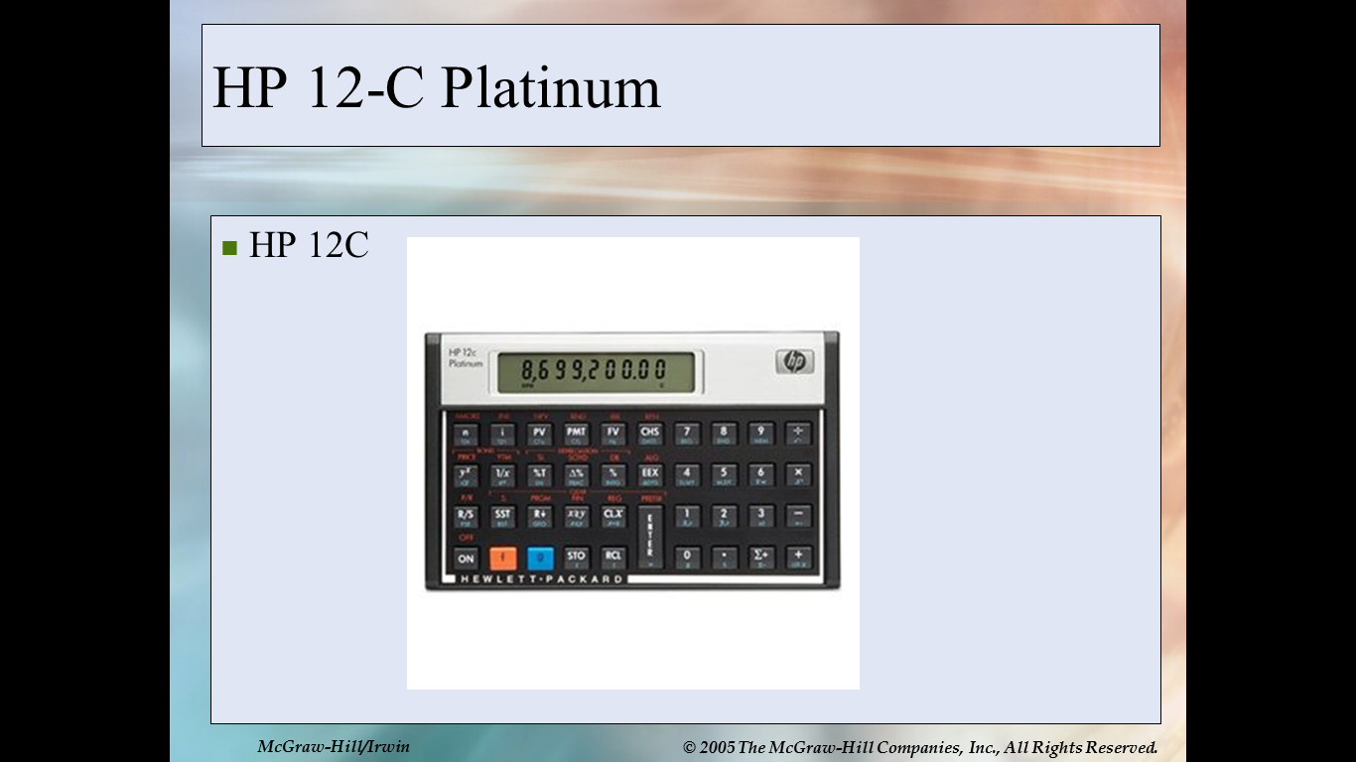

If you already have a calculator but are not sure if it is the correct type of financial calculator, you can be sure that you have the correct type if it has keys for “present value (PV), future value (FV), interest (“I” or “y”) and term (n).
WINTER 2017, SCHEDULE AND ASSIGNMENTS
FIN 301, PRINCIPLES OF FINANCE

WEEK 1: Monday, January 9, to Sunday, January 15
Reading Assignment due this week: Textbook, Chapters 2 and 3

Chapter 2: "Review of Accounting"
Chapter 3, "Financial Analysis
NOTE: We are skipping Chapter 2.

Homework 1 will be due by 6:00 p.m. on Sunday, January 15.
Be sure to meet the participation requirement.

WEEK 2: Monday, January 16, to Sunday, January 22
Reading Assignment due this week: Textbook, Chapters 4 and 5
Chapter 4, "Financial Forecasting"
Chapter 5, "Operating and Financial Leverage"

Most of our emphasis this week will be on Chapter 5.

Homework 2 will be due by 6:00 p.m. on Sunday, January 22.
Be sure to meet the participation requirement.

WEEK 3: Monday, January 23, to Sunday, January 29
Reading Assignment due this week: Chapters 6 and 7
Chapter 6 "Working Capital and the Financing Decision"
(In Chapter 6, we will do only expected value and term structure of interest rates.)
Chapter 7 "Current Asset Management"

Homework 3 will be due by 6:00 p.m. on Sunday, January 29.
Be sure to meet the participation requirement.

WEEK 4: Monday, January 30, to Sunday, February 5

Reading Assignment due this week: Chapters 9 and 10

DO:
Chapter 9, "The Time Value of Money"
Chapter 10 "Valuation and Rates of Return"

SKIP: Chapter 8, “Sources of Short-Term Financing”

Download calculator: Hewlett Packard 12C Platinum (NOT Classic).
See instructions in the front part of this syllabus. If you prefer, you can instead use use Excel to solve the time value problems or else use the website calculator emulator at http://www.epx.com.br/ctb/hp12c.php

Homework 4 will be due by 6:00 p.m. on Sunday, February 5.
Be sure to meet the participation requirement.

WEEK 5: Monday, February 6, to Sunday, February 12

Midterm: Chapters 2 through 10, excluding Ch. 8.
The exam will be posted on Monday, February 6 and due by 6:00 p.m. on Sunday, February 12. Post your answers to the midterm exam slot on Canvas.

There is no reading assignment, homework or Discussion Conference Participation requirement this week.

WEEK 6: Monday, February 13, to Sunday, February 19

Reading Assignment due this week: Chapters 11 and 12
Chapter 11 "Cost of Capital"
Chapter 12 "The Capital Budgeting Decision"

Homework 5 will be due by 6:00 p.m. on Sunday, February 19.
Be sure to meet the participation requirement.

WEEK 7: Monday, February 20, to Sunday, February 26

Reading Assignment due this week: Chapters 13 and 14
Chapter 13 "Risk and Capital Budgeting"
Chapter 14 "Capital Markets"

Homework 6 will be due by 6:00 p.m. on Sunday, February 26.
Be sure to meet the participation requirement.

WEEK 8: Monday, February 27, to Sunday, March 5

Reading Assignment due this week: Chapters 15 and 17

DO: Chapter 15 "Investment Banking"
Skip Chapter 16
DO: Chapter 17 "Common and Preferred Stock Financing"

Homework 7 will be due by 6:00 p.m. on Sunday, March 5.
Be sure to meet the participation requirement.

WEEK 9: Monday, March 6, to Sunday, March 12

Reading Assignment due this week: Chapters 18 and 19

Chapter 18 "Dividend Policy and Retained Earnings"
Chapter 19 "Convertibles and Warrants"

Homework 8 will be due by 6:00 p.m. on Sunday, March 12.
Be sure to meet the participation requirement.

WEEK 10: Monday, March 13, to Saturday, March 18

Final Exam: Chapters 11 through 19, skipping Chapter 16. The exam will be posted on Monday, March 13 and due by 6:00 p.m. on Saturday, March 18. Your answers should be posted to Canvas.

There is no reading assignment, homework or Discussion Conference Participation requirement this week.

