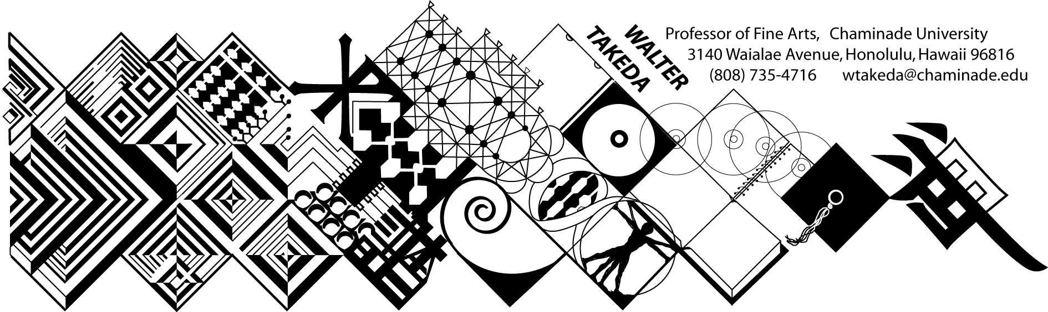
ART 202 Spr 2017
Survey of Art II
Tues/Thurs 8:30-9:20 am in Henry 227
Walter Takeda
Office Hrs: afternoons
or appointment E212

COURSE DESCRIPTION: Art 202 is a general survey course, with no prerequisites, that may be used to fulfill CUH's general education fine arts requirement or used as a liberal arts elective.

The material covers a survey of Western art, sculpture, and architecture from the Renaissance to present. In this age of frequent travel, you will undoubtedly have opportunity to visit many of the areas covered. Study of these cultures will result in a deeper understanding of this rich human legacy.

COURSE OUTCOMES: Student Learning Outcomes linked to Program Learning Outcomes:
The student will understand the historical and theoretical influences as well as the interdisciplinary forces that shape the history of art. The student, in the papers, will research and apply this knowledge of those influences.

More specifically, upon successful completion of this course, the student will demonstrate an:
- Understanding of the placement of art within its historical context;
- Ability to recognize important aspects of a style, country, or movement;
- Ability to use this understanding and ability to contextualize a given piece of art or artistic movement.
- For E+ID students, this course addresses CIDA Standard 10, in which you understand art and architecture in socio-political context and beyond, so that this knowledge can be applied in future E+ID courses.

This class presents material in chronological order. For those who would be more comfortable with reading parallel material in a textbook, several, such as Gardner’s Art Through the Ages are available through various less expensive sources. At the beginning of each class, a pool of slides will be shown of previous critical material. After each class, keep a list of this pool of slides, correctly spelled as to artist, title of work and school or style. Use this "mini-review" to good advantage; cramming for THIS class is a poor idea.
Before each exam is a thorough review of the material. Audiotaping this review helps many students. Review slides will be placed on Canvas for you to download well before exams.

COURSE REQUIREMENTS:

Examinations will include objective questions (multiple choice, true/false), slide identification (artist, title, school), and a written comparative analysis (paper) between two works. Your ability to recognize artists and/or styles not in the review pool will take the test beyond mere rote memory; this will be an assessment tool to gauge important goals of this course. These goals include your ability to place art in historical context, recognize important aspects of a style or movement, and recognize individual styles of artists. As such, additional quizzes (which may not count to the grade) may be administered.

A comparative analysis paper is also required; a handout to this effect will be distributed later.

MAKEUP EXAMS are a serious matter. Students will notify the instructor BEFORE the exam (at wtakeda@chaminade.edu, then bring in a verifiable excuse, such as a service station invoice, doctor's slip, etc. It is the student's responsibility to abide by these two conditions and the instructor's prerogative to refuse a makeup. The makeup will be scheduled by the instructor, and if the student is again absent, he or she will be given a zero. If the student cannot get an excuse from a conflicting class, it will be administered at 7:30 a.m. In fairness to other students, a different makeup exam will be administered; if it is at all possible to take the test on time, make every effort to do so rather than risk a more difficult exam. THERE IS ABSOLUTELY NO EXTRA CREDIT IN THIS COURSE!

GRADING POLICY: A:100-90, B: 89-80, C: 79-70, D: 69-60. Please note that this scale may be different from other instructors. Each exam, including the final, will be equally weighted.

COURSE SCHEDULE:
The instructor reserves the right to adjust the schedule and contents of this syllabus, such as exam times or grading criteria or any other changes. Any announced change made in class is the student's responsibility.

The student is obligated to abide by the conditions of this syllabus, the Chaminade catalog, and the Chaminade student handbook, and cannot claim ignorance of these conditions as an excuse for noncompliance with the requirements herein set.

TUESDAY THURSDAY
Jan 17 | Intro; historical overview; Proto-Renaissance | Jan 19 | Proto-Renaissance; Brunelleschi and the triumph of the Renaissance
Jan 24 | Italian Renaissance artists of 15thC | Jan 26 | Ital. Ren. Artists continued
Jan 31 | Int’l Gothic to Early Flemish | Feb 2 | High Renaissance: daVinci, Raphael
Feb 2 | Michelangelo | Feb 4 | Mannerism, Venetian, French Ren.
Feb 7 | FIRST EXAM REVIEW | Feb 9 | FIRST EXAM
Feb 14 | German painting; Italian Baroque | Feb 16 | Spanish and Flemish Baroque
Feb 21 | Dutch Realism | Feb 23 | Dutch Realism
Feb 28 | 17thC French ptg; Versailles | Mar 2 | Rococo
Mar 7 | Neoclassicism | Mar 9 | SECOND EXAM REVIEW
Mar 14 | SECOND EXAM | Mar 16 | Romanticism
Mar 21 | SPRING BREAK | Mar 23 | SPRING BREAK
Mar 28 | Romanticism cont. to Realism | Mar 30 | Impressionism
Apr 4 | Impressionism to Post-Impress. | Apr 6 | Post-Impressionism continued
Apr 11 | Cubism | Apr 13 | Fauve, Dada, Surrealism
Apr 18 | European Expressionism to Action | Apr 20 | Pop to Post-Modern art
Apr 25 | Internat. Style to Post-Modern arch. | Apr 27 | FINAL REVIEW
Tuesday  May 2 | FINAL EXAM – same room 8:30

Monday, April 10: Deadline to withdraw or go credit/no credit.

