CJA 606: Research Methods
Course Syllabus
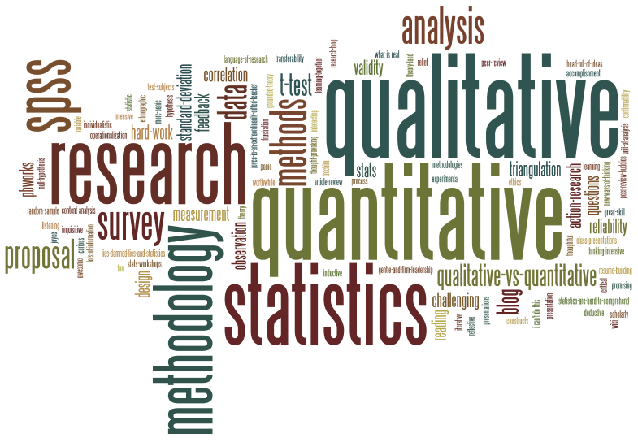
Fall 2016

Instructor: Janet T. Davidson, Ph.D.
Email: jdavidso@chaminade.edu
Phone: 739-4659
Office: Behavioral Sciences #108
Office Hours: By appointment
Class Times: Monday 5:30 - 9:40 p.m.
Class Location: H107

Course Prerequisites: None.

Description:

This course is designed as an examination of research methods used to solve social problems and resolve issues in public administration and criminal justice system components. This course will stress the application of social-scientific approaches to problem solving through empirically based research. Additionally, you will learn how to apply the knowledge you have gained to gauge the work of others, academic and otherwise, in the field.

Student Learning Outcomes:

Upon successful completion of this course, the student will:
- Create a basic research plan for a specific social science research question or hypothesis;
- Design measurement procedures for concepts for a specific social science research question or hypothesis;
- Illustrate ethical protections afforded to human subjects in social science research;
- Produce a sampling methodology specific to a social science research question or hypothesis;
- Distinguish quantitative methodologies from qualitative ones; and
- Evaluate published research.
Learning Outcomes | Knowledge | Skill | Disposition | Program Learning Outcomes | Marianist Values | Native Hawaiian Values | CUH Levers of Success | WASC Core Competencies
The student will create a basic research plan for a specific social science research question or hypothesis. | M | C | C | PLO 2,5 | MV2,5 | NHV2,5 | 1 | 1, 5
The student will design measurement procedures for concepts for a specific social science research question or hypothesis. | M | C | C | PLO 2,5 | MV2,5 | NHV2,5 | 1, 2 | 5
The student will illustrate ethical protections afforded to human subjects in social science research. | M | C | C | PLO 2,3,5 | MV2,5 | NHV2,5 | 1, 2 | 5
The student will produce a sampling methodology  specific to a social science research question or hypothesis. | M | C | C | PLO 2,5 | MV2,5 | NHV2,5 | 1, 2 | 5
The student will distinguish quantitative methodologies from qualitative ones. | M | M | C | PLO 2,5 | MV2,5 | NHV2,5 | 1 | 5
The student will evaluate published research. | M | C | C | PLO 2,5 | MV2,5 | NHV2,5 | 1 | 4,5

Note: Knowledge, Skill, Disposition: I=Introduced the Concept; D=Developing; C=Competent; M=Mastered

Required Text:

Bachman, Ronet and Russell K. Schutt. 2014. The Practice of Research in Criminology and Criminal Justice.
SAGE Publishing.

Additional weekly readings will accompany the text and will be handed out in class.

Reading Assignments:

Reading assignments must be completed prior to class. You will not be prepared to discuss the material or work on any in class assignments without reading beforehand. Lectures are prepared based on the assumption that you have read all required material.

Grading:

- Final Product - Research Proposal: You have a final paper requirement for this course. Your final paper, a research proposal, will be graded primarily on content, including your understanding of a particular research methodology (e.g., experimentation, ethnography, survey research, etc.) utilized to answer a research question and/or test your research hypothesis(es). You will be asked to define a specific research question related to your research problem, conduct a literature review, develop a research design and analytic plan, and discuss the implications of possible findings from your proposed research. Note also that you will be graded on the overall quality of the paper, including readability, grammar, structure, and punctuation. Make sure to include at least 7 peer reviewed sources for your proposal, particularly for the literature review. Make sure to get help with your writing if you are not a strong writer. Make sure to do your own work in your own words. Evidence of plagiarism will result in an automatic F for the class, no exceptions will be made. Following are characteristics for grades on your paper:

- A paper: An A paper is one in which there are few, if any, errors. This paper will contain all of the required components, and will have engaged existing research literature in a critical and constructive manner. Additionally, the research question or hypothesis to be researched will be logically connected to your methodological design. This paper is one in which you have clearly demonstrated that you understand how to collect data in order to answer a research question, is well written at the graduate level, and is mainly free of any errors in writing.

- B paper: this paper will cover the basic requirements of the assignment, yet is not as clear and cohesive as an A paper. In other words, while the basic requirements may be present, the logical connections and flow are not as evident. Additionally, this paper has some problems with grammar, punctuation, sentence structure, or word usage.

- C paper: this paper will cover the basic requirements of the assignment, yet contains serious problems with cohesiveness, especially as it pertains to demonstration that you understand the assignment and research methodology. Also, this paper is likely to be written below a level that is accepted for graduate work.

- D paper: this paper is one that is not well written, and in which there is little demonstration that you understood the requirements of the assignment. Additionally, a paper will be considered a D if it is virtually impossible to read due to grammar, spelling, and sentence structure errors.

- F paper: this paper is one that contains little or no requirements of the assignment or is so poorly written that it cannot be read. Additionally, any evidence of plagiarism will result in an automatic F in the final paper.

Please do not ask me to review drafts ahead of time. I will only grade the proposal one time. It is extremely helpful to have someone else review your work for errors and thoughtfulness prior to submission. You are certainly free to ask specific questions along the way. No late proposals will be accepted. Your proposal is due by 11:59 p.m. on Wednesday, December 7th, 2016. Your proposal is worth 40% of your final grade.

- Presentation - Proposal: You will be responsible for presenting your final proposal on the last day of class. You should plan on presenting in ‘conference’ style and via power point. More information about this will be discussed during the semester. Please do not ask to leave once you complete your presentation. This last class period is still a class period, please respect it as such. This presentation is worth 50 points toward your final grade, or 10% of the overall grade. Presentations will be limited to 15 minutes.

- Weekly discussion questions. Each student is required to help facilitate discussion of our research articles each week. Each class, be prepared to offer two questions for the class that encourage conversation about the non-text reading material. Your questions should engage with at least some of the bulleted topics for that week or major topics discussed in the main text. These should not be substantive questions! Be prepared to pose your questions to the class. Weekly discussion questions are worth 20% of your final grade (12.5 points each week for weeks 2-9). Typed questions should be turned in at the end of the class, not emailed after class. No late questions are accepted.

- Participation: As an accelerated graduate research course, you are expected to come to all of your classes, be prepared and ready to participate at the start of each class. As such, both of these factors are computed in your final grade. You will lose points if you miss a class or fail to participate. In addition, you may not miss more than ONE class for any reason. Upon your second absence, you will be administratively withdrawn from the course and you must wait to retake this required course when it is offered again. You should also plan on attending the entire class each week. Do not ask when class will be finished. Do not ask to leave class early. Do not show up late. We will finish class no later than 9:40 p.m. each week. Discussion and participation are worth 20% of the overall grade.

- Other: You will need to submit a research topic and specific question (10 points), a list of your proposed literature sources (15 points), and a detailed outline for your proposal (25 points). The dates are listed in the syllabus and we will discuss each of these in class. These items are worth a total of 50 points towards your final grade, or 10% of the overall grade.

Grades

Point Distribution & Scoring System: | % of Final Grade | Point distribution
Research Proposal | 40% | 200
Research Proposal Presentation | 10% | 50
Weekly Discussion Questions (12.5 points each) | 20% | 100
Participation | 20% | 100
Other (Topic, Lit Sources, Outline) | 10% | 50
Total | 100% | 500

Grade point distribution:
A = 90-100% of total points (450-500 points) B = 80-89% of total points (400-449 points)
C = 70-79% of total points (350-399 points) F = 0-69% of total points or below (349 points and below)

Course Schedule

- Week One: October 3, 2016 – Introduction to Social Scientific Research
    - Explanation on social science research
    - Basic methodological practices
  - Bachman & Schutt: Chapter 1

- Week Two: October 10, 2016 – Defining Problems for Scientific Research and Ethics
    - Selecting and formulating a research problem
    - Validity and reliability
    - Basic types of research
    - Major ethical principles
  - Bachman & Schutt: Chapters 2 & 3
  - Additional readings as passed out in class

- Week Three: October 17, 2016 – Conceptualization & Measurement
    - Attributes and variables
    - Units of analysis
    - Levels of measurement
    - Ecological fallacy
    - Conceptualization and operationalization
  - Bachman & Schutt: Chapter 4
  - Additional readings as passed out in class
  - Research Proposal Topic Due in Class (Typed)

- Week Four: October 24, 2016 – Sampling
    - Descriptive versus inferential statistics
    - Sampling theory and standard error
    - Sampling designs
  - Bachman & Schutt: Chapter 5
  - Additional readings as passed out in class

- Week Five: October 31, 2016 – Causation & Experimental Designs
    - Classic experimental design
    - Control groups
    - Internal and external validity
    - Quasi-experimental designs
  - Bachman & Schutt: Chapters 6 & 7
  - Additional readings as passed out in class

- Week Six: November 7, 2016 – Survey Research
    - Survey and questionnaire design
    - Reliability and validity
  - Bachman & Schutt: Chapter 8
  - Additional readings as passed out in class
  - List of Literature Review Sources Due in Class (Typed)

- Week Seven: November 14, 2016 – Qualitative Methods/Ethnography
    - Why ethnography?
    - Mechanics of fieldwork: observing and writing
    - Qualitative interviews
    - Coding and analyzing qualitative data
  - Bachman & Schutt: Chapter 9
  - Additional readings as passed out in class

- Week Eight: November 21, 2016 – Analyzing Content / Nonintrusive Research
    - Doing archival research
    - Tracing social change over time
    - Theorizing past events
  - Bachman & Schutt: Chapter 10
  - Additional readings as passed out in class
  - Research Proposal Outline Due in Class (Typed)

- Week Nine: November 28, 2016 – Mixed Methods & Evaluation/Policy Analysis
    - Defining mixed methods
    - The utility of mixed methods
    - The place of policy and evaluation research in academia and beyond
  - Bachman & Schutt: Chapters 11 & 12
  - Additional readings as passed out in class

- Week Ten: December 5, 2016: Reporting Research Results & Proposal Presentations
  - Bachman & Schutt: Chapter 14
  - Research Proposal Presentations
  - Research Proposals Due – 11:59 p.m., December 7th, 2016

The instructor reserves the right to change the syllabus. Any change will be announced in class.

Chaminade University and MSCJA program policy requires graduate students to maintain a minimum cumulative GPA of 3.0. Students whose graduate GPA falls below 3.0 will be placed on academic probation and given two terms to bring their GPA up to an acceptable 3.0 or higher level. Failure to do so will result in dismissal from the MSCJA program. Students will be allowed to repeat only two (2) courses. After a third “C” grade, the student will be dismissed from the program.

