Senior Environmental Capstone Experience
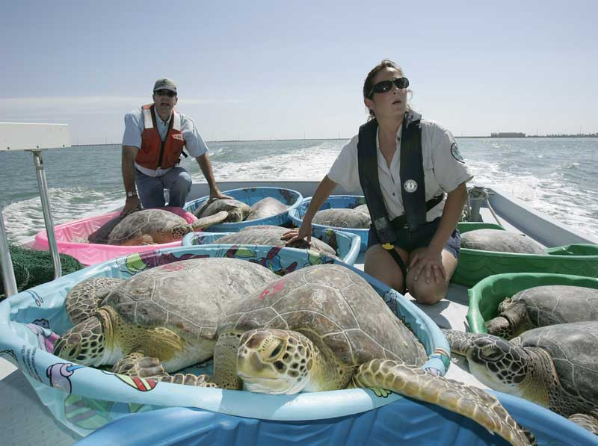


ENV 485

Syllabus

Instructor: Dr. Gail Grabowsky

Address: Wesselkamper, rm 108 ← NOTE: I have moved!!!
Chaminade University
3140 Waialae Ave
Honolulu, HI 96816

Phone: Office: 735-4834 (ext. 4834 if calling from on campus); cell: (808) 387-9319 (no calls after 9:00 PM please)

E-mail address: ggrabows@chaminade.edu

Office hours: MF 3:00-5:00, T 11:30-3:00; Or by appointment

Course Description:
This capstone course seeks to integrate and assess the experiences and program learning outcomes of the Environmental Studies major around a real environmental issue that the student actively participates in problem-solving through research and/or service. Each student is required to demonstrate their interdisciplinary understanding and problem-solving competency pertaining to the particular issue they are involved in.

General Purpose of the Course:
The purposes of this course are threefold.
- The student is required to either (1) participate in real environmental problem solving by working on or researching an environmental issue through an agency outside of Chaminade University, or (2) complete and original environmental research project on their own. Students choosing to work “in the field” with an environmental agency must complete at least 20 volunteer hours over course of the semester.
- This second purpose of this course is to have the student summarize in writing their capstone project and reflect upon all of the components of the environmental issue(s) their project involved as well as the solution strategies they or their agency employed (if your project contains a solution component).
- The final purpose of this course is to assess the Environmental Studies Program Student Learning Outcomes.

Student Learning Outcomes: Students will demonstrate an understanding of:

- The in-depth causes and consequences of the particular issue(s) they studied/worked on.
- Environmental problem solving field skills specific to the problem and agency they volunteered with
- Integrating the many components of environmental problem-solving
- The roles and general job activities of environmental professionals
- Career opportunities in the environment

Course Grading: The proportions that each portion of the course contributes to your grade are:

Field Experience 30% (300 pts)

Capstone Experience Summary Reflection Paper 50% (500 pts)

Attendance @ 4 mandatory meetings 20% (200 pts)(50 pts each)

The student must complete 20 hours of work in the field or for a single environmental agency, lab, business, etc. All of the student’s work should be related to a single environmental issue. If a student fails to complete all of the necessary hours the student’s grade will be diminished to a degree commensurate with the number of hours completed. (20+ hours = A, 15-19 hours total = B, 10-14 hours total = C, 5-9 hours = D, <5 hours = F).

In addition to the 20 internship hours the student will be required to write a Capstone Experience Summary Reflection Paper. The aim of the paper is for the student to put their work into the greater context of the entire environmental issue they were involved in and to relate their project to the Environmental Studies Student Learning Outcomes. The paper is due on 12/9 by noon; late papers will not be accepted.

Mandatory Course Meetings: There will be FOUR MANDATORY COURSE MEETINGS for ENV 485: TWO at the beginning of the semester to introduce the course and determine each student’s internship experience, one in the middle of the semester to check on the progress of your research/projects collectively and discuss the Capstone Experience Summary Reflection paper and the Environmental Studies Program Assessment assignment. All meetings will be held from 2:30-3:20 in Beh Sci room 103. (This is the time and place the course was scheduled for.) Unexcused absences will result in a loss of 50 points towards your grade.

Meeting Dates: Tues: 8/23, Tues: 9/6, Tues: 10/18, Tues: 11/29.

Throughout the course I will be in touch with you all individually and collectively through e-mail, as well as our group meetings and one-on-one visits, so make sure I have your preferred email address. If you do not respond to an email inquiry I will assume you received it, so make SURE I have your preferred address to which I will send ALL course-related communiqués.

Required Texts: This year I have required you all to buy a helpful book because I think it will help you to get a job! It is:

Fasulo, Mike and Paul Walker. 2007. Careers in the Environment. McGraw-Hill Professional Publishing. ISBN#: 9780071476119


