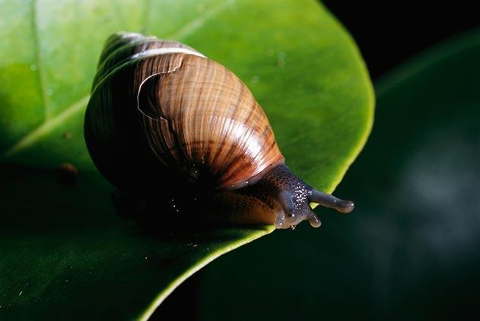
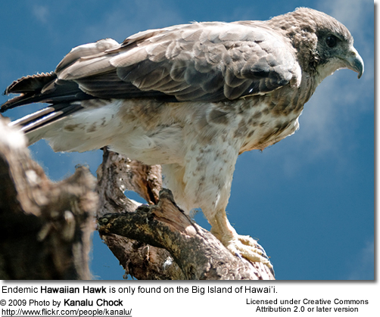
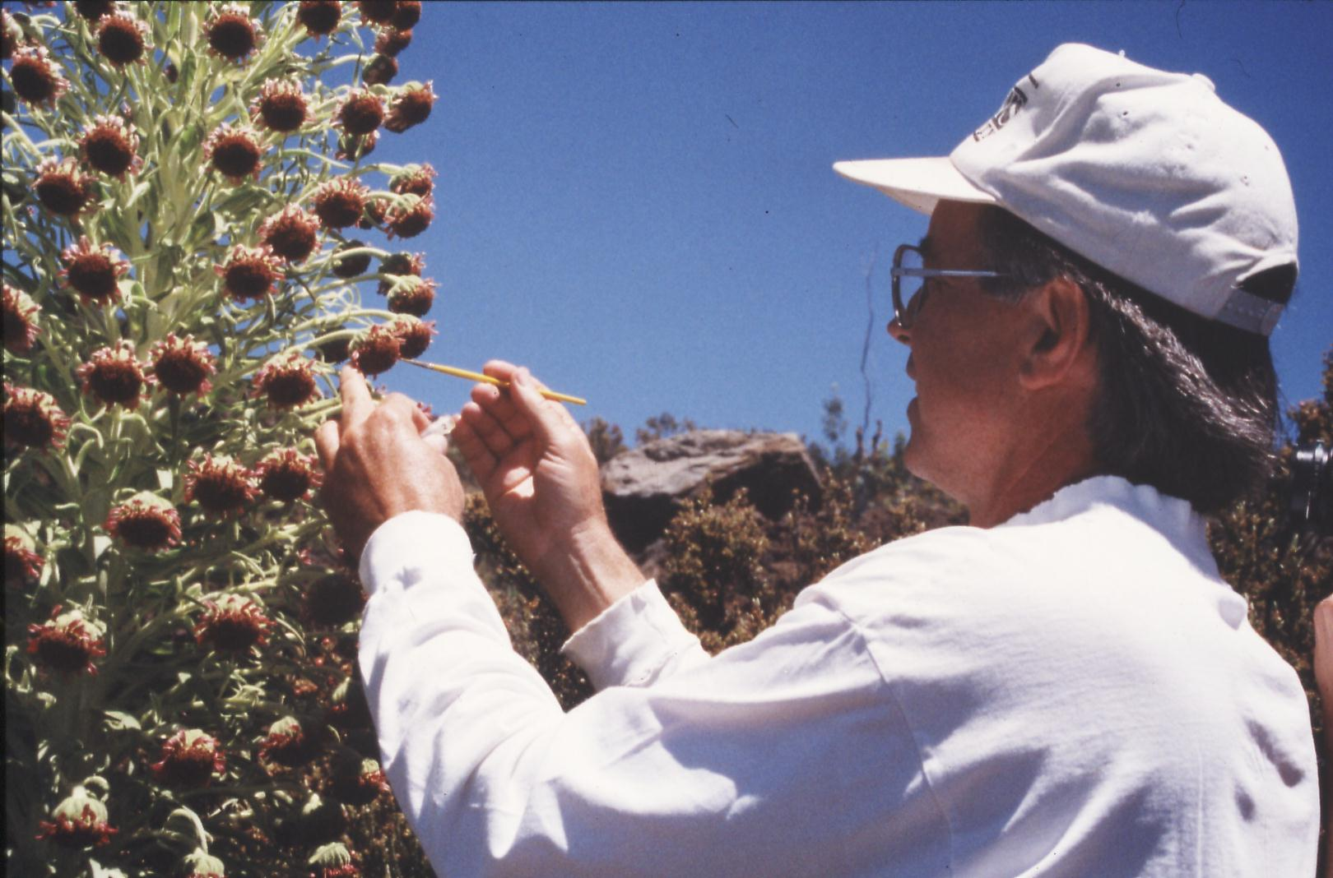

ENV 201 & 201L: Conservation Biology & Ecology Lecture and Laboratory
Fall 2016
Dr. Gail Grabowsky

Syllabus

The Earth’s resources are also being plundered because of short-sighted approaches to the economy, commerce and production. The loss of forests and woodlands entails the loss of species which may constitute extremely important resources in the future, not only for food but also for curing disease and other uses…. It is not enough, however, to think of different species merely as potential “resources” to be exploited, while overlooking the fact that they have value in themselves. Each year sees the disappearance of thousands of plant and animal species which we will never know, which our children will never see, because they have been lost forever.
Pope Francis, Laudato Si 2015

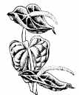
A worldview does not dissolve overnight. Rather, like one of Hutton’s mountain ranges, it erodes through long centuries.
Lorien Eisley

Few will have the greatness to bend history itself; but each of us can work to change a small portion of events, and in the total of all those acts will be written the history of this generation.
Robert F. Kennedy

A thing s right if it tends to preserve the integrity, stability and beauty of the biotic community. It is wrong if it tends to do otherwise.
Aldo Leopold

Change your thoughts and you change the world.
Norman Vincent Peale

The scientific community is no private club. In principle, and in its best and broadest sense of the words, scientific inquiry can be undertaken by anyone on almost any subject matter.
W. Quine and J. Ullian

ENV 201 & 201L: Conservation Biology & Ecology
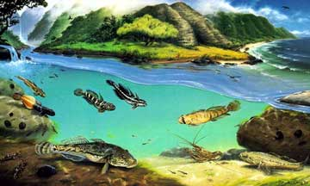
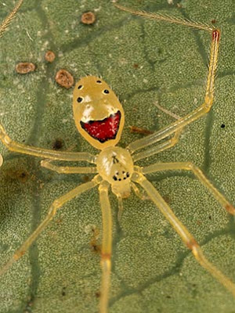
Lecture & Laboratory

Fall 2016

Course Introduction
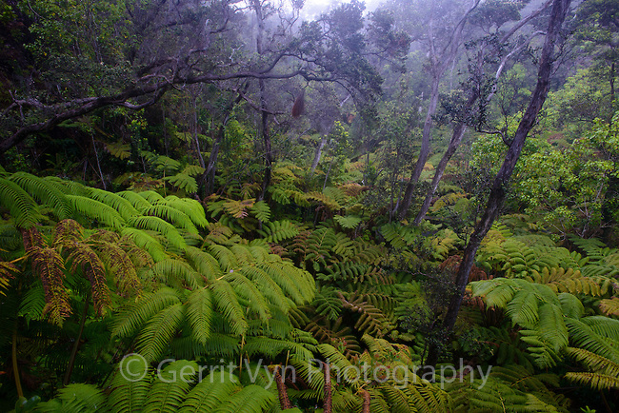

Instructor: Dr. Gail Grabowsky

Address: Wesselkamper, rm 108
Environmental Studies
Chaminade University
3140 Waialae Ave
Honolulu, HI 96816

Phone: 735-4834 (ext. 834 if calling from on campus)

E-mail address: ggrabows@chaminade.edu

Office hours: MF: 3:00-5:00; Tu 11:30-3:00; Or by appointment

Environmental Studies Program Student Learning Outcomes:
This course is one of the required courses for the major, minor or certificate in Environmental Studies at Chaminade University. As such, it has been designed to help students achieve a number of the Learning Outcomes for the Environmental Studies Program:

The Environmental Studies student will demonstrate an understanding of: (The underlined learning outcomes above are those that this course mainly helps you achieve.)

- The central importance of spirituality, ethics and worldviews in the “environmental movement”
- The importance of the environment in our own health and well being
- The major environmental issues and their potential solutions
- Problem-solving skills from diverse disciplines for diverse populations
- Scientific reasoning and methodology
- The roles and importance of laws, politics and economics in environmental issues
- Career opportunities in the environment

This course also meets the General Education requirements for a Natural Sciences course for those students not majoring or minoring in Environmental Studies.

Catalog Course descriptions:
ENV 201: An introduction to conservation biology issues and goals and the principles of ecology. The course includes consideration of the impacts of human activity on ecosystems and our efforts to ameliorate destructive impacts. Major topics include the effects of industrialization, agriculture, pollution, species introductions and human population growth and development on the health and future sustainability of ecosystems and humans alike. Particular emphasis is placed on island ecosystems.

ENV 201L: Students perform laboratory and field research techniques used in conducting conservation biology and ecological research and restoration. Analyses are conducted in the laboratory and the field.

Introduction:
Welcome to Conservation Biology & Ecology. I really enjoy teaching/facilitating this class because it comes from the heart (and the mind) as I am, like many of you, concerned for the current and future environment. This courser mainly focuses on the condition of earth’s terrestrial (land) ecosystems: what threatens them and why and how to keep them healthy or return them to a healthier state once they are degraded. I feel this class is not simply a course you take in college, it changes the lives of most who take it, as it introduces you to and helps you understand the causes and consequences of the real-world environmental issues we confront every day (or every time we take a sip of water…).
This course is one of two, the second course being ENV 202 & 202L: Environmental Physics. In this course we will be examining the causes and consequences of environmental issues that affect organisms (including humans) and ecosystems. We will use science: its methods and results, to understand organisms, ecosystems and environmental issues. Science however is not undertaken in a vacuum, it is only a tool, a systematic methodology, for determining what may very well be “reality.” The formalized scientific method was invented by a particular culture, but peoples all over the world have been doing things that are similar to science in order to learn about their world for a very long time. Thus scientific reasoning is really common to us all, even if its formalization as a rigorously defined methodology is not.
One thing I want all of us to realize through this course is that science is NOT a “sacred cow.” It is a very useful tool, but it is not in itself infallible or the solution to our environmental and ecological challenges. Both of these points may take some time to understand and are some of the goals of this course (so don’t panic if they don’t make sense right now). Even though I am a scientist and thus I obviously very highly value what science can tell us about the world, I, and (most) other scientists, fully realize that science is a human endeavor. Although scientists like to believe that science is completely objective and that the scientist is a completely detached observer, we know that in reality science is subject to the effects of culture, our own minds/machines’ ability to perceive/conceive reality, the kinds of questions we are interested in asking about reality, etc. In addition, to solve or consider any environmental problem, we need to consider the people involved, their values and beliefs, their economics, politics, history, needs, desires, etc! The science we do only helps us gather information about a phenomenon or determine how to behave in order to change a situation, it does not tell us what is better or worse, right or wrong, what we should or should not do.
Because of the complexity of environmental issues and the fact that science is only one of the players involved in learning about and solving environmental issues, we will have to touch on those other factors in this science course. I need to have you understand the context in which the science occurs and be sensitive to the importance of the ethics and values that are also part of any environmental issue.

Course Objectives:
Lecture: When you complete this course you should:
- Know what science is and how scientific research is conducted and shared with others
- Understand the role of science in enabling us to understand and problem-solve environmental phenomena
- Understand the role of ethics in allowing us to define environmental problems and
solutions
- Be able to describe the major physical causes of habitat/ecosystem degradation and destruction
- Be able to describe a number of potential solutions for global and Pacific Island habitat/ecosystem degradation and destruction
- Know the basic structure and types of fresh water and terrestrial ecosystems
- Understand the generalized sorts of interactions between organisms and their environment
- Understand what a healthy ecosystem is and what sustainability means in general
- Understand why human population growth occurred and what its future implications are for ourselves and other species
- Demonstrate an understanding of the connections between academic work and real-life situations

Lab: When you complete this course you should:
- Understand the scientific method and how to apply it to real environmental issues
- Understand what descriptive science is and how it is important in environmental biology
- Know the basic units used in making scientific measurements
- Know and understand the taxonomic hierarchy, systematic biology methodology and the species concept
- Know how to determine species abundance and distributions
- Know some of the measures used to determine ecological stress
- Know how to interpret and create graphs, tables and maps
- Learn the importance of, and how to access and read, the primary scientific literature
- Know how to design a scientific experiment aimed at supporting or disproving a particular hypothesis
- Know how to prepare a formal laboratory write-up

Course Requirements:
Your grades in lecture and lab will be based on the following assignments. Each of the items/activities listed below will be described to you in writing or orally in class. The dates of each activity (or its parts) are indicated on the Schedule portion of this syllabus.
In the past, service learning has been a required portion of all of my courses. This semester I am going to make service learning extra credit, but give you big incentive to participate. I will be participating in a number of service outings myself with you. See below for details regarding service learning in this class.

Lecture Grade:
- 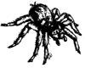Two in class exams and one in class final exam
- Habitat Type oral project
- Pop Quizzes on readings and miscellaneous assignments

The proportion that each contributes to your grade in this course is as follows:

Exam I 20% 200 pts
Exam II 20% 200 pts
Final Exam 20% 200 pts
Habitat Type Project & miscellaneous assignments 20% 200 pts
Pop Quizzes on readings 20% 200 pts
100% 1000 pts
Lab Grade:
- Assignment(s) for each lab
- Formal lab write-up
- Hypothetical Experiment written assignment
- Attendance

The proportion that each contributes to your grade in this course is as follows:

Lab assignments 40% 400 pts
Formal Lab Write-Up 20% 200 pts
Hypothetical Experiment 20% 200 pts
Attendance 20% 200 pts
100% 1000 pts

Grading: Lecture exams will be as objective as possible although they will contain some essay/short answer questions which tend to be more subjective. For oral and written assignments and laboratory worksheets you will be graded on your effort, correctness (when there is a correct response etc.) and your thoughtfulness.
Effort in general manifests itself as neatness, completeness, thoroughness, calories expended per unit time(!), timeliness, correct spelling, any extra creative things you do above-and-beyond what is expected, etc. Correctness means do your statements jive with corresponding scientific knowledge, do your conclusions follow from the evidence before you, did you calculate an equation correctly, interpret a graph accurately, make a table that illustrates your data properly, etc. Thoughtfulness can show up in many ways, perhaps you really think things through, trying to consider all the variables or you worked hard to tie pieces of evidence together, maybe you consider something that may be important that everyone else ignores. By being “thoughtful” I don’t mean that you look out for other people (i.e. are kind) I mean that you have done some thinking, really reflected upon a topic, have given it some time, have analyzed it, etc. thoroughly.

Required texts:
Withgott, J. and S. Brennan. 2013. Environment: The Science Behind the Stories. 5th edition. Pearson Benjamin Cummings. ISBN 9780321927576

Other readings and exercises will come from other sources and will be provided to you in Google Drive. These sources may include:
Allen, John, H. 1997. Student Atlas of Environmental Issues
Juvik, Sonia, P. & James O. Juvik (Editors). 1998. Atlas of Hawaii. 3rd edition. University of Hawaii Press.
Kay, E. Alison (Editor). 1994. A Natural History of the Hawaiian Islands. University of Hawaii Press.
Lee, J.A. 1999. The Scientific Endeavor: A Primer on Scientific Principles and Practice. Benjamin Cummings.
Loban, C. S., M. Schefter, F. Camacho & J. Jocson. 2014. Tropical Pacific Island Environments. Bess Press, Honolulu, Hawaii.
Quine, W.V. and J.S. Ullian. 1970. The Web of Belief. 2nd ed. Randon House, New York.
Rapaport, M. 1999. The Pacific Islands. Bess Press.
The Worldwatch Institute. 2013. Vital Signs. Volume 20. W.W. Norton & Co, New York.
The Worldwatch Institute. 2014. State of the World 2014: Governing for Sustainability. Island Press.
Weeks, John. R. 2005. Population: An Introduction to Concepts and Issues. (9th edition). Wadsworth.
Wynn, Charles, M. and Arthur W. Wiggins. 1997. The Five Biggest Ideas in Science. John Wiley & Sons, New York.
Ziegler, Alan, C. 2002. Hawaiian Natural History, Ecology and Evolution. University of Hawaii Press.

Required Extras:
- Lab notebook/folder: This must be a separate notebook from whatever you use to keep your lecture material from this course in. You will be receiving lots of separate handouts and reading materials for the lab so the notebook should be one that you can easily add materials to. The purpose of the notebook is to provide a place for you to record data, make observations, keep lab protocols, file returned documents, etc. It is a precious record of your work.
- Outdoor “field” clothing: You’ll need to have something to cover your feet that can get wet and/or muddy. A bottle of mosquito repellant is a good idea too!
- Bottled water: We can’t have you getting dehydrated, so keep a bottle of water (at least a half liter) handy that you can bring to labs when we are going out “into the field.” If you come on a service outing always bring at least a liter of water with you.

Extra Credit Options:
Throughout the course Dr. Gail will be making numerous environmental service-learning outings available to you. You may also find environmental service opportunities on your own. Those that Dr. Gail organizes or brings to your attention will typically be on Saturdays or after school. For every service-learning activity that you participate in, that entails 4-5 hours of work, will receive +5 extra credit points.
Also, periodically throughout the course there will be talks and presentations you may attend that pertain to the course material. Dr. Gail will let you know when these opportunities arise OR you may discover them and bring them to the class’s attention. You can earn +2 extra credit points towards a lecture exam for each talk you attend with content related to the course content.
In order for all talks and service activities to count for extra credit you MUST have them approved by Dr. Gail PRIOR TO the event and you MUST document your presence (if Dr. Gail is not also in attendance) with a photograph of yourself participating AND give Dr. Gail the name and phone number of the person in charge or speaker/presenter. If there are any handouts from the event bring them as evidence of your attendance as well. You may earn up to 30 extra credit points from service activities and 10 from attending talks/presentations.

Attendance:
While I dearly hope that you can make every class…, since you are adults now, you are free to miss any lecture class you choose… but KNOW that there may be some consequences should you choose to exercise this option: your grade could (and most likely WILL) suffer. I believe that students who have missed a lot of classes ALWAYS would have done better if they had not missed classes. There simply is no substitute for being in class when it comes to understanding the material. I can give you a fishing pole, but I cannot make you fish.
If you miss a lecture exam or lab your absence must be excused if it is not to formally effect your grade. Excused absences occur when you bring in a doctor’s note, a funeral announcement for a family member, notice of participation in athletic events, etc. Unexcused absences occur when you were working, surfing, sleeping, cramming for an exam in another class, etc. Unexcused absences from lab will negatively affect your grade. For each unexcused lab absence you will lose 20 points (the equivalent of one full grade for your formal lab write up). I am a scientist; I require hard evidence if an absence is to be excused. If your car breaks down on the way to lab take a picture and make SURE I can verify the date and time of the breakdown and it will be an excused absence, ☺, however, no evidence; no excused absence.

If you are handicapped under the Americans with Disabilities Act:
Chaminade will provide assistance for any student with documented disabilities. Any student who believes he/she may need accommodations in this class must contact Dr. June Yasuhara (735-4845), at the Counseling Center (office is next to security), in order to determine if you meet the requirements for a documented disability in accordance with the Americans with Disabilities Act. Please contact Dr. Yasuhara as soon as possible so that accommodations can be implemented in a timely fashion.

Classroom Atmosphere:
Guys, I value a very open, yet courteous class atmosphere. Express your thoughts! Ask your questions! (The only dumb question is the one in which you ask yourself if you should ask your question.) Respect the thoughts and ideas and opinions of others – really think about what others say. Let them express themselves fully, then you do the same. The thing I value most from my college days are all the wonderful, valuable, diverse ways of looking at and understanding the world that I was exposed to. Be an open vessel – take ideas in! You will learn as much from each other as you do from me.

This syllabus and course schedule are living documents: they are free to change. I try to adhere as closely as possible to them for your convenience, but there will be times in which we will take longer on a particular topic or add or delete a topic to enhance the course. I like to be able to react to you as the course proceeds and go with the flow a bit in order to make the course experience sort of custom fit to you!


You are responsible for all of the information in this document: losing it or not reading it do not make you exempt from knowing what’s in it!
Use it to keep you organized and aware of important dates and how your grade is determined.
Class Schedule: Fall 2016
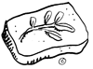 Why enviro science? Connectedness with nature

Part I
Knowledge, Ethics & the Environment

DATE TOPIC ACTIVITIES
8/22/16 Course introduction & outline; Survey Review course syllabi; questionairre
who we are; Where we’re from Read: “Human Dom…”, “A Safe Operating…”
8/24 Course path; Important terms & concepts QUIZ on “Human Domination” paper!
8/25 Lab: Overview of enviro issues “Endangered Planet” DVD
8/26 NO 11:30 CLASSES: Fall Convocation
_____
8/29 General human effect on the environment Read: Chapter 5 in your textbook
8/31 General human effect on the environment (cont’d) Read: “A Safe Operating …” paper!
9/1 Lab: Survey of issues that concern us Bring an environmental issue to share
9/2 NO CLASS: Dr. G @ World Conservation Congress
_____
9/5 NO CLASSES: Labor Day
9/7 General human effect on the environment (cont’d) QUIZ on “A Safe Operating …” paper!
9/8 Lab: Scientific systems of measure Take-home Worksheet
9/9 General human effect on the environment (cont’d) Read: Chapter 1 in your textbook
_____
9/12 What is science? Why do it? Read: “The Philosophy of Science”
9/14 Science: Underlying philosophy & methods QUIZ on “The Philosophy of Science” paper!
9/15 Lab: Indigenous knowledge in action DVD; Bring in an example of IK to share
Explain the Hypothetical Experiment Project
9/16 Science, traditional knowledge and ecological ethics Read: Chapter 6 in your textbook
_____

Part II
Pristine Nature: Biodiversity and Ecology

DATE TOPIC ACTIVITIES
9/19 The history of life on earth Read: Chapter 3 in your textbook
9/21 The characteristics and requirements of life History of Life Power Point by Dr. Gail
9/22 Lab: Value lab Bring in something to assign “value” t o
9/23 Life: unity and diversity and their implications...
_____
9/26 Biodiversity and classification Biodiversity Power Point by Dr. Gail
9/28 Biodiversity in space and time Read: Chapter 11 in your textbook
9/29 Lab: Biodiversity & ecological interactions Fieldtrip to Zoo: Worksheet & photojournal
9/30 Evolution: Evidence Evidence of Evolution Power Point by Dr. G.
_____
10/3 Evolution: Mechanisms & Speciation Hypotheses Due
10/5 E X A M I
10/6 Lab: Island species: Native and alien/invasive St. Louis Hike; Worksheet
10/7 Human historical place in nature Read: Chapter 8 in your textbook
_____
10/10 NO CLASSES: Discoverer’s Day
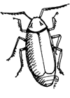
10/12 Human population growth
10/13 Lab: Population and Fertility Rate Worksheet; bring in data on your own family
10/14 Ecological principles; causal networks Read: Chapter 4 in your textbook
_____
10/17 Abiotic ecological interactions Revised Hypoths due!
10/19 Biotic interactions Habitat Type Project Explained
10/20 Lab: Calculating your ecological footprint Online homework
10/21 Biotic interactions (cont’d)
_____
10/24 Ecological productivity; Ecosystems Read: Chapter 9 in your textbook
10/26 Soil
10/27 Lab: Habitat project reports Habitat Type Oral Presentations
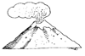10/28 Earth’s habitats & systems ecology wrap-up
_____

Part III

Island Populations and Challenges

DATE TOPIC ACTIVITIES
10/31 Pacific peoples and their island homes Read: “Hawaiian Archipelago Formation”
11/2 Islands: Types Island Types Power Point by Dr. Gail
11/3 Lab: The impacts of food consumption Fieldtrip to the supermarket; Worksheet
Use the internet: calculate distance food traveled
11/4 Islands: Geology & Climate QUIZ on “Hawaiian Archipelago Formation”
_____
11/7 Islands: Why each is unique & things they all share…
11/9 NO CLASS: Dr. Gail at Coral Reef Advisory Council Meeting
11/10 Lab: IDing birdsong in a native Hawaiian forest Bring a portable internet device to lab!
11/11 Islands: Endemism and adaptive radiations Read: “Historic Ecology” handout

_____

11/14 Islands: Invasive species QUIZ on “Historic Ecology”
11/16 Conservation Biology Read: Chapter 11 in your textbook
11/17 Lab: Quantifying habitat variation in the field Fieldtrip to Makapu’u; Graph worksheet
11/18 E X A M I I Handout: Writing up a scientific research paper
_____

Part IV

Living Sustainably on Island Earth

DATE TOPIC ACTIVITIES
11/21 Formal Lab Help Day! (Don’t miss it!) Bring Makapu’u data in Excel table & one
graph
11/23 Natural Resource Management Read: Chapter 12 in your textbook
11/24 NO CLASS: THANKSGIVING
11/25 NO CLASSES: THANKSGIVING HOLIDAY
_____
11/28 Sustainability; Is it doable? Read: Chapter 24 in your textbook
11/30 Sustainability at-large (cont’d) Go to: https://sustainabledevelopment.un.org/topics/sustainabledevelopmentgoals
12/1 Lab: Invasive or endangered species solutions Share solutions for 1threatened OR 1 invasive
spp.
12/2 Sustainable answers for Hawaii
_____

Important Dates You Should Know:
- Your formal lab write-up (if you are in lab) are all due by the day of the Final Exam no later than 11:05 AM. Late papers will not be accepted.

- Final Exam: Wednesday, December 7th, from 11:00 – 1:00 PM in our regular classroom.

Environmental Science Questionnaire

This is a non-graded questionnaire which I give you so that I may assess where your interests are regarding the environment and your education at Chaminade, what you expect out of this course and a little bit about you and your background.

Name: _____________________________________
Where did you grow up? _______________________________________
Year at Chaminade: _______________________
When are you planning on graduating? _____________________
What is your major? (If you don’t have one yet what are you thinking about majoring in?): ____________________________________
Did you know that Chaminade has an Environmental Studies major/minor? ________________
Would you be interested in obtaining material about the Environmental Studies Program? _______________
Are you thinking about majoring/minoring in Environmental Studies? _______________
Would you like to be part of the new Environment Club at Chaminade? _______________

Why did you take this class?

Are you interested in environmental issues? ____________
Why or why not?

On a scale of 1 to 10 (10 being of utmost importance) how important do you think the environmental issues facing us today are? ____________

What kinds of things are AS important as environmental issues in your opinion?

What kinds of things are MORE important than environmental problems in your opinion?

Do you have any experience with environmental volunteer work, education, etc.

Are you interested in a career in the environment? ____________
If yes what specifically? (If you have an idea.)

What one environmental issue do you feel is the most important one facing the planet?

What science classes have you had in college or high school:

What are you hoping this course will teach you?

What are you hoping we will get to do in this course?

Finish this sentence: Good teachers . . .

Finish this sentence: Poor teachers . . .

