
AR 103/ID 216
VisDes/DesPrinc
Fall 2016 Eiben108
-01: TR 11:30-12:50
-02: 10:00-11:20
office hrs afternoons

COURSE DESCRIPTION: ID 216 is a pre-major studio course for all ID candidates or may serve as a fine arts general education requirement. Students produce projects on the elements and principles of design.
COURSE OUTCOMES: Upon successful completion of this course, the student will demonstrate an:
- Understanding and appreciate the purpose of design;
- Understand the evolvement of creative activity, both rejection and enhancement;
- Practice increasing refinement of visual ideas

COURSE REQUIREMENTS INCLUDE THE FOLLOWING:

ATTENDANCE IS MANDATORY! Students must be on time and stay the full period. Instructions & possible quizzes are at the beginning of class. Anything over two unexcused absences (e.g. a tardy, leaving early) will result in a lower grade for the ENTIRE COURSE. More specifics on attendance policy and penalties are in the Supplement to Syllabus.
ADOBE ILLUSTRATOR AND PHOTOSHOP will be used to do projects. If you are lacking computer skills, this may not be your course. Unless you have these programs at home, you will have to listen carefully and work diligently in class, where these programs are installed. Download all the materials on Canvas by next class. The instructor will provide added instructions and handouts. It is wise to load them onto your electronic devices. You may want to download and put into your laptop or tablet the official Adobe Illustrator CC PDF manual at: https://helpx.adobe.com/pdf/illustrator_reference.pdf. Do not waste valuable class time downloading handouts in class – that leaves a very bad impression on; If this occurs too often, quizzes are in store.
If you cannot finish during class time, you will have to come into the classroom when it is unoccupied.
In future, it would be a great advantage to know these popular programs. Another benefit is that there are no need for books and traditional art materials. If you fall behind you have to resort to renting these programs from Adobe; there’s a free first month trial, but use it wisely only if you fall behind.
DUE DATES and TIMES: Designated deadlines for projects are absolute – no excuses! A pink slip in your future is exponentially more consequential than an F in a project. You must submit your project in 2 files, usually both .jpeg and an Illustrator - .ai file, via e-mail to me only at wtakeda@chaminade.edu. Make sure – open your mail’s “sent items” folder to verify that it was transmitted along with attachments. Never delete these “sent items” till the course is over. This is your responsibility. If there is a question, you must provide a screen capture as proof: open the verifying e-mail; press “Print Screen” on keyboard; open a Word Document; click “Paste” and e-mail this.
PRESENTATIONS by the student and critique by the class will be conducted on the Design Principle projects, time permitting. A poor presentation detracts from the project grade; so take it seriously - prepare explanations, methodology, etc. Your professional growth must include ability to articulate and persuade an audience.
EFFICIENT CLASS TIME: The purpose of each project is to exercise creativity with instructional interaction. Again, go over the handouts thoroughly before coming to class.
GRADING POLICY: Grading is a subjective matter and all the more so in the artistic area. A mere compliance with the minimal requirements of the project results in a C. There is nothing wrong with a C - it denotes adequate work if correctly fulfilling the basic requirements. Any higher grade requires more creativity within the assignment’s parameters, a higher degree of execution, greater aesthetic quality, excellent presentation, etc.
Grading criteria: A=100-90, B= 89-80, C= 79-70, D= 69-60, F= 59 or below
Late Penalties: Principles projects are twice the value of Elements projects. Logo is weightier still.
Any project sent the start of class deadline will suffer a deduction as explained in the Supplement.
THE FOLLOWING COURSE SCHEDULE may be changed. The student, if absent, is still responsible for any verbal changes of assignments and due dates stated in class; check with classmates.
Remember that possible quizzes may precede the Intro to new projects at the beginning of class- read handouts beforehand to pass quizzes; wrong answers will be deducted from your Project grade.

TUESDAY THURSDAY
Aug 23 | Intro Illustrator; intro & work on Value project | Aug 25 | Assessment Form due; Work on Value Project
Aug 30 | ** Intro & work on Line/Shape project | Sept 1 | Work on Line/Shape Project, (ultimately will be Size Var. Proj).
Sep 6 | ** Intro & work on Color Project (add color to previous Line/Shape Project.) | Sep 8 | Work on Color Project
Sep 13 | **Intro & work on Line/Texture Project (adding this to previous proj.) | Sep 15 | Work on Line/Texture Project – worth 2x  regular project
Sep 20 | **Intro & work on Illusion of Space Project | Sep 22 | Work on Illusion of Space Project
Sep 27 | **Intro & work Shapes within the Container Project | Sep 29 | Work on Shapes within the Container Project
Oct 4 | **Intro & work on Focal Point by Isolation project | Oct 6 | **Intro & work on Focal Point by Isolation project
Oct 11 | **Intro and work on Transition project | Oct 13 | Work on Transition Project
Oct 18 | **Intro & work on Unity (Photoshop) | Oct 20 | Work on Unity project
Oct 25 | Work on Unity Project | Oct 27 | ** Intro & work on Room Alteration Project (Photoshop)
Nov 1 | Work on Room Alteration Project | Nov 3 | Work on Room Alteration Project
Nov 8 | **Work on Logo Project part I | Nov10 | **Work on Logo Project part 2
Nov 15 | Work on Logo Project Part 2 | Nov17 | **Work on Logo Project part 3
Nov 22 | **Work on Logo Project part 4 | Nov24 | THANKSGIVING
Nov 29 | Work on Logo project part 4 | Dec 1 | Work on Logo project and turn in by midnight of this day

**Double asterisk means that the previously worked on project is to have been emailed me before the start of the class. Anything over the start time of the class will have a deduction. For example, on August 30, the previously worked on project Value, is to be attached to an email only to:
wtakeda@chaminade.edu -nowhere else!

DEADLINE for withdrawal or credit/no credit is Friday, Nov 11, which is a holiday, so do this prior.

SYLLABUS RESPONSIBILITY: The student is responsible for reading, comprehending, and abiding by the terms and directions of this syllabus, the Supplement to the syllabus, and the Project directions placed on e-college, and cannot claim ignorance of its contents as an excuse.

SYLLABUS SUPPLEMENT – Specific Class Policies and their Penalties

ABSENCES should not be taken lightly.
- Excused absences: upon return, you must produce verifiable, dated documentation with phone number (i.e. doctor’s slip, service station invoice, etc.). Just your word is not enough.
- If LATE, roll will already have been taken at the start of class. It is your responsibility to make your presence known to the instructor. If you are chronically late, 3 “lates” will equal one unexcused absence against you.
- Three or more unexcused absences will result in a full letter grade drop on your final class grade.

LATE PROJECT SUBMISSIONS:
The above Absence policy is independent of these late project submission policies.
Deadlines are before class after workdays on that project. Again, note the syllabus schedule - the double asterisk (**) before a class means that the previous project is due before the start of class.
Always save onto your laptop, flash drive, or other device/method – not on the classroom desktops. This way, you can email the project, finished or not, from your home, and avoid a penalty.
If the ‘before class’ deadline is not met, you have until midnight of that deadline date to submit, at a 10% penalty in grade. So a submission of 1 minute after class starts till midnight that day has the same 10% penalty.
Thus, if you are absent, make a decision which would be a worse penalty: the late submission or an incomplete work submitted on time. Nothing will be accepted after the midnight deadline.

FILENAMES OF PROJECT SUBMISSIONS - GENERALLY REQUIRED ON 3 PLACES: Projects will be submitted as an Illustrator file (.ai) and a .jpeg file conversion of the .ai file. Later there will be Photoshop files (.psd).
- You will be provided with a template for most projects; on that template will be a layer where you will type your section and name.
- Both files are to be submitted as 2 attachments on 1 e-mail. DON’T send 2 emails – 1 for each!
- The filename of both will be your section (01 or 02 followed by LastnameFirstname as follows:
01 TakedaWalter Do not add anything before or after. -5% on first offense, more if you
continue to forget.
- To convert your Illustrator file to .jpeg, go to “File > Export” – you cannot use “Save As”
- When you get to this window, you MUST check “Use Artboards” -5% on first offense, more if you continue.
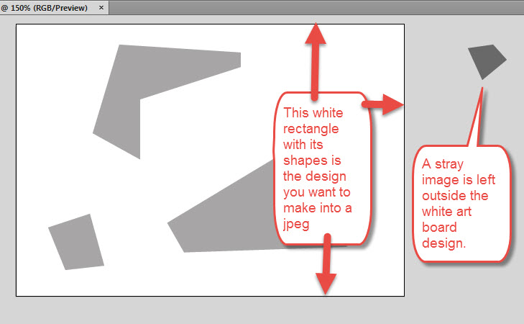
Use Arboards was checked, so the proper margins of the original Artboard appears. The forgotten stray object to the right outside of the artboard is correctly not included in the jpeg.

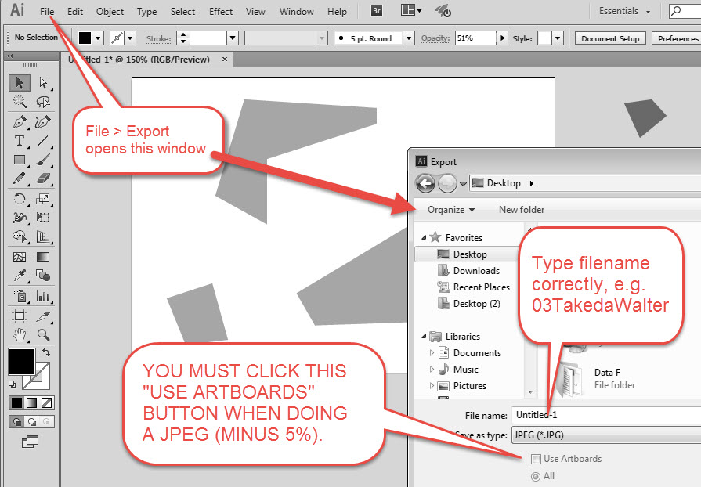

An .ai Illustrator file is a vector image, so it must be converted to a raster (pixel-based) image. Thus it must be “Exported” (converted), not “Saved As.”
LATER PROJECTS IN PHOTOSHOP:
Save As (jpeg) will flatten all your Photoshop layers into one. If you wish to further alter the image with its separate layers, save it as a Photoshop (.psd) file.

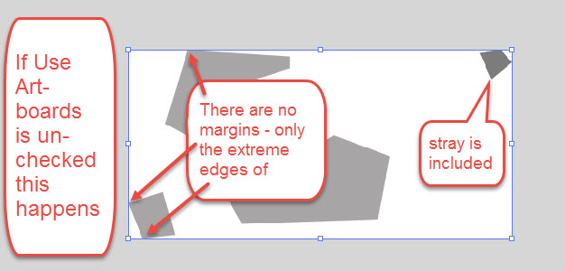
Use Artboards was not checked, so the jpeg image made will only include up to the extreme horizontal and vertical points of all the objects, even the stray outside of the artboard.

Double check your Color Mode on the next window – Do not leave at professional printing CMYK mode.
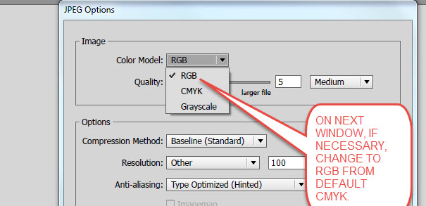

CLASSROOM WORKTIME
Maximize your time in class on working on the Adobe programs.
Only work on the project scheduled for that day. Find time later in a studio when there is no class and catch up on a late project. Ask the instructor if it is OK to work in a class in progress.
Do not be texting or doing other work during this time, or being on social media. Some projects have phases that can be worked out at home – such as gathering objects on Google Images for the Logo.

