Philosophy 100 -- Introduction to Philosophy (Online)
Summer Session II 2016
Instructor: Dr. Thomas (Toby) Yos
Meeting Dates: Monday, June 27 - Sunday, August 7
Office Hours: Visit My (virtual) Office anytime
E-mail: thomas.yos@chaminade.edu or through eCollege Email on Course Toolbar
Text Books:
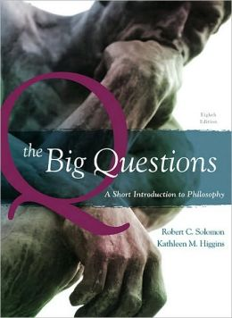

BIG QUESTIONS

REQUIRED |By SOLOMON
- EDITION: 8TH 10
- PUBLISHER: CENGAGE L
- ISBN: 9780495595151
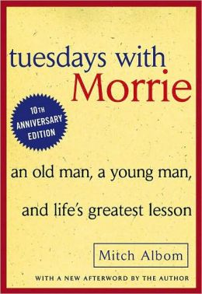

TUESDAYS WITH MORRIE

REQUIRED |By ALBOM
- EDITION: 97
- PUBLISHER: PENG RAND
- ISBN: 9780767905923
Catalogue Description - PH 100 Introduction to Philosophy:
A study of the nature of philosophical thought and methods by examining actual examples from a selection of classical Greek, medieval Christian, and modern European philosophers. Students will develop an understanding of the ways in which western culture functions.
General Education Learning Outcomes for Philosophy from Student Handbook:
Students who successfully complete the General Education Core program will:
1. Demonstrate an understanding of the broad themes found in the Western philosophical tradition.
2. Demonstrate skills and techniques necessary to successfully execute critical and creative literary papers.
3. Identify and discuss literary themes and universal concepts present in literary texts, including, but not limited to, the exploration of truth, faith, and ethics.
Course Learning Outcomes:
In order that the students may have a better understanding of what they will learn in Philosophy 100, the following outcomes are provided. Through the course, the student will:
1. Demonstrate familiarity with the major philosophers, ideas and development of western thought by identifying and explaining these in an essay and exam.
2. Be able to articulate the central philosophical issues of western thought through participation in class discussion and by means of written assignments.
3. Begin to think philosophically by reflecting on her/his own views of these issues and demonstrate this reflective process in class discussions and in written journal entries.
Assignments:
- Online Material: You are expected to go through all of the online material each week.
- Reading: There is weekly assigned reading in both the textbook and the Tuesdays With Morrie novel.
- Discussion Postings: You must make at least nine quality online discussion postings per week.
- Tuesdays With Morrie Reflections: You have to write a one page Tuesdays With Morrie Reflection paper each week.
- Essay: You must write a final 5 page essay.
- Final Exam: There will be a final exam at the end of the course.
Points will be awarded as follows:
Discussion Postings: 72 points (12 points X 6 Weekly Units)
Tuesdays With Morrie Reflections: 50 points (10 points X 5 Reflections)
Essay: 50 points
Final Exam: 50 points
Course Grade: You will be able to earn a maximum of 222 points in this course. The number of points that you earn will determine your final grade for the course.
If you earn 90% to 100% of the points you will get a grade of “A” for the course.
If you earn 80% to 89% of the points you will get a grade of “B” for the course.
If you earn 70% to 79% of the points you will get a grade of “C” for the course.
If you earn 60% to 69% of the points you will get a grade of “D” for the course.
If you earn 0% to 59% of the points you will get a grade of “F” for the course.
Got Questions?
- About the content, structure, or expectations of this course? Visit My (virtual) Office and ask your question.
- About more personal matters? Feel free to send me an e-mail.
- About technical, computer stuff? Check out the "Student Orientation Tutorial" or the "Tech Support" or "Help" tabs on the course toolbar.
For more information about each kind of assignment and for the course schedule please see the corresponding tabs under "Course Home."

