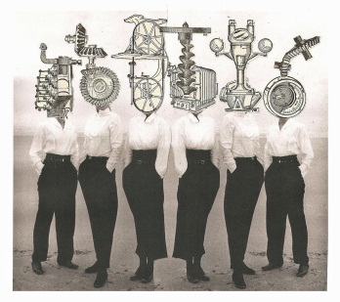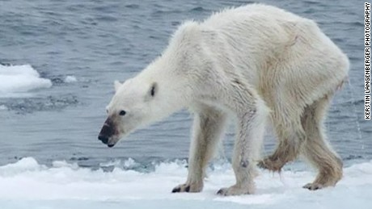

ENV 380: State of the Planet: Science and Spirit

Course Syllabus
Spring 2016

Instructor: Dr. Gail Grabowsky

Address: Wesselkamper, rm 108
Environmental Studies
Chaminade University
3140 Waialae Ave
Honolulu, HI 96816

Phone: 735-4834 (ext. 834 if calling from on campus)

E-mail address: ggrabows@chaminade.edu

Office hours: MF: 3:00-6:00; Tu 11:30-2:00; Or by appointment
Texts:
Required: The required texts for the course are these (you need to have access to each throughout the course):

Encyclical Letter: Laudato Si of the Holy Father Francis: On Care for Our Common Home (available online free @ http://w2.vatican.va/content/dam/francesco/pdf/encyclicals/documents/papa-francesco_20150524_enciclica-laudato-si_en.pdf

Brynjolfsson, Erik and Andrew McAfee. 2014. The Second Machine Age. W.W. Norton & Company. New York.
Klein, Naomi. 2014. This Changes Everything: Capitalism vs Climate Change. Simon & Schuster Paperbacks. New York.
Leonard, Annie. 2010. The Story of Stuff. Simon & Schuster Paperbacks. New York.

Other: Throughout the course there may be readings and videos from other sources. I will share with you e-copies of all of the additional readings or videos that are mandatory for the course. You will need to share all the readings and videos you assign us as well. Sharing will be done via a course file in Google Drive. So make sure you can use Chrome as your search engine as accessing Google Docs, Drive etc. works best with it.

Course Description:
This course was inspired by our current Pope Francis: Jorge Mario Bergoglio, and his most recent encyclical: Laudato Si “On Care for Our Common Home.” The encyclical focusses heavily on climate change and the current state of global human well-being. It covers much more than climate change however and is basically an amazing and timely causes-and-solutions document that confronts issues from scientific and spiritual perspectives. It offers explanations for the causes of our current environmental and human equity issues from both a spiritual (Catholic; Christian) perspective as well as from sociological and scientific perspectives. It is beautifully written, extremely thought-provoking and powerful. We will read it slowly and savor it, taking time to discuss its main points and nuances.
I decided that I really had no choice, as someone who grew up Catholic, has many students critically effected by climate change, and the Director of Chaminade’s Environmental Studies Program, but to offer a course on the encyclical at this private Catholic Marianist institution! We are called by our spiritually-based and science-based ethics and understanding to discuss the encyclical’s contents from our own perspectives as Christians, Catholics, Marianists, environmentalists, people coming from a high consumer culture, Pacific Islanders, etc.!
We will not be reading the encyclical as a textbook that we take on faith. We will be reading it to really, deeply and thoughtfully consider what is says and decide, each of us for ourselves, what it offers, if we agree with it, if it transforms us, if it is correct and if we think it will lead to change.
In order to spark discussion throughout the course we will be coupling the encyclical – which we will read carefully and slowly – with three other very recent novels that indirectly comment on, compliment or run contrary to the encyclical. All three books are best sellers. One, originating on the web: The Story of Stuff, has been viewed by more than 12 million Americans and provides clean quick descriptions of the material causes for our problems. This Changes Everything is specifically about climate change and this bestselling book from last year argues that capitalism created climate change and that it cannot fix the problem. The author however does offer positive solutions to the problem and feels ironically that climate change may actually lead to a global fix for humanity…if we meet the challenge well. I wonder if her plan is in line with Pope Francis? We will find out! The third book, a NY Times Bestseller, is titled The Second Machine Age. Its authors are our MIT technophiles and economists. They see the digital age as a new beginning and feel it can make the world a much better place…but for all? Let’s see if their story is something the Pope or we agree with? Things that make you go “hmmmmmm.”
Are you ready for this important and heady adventure!? I hope so. Let’s get started!

Student Learning Outcomes:
Students will:
- Learn about Pope Francis – his background and priorities
- Learn about the material causes of environmental issues
- Learn why some people feel the digital age can make the world a better place
- Learn what the Pope feels are the majors causes of climate change and other global environmental issues
- Learn why the Pope feels that environmental degradation and inequality are causally related
- Learn what role the Pope feels capitalism and consumer culture plays in environmental and spiritual degradation
- Learn what Pope Francis and the authors of the books we read think are solutions for the future
- Engage in personal activities that help ameliorate or stop climate change and decrease human inequality
- Develop opinions regarding whether Pope Francis is correct in his positions
- Formulate their own future systems-solution that is both spiritually and materially based

Course Requirements:
Your grade in this course will be based on the following. Each of the items/activities listed below will be described to you below and in writing or orally in class.

- Quizzes on readings 25%
- Weekly presentations 25%
- In class tasks/ homework assignments 25%
- Final Paper/Personal Holy Experiential Project 25%
Course Grading:
The proportion that each of the above contributes to your grade in this course is as follows:

Quizzes on readings 250
Weekly presentations 250
In class tasks/homework assignments 250
Final Paper/Personal Experiential Project 250
1000

Assignments:
The details for each of the assignments will be explained orally and with handouts in class prior to the initiation of each. In general for each:

Quizzes on readings: There is the possibility that after every reading there will be quiz on the reading. I say possibility because there may be a quiz on every reading or a quiz on just a few of them. These are therefore true “pop” quizzes because you guys will not be told ahead of time which readings will be accompanied by a quiz on the day you are supposed to have the reading done. This is because I want you to read all the papers/handouts! I will read them all myself….but I may not make a quiz on every one.... If you miss a quiz and do not have an excused absence you will receive a zero for that quiz. If you miss class on an excused absence (see below for what absences are excused) then you may make up the quiz – IFF it has not been returned to class yet. Otherwise that quiz will not be included in your grade calculation.

Weekly presentations: You each will do one of these. Alone. It will last for 90 minutes. The specifics for this assignment will be developed in class by all of the first week of the course.

In class tasks/ homework assignments: These unpredictable little assignments will vary and depend upon our goals and learning from the day. They will build on our collective past learning as we go through the course. Some will be service efforts/ideas. Others will be discussion. Others will be brief writing assignments. Others will be brainstorming or web research assignments…. These are go-with-the-flow and state-of-the-art. You guys will think up a number of them as we go. They may be unannounced and if so, if you miss class you miss the assignment so don’t miss class.

Final Paper/Personal Holy Experiential Project: This requirements and grading rubric for this assignment will be developed by YOU the class in class!

Assessment:
Beginning on the first day and throughout class, there may be a number of course assessment assignments. These are all non-graded. They are undertaken for the sole purpose of assessing your baseline knowledge or learning what you have learned in the course. I will always let you know if an assignment is for assessment purposes and therefore not graded.

Attendance:
Excused absences include: being ill with a doctor’s note, missing for an emergency work-related, or family-related event/obligation and/or missing for an athletic event, religious retreat, friend’s wedding or research paper presentation at a symposium. You’ll need to provide some kind of documentation in order to verify the reason for your absence no matter the reason. I am a scientist; I require hard evidence if an absence is to be excused. A doctor’s note, wedding invitation, airline ticket stub, etc. will do. If your car breaks down on the way to class take a picture of your smoking engine or flat tire and make SURE I can verify the date and time of the breakdown and it will be an excused absence, . No evidence; no excused absence. Otherwise you are all allowed TWO, and only two, unexcused absences, after the second absence you will lose 25 points from your overall grade for each unexcused absence….

Extra Credit Options:
Throughout the course Dr. Gail will be making numerous environmental service-learning outings available to you. You may also find environmental service opportunities on your own. Those that Dr. Gail organizes or brings to your attention will typically be on Saturdays or after school. For every service-learning activity that you participate in, that entails 4-5 hours of work, you will receive +5 extra credit points.
Also, periodically throughout the course there will be talks and presentations you may attend that pertain to the course material. Dr. Gail will let you know when these opportunities arise OR you may discover them and bring them to the class’s attention. You can earn +2 extra credit points towards a lecture exam for each talk you attend with content related to the course content.
In order for all talks and service activities to count for extra credit you MUST have them approved by Dr. Gail PRIOR TO the event and you MUST document your presence (if Dr. Gail is not also in attendance) with a photograph of yourself participating AND give Dr. Gail the name and phone number of the person in charge or speaker/presenter. If there are any handouts from the event bring them as evidence of your attendance as well. You may earn up to 30 extra credit points from service activities and 10 from attending talks/presentations.

Course Atmosphere:
If you are handicapped under the Americans with Disabilities Act:
Chaminade will provide assistance for any student with documented disabilities. Any student who believes he/she may need accommodations in this class must contact Dr. June Yasuhara (735-4845), at the Counseling Center (office is next to security), in order to determine if you meet the requirements for a documented disability in accordance with the Americans with Disabilities Act. Please contact Dr. Yasuhara as soon as possible so that accommodations can be implemented in a timely fashion.

Nothing is Certain but Change Itself Clause…
This syllabus and course schedule are living documents: they are free to change. I try to adhere as closely as possible to each, but there will be times in which we will take longer on a particular topic or add or delete a topic to enhance the course. I like to be able to react to you as the course proceeds and go with the flow a bit in order to make the course experience sort of custom fit to you!

You are responsible for all of the information in this document: losing it or not reading it are not excuses for not knowing what’s in it!

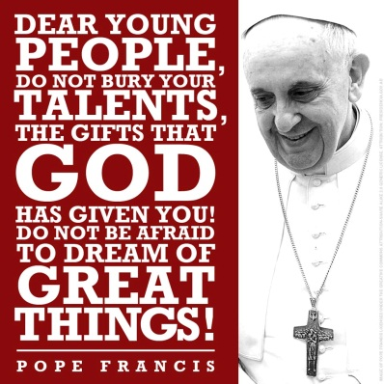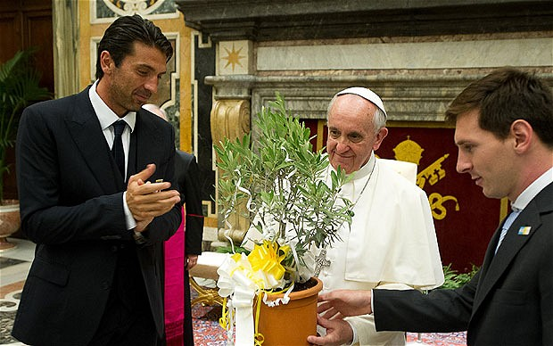
All “TBA’s” will be announced at least one week prior to class

First day of class version!

State of the Planet: Science and Spirit

Course Schedule: Spring 2016

WEEK TOPIC PRESENTERS ACTIVITIES
1/11 – 1/15 Course Introduction, Mechanics & Design Introductions; Course Decisions
Introduction to the Pope and authors Dr. Gail e-reads about the authors

1/20 – 1/22 Laudato Si Introductory discussion Dr. Gail Read ¶1-16
Chpt 1: The Machine Age Read Chpt 1: The Machine Age

1/25 – 1/29 Climate Change as a fix for us all? Dr. Gail Read Chpt 1: This Changes…
TBA Dr. Gail Read/Do:

“What is Happening to Our Common Home?”
2/1 – 2/5 Laudato Si: Pollution & Climate Change ________________ Read ¶17-26
TBA Dr. Gail Read/Do:

2/8 – 2/13 Laudato Si: Water, Loss of Biodiversity ________________ Read ¶27-42
TBA Dr. Gail Read/Do:

2/17 – 2/19 Laudato Si: Human Life & Inequality ________________ Read ¶43-52
Laudato Si: Weak Responses, Many Opinions ________________ Read ¶53-61
“The Gospel of Creation”
2/22 – 2/26 Laudato Si: Light of Faith, Biblical Wisdom ________________ Read ¶62-75
TBA Dr. Gail Read/Do:

2/29 – 3/4 Laudato Si: Mystery, Message in Creatures ________________ Read ¶76-88
Laudato Si: Universal Communion… ________________ Read ¶89-100

“The Human Roots of the Ecological Crisis”
3/7 – 3/11 Laudato Si: Tech, Globalization ________________ Read ¶101-114
Laudato Si: Anthropocentricism ________________ Read ¶115-136

“Integral Ecology”
3/14 – 3/18 Laudato Si: Ecology & the Common Good ________________ Read ¶137-162
TBA Dr. Gail Read/Do:
3/21 – 3/24 SPRING BREAK! (Read on the beach!)

“Lines of Approach and Action”
3/28 – 4/1 Laudato Si: International Dialog, New Policy ________________ Read ¶163-181
Laudato Si: Transparency, Politics and Sci ________________ Read ¶182-201

“Ecological Education and Spirituality”
4/4 – 4/8 Laudato Si: New Lifestyle & Education ________________ Read ¶202-215
TBA Dr. Gail Read/Do:

4/11 – 4/15 Laudato Si: Ecology, Joy, Peace and Love ________________ Read ¶216-232
TBA Dr. Gail Read/Do:

4/18 – 4/22 Laudato Si: Sacramental Signs & Celebration ________________ Read ¶233-246 pau!
TBA Dr. Gail Read/Do:

4/25 – 4/29 Course Wrap up! Dr. Gail; All of Us! Reading/Discussion

Important Dates You Should Know:

Final Exam: Tuesday, May 4th, from 1:15-3:15 PM in our regular classroom.
Final Paper or Holy Experiential Project Report Due by 1:20 on May 4th, 2016.

