 | BU 308 Course Syllabus  3140 Waialae Avenue - Honolulu, HI 96816  www.chaminade.edu

Course Number: BU 308
Course Title: Professional Writing and Presentation
Department Name: Business
College/School/Division Name: School of Business and Communication
Term: Spring 2016
Credits: 3

Instructor Name: Dr. Hans Chun
Email: hans.chun@adjunct.chaminade.edu
Phone:
Office Location: TBA
Office Hours: MWF 2:00 pm – 2:30 pm and by appointment

University Course Catalog Description
Letters, proposals, reports, and presentations are often the vehicles through which professionals get their ideas accepted and their contributions valued. This course teaches students the rhetorical principles and writing and presentation practices required for effective communication in business. The course focuses on format, layout, and design strategies for developing informative documents and presentations that use business data to address specified audiences in a variety of professional situations.

WASC Core Competencies
- Written communication
- Oral communication
- Quantitative reasoning
- Information literacy
- Critical thinking

Marianist Values
- Educate for formation in faith
- Provide an integral quality education
- Educate in family spirit
- Educate for service, justice and peace
- Educate for adaptation and change

Chaminade Levers of Success
- Enhance educational excellence
  - Build academic quality
  - Known for fully prepared, competitive graduates
  - Develop capacity to support excellence
- Partner for the common good
- Expand level of international engagement
- Use tech to achieve pedagogical advantage

Program Learning Outcomes
- Written and oral communication abilities appropriate to business-related tasks;
- The ability to select and use appropriate quantitative tools, including statistics and management science, for decision-making;
- An understanding of tasks associated with career selection, entry, and management;
- An understanding of the functional areas of business, including central theories, modes of analysis, tasks, and strategies;
- The ability to use integrative and reflective thinking to assess and create business strategy appropriate for organizations in specified business environments;
- An understanding of legal obligations of organizations and the ethical dilemmas faced by businesses, along with appropriate frameworks for addressing these dilemmas;
- An understanding of information technology as it influences organizational processes and system tasks. Demonstrate the ability to use information technology to address functional business tasks;
- An understanding of domestic and global economic environments and their influence on firm-level organizational decision-making and operations;
- An understanding of individual and group dynamics in organizations; and
- An understanding of the connections between academic work and real-life situations as a result of the Service-Learning experiences.

Course Learning Outcomes
Written correspondence and presentations are often the vehicles through which professionals get their ideas accepted, their contributions valued, and communicate with internal and external stakeholders. This course reviews the principles of professional writing and presentation required for effective communication in business. After the learning experience, through case-based exercises, critical thinking opportunities, active learning activities, collaborative presentations, project-based scenario, and examination, students should be able to:

- Write effective professional correspondence
- Illustrate cross-cultural communication
- Distinguish effective workplace communication strategies
- Employ an effective job search campaign
- Showcase the ability to conduct presentations
- Recognize effective formal reports and proposals

CLO | Knowledge | Skill | Disposition | Program LO | CUH LS | WASC Core Competency | Marianist Values
1 | D | D | D | 1, 3, 4, 5, 6, 8, 9 | 1a, 1b, 4 | 1, 4, 5 | 2, 5
2 | C | C | C | 1, 3, 4, 5, 6, 8, 9 | 1a, 1b, 4 | 1, 4, 5 | 2, 5
3 | D | D | D | 1, 3, 4, 5, 6, 8, 9 | 1a, 1b, 4 | 4, 5 | 2, 5
4 | D | D | M | 1, 3, 4, 6, 8 | 1a, 1b, 4 | 1, 4, 5 | 2, 5
5 | D | D | D | 1 | 1a, 1b, 4 | 2, 4, 5 | 2, 5
6 | D | D | D | 1, 4, 5, 6 | 1a, 1b, 4 | 1, 4, 5 | 2, 5
(I= Introduced to the concept; D= Developing; C= Competent; M= Mastered)

Learning Materials
- Rentz, K., Flatley, M., & Lentz, P. (2013). Lesikar’s Business Communication: Connecting in a Digital World. 13th ed., New York: McGraw-Hill.
- Other open education resource readings and video links will be provided.

Assessment
Assignments | Max Points | Your Points
Critical thinking opportunities x 4 (5 points each) | 20 | / / /
Case-based exercises x 3 (10 points each) | 30 | / /
Presentation | 5 | /5
Project-based scenario | 12.5 | /12.5
Participation/Active learning activities | 20 | /20
Final Exam | 12.5 | /12.5
Total | 100 | /100
May be subject to change based on the dynamics of current events.

Grading scale
100-90% | A
89-80% | B
79-70% | C
69-60% | D
59-0% | F

Academic Honesty
Violations of the Honor Code are serious. They harm other students, your professor, and the integrity of the University. Alleged violations will be referred to the Office of Judicial Affairs. If found guilty of plagiarism, a student might receive a range of penalties, including failure of an assignment, failure of an assignment and withholding of the final course grade until a paper is turned in on the topic of plagiarism, failure of the course, or suspension from the University.

Violations of Academic Integrity: Violations of the principle include, but are not limited to:
- Cheating: Intentionally using or attempting to use unauthorized materials, information, notes, study aids, or other devices in any academic exercise.
- Fabrication and Falsification: Intentional and unauthorized alteration or invention of any information or citation in an academic exercise. Falsification is a matter of inventing or counterfeiting information for use in any academic exercise.
- Multiple Submissions: The submission of substantial portions of the same academic work for credit (including oral reports) more than once without authorization.
- Plagiarism: Intentionally or knowingly presenting the work of another as one’s own (i.e., without proper acknowledgment of the source).
- Abuse of Academic Materials: Intentionally or knowingly destroying, stealing, or making inaccessible library or other academic resource materials.
- Complicity in Academic Dishonesty: Intentionally or knowingly helping or attempting to help another to commit an act of academic dishonesty.

Plagiarism includes, but is not limited to:
- Copying or borrowing liberally from someone else’s work without his/her knowledge or permission; or with his/her knowledge or permission and turning it in as your own work.
- Copying of someone else’s exam or paper.
- Allowing someone to turn in your work as his or her own.
- Not providing adequate references for cited work.
- Copying and pasting large quotes or passages without properly citing them.

Title IX Compliance
Chaminade University of Honolulu recognizes the inherent dignity of all individuals and promotes respect for all people. Sexual misconduct, physical and/or psychological abuse will NOT be tolerated at CUH. If you have been the victim of sexual misconduct, physical and/or psychological abuse, we encourage you to report this matter promptly. As a faculty member, I am interested in promoting a safe and healthy environment, and should I learn of any sexual misconduct, physical and/or psychological abuse, I must report the matter to the Title IX Coordinator. Should you want to speak to a confidential source you may contact the following:
• Chaminade Counseling Center| 808-735-4845.
• Any priest serving as a sacramental confessor or any ordained religious leader serving in the sacred confidence role.

Disability Access
The University is committed to providing reasonable accommodations for all persons with disabilities. This syllabus is available in alternate formats upon request. Students who need accommodations must be registered with Student Disability Services. Students with special needs who meet criteria for the Americans with Disabilities Act (ADA) provisions must provide written documentation of the need for accommodations from the Counseling Center by the end of week three of the class, in order for the instructor to plan accordingly. Failure to provide written documentation will prevent your instructor from making the necessary accommodates. Please refer any questions to the Dean of Students.

One-on-One Tutoring
Student Support Services and the Academic Achievement Program offer free, one-on-one tutoring for all undergraduate students at Chaminade University. Tutoring services are designed to guide students to the point at which they become independent learners, no longer needing a tutor. Subjects tutored include, but are not limited to: biology, chemistry, math, nursing, English, etc. The tutoring corps consists of trained Peer and Professional Tutors.

Tutoring is available by appointment only. Tutoring takes place in the Student Support Services building during the hours of 9:00 am to 5:00 pm, Monday through Friday. In order to receive tutoring, a student must first complete and submit an intake form. After submitting the intake form, a staff member will assist the students in creating an online account that allows him/her to book an appointment through the online system. All appointments must be made two (2) days prior to the desired appointment. Cancellations must be made 24 hours in advance. For further information, contact Student Support Services at (808) 735-4724.

Schedule
Week | Topic | Review/Do
Jan. 11 – Jan. 17 | Understanding Workplace Communication | *Complete KWL for chapter 1  *http://www.howcast.com/videos/183206-How-to-Practice-Proper-Cellphone-Etiquette/
Jan. 18 – Jan. 24  Jan. 18 – MLK Day, no class | Communicating Across Cultures / Adapting Your Words to Your Readers | *Complete KWL for chapter 2 & 3  *Critical thinking opportunity #1  *https://youtu.be/BrJTf97Ev8o  *https://youtu.be/Knoj3BPiIak  *https://youtu.be/YMyofREc5Jk
Jan. 25 – Jan. 31 | Adapting Your Words to Your Readers | *Critical thinking opportunity #2
Feb. 1 – Feb. 7 | Constructing Clear Sentences and Paragraphs / Writing for a Positive Effect | *Complete KWL for chapters 4 & 5
Feb. 8 – Feb. 14 | Choosing the Best Process and Form / Good News and Neutral Messages | *Complete KWL for chapters 6 & 7  *Case-based exercise #1
Feb. 15 – Feb. 21  Feb. 15 – Presidents’ Day, no class | Good News and Neutral Messages | *Case-based exercise #1
Feb. 22 – Feb. 28 | Maintaining Goodwill in Bad News Messages | *Complete KWL for chapter 8  *Case-based exercise #2
Feb. 29 – March 6 | Maintaining Goodwill in Bad News Messages | *Case-based exercise #2
March 7 – March 13 | Making Your Case with Persuasive Messages and Proposals | *Complete KWL for chapter 9  *Case-based exercise #3
March 14 – March 20  March 21 – March 27  Spring Break | Making Your Case with Persuasive Messages and Proposals | *Critical thinking opportunity #3  *Case-based exercise #3
March 28 – April 3 | Conducting a Winning Job Campaign / Communicating Effectively in Meetings and Conversations | *Complete KWL for chapters 10 & 15  *https://youtu.be/DHDrj0_bMQ0  *https://youtu.be/qSylCmes5dw  *https://youtu.be/guUOmfq303s
April 4 – April 10 | Delivering Oral Reports and Business Speeches / Preparing Informative and Influential Business Reports | *Complete KWL for chapters 11 & 16
April 11 – April 17 | Choosing the Right Type of Report | *Presentation
April 18 – April 24 | Project-based scenario assignment
April 25 – April 29 | Project-based scenario assignment
May 2 | *Final Exam

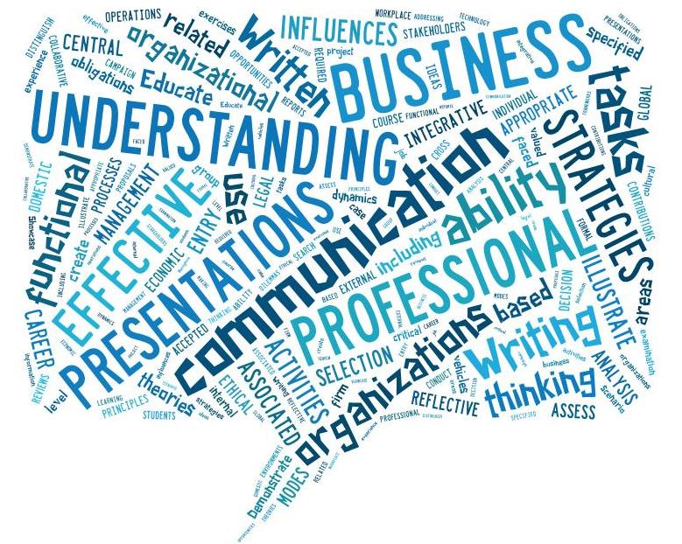

The world of possibilities in business through effective communication.

