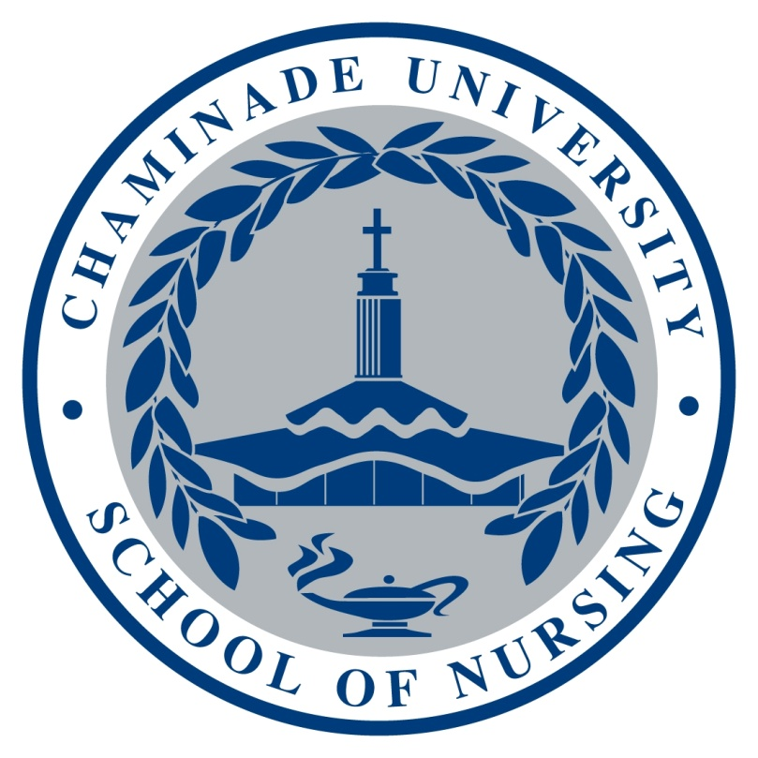

Chaminade University of Honolulu

School of Nursing

Course Syllabus

NUR 301

Infection and Immunity

Course: NUR 301 Infection and Immunity: Global Perspectives
Credits: 2 (Didactic Course)
Class Days and Times: Section 1- Tuesdays 1:30pm-3:20pm
Section 2- Thursdays 1:30pm-3:20pm

Faculty: Eurina Y. Kee, Ph.Dc, RN, MSN, CRRN
Office: Henry Hall RM 118C
Phone: 808-739-7438
Email: eurina.kee@chaminade.edu

Office hours: Mondays 10:30am-12:20pm
Fridays 8-10am
or by appointments

Catalog Description: This course explores the complex challenges that globalization, population increases, transnational commerce, existing and emerging infectious diseases, and re-emerging infectious diseases pose on systems of healthcare delivery globally. Principles of immunology and epidemiology and the determinants of health will be presented. The role of the nurse as well as the role of international organizations in influencing disease control and prevention will be explored. Other topics for discussion include global healthcare policy, global health care issues, lifespan health issues, international research methods, legal issues, and ethics.

Prerequisites: BI 151/151L, BI 152/152L, CH 201/201L, CH 254/254L, NUR 202, NUR 203

Course Learning Outcomes: Upon successful completion of this course, the student will:
- Describe immunological principles and clinical consequences in the context of bacterial, viral, and other infectious diseases;
- Compare and contrast current critical global health issues and strategies for infection control and disease prevention in developed and developing countries;
- Define the role of the nurse in identifying appropriate nursing assessments, interventions, and health education topics related to the diagnosis, treatment, and control of common infectious diseases;
- Identify barriers and solutions to vaccine preventable diseases in both local and global contexts;
- Explain the role of major international organizations in influencing disease prevention and treatment strategies;
- Describe the role of research, ethics, and legal issues in the areas of immunology and epidemiology; and
- Apply principles of epidemiology, biostatistics, and determinants of health in a cultural context across the lifespan.
- Linkages between Program Learning Outcomes (PLOs) and Course Learning Outcomes (CLOs)

Goals:

The goals of the Nursing Program are to:

1. Provide a 4-year program leading to a baccalaureate degree in nursing, in which students will acquire the knowledge, skills, and Marianist values necessary for professional nursing practice and leadership in health care.
2. Ensure an educational foundation in the biological, physical, and social sciences as well as in the humanities, all of which are essential to professional nursing practice.
3. Foster an attitude of intellectual and critical inquiry that promotes evidence-based practice.
4. Provide an educational experience that emphasizes engagement of students through active learning.
5. Create a collegial environment that fosters professional development of students including life-long learning, scholarship, and leadership.
6. Prepare students for professional nursing roles in a dynamic health care environment.
7. Prepare the student for the National Council Licensure Examination (NCLEX) examination and practice as a professional registered nurse.
8. Provide a foundation for graduate study.

Program Learning Outcomes:

The student will demonstrate the ability to:

- Use the nursing process for comprehensive assessments of health and illness parameters in patients using developmentally, and culturally, appropriate approaches;
- Provide safe, holistic, patient-centered care, across the health-illness continuum, across the lifespan, using state-of-the-art methodologies, and in all healthcare settings;
- Engage in dialogue about contemporary issues in healthcare, effectively advocate in the interest of patients, and lead others in the professional nursing role;
- Communicate and collaborate effectively with patients and professionals from a variety of disciplines;
- Critically evaluate and integrate research and reliable clinical evidence to inform nursing practice;
- Incorporate informatics and healthcare technologies into the practice of professional nursing;
- Use determinants of health, tools for measurement, and mechanisms to affect change in populations; and
- Describe the elements of health care policy and finance within a regulatory environment

PLO Program Learning Outcomes | CLO1 | CLO2 | CLO3 | CLO4 | CLO5 | CLO6 | CLO7
PLO#1: Use the nursing process for comprehensive assessments of health and illness parameters in patients using developmentally, and culturally, appropriate approaches. | I |  | I | I |  | I | I
PLO#2: Provide safe, holistic, patient-centered care across the health-illness continuum, across the lifespan, using state-of-the-art methodologies, and in all healthcare settings. | I |  | I | I |  | I | I
PLO#3: Engage in dialogue about contemporary issues in healthcare, effectively advocate in the interest of patients, and lead others in the professional nursing role. |  | I | I | I | I | I
PLO#4: Communicate and collaborate effectively with patients and professionals from a variety of disciplines. |  |  | I | I | I
PLO#5: Integrate research and reliable clinical evidence to inform their nursing practice. | I | I
PLO#6: Incorporate informatics and healthcare technologies into the practice of professional nursing. | I |  |  |  |  | I
PLO#7: Use the determinants of health, tools for measurement, and interventions for health promotion and disease prevention in populations. | I |  | I | I |  | I | I
PLO#8: Describe the elements of health care policy and finance within a regulatory environment. |  | I |  |  | I
(Key: I=Introduced, D= Developed, M=Mastered)
Program Associated Hawaiian Core Values | CLO  1 | CLO  2 | CLO  3 | CLO  4 | CLO  5 | CLO  6 | CLO  7
- Patient Centered-Care,  Ka mālama olakino pili pono i ia kanaka | I | I | I | I |  | I | I
- Community Based Care,  Ka mālama olakino ma o ke kaiāulu | I | I |  | I | I | I | I
- Developmentally and Culturally Appropriate Care,  Ka mālama olakino kūpono no ka ho’omōhala a me ka mo’omeheu | I | I |  | I |  | I
- Care Across the Lifespan  Ka mālama olakino o ka wā ola | I | I |  | I |  | I
(Key: I=Introduced, D= Developed, M=Mastered)

COURSE POLICIES

All policies stated in the Chaminade University and Chaminade University School of Nursing handbooks are in effect in this course.

Academic Honesty:
Nursing students are responsible for promoting academic honesty in all educational settings. Nursing students represent Chaminade University and the School of Nursing and as such are expected to demonstrate professional, ethical behavior in the classroom, in laboratory settings, in the clinical setting, and in the community. The Chaminade student nurse shall be committed to the Marianist values and the core values of the School of Nursing.

Course Atmosphere: This course is not strictly a lecture course. Some of the content will be presented in a lecture format; however, we will be discussing the assigned readings, sharing our reflections on what we’ve read and our own personal experiences, and working in small and large groups. Everyone’s participation is essential as we will learn and grow from the sharing that occurs. It is important that student’s come to class prepared to actively participate.

Attendance: Class is mandatory and students are expected to attend all classes. The classroom is a teaching and learning environment where there is an exchange of knowledge and experience, so it is essential that students attend class and participate in classroom activities to maximize individual learning. Students who are absent from class not only miss a part of the subject matter of the course but also diminish the opportunities for contributing to the learning environment for the entire class. Each student will be encouraged to develop a professional work ethic that reflects personal responsibility, initiative, and teamwork. Students should notify the instructor by phone or email when illness prevents them from attending class and make arrangements to complete missed assignments that are allowed to be made-up. Any student who stops attending class without officially withdrawing may receive a failing grade. Unexcused absences equivalent to more than a week of class may lead to a grade reduction for the course. Any absence of two weeks or more must be reported to the Associate Provost and the Records Office by the instructor.

Academic Conduct: Please refer to and follow all policies and procedures included in the Student Handbook (available in hard copy and online) and carefully read all areas. Please pay attention to the sections that discuss plagiarism, classroom respect, student conduct, freedom of speech, and all academic policies regarding grading.

Assignments: It is expected that assignments will be handed in on time. The point deduction of the grade for any late or improperly submitted assignment will be 10% per day after the deadline. No assignments will be accepted after the 5th day. The instructor reserves the right to not accept any late assignments. Student should comply with all details on required area of assignment for full grade points. No make-up opportunity will be given for missed or late assignment submission.

Writing policy: All papers should demonstrate mastery of grammar, punctuation, spelling and syntax expected of college level students. Use of APA is required for all papers. If you need writing assistance, please seek help from Student Support Services and the Academic Achievement Program at 735-4881. All papers are to be word processed, proofread, and solely the work of the author.

Testing policy: Students are expected to take tests on the designated day. In case of an emergency, please contact the instructor prior to the test so that an alternate plan can be made. Failure to do so will result in a zero. If a test is to be made up, it must be taken before the next class. Approval for taking a make-up test must be granted by the instructor.

Cell phones & Laptops: Use of music devices and cell phone is prohibited during all Nursing classes at Chaminade unless specifically permitted by your instructor. Use of cell phones and music devices in the laboratory, simulation, or clinical settings is a safety and privacy issue. In addition, use of cell phones and music devices in any class is discourteous and may lead to suspicion of academic misconduct. Students who cannot comply with this rule will be asked to leave class and may receive unsatisfactory performance for that day. Please refer any questions to the Dean for Nursing. Laptops maybe used in class for taking notes and for in class activities as directed by the instructor. Any student found using the laptop in class for activities other than related class work (e.g. completing a paper from another course, facebook, etc.) will be prohibited to use the laptop in class.
ADA Accommodations: Students with special needs who meet criteria for the Americans with Disabilities Act (ADA) provisions must provide written documentation of the need for accommodations from the CUH Counseling Center (Dr. June Yasuhara; phone 735 4845) by the end of week three of the class, in order for the instructor to plan accordingly. Failure to provide written documentation will prevent your instructor from making the necessary accommodates. Please refer any questions to the Dean of Students and review the procedures at http://www.chaminade.edu/student_life/sss/counseling_services.php
TEACHING/LEARNING STRATEGIES
Lecture, group discussion, in-class activities, quizzes composed of multiple choice or true-false questions, written assignments, professional presentation.

COURSE GRADING

Your grade in this course will be based on the following:
Quiz (5 x10points) 50 points
Mid Term Exam 60 points
Final Exam 60 points
Newspaper Articles (5 x10points) 50 points
Case Study 10 points
Flip Class Group Presentation 30 points
Team Project – Video clip 20 points
Class Participation Activity (10 x2points) 20 points
300 TOTAL POINTS

GRADING SCALE COURSE POINTS

A=90-100 A=270-300
B=80-89 B=240-269
C=70-79 C=210-239
D=60-69 D=180-209
F= 59 and below F= 179 and below

* Final points based on the scale will not be rounded off

COURSE REQUIREMENTS/METHODS OF EVALUATION

Overall Course Grading
Assignments | Points | Percentage/equivalent
Quiz (5 x10points) | 50 | 20%
Mid Term Exam | 60 | 10%
Final Exam | 60 | 10%
Newspaper Articles (5 x10points) | 50 | 20%
Case Study | 10 | 5%
Flip Class Group Presentation | 30 | 10%
Team Project – Video | 20 | 5%
Class Participation Activity (10 x2points) | 20 | 20%
Total | 300 | 100%

Required Texts:

Holtz, C. (2008). Global health care: Issues and policies.(2nd ed). Sudbury, MA: Jones
and Bartlett Publishers.

Recommended Texts:

American Public Health Association (2008). Control of communicable diseases in
man.(19th ed). Washington, DC: American Public Health Association.

ASSIGNMENTS

QUIZ

There will be 5 paper/pencil quizzes every other week. If you missed it, there is NO MAKE-UP. Further detail information regarding quiz will be TBA.

EXAM
There are cumulative midterm and final exam (paper/pencil). The schedule will be TBA

NEWSPAPER ARTICLE

Select a news media article (i.e. newspaper article only) with topics of infection, immunity, or global health on assigned week. Summarize the article and describe your reflection in a total of 5 pages report (a title cover page, Introduction, summary, and Reflection, References, and a screen shot copy of newspaper article, double space, Times New Roman/font size 12). Points will be deducted for poor quality of report, missing information, and non-compliance of given direction. Further detail information regarding Newspaper article report will be TBA.

CASE STUDY

Interdisciplinary case study will be assigned regarding communicable disease. The goal of this activity is to learn interdisciplinary approach to

FLIP CLASS GROUP PRESENTATION

You will choose your own partner for two parts of group project (PP slides Flip Class lecture and Video clip). Your group will select a topic of interest from a list provided by the instructor and present an in-depth lecture of the topic and show the video message to the class. Please see rubric for grading/evaluation criteria. Criteria for grading/evaluation include appropriate content, thoroughness of presentation, clarity of content, professionalism including dress and manner, creativity, and delivery of presentation.

1. Flip Class Lecture: Your group is required to prepare the flip class lecture as a group presentation with PP slides/Prezi regarding global infectious diseases or communicable diseases. Detail required content will be TBA.
2. Summary of your content: Your group is required to prepare 2-3 minutes audio/video clip and play it at the end of your group presentation.

Sample Topics for Group Project:

Cholera
Dengue Fever
Malaria
Avian Flu
West Nile Virus
Severe Acute Respiratory Syndrome (SARS)
Ebola
Hepatitis A, B, C
STDs
Tuberculosis
HIV/AIDS
MRSA
Salmonella
Scabies
Pertussis
Anthrax
CAM

Course Content:
Part 1. Key principles/concepts in infection and immunity
- Immunological Principles: population-based approach
- Epidemiology
- Determinants of health
Part 2. Global healthcare policies, methods, and delivery
- Global health in developed vs. developing countries
- Global economics and health care
- Politics and Policy
Part 3. Global healthcare issues
- AIDS/HIV
- Infectious Diseases
- Chronic disease
- Complementary and alternative medicine (CAM)
- Others: Violence and injury, mental health, environmental health
Part 4. Global lifespan health issues
- Reproduction and infants
- Global healthcare throughout the life span
- Worldwide health issue
COURSE SCHEDULE

Please come to class having completed the assigned reading(s) and prepared to contribute to the class.
Week  Section1 / Section2 | Topic | Assignment
Week1 | Introduction of the course | Bring textbooks and syllabus to class  Reading: Doc Sharing file, Chapter 1,
Week2 | Infection & Immunity – global perspectives | Reading: Chapter 2, 3  Newspaper Article #1
Week3 | Global health issues | Reading: Chapter 1, 2, 3  Quiz#1  Class Activity #1
Week4 | Global health perspectives  Tobacco | Reading: Chapter 5  Newspaper Article#2  Class activity #2 & #3
Week5 | Global health perspectives  Infectious Diseases | Reading: Chapter 7  Quiz#2
Week6 | Global health perspectives  HIV/AIDS, cancer | Reading: Chapter 8  Newspaper Article#3  Class activity #4
Week7 | Flip class lecture – subject TBA | Reading: Chapter 7,8,9 related to subject  Quiz#3  Class activity #5
Week8 | Flip class lecture – subject TBA | Reading: Chapter 7,8,9 related to subject  Newspaper Article#4  Class activity #6
Week9 | Midterm exam  Guest speaker | Case study
Week10 | Flip class lecture – subject TBA | Reading: Chapter 7,8,9 related to subject  Newspaper Article#5  Class Activity #7
Week11 | Flip class lecture - subject TBA | Reading: Chapter 7,8,9 related to subject  Class Activity #8
Week12 | Global health issues  Nutrition & Environmental health | Reading: Chapter 14, 16  Class Activity #9
Week13 | Infection & Immunity  Worldwide Health view | Reading: Chapter 22, 23  Class Activity #10
Week14 | Thanksgiving holiday | ATI review module
Week15 | Review course content for final exam
Week16 | Final Exam (comprehensive) | TBA

Note: The course schedule may be modified by the instructor at any time and will be announced

