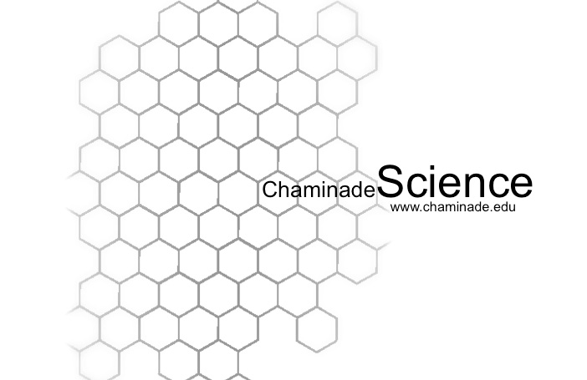
Fall 2015 Syllabus
Course Code:PHY-251-02-1

I. Instructor Information
Name: Eric Dodson, M.S.
Office: 110 Wesselkamper
Phone: 739-8363
email: eric.dodson@chaminade.edu
Office Hours: MWF: 12:30-1:20, TuTh: 3:00-4:00 and by appointment
II. Course Information
Meets: MWF 9:30-10:20 in Wesselkamper 120
and Friday 1:30-2:20 in Henry Hall Room 223

III. Required Text
Randall Knight, Physics for Scientists and Engineers, 3rd
dition, 2012, ISBN 10:0-321-83282-5

IV. Course Title: University Physics I
V. Course Description: A broad calculus-based introduction to mechanics and fluids. (Course Catalog Description)
VI. Learning Outcomes: At the conclusion of the course the student will be able to:
- Demonstrate the ability to think critically by applying the appropriate laws of physics (correctly) to a given physical situation
- Given a problem statement written in English, determine the appropriate equations which describe the physical situation and convert it into a mathematical formulation and
- apply the appropriate mathematical analysis to solve for the prescribed physical quantity

VII.Course Elements
This course is the first part of a year long introductory physics sequence focusing on the application of physical principles, logical reasoning and mathematical analysis needed to understand a broad range of natural phenomena. Topics include classical mechanics, fluids and thermodynamics
The table below shows the proposed schedule of the material to be covered and the associated chapters from the textbook
Week | Topic(s) | Chapter(s)
1 | Units, Coordinate Systems, Position, Velocity, Acceleration, 1-D kinematics | 1,2
2 | Motion with constant acceleration, Graphical analysis of 1-D motion, Vectors | 2,3
3 | 2-D kinematics, Projectile motion | 4
4 | Projectile motion (cont.), Trajectories, Midterm 1 | 4
5 | Newton's Laws, Free-body-diagrams, Weight and mass | 5,6,7
6 | Friction, Circular Motion | 6, 8
7 | Work, Kinetic Energy, Potential Energy | 10,11
8 | More energy, Power, Midterm 2 | 10,11
9 | Center of Mass, Momentum, Collisions, Impulse | 9
10 | Rotational kinematics, Moment of Inertia, Torque, Rotational Dynamics | 12
11 | Statics, Angular Momentum | 12
12 | Simple Harmonic Motion | 14
13 | Fluids | 15
14 | Temperature, Specific Heat, Ideal Gas Law, Phase Changes | 16
15 | Laws of Thermodynamics | 17-19
VIII. Grading Scale

A Excellent >85%
B Good >75%
C Average >60%
D Below Average >50%
F Failure <50%

IX. Assignments and Grading
The course grade will be based on the following:
- Quizzes 20%
- Class Notebooks 10%
- Midterms(3) 45%
- Final Exam 25%

Homework : Homework will be assigned each week. At the beginning of fourth hour a 10 to 15 minute quiz will be given based on the assigned problems. The idea is that if you understand the homework problems you will do well on the quiz. Your homework will be collected on occasion. I encourage you to work together on homework, but you must turn in your own work. Remember the main purpose of the homework is to help you understand the material and prepare for the midterms.

Quizzes: A two to five minute quiz will be given (promptly) at the beginning of each class. This is an attempt to help keep you from falling behind and to encourage you to show up on time each day. Attendance is very important in physics and it is very important not to fall behind as the material constantly builds on itself.

Class Notebooks:
Essentially all exam material will come from concepts and examples that have been presented in class on the board. It is essential that you take good notes during class. To encourage this practice I will collect your class notebooks and evaluate them once every two weeks. The notebook will be graded based on completeness and effort. Each page of the notebook should could be numbered and dated at the top.

Midterms: Three midterms will be given. Our midterms will consist of twenty multiple choice problems worth three points apiece and two twenty point problems that will be graded for partial credit. The midterms will be closed book, closed notes. A formula sheet will be provided. The midterms will be held during fourth hour.

Midterm I Friday, September 18
Midterm II Friday, October 16
Midterm III Friday, November 13

Final Exam: The final exam will be comprehensive

Time: Monday, December 7 from 11:00-1:00
Location: Wesselkamper 120

X. Additional Departmental and University Polices

1. Electronic Devices
Use of music devices and cell phones is prohibited during all Natural Science and Mathematics classes at Chaminade, unless specifically permitted by your instructor. Use of cellphones and music devices in laboratories is a safety issue. In addition, use of cellphones and music devices in any class is discourteous and may lead to suspicion of academic misconduct. Students who cannot comply with this rule will be asked to leave class and may be subject to laboratory safety violation fines. You will be asked to leave class and marked absent if you do not comply. This will negatively affect your grade. Please refer any questions to the Dean of Natural Sciences and Mathematics.

2. ADAA Statement
2.1 Pursuant to several federal and state laws, including the Americans with Disabilities Act of 1990, as amended by the ADA Amendments Act of 2008, and Section 504 of the Rehabilitation Act of 1973, all qualified students with disabilities are protected from discrimination on basis of disability and are eligible for reasonable accommodations or modifications in the academic environment to enable them to enjoy equal access to academic programs, services, or activities. If a student would like to determine if they meet the criteria for accommodations, they should contact the Counseling Center at 808-735-4845 for further information.

3. Attendance & Tardiness
3.1 Students are expected to attend regularly all courses for which they are registered. Students should notify their instructors when illness or other extenuating circumstances prevents them from attending class and make arrangements to complete missed assignments. Notification may be done by emailing the instructor’s Chaminade email address, calling the instructor’s campus extension or by leaving a message with the instructor’s division office (Natural Science and Math 1 (808) 440-4204). It is the instructor’s prerogative to modify deadlines of course requirements accordingly. Any student who stops attending a course without officially withdrawing may receive a failing grade.

3.2 Unexcused absences equivalent to more than a week of classes may lead to a grade reduction for the course. Any unexcused absence of two consecutive weeks or more may result in being withdrawn from the course by the instructor, although the instructor is not required to withdraw students in that scenario. Repeated absences put students at risk of failing grades.

3.3. Tardiness: Quizzes will begin promptly at the beginning of class. Show up on time and you will get the full amount of time to complete your quiz

4. Policy on Make-Up Tests
Make-ups will only be allowed with a valid excuse.

5. Policy on Communication
5.1 The University provides a Chaminade email address for all students. Official Chaminade communications will be sent to the students’ Chaminade email address and instructors will use only this email to communicate with students. It is the responsibility of the student to check their email frequently. Report email-related problems to the Helpdesk at 808-735-4855 or helpdesk@chaminade.edu.

6. Laboratory Safety Information
The following guidelines are established to provide instructions in maintaining safety for students, staff, and faculty while using any of the science laboratories at Chaminade University. The Division of Natural Sciences and Mathematics (NSM), along with the University Environmental Safety Office are responsible for enforcing the regulations set forth in the current Student Handbook. Queries should be addressed to: Dean of Natural Sciences and Mathematics (808) 440-4204; Environmental Safety Officer (808) 739-4811

7. Title IX Declaration
Chaminade University of Honolulu recognizes the inherent dignity of all individuals and promotes respect for all people. Sexual misconduct, physical and/or psychological abuse will NOT be tolerated at CUH. If you have been the victim of sexual misconduct, physical and/or psychological abuse, we encourage you to report this matter promptly. As a faculty member, I am interested in promoting a safe and healthy environment, and should I learn of any sexual misconduct, physical and/or psychological abuse, I must report the matter to the Title IX Coordinator. Should you want to speak to a confidential source you may contact the following:
• Chaminade Counseling Center| 808 735-4845.
• Any priest serving as a sacramental confessor or any ordained religious leader serving in the sacred confidence role.

8. Academic Honesty
Students are expected to have read and to abide by the “Student Rules of Conduct” which are available in your copy of Chaminade University’s Student Handbook. Cheating in the form of plagiarism, collusion, deception and will not be tolerated and will negatively affect your grade.

