EID 217 Introduction to CAD
Monday and Wednesday evenings
Laurent Chouari

Course Description
Students will learn how to create architectural construction documents using AutoCAD 2015

Course Objectives
At the end of the course, students will be able to:
- Demonstrate proficiency in the use of AutoCAD 2015 as a means to produce 2-dimensional architectural construction documentation
- Demonstrate proficiency in appropriately organizing information within the context of a construction set, as well as on individual construction sheets
- Demonstrate an understanding of how to provide accurate takeoffs to assist in determining budgetary material costs for specified finishes, fixtures and equipment
- Demonstrate an understanding of how to navigate building codes.
Students will learn by doing. Upon completion, they will be able to confidently create construction documents for a small renovation project. Construction documents include: title sheet, floor plan, elevations, electrical, lighting, countertop, soffit, flooring and detail plans, door, window, and finish schedules. During this course, students will learn a little about file organization, construction, budgeting and cabinetry. Only AutoCAD’s 2D tools will be covered. Toward the end of the semester, SketchUp will be introduced.

Course Outline
These are the assignments:
- create a personal logo and put this into AutoCAD.
- a small bath renovation drawing set.
- master suite of your own design.
- custom bed.
- design of a hotel suite.
- The final project will be to create and present the hotel suite in SketchUp

Class Structure
Each class will begin with a review of what was addressed in the last class (approximately 10 minutes). There will be a chance for questions and then I will introduce the next topic (approximately 25 minutes). Students will then work on their projects; I will work with each student individually during this remaining time.

Grading
Grading is based on attendance, class participation and preparation (30%), tests (35%), and projects (35%).

Required Text
AutoCAD 2015 for Interior Design and Space Planning

Tools to bring to each class
Notebook, something to write with

Week 1
24 & 26 August

- Introduction to commands:

L line
PL polyline
PE polyline edit
O offset
CO copy
M move
M ; P move, previous
Z ; E zoom extents
C circle
TR trim
EX extend
F fillet
F ; R fillet ; radius
REC rectangle
RO rotate
MI mirror
MT multi-line text
S stretch
U undo
DI distance
ED edit dimension
PS paperspace
SC scale
A arc
E erase
MA match attributes
X explode

DIVIDE
ARRAY
BLOCK
WBLOCK save a block to another location
LTSCALE in model space, set LTSCALE to 22; in paperspace set LTSCALE to 1
ATTDEF make an editable text block
L@_<_ draw a line a length of _ at an angle of _

Ctrl+C copy
Ctrl+V paste
Ctrl+Tab switch between open AutoCAD files

UNITS

F1 help
F2 history
F3 object snap
F7 display grid
F8 ortho mode
F9 snap mode

- Start drawing logo

Week 2
31 August & 2 September
Review commands
- Start Project 1
Save file as EID217_yourlastname_project2
Create: floor plan, two elevations, soffit plan, flooring plan, countertop plan, lighting plan.

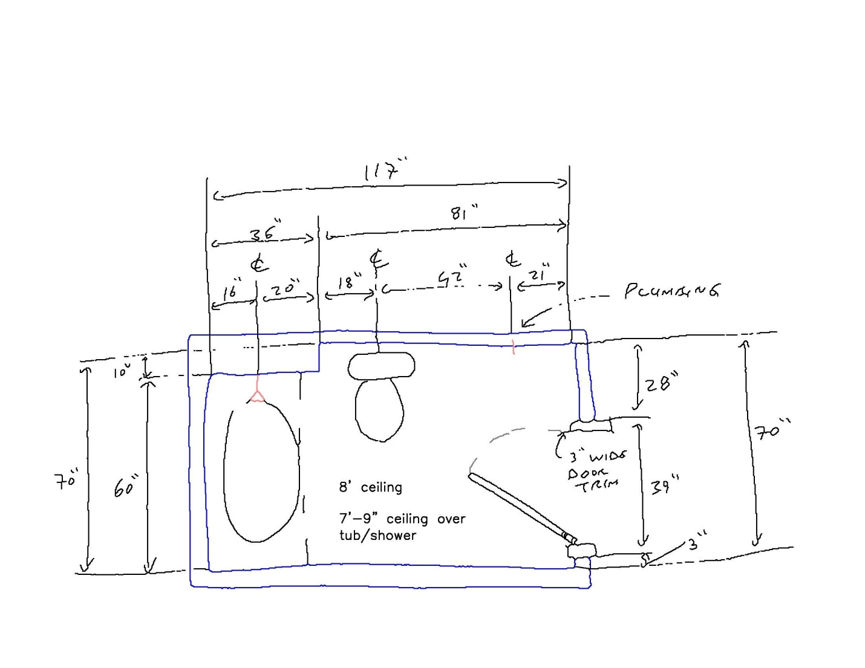

Review video: http://www.youtube.com/watch?v=sV2aCpR53ko
(How to install a flat jamb interior door - The Home Depot)

- Students to get ready to present to classmates the following commands next week.
Suggest using the F1 key (help), google, and YouTube.

Rhea Gayle
polyline; polyline edit

Zhu
Copy; move; move previous

Musuai
Multi-line text; text with a leader

Linda
Stretch; undo; distance

Jenelyn
Hatching, modify hatch

Nicolle
Rotate; divide

bonus
Fillet; fillet with a radius; extend

bonus
Array; arc

Week 3
(No class on Monday, 7 September.) 9 September
- Students to present the commands listed above to the rest of the class
- Continue with Project 1

Week 4
14 & 16 September
- finish Project 1

Week 5
21 September (possibly no class on 23 September)
- test # 1

Week 6
28 & 30 September
- Start project 2

Week 7
5 & 7 October
- Continue project 2

Week 8
(no class on Monday, 12 October) 14 October
- Finish project 2

Week 9
19 & 21 October
- Project 3 – custom bed

Week 10
26 & 28 October
- test 2
- Start project 4

Week 11
2 & 4 November
- Continue project 4

Week 12
9 November (no class on Wednesday, 11 November)
- Continue project 4

Week 13
16 & 18 November
- Continue project 4

Week 14
23 & 25 November
- Finish project 4

Week 15
30 November and 2 December
Last week of class
- SketchUp

