- Course and Contact Information
- Term: Spring (Graduate) 2015
- Delivery: 100 % Online
- Course: EDUC 749 Research in Educational Administration (3 Credits)
- Instructor: Joe Peters
- Required Texts
Machi, L., & McEvoy, B. (2012). The literature review: Six steps to success. (2nd ed.). Thousand Oaks: Corwin.
Briggs, A., Coleman, M., & Morrison, M. (2012). Research methods in educational leadership and management. (3rd ed.). London: Sage Publications Ltd.
- Recommended Text (Also used in other courses)
American Psychological Association. (2010). Publication manual of the American Psychological Association. (6th ed.). Washington, DC: Author.
- Web Resources (Initial List)
  - eCollege: http://chaminade.ecollege.com/
  - LiveText: https://college.livetext.com
  - APA Resource: http://owl.english.purdue.edu/owl/resource/560/01/
  - APA Code of Ethics: http://www.apa.org/ethics/code/index.aspx
  - VassarStats: http://vassarstats.net/
  - Google Docs and Tools: https://docs.google.com/ & http://www.google.com/intl/en/about/products/index.html
  - Human Subjects (IRB): http://phrp.nihtraining.com/users/login.php?l=3
  - FERPA: http://ptac.ed.gov
  - Hawaii Public Schools Research: http://apps.hidoe.k12.hi.us/research/Pages/Home.aspx
  - Framework for 21st Century Learning: http://www.p21.org/
  - Common Core Standards: http://www.corestandards.org/
  - Statistics Tutorials: http://stattrek.com/
  - National Center for Education Statistics: http://nces.ed.gov/
  - U.S. DOE Research and Statistics: http://www2.ed.gov/rschstat/landing.jhtml
  - Khan Academy Statistics: http://www.khanacademy.org/#statistics

- Catalog Course Description
- This course introduces participants to the purposes, methods and practices of educational research applied to contemporary issues in educational leadership and administration. The course begins with an introduction to the fundamentals of educational research, covering different purposes and types of research, varieties of research strategies including mixed methods, authenticity and ethics in research, and tools used in carrying out research. Participants will critically review a series of research articles throughout the course, while referencing the research methods used in those reports.
(http://www.chaminade.edu/education/documents/MED-Catalog.pdf)

- Guiding Philosophy
- The Education Division’s guiding philosophy is based upon a set of beliefs that flow from Chaminade University’s vision and mission statements, the Education Division’s mission statement, the Marianist Core Academic Beliefs, and the Hawai'ian 'Ōlelo of Mana (intrapersonal; spirit; embodiment of love, faith, and ethical practice), Aloha (interpersonal; love; sacredness; divine breath), 'Ohana (classroom; family; interconnectedness), Pono (community; being in alignment and balance in life and the community), and Ho'oma'ama'a (world; become adapted to; teach one to work). These values and beliefs are based on the Catholic Marianist principles; a commitment to mentor instructional and educational leaders to their fullest potential; a commitment to teaching excellence, engagement in scholarship in the pursuit of truth; and a commitment to scholarly service for the university and the larger community. This alignment is designed to prepare education professionals for effective classroom and school leadership by demonstrating professional dispositions, content knowledge, pedagogical skills, and leadership to work effectively with a diverse community of learners.

- Education Division Mission Statement
- The Education Division’s mission is to foster the development of knowledgeable, proficient, and reflective teachers and educational leaders. Our programs are based in the liberal arts tradition, Catholic Marianist values, current research, best practice, and professional standards. In this context we develop educators who demonstrate ethical, effective and culturally responsive practices, and a commitment to building a just and peaceful society.

- Marianist Values
- Education for Formation in Faith (Mana): Within the community of learners, reason and personal faith are seen as mutually complementary roads to truth. All Education Division members join the larger community of faith, hope, love and ethical practice.
- Integral, Quality Education (Aloha): The community is committed to an integral, quality education that begins with respect for the complexity and diversity of each person. All Education Division members attempt to engage the whole person with quality courses and activities that challenge the intellectual, emotional, aesthetic, physical, and ethical dimensions that make up each student's life experience.
- Education and the Family Spirit (Ohana): The community of learners is a second family which encourages the personal development of each of its members. Mutual respect for all members of the Education Division family allows the community to share responsibility for decision making at all levels.
- Education for Service, Peace and Justice (Pono): All members of the community strive to serve the university community and the larger community. Education Division community members are committed to scholarly service and to dispense and receive justice to and from each other and to the larger community.
- Education for Adaptation and Change (Ho‘oma‘ama‘a): True to the tradition of faith, a Marianist-founded education prepares students for tomorrow and adapts to its time. The Education Division scholarly community of learners regards technology as a critical aid in the quest for understanding in a changing world.
- MEd. Program Learning Outcomes
- The program learning outcomes for the Master of Education (Educational Leadership) are derived from two national standards and recommendations including (1) the Educational Leadership Constituent Council (ELCC, 2002), the Specialty Professional Association (SPA) that evaluates advanced programs in educational leadership for recognition by the National Council for Accreditation of Teacher Education (NCATE) and (2) the Educational Leadership Policy Standards: Interstate School Leaders Licensure Consortium (ISLLC) 2008 that are required by the Hawai`i Department of Education.
  - PLO 1: Demonstrate knowledge of impact of socio-economic, legal and cultural factors on schools, teachers, and students.
  - PLO 2: Demonstrate knowledge of organizational life in schools, organizational change processes and their connections to the development of positive school cultures that promote learning and social development of students.
  - PLO 3: Conduct systematic inquiries into programs and policies that are relevant, integral, and essential to the success of children, schools, and school leaders.
  - PLO 4: Develop skills in facilitating collaboration and communication among schools, school communities, families, other educational and service agencies, and professional organizations.
  - PLO 5: Develop knowledge and skills in managing personnel.
  - PLO 6: Demonstrate understanding of the ethical, moral, and caring dimensions of educational leadership.
  - PLO 7: Use informed scholarship to analyze and offer solutions for school policies and problems.
  - PLO 8: Articulate a vision for the school, district, or organizational context in which the participant works that reflects PLO #1-7 dimensions.

- Course Learning Outcomes (CLOs)
- At the end of this course the educational leadership candidates will be able to:
  - CLO 1: Assess the quality and relevancy of educational research.
  - CLO 2: Identify appropriate methodologies used in educational research.
  - CLO 3: Cite connections between the real-world challenges educational leaders face and how formal research knowledge can inform, guide, or otherwise effect practitioner behavior.
  - CLO 4: Create a literature review that summarizes a given topic in educational research.
  - CLO 5: Use a literature review to develop a research plan to enhance the current body of knowledge on a topic.

- PLO/CLO/Assignment/Assessment/Grade Alignment
 | PLO 1 | PLO 2 | PLO 3 | PLO 4 | PLO 5 | PLO 6 | PLO 7 | PLO 8 | Assignment | Assessment Method | Points Toward Grade
CLO 1  Assess the quality and relevancy of educational research |  | D |  |  |  |  |  |  | Introduction Proposal | Instructor Evaluated Using Assignment Rubric | 100
CLO 2  Identify appropriate methodologies used in educational research |  |  |  |  |  |  | I |  | Weekly Quizzes | Quiz Grades | 100 (10 points per week)
CLO 3  Cite connections between the real-world challenges educational leaders face and how formal research knowledge can inform, guide, or otherwise effect practitioner behavior | I |  |  |  |  |  |  |  | Readings and Participation in Class Online Discussions | Discussions Rubric | 100 (10 points per week)
CLO 4  Create a literature review that summarizes a given topic in educational research |  |  |  |  |  |  | I |  | Literature Review  Proposal | Instructor Evaluated Using Assignment Rubric | 100
CLO 5  Use a literature review to develop a research plan to enhance the current body of knowledge on a topic |  |  | I |  |  |  | I | I | Methodology Proposal | Instructor Evaluated Using Assignment Rubric | 100
* Introduced, Developing, and Mastered Total Points: |  |  |  |  |  |  |  |  |  |  | 500

- Big Ideas and Essential Questions
- Big Ideas (see: http://www.authenticeducation.org/ae_bigideas/
article.lasso?artid=99)
  - Research is the systematic inquiry that is used to produce and analyze data and inform decisions.
  - Descriptive statistics are the quantitative descriptions of the measures of central tendency of a data collection.
  - Inferential statistics refers to the use of statistical procedures to support or refute a hypothesis.
  - Qualitative research relies on non-statistical methods to collect and analyze data.
  - Educational research is designed, conducted, and reported in a logical sequence.
  - American Psychological Association (APA) style is commonly used in reporting educational research.
- Essential Questions (See: http://www.authenticeducation.org/ae_bigideas/
article.lasso?artid=53)
  - How is educational research designed?
  - How do researchers use education research literature to inform them, make decisions, and design their own studies?
  - What are the ways to collect quantitative, qualitative, and mixed-methods data?
  - How is research data analyzed in quantitative, qualitative, and mixed-methods studies?
  - How do we protect the research subjects when conducting research?
  - What are the key elements of APA style?

- Course Requirements
 | Assignment | Points | Description | Due Date | Submission
 | Reading and Participation in Class Discussions | 100 (10 points per week) | There will be text readings each week. Discussions will be in eCollege and will be based on text readings and other course topics and student research needs.  (See Rubric for Online Discussions below) | Week 1 through  Week 10 | Discussions questions are in eCollege. Initial posts are due by 11:55 p.m. on Wednesday and the responses to the initial posts are due in eCollege by 11:55 p.m. on Sunday
 | Weekly Quizzes | 100 (10 points per week) | There will be weekly quizzes on the readings. These will cover the weekly content. | Week 1 through  Week 10 | Quizzes are in eCollege and submitted to eCollege by 11:55 p.m. on Sunday
 | Introduction Proposal | 100 | This is an introductory chapter for a research study. | Week 6 | These will be posted in the eCollege document sharing – share with all classmates.
 | Literature Review  Proposal | 100 | This is a literature review chapter for a research study. | Week 8 | These will be posted in the eCollege document sharing – share with all classmates.
 | Methodology Proposal | 100 | This is a methodology chapter for a research study. | Week 10 | These will be posted in the eCollege document sharing – share with all classmates.
* The combined overview chapter, literature review chapter, and methodology chapter have to be turned into LiveText to receive a course grade.
- Topic List
- Analyze the elements of effective graphs and charts used to present data
- Analyze the purpose and use of descriptive statistics
- Analyze uses for z-scores when conducting research
- Analyze uses for t-scores when conducting research
- Create documents using American Psychological Association (APA) style
- Describe a normal, bimodal and skewed distribution
- Describe confidence intervals
- Describe guidelines for conducting research using human subjects
- Describe the appropriate use of an ANOVA and ANCOVA (MANCOVA)
- Describe the difference between one- and two-tailed tests
- Describe the importance of validity and reliability
- Describe the legal and ethical issues associated with educational research
- Describe the purpose of educational research
- Describe the relationship between hypothesis testing and p-values
- Describe the standard error of the mean
- Describe the steps involved in conducting a literature review
- Describe the use of mixed-methods research
- Describe the various methods for collecting different types of data
- Describe the constant comparative method used in the development of a theory
- Describe the use and purpose for the standard deviation in data analysis
- Determine appropriate statistical procedures based on the research purposes
- Determine the appropriate use of correlation statistics in educational research
- Differentiate between the methodologies associated with qualitative research.
- Differentiate between a sample and population mean
- Differentiate between a sample and population variance
- Differentiate between primary and secondary literature sources
- Differentiate between type 1 and type 2 errors
- Differentiate between z-statistics and t- statistics
- Differentiate qualitative from quantitative research
- Differentiate situations when descriptive or inferential statistics should be used
- Differentiate the appropriate uses for measures of central tendency
- Discuss the purpose of tests of statistical significance in educational research
- Distinguish the elements of an action research proposal
- Evaluate scholarly literature to document research problems
- Evaluate sources for research literature and ideas
- Examine appropriate methods for conducting educational research
- Examine the elements of the APA written code of ethics
- Examine the ethical issues that can arise when publishing reports of a research study
- Examine how qualitative data is coded and organized
- Examine the purpose of standard deviation in data analysis
- Examine the use of correlation statistics in educational research
- Examine uses for frequency distributions in data collection and analysis
- Explain how elements of research can affect validity and reliability
- Explain how research impacts decision-making and educational practice
- Identify appropriate uses for measures of central tendency
- Identify the elements of an effective literature review
- Illustrate the importance of sampling methods
- Present a rationale for using null and alternate hypotheses
- Produce a comprehensive overview, literature review and methodological design to support a problem statement.

- Three Written Chapter Assignments (Introduction, Literature Review, Methodology)
- These are major assignments for this course.
- There is not a minimum or maximum page number.
- Assignment: Writing the first three sections (Introduction, Literature Review, Methodology) of an action research study to be conducted by the student on a topic of his or her choice in the field of education.
- The final paper (with all three chapters) will be submitted to LiveText and should include the following:
  - Title page
    - This is numbered as page 1 and includes the title, your name, and the institution (not my name, the date, or other things).
    - Include the running head on this page with the words “Running head:”
    - See http://owl.english.purdue.edu/owl/resource/560/01/ and http://owl.english.purdue.edu/owl/resource/560/18/ for a title page example.
    - Double space this page and the rest of the document, including the references.
    - Do not add extra space between paragraphs or sections in the document. See the paragraph tab in Microsoft Word. Spacing between paragraphs should be set to “0.”

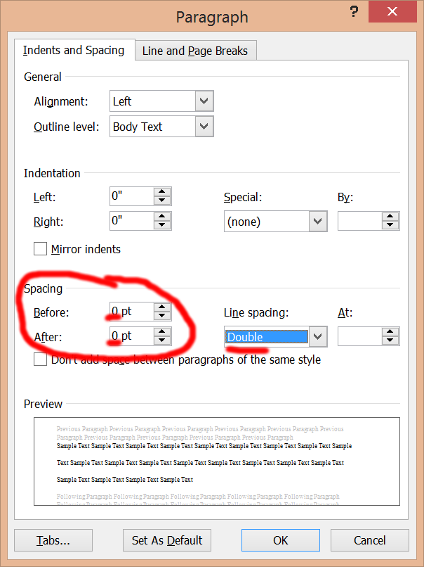

  - Table of Contents
    - This is page 2 and should include a centered, not-bolded, title-case heading for “Table of Contents.”
    - Note that the running head changes here and the “Running head:” part is dropped. To do this in word, select “Different first page” in the header design tab (this is also possible in Pages for the Mac).

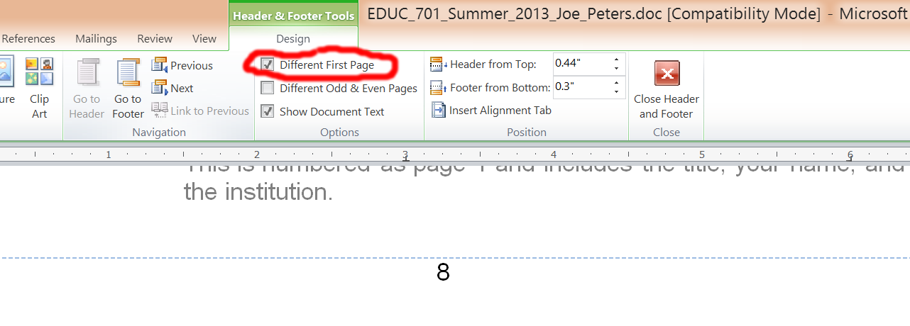
    - Microsoft Word can help create the Table of Contents for you but it may be difficult to have it look correct if you are not familiar with Word (see the References tab in Word).

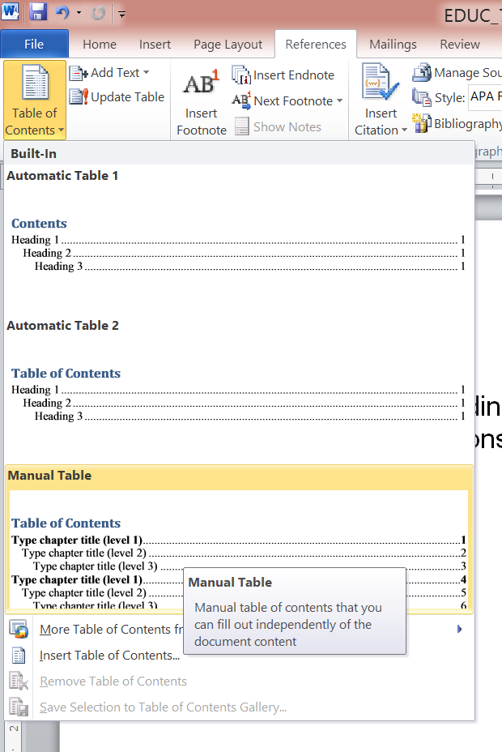

  - Abstract
    - The abstract starts at the top of page 3 and is a brief summary of the contents of the entire paper (generally 150-250 words).
    - Include Key Words as described in the APA book and OWL (https://owl.english.purdue.edu/owl/resource/560/01/)
    - See pages 25-27 in the APA book and the http://owl.english.purdue.edu/owl/resource/560/01/ and http://owl.english.purdue.edu/owl/resource/560/18/ links.

  - Introduction (The first chapter assignment)
    - This is one of five major parts of the paper (along with the Literature Review, Methodology, Results, and Discussion).
    - This section begins on page 4.
    - The body of the paper should begin with a repeat of the title, centered, title case, and not bolded. Note that the heading “Introduction” is not used. See the example at the http://owl.english.purdue.edu/owl/resource/560/18/ link.
    - Begin by introducing the section and what the reader will read about in the introduction (overview of the introduction).
    - Your introduction should minimally have level 2 subheadings of the:
      - Statement of the Problem (Describe why you are doing this action research? Why is this problem important for you? What have you observed in your classroom or school that you would like to explore, problem solve, or make an informed decision on as a result of your research)
      - Background (A very brief description of the historical aspects such as what published research has already been completed related to the study. This should be grounded in the available published research such as books and journal articles. Include citations to support your views.) Be clear and concise (see: http://owl.english.purdue.edu/owl/
resource/560/15/).
        - Cite your sources. See: http://owl.english.purdue.edu/owl/resource/560/02/, http://owl.english.purdue.edu/owl/resource/560/03/, and your APA book.
      - DO NOT MAKE CLAIMS THAT ARE NOT CITED. For example avoid things like “I felt that there were too many approaches to classroom management.” It should be something like “Brophy (2011) discusses how the “proliferation of techniques continues,” indicating the many approaches to classroom management (p. 27).

Your reference for this would look like the following (Note the use of a hanging indent as opposed to a return and tab):

Brophy, J. (2011). History of research on classroom management. In C. M. Evertson & C. S. Weinstein (Eds.), Handbook of classroom management: Research, practice, and contemporary issues (pp. 17-46). New York: Taylor & Francis.
      - Research Question: End this section with a clear statement of your research question and your hypothesis. Your research question is limited by the data you will collect so limit the scope of your research question. Do not try to change the world with one small study. Remember your data will need to clearly support or refute your research question. You cannot do a small classroom management study on the use of “Chaminadebucks” (classroom currency for promoting positive behavior) and make claims that any classroom could benefit from this approach or that it would improve achievement of all ELL students.
    - Note that level two headings are “Left-aligned, Boldface, Uppercase and Lowercase Heading” (see: http://owl.english.purdue.edu/owl/resource/560/16/).
    - End this section with a transition sentence to the literature review.
    - Make sure you do not have any widows or orphans (http://en.wikipedia.org/wiki/Widows_and_orphans). Word can control this for you but may miss a heading.
    - Include references in APA format at the end of the chapter.

  - Literature Review (The second chapter assignment)
    - Use a level one heading titled “Literature Review” which is “Centered, Boldface, Uppercase and Lowercase.” Please see the http://owl.english.purdue.edu/owl/resource/560/16/ page.
    - Note that sample research papers in APA often include the literature review as part of the introduction. Thesis, action research, and dissertations separate the introduction and review of literature.
    - This section is a synthesis of all of the relevant scholarship and makes the case for your research question(s).
    - Begin with a transition from the introduction and provide an overview of the literature review section.
    - Include subsections for major strands (level 2 headings). As an example, if you were doing something on classroom management, you would have subsections such as “Behavioral Approaches to Classroom Management,” “Ecological Studies of Classroom Management,” The Teacher as a Classroom Leader,” “Student Socialization and Disciplinary Intervention” and “Other Related Management Studies.”
    - Do not include unnecessary details about the studies you cite here. Describe the findings and how your study will be similar and/or different. If there are multiple studies with similar findings, describe them together as a synthesis of the works.
    - Include a subsection (level 2) of the “Definition of Terms.”
      - These are terms you use in the paper that may be unfamiliar to the reader.
      - Each term is a new paragraph and you need to cite a source for each term.
    - End this section by restating your research question(s) and how the literature supports these questions. Finish with a transition sentence to the methodology.
    - Include cumulative references (chapters 1 & 2) in APA format at the end of the chapter.

  - Methodology (The third chapter assignment)
    - Begin this section with a level 1 heading of “Methodology.”
    - Before going to the subheadings, provide an overview of the section and transition from the literature review.
    - Minimally include subsections for:
      - Subjects (Describe the subjects and the school setting without using specific names. Include demographic statistics such as age, gender, etc. Include the sampling procedure for how subjects are to be selected. If it is a sample of convenience, note why you cannot randomize the selection. See APA page 30.)
      - Measures (Describe your variables here and how the information on the variables will be collected. If you have a survey, include it as an appendix and refer to the appendix in this section. See APA page 31.)
      - Design (Describe how you will analyze your collected data. Include citations that support your methods. For example, of you use VaserStats [http://www.vassarstats.net/ & http://vassarstats.net/textbook/], cite that website. If you use Slavin’s text for developing your method, cite it here.)
      - Procedures (What will you actually do to collect and analyze the data. This should be brief but specific enough that others can complete a similar study.)
      - Human Subjects Protection (This refers to IRB and FERPA. Include a brief description of how you will protect the student’s. Include your IRB letter that you will use as an appendix and refer to it here.)
      - End this section with a transition sentence to the results section.
      - Include cumulative references (chapters 1, 2 & 3) in APA format at the end of the chapter (see references below).

  - Results [You will not be required to complete this section]
    - Use a level 1 heading of “Results.”
    - Before going to a subheading, begin with a transition from the methodology and overview of the results section.
    - This section describes what you found (i.e. the analyzed data) – without any interpretation. For this course, briefly describe anticipated results since you will not have actually completed the study. This will help you think about the subjects, data collection, data analysis, etc.
    - For this section and others, make sure tables and figures are in APA style. See the http://owl.english.purdue.edu/owl/resource/560/19/ and http://owl.english.purdue.edu/owl/resource/560/20/ links.
    - End this section with a transition to the discussion section.

  - Discussion [You will not be required to complete this section]
    - Use a level 1 heading.
    - This section is where you evaluate and interpret your results presented in the previous section. (See: APA book pages 35-36 and the http://owl.english.purdue.edu/owl/resource/560/18/ link.)
    - Transition from the results section, overview this section and then begin the subheadings with the support or non-support of your hypothesis.
    - Provide an anticipated interpretation for the results from the previous section.
    - Minimally include the following subheads:
      - Limitations (Briefly describe the limitations of the study. This refers to how generalizable the study is to others. Examples of limitations are a small sample size, inability to randomize, the length of time that the effect was studied, or similar things that prevent it from being a truly scientific study.)
      - Implications for Further Study (Based on this research, what future research might be suggested. For example if it is a classroom study one implication would be to try it schoolwide or with a similar set of students in another school.)
      - Conclusions (End this section with your anticipated general conclusions of your study.)
    - Again, these sections will not be complete since your study is not finished.

  - References (include this section in the document sent to LiveText)
    - This section starts on a new page with the centered, title-case, not-bolded word “References.”
    - There is a 1:1 correlation between citations and references. Check names and dates against citations. Do not include citations that are not referenced or references that do not appear cited in the previous sections.
    - References are double-spaced.
    - Use your APA book and OWL to format references.
      - http://owl.english.purdue.edu/owl/resource/560/05/
      - http://owl.english.purdue.edu/owl/resource/560/06/
      - http://owl.english.purdue.edu/owl/resource/560/07/
      - http://owl.english.purdue.edu/owl/resource/560/08/
      - http://owl.english.purdue.edu/owl/resource/560/09/
      - http://owl.english.purdue.edu/owl/resource/560/10/
      - http://owl.english.purdue.edu/owl/resource/560/11/

  - Appendices [You will not be required to complete this section]
    - These are centered, not-bolded, title-case with the word “Appendix” followed by the letter identifying the appendix such as “Appendix A.” Under the Appendix heading (double spaced) put the title of the appendix.
Appendix A

Human Subjects Permission Letter and Form

    - Start each appendix on a new page. See: http://owl.english.purdue.edu/owl/resource/560/18/ as an example.
- Note: This is a pilot to the full study completed in subsequent courses.

- Chapter Grading Rubric
Criterion | Performance Rating |  |  |  | Score
 | Exceeds  Expectations | Meets  Expectations | Approaching Expectations | Does Not  Meet Expectations
Title page, table of contents, abstract, and introduction.  Statement of the problem, background, the need for the research, the research questions, and hypothesis. | Title page (APA pg. 23), table of contents, abstract, and introduction (APA pg. 27) are in APA format.  Introduction describes why the problem is important, previous work, the hypothesis, the theoretical and practical implications of the study, and a clearly-defined research question that is answerable based on the design noted in the methods section.  The hypothesis corresponds to the research design. The abstract appropriately describes the study. The table of contents, title page, and abstract are complete and correctly formatted.  The importance of the problem is provided (APA pg. 28).  For quantitative studies, the hypothesis is clearly stated (APA pg. 28) and an alternative hypothesis is provided.  For qualitative studies, the initial research question is provided. | Title page (APA pg. 23), contents, abstract, and introduction (APA pg. 27) are in APA format.  Introduction describes why the problem is important, previous work, the hypothesis, and the theoretical and practical implications of the study.  The importance of the problem is provided (APA pg. 28).  For quantitative studies, the hypothesis is clearly stated (APA pg. 28).  For qualitative studies, the initial research question is provided. | Title page (APA pg. 23), contents, abstract, and introduction (APA pg. 27) are in APA format.  The importance of the problem is provided (APA pg. 28). | Title page, contents, abstract, and/or introduction are missing.  The statement of the problem, background and need, and/or the research questions are missing. | 100
Review of Literature | The relevant scholarship is clearly and completely synthesized (APA pg. 28) Scholarly journals are used as opposed to trade magazines.  Articles are synthesized into common themes and not presented one at a time. The summary is accurate, points are well organized, and writing is coherent.  Insightful connections are made between the articles and the proposed area of research. | The relevant research is included (APA pg. 28). Scholarly journals are used as opposed to trade magazines.  Articles are synthesized into common themes and not presented one at a time. The summary is accurate, points are well organized, and writing is coherent. | Research is included. | The research section is missing. | 100
Methodology | The methodology is appropriate to the study and hypothesis and/or research question (APA pg. 29).  Participant characteristics are clearly provided.  Sampling procedures are clearly explained. | The methodology is appropriate to the study and hypothesis and/or research question (APA pg. 29).  Participant characteristics are clearly provided. | The methodology is appropriate to the study and hypothesis and/or research question is found (APA pg. 29). | The methodology section is missing. | 100
Results | Anticipated results are provided and an explanation of why these results are expected is made (APA pg. 32). | Anticipated results are provided. (APA pg. 32). | Results section is identified (APA pg. 32). | The results section is missing. | 0 (not required)
Discussion | The anticipated interpretations of the data are provided and an explanation of why these conclusions are expected is made (APA pg. 35). | The anticipated interpretations of the data are provided (APA pg. 35). | The discussion section is identified (APA pg. 35). | The discussion section is missing. | 0 (not required)
References and Citations/ Appendix | References and citations follow APA style (APA p. 193).  Citations are included where needed (APA pg. 169). There is a perfect correlation between references and citations.  Required elements such as authors, year, month, title, periodical title, volume, issue, page numbers, publication location, and/or publisher are included.  Appendices are included and properly formatted. The Human subjects information is included as well as the survey-type material (quantitative study) and/or interview question type material (qualitative study). | References and citations follow APA style (APA p. 193). Citations are included where needed (APA pg. 169).  Required elements such as authors, year, month, title, periodical title, volume, issue, page numbers, publication location, and/or publisher are included.  Appendices are included and properly formatted. | References and citations follow APA style (APA p. 193).  Appendices are included. | The references, citations, or appendices are missing. | (included in chapter grades)
 |  |  |  | Total Points: | 300  (100 per chapter)

- Rubric for Online Discussions
Criterion | Performance Rating |  |  |  | Score
 | Exceeds  Expectations | Meets  Expectations | Approaching Expectations | Does Not  Meet Expectations
Your Posting | Initial postings are completed by Wednesday and have a minimum of 100 words (unless otherwise indicated), spelling and grammar are checked, and student thoughtfully summarizes and speaks to the topic.  Personal opinion and experiences are backed with specific information and resources (i.e. provide citations). | Initial postings are completed by Wednesday and have a minimum of 100 words (unless otherwise indicated), spelling and grammar are checked, and student thoughtfully summarizes and speaks to the topic. | Initial postings are completed by Wednesday and have a minimum of 100 words (unless otherwise indicated). | No posting or less than 100 words (unless otherwise directed). | 8 points for exceeds expectations  4 points for meets expectations  2 points for approaching expectations.  0 points for does not meet expectations
Your Responses (2 required unless otherwise directed) | Two comments are posted by Sunday and there is a minimum of 50 words each (unless otherwise directed), spelling and grammar are checked, and student thoughtfully responds to a classmates posting.  Personal opinion and experiences are backed with specific information and resources (sources are correctly cited and a reference appears in the posting). | Two comments are posted by Sunday and there is a minimum of 50 words each (unless otherwise directed), spelling and grammar are checked, and student thoughtfully responds to a classmates posting  (Sources are correctly cited and a reference appears in the posting). | Only one comment or not the minimum number of words (unless otherwise directed). | No comments are provided. | 1 point each for comments (2 points total) for exceeds expectations  1/2 point for each comment (total of 1 point) for meets expectations  1/4 point (1/2 point total) for approaching expectations  No points for does not meet expectations

- Policy for Late Assignments
- All assignments are due on the dates indicated on the syllabus. Late assignments will not be accepted unless the student has the Chaminade Counseling Center contact me because of a personal medical emergency or death in your immediate family. Note that eCollege tracks submission times.

- Grading
- Grading Point to Letter Conversion
  - A - 450-500 points (90-100%)
  - B - 400-449 points (80-89%)
  - C - 350-399 points (70-79%)
  - F - 0-349 points (0-69%)

- Course Outline (Subject to Change)
 | Week | Topic (Readings and Assignments)
 | Week 1 | - Readings  - Research methods in educational leadership and management  - Introduction  - Understanding Methodology  - Taking a Critical Stance in Research  - The literature review: Six steps to success  - Introduction  - Chapter 1: Step 1. Select a Topic  - Complete the weekly discussions in eCollege.  - Complete the eCollege quiz covering the readings and assignments for this week.
 | Week 2 | - Readings  - Research methods in educational leadership and management  - The Role of Culture in Interpreting and Conducting Research  - The Ethical Framework of Research Practice  - Research Design: Frameworks, Strategies, Methods and Technologies  - The literature review: Six steps to success  - Chapter 2: Step 2. Search the Literature  - Chapter 3: Step 3. Develop the Argument  - Complete the weekly discussions in eCollege.  - Complete the eCollege quiz covering the readings and assignments for this week.
 | Week 3 | - Readings  - Research methods in educational leadership and management  - Reviewing Educational Literature  - Authenticity in Research: Reliability, Validity and Triangulation  - The literature review: Six steps to success  - Chapter 4: Step 4. Survey the Literature  - Chapter 5: Step 5. Critique the Literature  - Complete the weekly discussions in eCollege.  - Complete the eCollege quiz covering the readings and assignments for this week.
 | Week 4 | - Readings  - Research methods in educational leadership and management  - Interviews  - Developing and Using Questionnaires  - Making Use of Existing Data  - The literature review: Six steps to success  - Chapter 6: Step 6. Write the Review  - Complete the weekly discussions in eCollege.  - Complete the eCollege quiz covering the readings and assignments for this week.
 | Week 5 | - Readings  - Research methods in educational leadership and management  - Documents and Documentary Analysis  - Discourse Analysis  - Reflection as Research: Using Diaries and Blogs  - Complete the weekly discussions in eCollege.  - Complete the eCollege quiz covering the readings and assignments for this week.
 | Week 6 | - Introduction Chapter Due (put in eCollege document sharing and share with class and instructor)  - Readings  - Research methods in educational leadership and management  - Mixed-Methods Research  - Surveys and Sampling  - Complete the weekly discussions in eCollege.  - Complete the eCollege quiz covering the readings and assignments for this week.  - Submit your Introduction chapter to the "Document Sharing" section of eCollege under the "Introduction Chapters" heading.
 | Week 7 | - Readings  - Research methods in educational leadership and management  - Case Studies  - Practitioner Research  - Complete the weekly discussions in eCollege.  - Complete the eCollege quiz covering the readings and assignments for this week.
 | Week 8 | - Literature Review Chapter Due (put in eCollege document sharing and share with class and instructor)  - Readings  - Research methods in educational leadership and management  - Grounded Theory Research  - Ethnography  - Complete the weekly discussions in eCollege.  - Complete the eCollege quiz covering the readings and assignments for this week.  - Submit your Literature Review chapter to the "Document Sharing" section of eCollege under the "Literature Review Chapters" heading.
 | Week 9 | - Readings  - Research methods in educational leadership and management  - Narrative and Life History  - Learner Voice in Educational Leadership Research  - Complete the weekly discussions in eCollege.  - Complete the eCollege quiz covering the readings and assignments for this week.
 | Week 10 | - Methodology Chapter Due (put in eCollege document sharing and share with class and instructor)  - Readings  - Research methods in educational leadership and management  - Academic Writing  - Complete the weekly discussions in eCollege.  - Complete the eCollege quiz covering the readings and assignments for this week.  - Submit the methodology chapter to the "Document Sharing" section of eCollege under the "Methodology Chapters" heading.  - Complete final assignment (3 chapters) and submit to LiveText by 11:59 p.m. Submission times are tracked and late assignments will not be accepted. NOTE: THE TERM ENDS ON SATURDAY JUNE 13.

- Education Division Attendance Policy
Education Division Attendance Policy
As stated in the Chaminade University Catalog, students are expected to attend all classes for courses in which they are registered. Students must follow the attendance policy as stipulated in the syllabus of Education Division courses. Penalties for not meeting the attendance requirements may result in lowering of the grade, withdrawal from the course, or failing the course.

1. Excused Absences.
1.1. Since it is expected that students will participate in all class sessions, excused absences are only granted in exceptional situations where evidence is provided by the student to the instructor. Examples would include illness (with verification by a doctor) or the death of a close family member. Students should notify their instructors when a situation prevents them from attending class and make arrangements to complete missed assignments. While notification of the instructor by a student that he/she will be absent is courteous, it does not necessarily mean the absence will be excused.

1.2. In cases where excused absences constitute a significant portion of a course’s meetings (e.g., more than 20% of on-ground course meetings, or a significant portion of online or hybrid courses), the instructor should refer the case to the Dean with a recommendation on how the case should be handled (e.g., withdrawal or incomplete).

2. Unexcused Absences. Chaminade University policy states that in cases where unexcused absences are equivalent to more than a week of classes the instructor has the option of lowering the grade. In the Education Division we have added detailed guidelines to cover different types of courses and class schedules.

2.1. On-ground courses. When unexcused absences total more than 10% of the number of classes will result in a lowering of the overall grade by one letter grade. A student who misses 20% or more should withdraw or be administratively withdrawn.

a. Accelerated Semester Classes (10 classes): More than one absence lowers grade one letter. Missing more than two classes results in failure or withdrawal.

b. Undergraduate Day Courses T/Th (30 classes): More than 3 absences lowers grade one letter. Missing more than six classes results in failure or withdrawal.

c. Undergraduate Day Courses M/W/F (45 classes): More than 4 absences lowers grade one letter. Missing more than nine classes results in failure or withdrawal.

2.2 Hybrid courses (online combined with 3 or more on-ground meetings) One absence from on-ground classes lowers grade one letter. Two or more absences from on-ground meetings results in failure or withdrawal. For the online portion of the course the instructor will specify and enforce expectations for online participation and receipt of assignments appropriate to the design of the course.

2.3 Online courses and online portion of hybrid courses. The instructor will specify and enforce expectations for online participation and receipt of assignments appropriate to the design of the course.
For this 100% online course, missing one set of assignments for any week (i.e. discussion questions, quiz, and/or other assignments) will result in one letter grade drop.

3. Additional Notes

3.1 If a student does not logon to an online or hybrid course for the first two weeks, the instructor should notify the Dean and the student will be withdrawn from the course.

3.2 Any student who stops attending an on-ground course or stops participating in an online course without officially withdrawing may receive a failing grade.

- Education Division Incomplete Grade Policy
- At the discretion of the faculty member, a grade of “I” may be assigned to a student who has successfully completed a majority of the coursework (over 80%), but who has an unavoidable and compelling reason why the remainder of the work cannot be completed on schedule. The issuance of an “I” grade is not automatic. Prior to reporting final grades, a contract must be made between the student and the instructor for the completion of the required coursework. This contract must reflect a final default grade if the student does not submit the required assignments. (For example, the grade notation would be: IB, IC, ID, or IF. The default for an “I” that is submitted without an alternative grade is “F.”) The contract must include a detail of the remaining coursework and the final deadline date by which the grade is to be submitted. (Note: the deadline date is 90 days past the end of term date and includes the time required by the instructor to review, grade, and submit the paperwork reflecting the final grade.) This deadline date will not be extended. Note: I will not issue an incomplete without a referral from the Chaminade Counseling Center as to a medical emergency or death in the family.

- Final Assignment (Due Week 10)
- To document teacher candidates’ progress toward the mastery of the requisite knowledge, skills and dispositions for teacher licensure, all required courses have a final assignment. Final assignments are accessed via a rubric linked to the relevant program learning outcome(s). All final assignments must be submitted on LiveText, where candidates may view their assessment results and any comments from the instructor.

- Academic Honesty Statement
- In the cases of alleged academic dishonesty (such as plagiarism, cheating, claiming work not done by the student, or lying) where a faculty member observes or discovers the dishonesty, the faculty members may choose to confront the student and handle the matter between the faculty member and the student, or the faculty member may choose to refer the incident to the Dean or Graduate Program Director. (If the Dean or the Director is the instructor in question, the concern shall be directed to the Provost; if the Provost is the instructor in question, the concern shall be directed to the President.) If the faculty member chooses to confront the situation and it is not satisfactorily resolved between the faculty member and the student, the matter may then be referred or appealed to the Dean or Director.
- In either case, the Divisional Dean or Graduate Program Director may choose to 1) resolve the matter through a meeting with both the student and the faculty member, or 2) refer the matter to the Provost. The findings, in either case are final.
- If alleged academic dishonesty is reported to a faculty member by a third party, then the faculty member will meet with the Divisional Dean or Graduate Program Director; to determine whether the evidence warrants an investigation, and how the investigation will be handled. It may also be decided that the faculty member will either confront the student or, assuming enough evidence is present to warrant action, turn the matter over to the Divisional Dean or Program Director to either resolve or organize a hearing.
- If the student is found guilty of the charges of academic dishonesty, the student may be subject to academic penalties such as failure of the course, exam, or assignment. Other penalties from the list of possible disciplinary sanctions may also be deemed appropriate.

- Disability and Full Inclusion Statement
- Chaminade University of Honolulu is committed to a policy of non-discrimination and recognizes the obligation to provide equal access to its programs, services, and activities to students with disabilities. If a student is in need of accommodation due to a documented disability, he/she should contact the Director of Personal Counseling at (808) 739-4603 or by email at the jyasuhar@chaminade.edu address. A determination will be made if the student meets the requirements for documented disability in accordance with the Americans with Disabilities Act. It is important to contact them as soon as possible so that accommodations are implemented in a timely fashion. Beyond the legal requirements Chaminade’s Education Division is committed to an integral, quality education that begins with respect for the complexity and diversity of each person. Subsequently, faculty members attempt to engage the whole person with quality courses and activities that challenge the intellectual, emotional, aesthetic, physical, and ethical dimensions that make up each student's life experience.

- Technical Support
- For technical questions contact the Chaminade eCollege helpdesk helpdesk@chaminade.ecollege.com, or call toll free (866) 647-0654.

- eCollege Account Support
- Call739-8327 or email helpdesk@chaminade.edu
- Web Link: http://chaminade.ecollege.com/
- User ID: 7-digit CUH student number
- Password: Last 4 digits of your SSN
- For technical questions: Contact the Chaminade eCollege helpdesk at helpdesk@chaminade.ecollege.com or call 866-647-0654

- LiveText Support
- https://www.livetext.com/overview/student-overview.html; Phone: 1-866-LiveText (1-866-548-3839); Technical Support Hours Mon - Thurs: 7am to 9pm (CT), Friday: 7am to 6pm (CT), & Sunday: 12pm to 9pm (CT).

- KSD Referrals
- Background: Implementation of the Knowledge/Skill/Disposition (KSD) referral system was approved by the Division at the Fall 2011 Chaminade Faculty retreat. The KSD referral system is in place to help undergraduate and graduate students in reaching their goals to become highly-qualified and highly-effective educators and administrators. As our Education Division mission states, we strive “To foster the development of teachers and leaders in education through programs based in the liberal arts tradition, Catholic Marianist values, current research, best practice, and state and professional standards.” Part of this is to ensure that each teacher candidate or educational leader taking our coursework is knowledgeable in the content area, possesses the needed skills to teach that content, and has dispositions that are reflective of an education professional with accompanying Marianist values.
- Referral Process: Any member of the Education Team, defined as an employee of the Education Division and including adjunct instructors, can initiate a KSD referral to the Dean at any time and for any student taking an education course (see attached form). Referrals can also be made to the Dean for our students taking non-education courses.

- Syllabus Change Policy
- This syllabus is a guide and every attempt is made to provide an accurate overview of the course. Occasionally, it necessary for the instructor to modify the syllabus during the semester due to the progress of the class, experiences of the students, and unforeseen changes in the schedule. Changes to the syllabus will be made with advance notice whenever possible.

- Netiquette for Online Activities
• Be polite and respectful of one another.
• Avoid personal attacks. Keep dialogue friendly and supportive, even when you disagree or wish to present a controversial idea or response.
• Be careful with the use of humor and sarcasm. Emotion is difficult to sense through text.
• Be helpful and share your expertise. Foster community communication and collaboration.
• Contribute constructively and completely each discussion. Add value in your comments. Avoid short, repetitive “I agree” responses.
• Consider carefully what you write. Make sure that you re-read all of your e-mail and discussion questions before you send or post to the class site. Remember that e-mail is considered a permanent record that may be forwarded to others.
• Be brief and succinct. Don’t use up other people’s time or bandwidth.
• Use descriptive subject headings for each e-mail message.
• Respect privacy. Don’t forward a personal message without permission.
• Cite references. Include web addresses, authors, names of articles, etc.
• Keep responses professional and educational. Do not advertise or send chain letters.
• Do not send large attachments unless you have been requested to do so or have permission from all parties.

- Student Acknowledgement
(Please cut and paste and return to the instructor via email)

Course:

Term:

Printed Name:

Signature:

[Note: signature is not required if submitting through email]

By emailing this, I agree that I have completely read this syllabus and understand and agree to the course requirements. I also agree to the academic honesty statement and understand that plagiarism or cheating will result in an "F" grade for the assignment or course, or dismissal from the program.

