EID 217 Introduction to CAD
Monday and Wednesday evenings
Laurent Chouari

Course Description
Students will learn how to create architectural construction documents using AutoCAD 2014

Course Objectives
At the end of the course, students will be able to:
- Demonstrate proficiency in the use of AutoCAD 2014 as a means to produce 2-dimensional architectural construction documentation
- Demonstrate proficiency in appropriately organizing information within the context of a construction set, as well as on individual construction sheets
- Demonstrate an understanding of how to provide accurate takeoffs to assist in determining budgetary material costs for specified finishes, fixtures and equipment
- Demonstrate an understanding of residential cabinetry and a designer’s role in its design and specification
Students will learn by doing. Upon completion, they will be able to confidently create construction documents for a small renovation project. Construction documents include: title sheet, floor plan, elevations, electrical, lighting, countertop, soffit, flooring and detail plans, door, window, and finish schedules. During this course, students will learn a little about file organization, construction, budgeting and cabinetry. Only AutoCAD’s 2D tools will be covered. Toward the end of the semester, SketchUp will be introduced.

Course Outline
These are the assignments:
- create a personal logo and put this into AutoCAD.
- a small bath renovation drawing set.
- master suite of your own design.
- custom bed.
- design of a hotel suite.
- The final project will be to create and present the hotel suite in SketchUp

Class Structure
Each class will begin with a review of what was addressed in the last class (approximately 10 minutes). There will be a chance for questions and then I will introduce the next topic (approximately 25 minutes). Students will then work on their projects; I will work with each student individually during this remaining time.

Grading
Grading is based on attendance, class participation and preparation (30%), tests (35%), and projects (35%).

Required Text
AutoCAD 2014 for Interior Design and Space Planning

Tools to bring to each class
Notebook, something to write with
January 12 & 14

- Introduction to commands:

L line
PL polyline
PE polyline edit
O offset
CO copy
M move
M ; P move, previous
Z ; E zoom extents
C circle
TR trim
EX extend
F fillet
F ; R fillet ; radius
REC rectangle
RO rotate
MI mirror
MT multi-line text
S stretch
U undo
DI distance
ED edit dimension
PS paperspace
SC scale
A arc
E erase
MA match attributes
X explode

DIVIDE
ARRAY
BLOCK
WBLOCK save a block to another location
LTSCALE in model space, set LTSCALE to 22; in paperspace set LTSCALE to 1
ATTDEF make an editable text block
L@_<_ draw a line a length of _ at an angle of _

Ctrl+C copy
Ctrl+V paste
Ctrl+Tab switch between open AutoCAD files

UNITS

F1 help
F2 history
F3 object snap
F7 display grid
F8 ortho mode
F9 snap mode

- Start drawing logo

January 19 & 21
No class this week.
Students to study on own to present to classmates the following commands on January 26.
Suggest using the F1 key (help), google, and YouTube.

Rosalina
polyline; polyline edit

Austin
Copy; move; move previous

Lauren
Multi-line text; text with a leader

Sierra
Stretch; undo; distance

Cassandra
hatching

Marisa
Rotate; divide

Kateryna
Fillet; fillet with a radius; extend

Kelsey
Array; arc

January 26 & 28
- Students to present the commands listed above to the rest of the class
- Start small bath renovation drawing set
Save file as EID217_yourlastname_project2
Create: floor plan, two elevations, soffit plan, flooring plan, countertop plan, lighting plan.

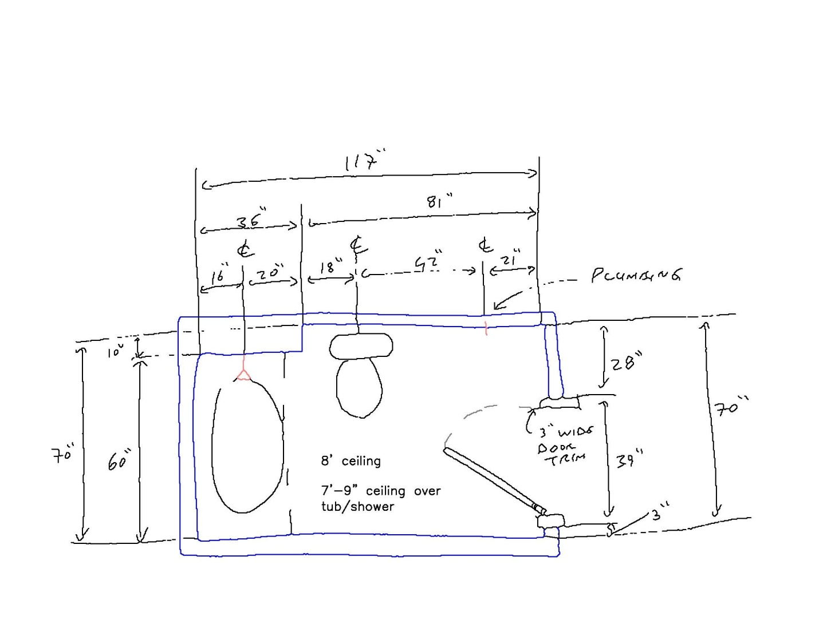

Review video: http://www.youtube.com/watch?v=sV2aCpR53ko
(How to install a flat jamb interior door - The Home Depot)

February 2 & 4
Contintue project 2

February 9 & 11
9 February – test 1
Finish project 2
Start project 3 – Master Suite

February 16 & 18
No class on 16 February
18 February: start project 3—a master suite of your own design

February 23 & 25
Continue project 3

March 2 & 4
Continue project 3

March 9 & 11
Project 4 – custom bed

March 16 & 18
16 March – test 2
Start project 5 – hotel suite

March 23 & 25
No class this week

March 30, April 1
Continue project 5

April 6 & 8
Continue project 5

April 13 & 15
Finish project 5

April 20 & 22
Start project 6 – SketchUp of project 5

April 27 & 29
Last week of class
Finish project 6

