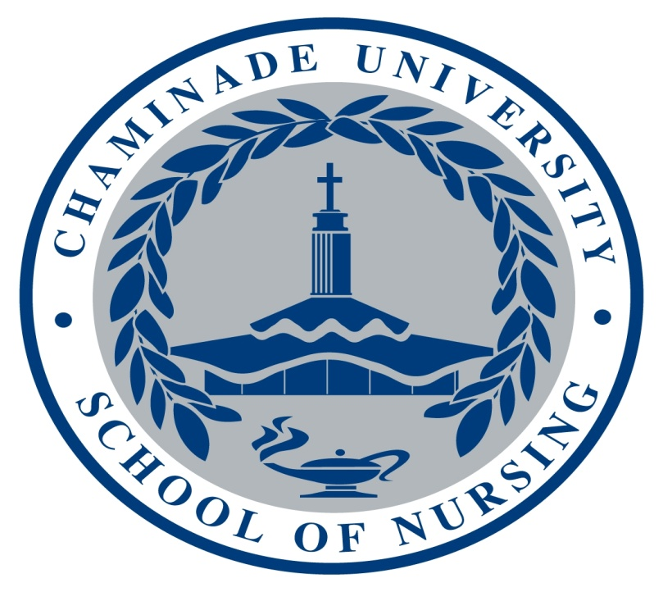

Chaminade University
School of Nursing
Course Syllabus
NUR 490
NCLEX Seminar

Chaminade University
SYLLABUS NURS 490 NCLEX Seminar (1 credit)
Spring 2014

- Course Coordinator: Julieta M. Rosado, APRN, Ph.D.
Office: Henry Hall 106
Email: julieta.rosado@chaminade.edu
Office Hours: Posted on Bulletin Board by nursing office
Lecture Hours: 2 hours Mondays 3:30 pm – 5:30 pm
- Weekly online sessions (7 weeks) with ATI Content Review Course
ATI Capstone Coach: Maxine Lesser
Email: Maxine.Lesser@ascendlearning.com
- CATALOG DESCRIPTION:
NUR 490 NCLEX Seminar (1 credits)
Catalog Description: This course will consist of the administration of the NCLEX Predictor and review for the NCLEX examination. Students will develop a self-directed study and preparation plan.

Prerequisites: BI 151 and BI 151L, BI 152 and BI 152L, CH 201and CH 201L, CH 254 and CH 254L, MA 107, NUR 190, NUR 290, NUR 291, NUR 201, NUR 202, NUR 203, NUR 204, NUR 206, NUR 301, NUR 304, NUR 305, NUR 403, NUR 404

Co-requisites: NUR 401, NUR 402, or NUR 405; NUR 499, NUR 406

COURSE LEARNING OUTCOMES
At the end of this course, the student will:
- Describe challenges with new nurse graduates’ professional transition from student to practicing nurse.
- Describe the nursing residency program in Hawai’i and how this program eases professional transition.
- Identify the legalities of obtaining and having a nursing license.
- Develop a preparation plan for success on the final RN Comprehensive Predictor Examination.
- Demonstrate mastery of nursing concepts at the beginning generalist nursing level as defined in the BSN Essentials.

Key progression in professional nurse practice: I= Introduced to the concept/skill D= Developing M= Mastered
PLO Program Learning Outcomes | CLO 1 | CLO 2 | CLO 3 | CLO 4 | CLO 5
PLO#1: Use the nursing process for comprehensive assessments of health and illness parameters in patients using developmentally, and culturally, appropriate approaches. |  |  |  |  | M
PLO#2: Provide safe, holistic, patient-centered care across the health-illness continuum, across the lifespan, using state-of-the-art methodologies, and in all healthcare settings. |  |  |  |  | M
PLO#3: Engage in dialogue about contemporary issues in healthcare, effectively advocate in the interest of patients, and lead others in the professional nursing role. | M | M | M | M | M
PLO#4: Communicate and collaborate effectively with patients and professionals from a variety of disciplines.
PLO#5: Integrate research and reliable clinical evidence to inform their nursing practice. | M | M |  | M | M
PLO#6: Incorporate informatics and healthcare technologies into the practice of professional nursing. | M | M |  | M | M
PLO#7: Use the determinants of health, tools for measurement, and interventions for health promotion and disease prevention in populations. |  |  |  |  | M
PLO#8: Describe the elements of health care policy and finance within a regulatory environment. |  |  | M |  | M

Program Associated Hawaiian Core Values | CLO 1 | CLO 2 | CLO 3 | CLO 4 | CLO 5
- Patient Centered-Care,  Ka malama olakino Pili pono I ia kanaka |  |  |  |  | M
- Community Based Care,  Ka malama olakino ma o ke kaiaulu |  |  |  |  | M
- Developmentally and Culturally Appropriate Care,  Ka malama ola kino noka ho’omohala a me ka mo’omeheu |  |  |  |  | M
- Care Across the Lifespan  Ka malama olakino o ka wa ola |  |  |  |  | M

- COURSE MANAGEMENT

- Nature of course meetings and learning experiences
Students will be engaged throughout their final semester in the ATI Capstone Content Review which is a review of all major NCLEX-RN content areas. In this review, ATI in partnership with Chaminade University School of Nursing, will pair each student with an ATI educator/coach to take students through a present calendar of 7 weeks of content review before taking the ATI Comprehensive Predictor. It is estimated that the program will require the student to spend approximately 8 hours a week reviewing and taking assessments depending on the knowledge level of the student. Individual action plans are created each week from the weekly assessments for the development of a customized review plan for each student.
The Capstone Content Review provides a complete review of key nursing content with separate, comprehensive units on medical-surgical, child health, childbearing and women’s health, and mental health/psychiatric nursing, followed by test questions written in NCLEX exam format.
- The objectives of the Capstone Content Review are the following:

In the nursing role of Member of the Profession of Nursing:
- Review of content from all courses in the program of study.
- Integrate content from all courses in the program of study.
- Practice test-taking skills using NCLEX-RN style questions.

Following the Capstone Content Review, students will be required to take a Comprehensive Predictor Examination. This examination will provide the student with a percentage probability of passing the NCLEX-RN. If the student demonstrates less than a 90% probability of passing the NCLEX-RN on the Comprehensive Predictor Examination, the student will be required to remediate and retake the examination. The student will be able to retake the Comprehensive Examination as many times as needed in order to obtain at least a score demonstrating a 90% probability of passing the NCLEX-RN. The first retake is free; however, ATI will assess a fee for subsequent examinations (approximately $20.00). If the student demonstrates less than a 90% probability of passing the NCLEX-RN on the first attempt; it is strongly suggested that the student engage in a Virtual ATI NCLEX review (there is an additional $200.00 fee for this review).
- TEXTBOOK(S) AND OTHER REQUIRED LEARNING MATERIALS
- ATI Capstone Content Review Program
- ATI Practice Exams and Focus Review
- Nursing Textbooks utilized throughout the curriculum
- I-Clickers
- It is strongly suggested that you bring a laptop to class each week

- Course Schedule:

NCLEX Seminar Preparation Assignments
Winter Break | Answer review questions assigned on 12/11/2013 and submit on Monday, 1/13/2014. (Will accept no later than Monday, 1/20/14).
Thursday 1/9/14 | Receive welcome email from Capstone Coach and directions on logging into Online Capstone Content Review Classroom.
Friday  1/10/14  due Monday, 1/13/14 by 11:59 pm. | - Complete standardized Fundamentals pre-assessment assignment and send answers to Capstone Educator by using the classroom messaging system before taking assessment on Tuesday, 1/14/2014.  - Develop a preparation plan for success on baseline comprehensive predictor exam.

Week One 1/13 - 1/17: Fundamentals
Monday  1/13/14 | - Take Comprehensive Predictor on campus.  - Submit answers to review questions (answers to questions will be accepted no later than 1/20/2014)
Tuesday  1/14/14 | Take Fundamentals Assessment on campus. (tentative time: 4:30 pm)
Homework  Assignments due Sunday, 1/19/14 by 11:59 pm. | - Complete ATI Fundamentals Assessment Focused Review for score areas less than 60%.  - Complete individualized Fundamental post-assessment assignment and message answers using classroom messaging system to your Capstone Educator.  - Review Tip of the Week.  - Receive and complete standardized pre-assessment assignment for Pharmacology and send answers to Capstone Educator by using the classroom messaging system before taking assessment on Tuesday, 1/21/14.  - Submit a preparation plan for success on the final RN Comprehensive Predictor Examination.

Week Two 1/20 - 1/24: Pharmacology
Monday 1/20/14 | Holiday Martin Luther King Day
Tuesday 1/21/14  or  Wednesday  1/22/14 | - Complete Pharmacology Exam (on campus)  - Submit review questions if not submitted on 1/13/14.
Homework Assignments  Due Sunday 1/26/14 by 11:59 pm. | - Complete ATI Pharmacology Assessment Focused Review for score areas less than 60%.  - Complete individualized Pharmacology post-assessment assignment and message answers using classroom messaging system to your Capstone Educator.  - Review Tip of the Week.  - Receive and complete standardized Med-Surg pre-assessment assignment and send answers to Capstone Educator by using the classroom messaging system on Monday, 1/27/14.

Week Three 1/27 – 1/31: Medical-Surgical
Monday  1/27/14 | - Complete Med-Surg assessment on campus.  - In class review of missed pharmacology & fundamentals content (Professor Rosado)
Homework  Due on Sunday 2/2/14 by 11:59 pm. | - Complete ATI Med-Surg Assessment Focused Review for score areas less than 60%.  - Complete individualized Med-Surg post-assessment assignment and message answers using classroom messaging system to your Capstone Educator.  - Review Tip of the Week.  - Receive and complete standardized Maternal Newborn pre-assessment assignment and send answers to Capstone Educator by using the classroom messaging system before taking assessment on Monday, 2/3/14.

Week Four 2/3 - 2/7: Maternal Newborn and Women’s Health
Monday  2/3/14 | - Complete Maternal Newborn assessment on campus.  - In class review of missed med/surg content (Professor Kanayama)
Homework  Due on Sunday 2/9/14 by 11:59 pm. | - Complete ATI Maternal Newborn Assessment Focused Review for score areas less than 60%.  - Complete individualized Maternal Newborn post-assessment assignment and message answers using classroom messaging system to your Capstone Educator.  - Review Tip of the Week.  - Receive and complete standardized Nursing Care of Children pre-assessment assignment and send answers to Capstone Educator by using the classroom messaging system before taking assessment on Monday, 2/10/14.

Week Five 2/10 - 2/14: Nursing Care of Children
Monday  2/10/14 | - Complete Nursing Care of Children assessment on campus.  - In class review of missed medical/surgical content (Professor Rosado)
Homework  Due on Sunday 2/16/14 by 11:59 pm. | - Complete ATI Nursing Care of Children Assessment Focused Review for score areas less than 60%.  - Complete individualized Nursing Care of Children post-assessment assignment and message answers using classroom messaging system to your Capstone Educator.  - Review Tip of the Week.  - Receive and complete standardized Mental Health pre-assessment assignment and send answers to Capstone Educator by using the classroom messaging system before taking assessment on Tuesday, 2/18/14.  - Receive and complete standardized Leadership pre-assessment assignment and send answers to Capstone Educator by using the classroom messaging system before taking assessment on Wednesday, 2/19/14.

Week Six 2/17 – 2/21: Mental Health
Monday  2/17/14 | HOLIDAY President’s Day
Tuesday  2/18/14 | - Complete Mental Health on campus (tentative time: 4:30 pm)  - In class review of missed pediatric & obstetric content (Professor Schlessman)
Wednesday  2/19/14 | - Complete Leadership Exam on campus (4:30 pm)
Homework  Due Sunday, 2/23/14 by 11:59 pm. | - Complete ATI Mental Health Assessment Focused Review for score areas less than 60%.  - Complete individualized Mental Health post-assessment assignment and message answers using classroom messaging system to your Capstone Educator.  - Review Tip of the Week.

Week Seven 2/24 – 2/28: Community Health & Leadership
Monday  2/24/14 | - In class review of missed mental health content (Dr. Magpantay-Monroe)  - In class review of missed leadership content (Dr. Ryan)  - Describe challenges with new nurse graduates’ professional transition from student to practicing nurse. (Dr. Ryan)  - Describe the nursing residency program in Hawai’i and how this program eases professional transition. (Dr. Ryan)  - Identify the legalities of obtaining and having a nursing license. (Dr. Ryan)
Homework  Due Sunday, 3/2/14 by 11:59 pm. | - Complete ATI Leadership Assessment Focused Review for score areas less than 60%.  - Complete individualized Leadership post-assessment assignment and message answers using classroom messaging system to your Capstone Educator.  - Review Tip of the Week and finish up all assignments for the week.  - Nurse Logic modules & assessments  - Practice Comprehensive exam (must obtain a score of 90% prior to sitting for proctored examination).

Week 8 3/3/14: Comprehensive Predictor
Monday  3/3/14 | ATI Comprehensive Predictor Exam on campus**
Friday  3/7/14 | Submit a preparation plan for success on the NCLEX-RN.
** Studies have demonstrated that the ATI Comprehensive Predictor Exam is very accurate in predicting the students’ probability of passing the NCLEX-RN. Please keep in mind, that if you do not pass the NCLEX-RN you will not be able to obtain a license and therefore you will not be employable as a registered nurse. It is strongly suggested that the student take the ATI Virtual Review Course if unable to achieve a 90% probability of passing the NCLEX-RN on the first attempt. If the student demonstrates less than a 90% probability of passing the NCLEX-RN on the Comprehensive Predictor Examination, the student will be required to remediate and retake the examination. The student will be able to retake the Comprehensive Examination as many times as needed in order to obtain at least a score demonstrating a 90% probability of passing the NCLEX-RN. The first retake is free; however, ATI will assess a fee for subsequent examinations (approximately $20.00). If the student demonstrates less than a 90% probability of passing the NCLEX-RN on the first attempt; it is strongly suggested that the student engage in a Virtual ATI NCLEX review (there is an additional $200.00 fee for this review).
- Course Grading

Final Grade: Pass/Fail
Study Guide Questions & Preparation Plans Grading Rubric
Assignment | Points
Study Questions | 30 points
Preliminary Comprehensive Predictor Preparation Plan | 10 points
Final Comprehensive Predictor Preparation Plan | 10 points
NCLEX-RN Prep. Plan | 10 points
Total Points for Study Guide Questions & Preparation Plans | 60 points

Capstone Weekly Activities:
- Pre-Assessment Assignment
- Assessment
- ATI Focused Review
- Post Assessment Assignment
Capstone Weekly Activities Grading Rubric
Points for Capstone
Assignment | Points
Pre-Assessment work | 10 points per week
Assessment | 10 points per week
Post- Assessment work | 10 points per week
Total points per week | 30 points x 7 weeks = 210 points
Total points for Capstone | 210 points
Nurse Logic & Practice Comprehensive Assessment Grading Rubric
(4) Nurse Logic Modules including lessons/assessments | Practice Comprehensive Assessment | Total Points
5 points each  Total 20 points | 10 points  (must achieve score of 90%) | 30 points

Total Possible Points
Study Guide Questions | 30 points
Preparation Plans (3 X 10 points) | 30 points
Capstone Weekly Activities (7 X 30 points) | 210 points
Nurse Logic (4 X 5 points) | 20 points
Practice Comprehensive Assessment (must achieve score of 90%) | 10 points
Total Possible Points | 300 points

NOTE: No points will be given for late assignments unless excused by course faculty.
You must direct your focus to this NCLEX content review course and plan your time carefully.
This course is graded as pass/fail. You must obtain a total of 300 points in order to pass this course. If the student demonstrates less than a 90% probability of passing the NCLEX-RN on the first attempt of the Comprehensive Predictor Examination; the student will be able to retake the Comprehensive Examination as many times as needed in order to obtain at least a score demonstrating a 90% probability of passing the NCLEX-RN. The first retake is free; however, ATI will assess a fee for subsequent examinations. If the student demonstrates less than a 90% probability of passing the NCLEX-RN on the first attempt; it is strongly suggested that the student engage in a Virtual ATI NCLEX review (there is an additional $200.00 fee for this review).

