ID 217 – Introduction to Computer Aided Design in AutoCAD 2011

Chaminade University
Mondays and Wednesdays from 6 pm until 8:50 pm
Laurent Chouari
228-0938

Course Description
Students will learn how to create architectural construction documents using AutoCAD 2011

Course Objectives
This course has three objectives: how to use AutoCAD 2011, how to organize information and how to present this work.
Students will learn by doing. Upon completion, they will be able to confidently create construction documents for a small renovation project. Construction documents include: title sheet, floor plan, elevations, electrical, lighting, countertop, soffit, flooring and detail plans, door and window schedules. During this course, students will learn a little about file organization, construction, budgeting and cabinetry. Only AutoCAD’s 2D tools will be covered.

Course Outline
After an introduction to AutoCAD’s workspace, the first task is to create a logo and customize their sheet borders. Then, we will begin with a small residential bathroom project. Students will learn how to create the floor plan, elevations, countertop plan, flooring plan, lighting, electrical, and soffit plans. They will calculate the quantities for the flooring and wall covering and prepare documents to obtain a countertop and splash quote. Notations for blocking and placement of the shower fixtures and lighting will be included.
Next, the students will be tasked to create both an independent-living master bath and a commercial restroom employing universal design principles and following ADA guidelines.
These drawings will also include notations required to obtain a building permit.

Class Structure
Each class will begin with a review of what was addressed in the last class (approximately 10 minutes). There will be a chance for short questions and then I will introduce the next topic (approximately 25 minutes). Students will then work on their projects; I will work with each student individually during this remaining time.

Grading
Grading is based on attendance (35%), class participation and preparation (30%) projects and final (35%).

Required Text
AutoCAD 2011 for Interior Design and Space Planning

_____________________________________________________________________________
WEEK #1

Customize:
crosshairs
crosshair color
right-click
import toolbars
set OSNAPS (F3)

Commands:

L line divide
PL polyline erase
PE polyline edit explode
O offset array
C copy block
M move wblock
M ; P move, previous F3
Z ; E zoom extents F8
C circle F2
TR trim TM1
EX extend TM0
F fillet ltscale
F ; R fillet ; radius attdef
REC rectangle ellipse
RO rotate
MI mirror
MT multi-line text
S stretch
U undo
DI distance
ED edit dimension
PS paperspace
SC scale
A arc

Review commands and file organization
Individual help with logos and sheet borders

_____________________________________________________________________________
WEEK #2

Layers

Start first bath project:
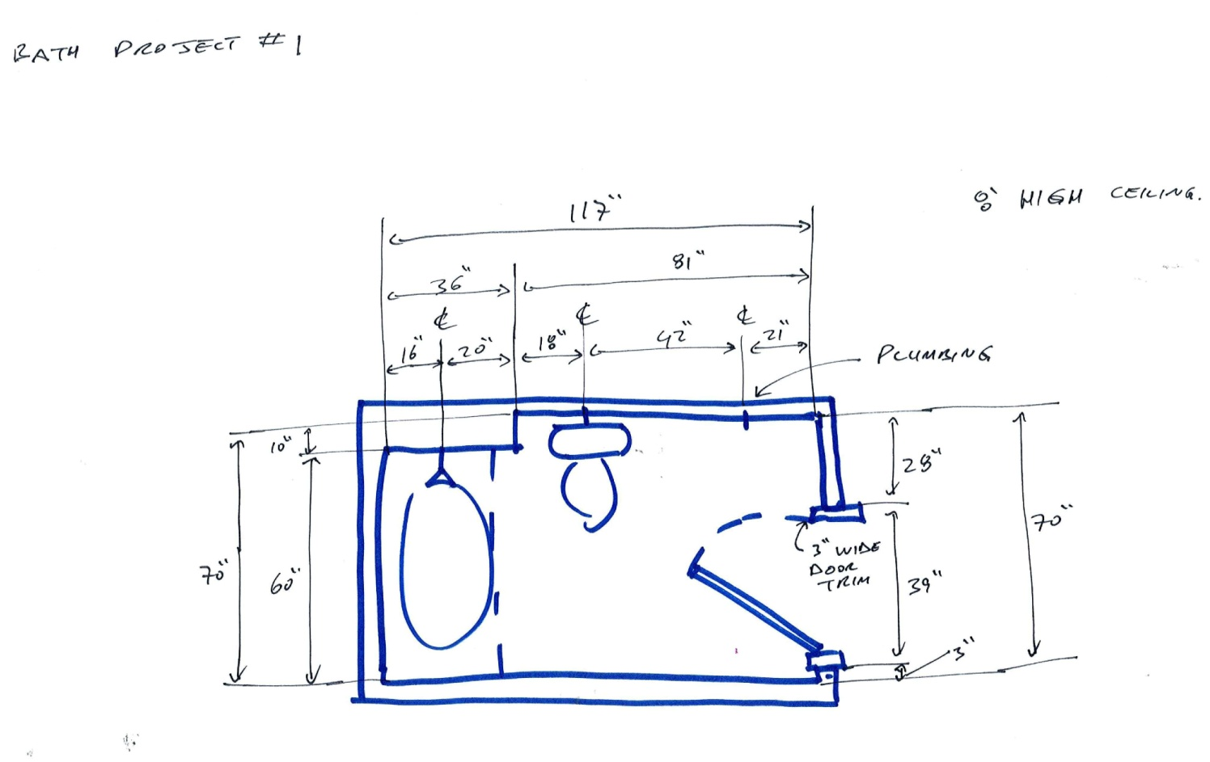
Assignment
Draw:
Floorplan
Two elevations
Soffit plan (reflected ceiling plan)
Flooring plan

Review video: http://www.youtube.com/watch?v=sV2aCpR53ko
(How to install a flat jamb interior door – The Home Depot)

Please review : http://books.google.com/books?id=rfji7Vxez7YC&pg=PA210&lpg=PA210&dq=blocking+for+grab+bars&source=bl&ots=MeMGCy3oUj&sig=OD0i3stpvQQxDRVklRYQlYkQ5Iw&hl=en&sa=X&ei=MF0QUbfEH-SXiALeroDYAg&sqi=2&ved=0CHIQ6AEwBg#v=onepage&q=blocking%20for%20grab%20bars&f=false
Black & Decker The Complete Guide to Dream Bathrooms

Layer states manager
Create new layer
Vplayer
View
Mview
Xref
Dimensions
hatch
Internet research, Design Center
_____________________________________________________________________________
WEEK #3

Review commands
Set up sheets and print, combine into multiple-page pdf
complete Bath Project 1 drawing set

_____________________________________________________________________________
WEEK #4

Start Master Suite Project 2 -- bedroom and bath of own design to incorporate independent-living space planning elements.

In this project we will generate the following:
Floorplan
Finished wall dimension plan
Elevations (at least four)
Electrical plan
Lighting plan
Countertop plan
Soffit plan
Flooring plan
Finish schedule

Plan for and note at least three guidelines from the:
U.S. Department of Justice 2010 ADA STANDARDS FOR ACCESSIBLE DESIGN
http://www.ada.gov/2010ADAstandards_index.htm

Ctrl + Tab to jump between drawings
Ctrl + C copy
Ctrl + V paste
Units

LAYERS tool bar
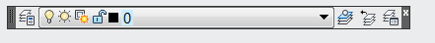

VIEWPORTS tool bar
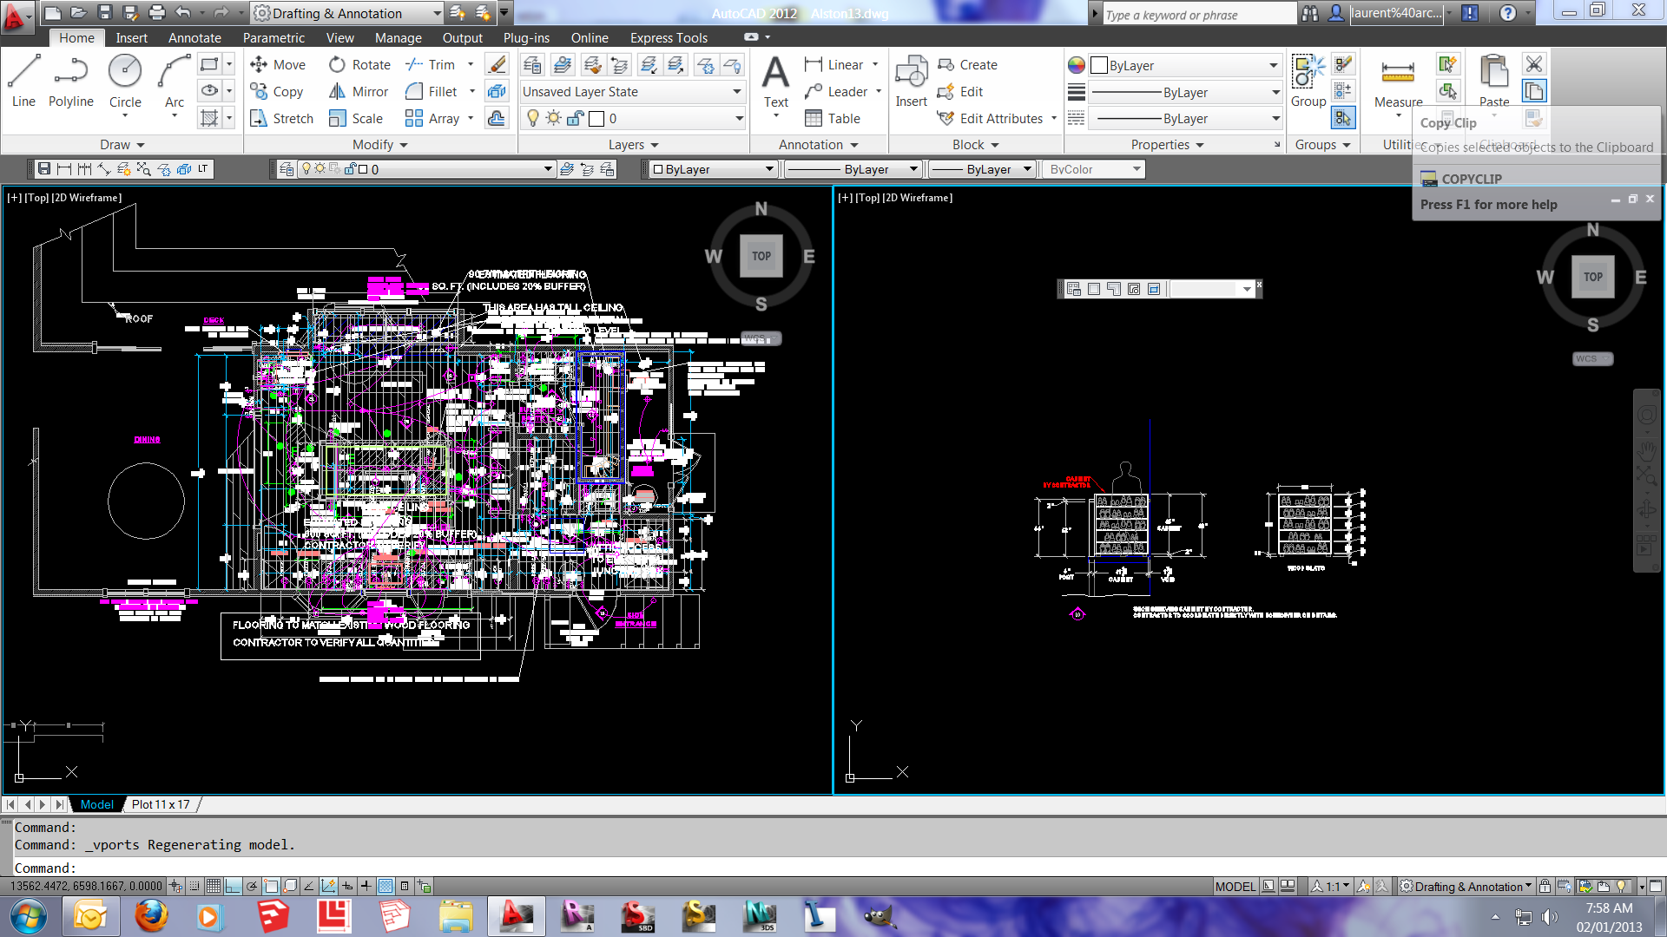
_____________________________________________________________________________
WEEK #5

Area
Continue with Master Suite Project 2
Add niches and accent tiles in shower, text with leaders.
Calculate quantities for flooring and wall covering

_____________________________________________________________________________
WEEK #6

continue Master Suite Project 2
Door and window schedule
Fixture schedule

_____________________________________________________________________________
WEEK #7

complete Master Suite Project 2 drawing set.

_____________________________________________________________________________
WEEK #8

City and County of Honolulu building code:
International Building Code, 2006 Edition
http://publicecodes.cyberregs.com/icod/ibc/2006f2/index.htm

Exceptions:
1. Detached one- and two-family dwellings and multiple single-family dwellings (townhouses) not more than two stories high with separate means of egress and their accessory structures shall be permitted to comply with the International Residential Code.
2. Existing buildings undergoing repair, alterations or additions and change of occupancy shall be permitted to comply with the International Existing Building Code.

International Residential Code for One- and Two-Family Dwellings, 2006 Edition,
http://publicecodes.cyberregs.com/icod/irc/2006f2/index.htm

Building permit checklist:
http://dev.honoluludpp.org/ApplicationsForms.aspx

Also helpful:
http://www1.honolulu.gov/council/ocs/roh/
http://www.nkba.org/Design/Professionals/Guidelines.aspx

Start ID270 Project 3
_____________________________________________________________________________
WEEK #9

Furniture layout and blocks for ID270 Project 3

note egress, illumination, smoke detectors

finish schedule:

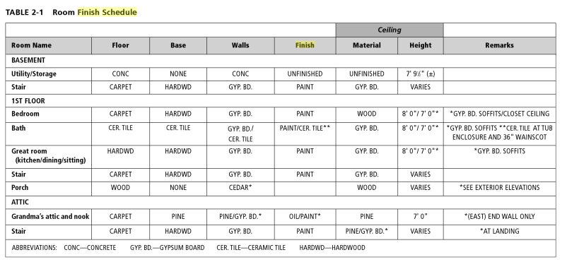

_____________________________________________________________________________
WEEK #10

Door and window schedule
Importing text and images into CAD

complete ID270 Project 3 drawing set.

_____________________________________________________________________________
WEEK #11

Start Condo Renovation Project 4.
Floor plan, elevations

Assignment: make blocks of bed in plan, elevation from foot of bed, elevation of side of bed.

_____________________________________________________________________________
WEEK #12

continue Condo Renovation Project 4.
Elevations, lighting, electrical, flooring, countertop

Purge
Break
Join
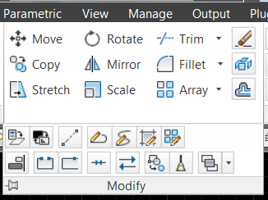

l@x<x

_____________________________________________________________________________
WEEK #13

Compile sheets, print
continue Condo Renovation Project 4.

_____________________________________________________________________________
WEEK #14

complete Condo Renovation Project 4 drawing set.

_____________________________________________________________________________
WEEK #15

Design and detail a piece of custom furniture: bed, chair, table, etc.

_____________________________________________________________________________
WEEK #16

Sketchup

