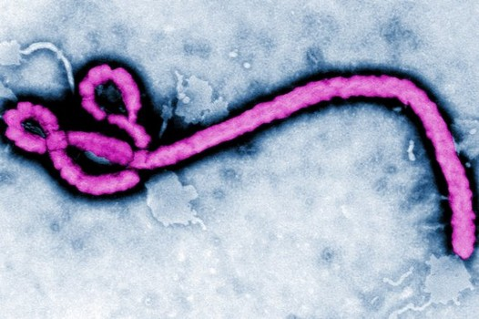
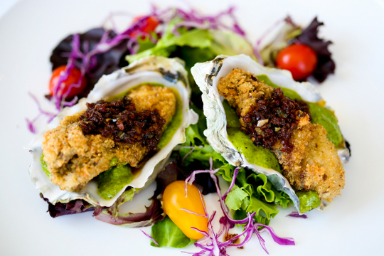
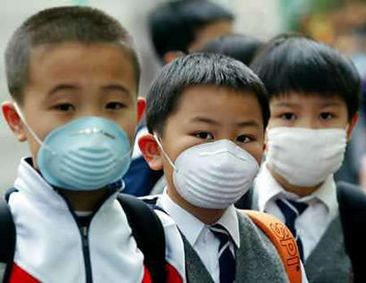

ENV 380:

The Environment and Your Health

Course Syllabus
Spring 2013

The dose makes the poison. Paracelsus (16th century father of toxicology)
Although gold dust is precious, when it gets in your eyes it obstructs vision. Hsi-Tang
I am a great eater of beef, and I believe that does harm to my wit. Shakespeare, (Sir Andrew Aguecheek, in Twelfth Night)
Audacious at trying out everything, men rush headlong into the things that have been forbidden. Virgil
That's human nature. Nobody does anything until it's too late. Michael Crichton, from the novel Prey
Earth provides enough to satisfy every man's need, but not every man's greed. Mohandas Gandhi
The weight of our civilization has become so great, it now ranks as a global force and a significant wild card in the human future along with the Ice Ages and other vicissitudes of a volatile and changeable planetary system Dianne Dumanoski, Rethinking Environmentalism
Environmentally friendly cars will soon cease to be an option...they will become a necessity. Fujio Cho, President of Toyota Motors
A Healthy Ecology is the Basis for a Healthy Economy. Claudine Schneider, U.S. Representative in The Green Lifestyle Handbook
Never doubt that a small group of thoughtful, committed citizens can change the world; indeed, it is the only thing that ever has. Margaret Mead
You must be the change you wish to see in the world. Mahatma Gandhi
Just because you always did it that way, doesn't make it right…. (unknown)

Instructor: Dr. Gail Grabowsky
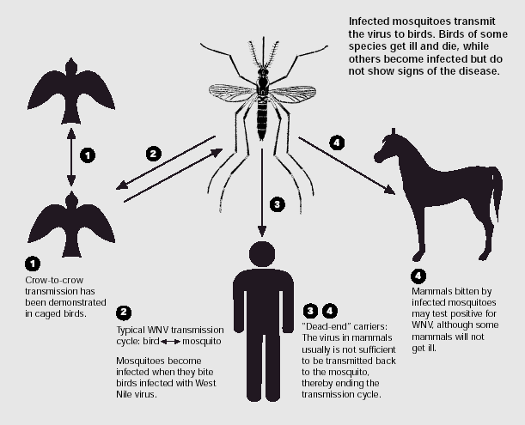

Address: Behavioral Sciences Building, room 107
Environmental Studies
Chaminade University
3140 Waialae Ave
Honolulu, HI 96816

Phone: 735-4834 (ext. 834 if calling from on campus)

E-mail address: ggrabows@chaminade.edu

Office hours: TThF: 2:30 – 5:00; Or by appointment

Texts:
Required:
Selhub, Eva, M. and Alan C. Logan. Your Brain on Nature: The Science of Natuere’s Influence on Your Health, Happiness and Vitality. 2012. Wiley.
McCally, Michael (Editor). Life Support: The Environment and Human Health. 2002. The MIT Press.

Other:
We may, throughout the course use other written and media sources. I will provide hard-copies or e-copies of these additional source articles etc. I am also using: Environmental Health: From Global to Local by Howard Frumkin (2010) as my own thorough reference source throughout the class.

Course Description:
This one-time only course focuses on those things in our natural and built environment that are either important to facilitating/enhancing our personal health or in threatening or diminishing our health. This course is meant to be a sweeping general survey for undergraduates. It also aims to pay particular attention to recent and emerging discoveries regarding what kinds of things in our environment are just currently being recognized as harmful/potentially harmful (that we may be getting too much of) and what kinds of things/behaviors we are learning are good for our health (that we may perhaps not be getting enough of). The course will pay particular attention to stress-, disease- and obesity-causing factors.

Student Learning Outcomes:
Students will demonstrate an understanding of:
- General categories of environmental conditions that are harmful or helpful to our health
- General human behaviors linked to the environment that are harmful or helpful to our health.
- New and emerging research demonstrating how specific nature experiences can maintain or enhance our health.
- Particular case studies pertaining to major environmental health catastrophes.
- Particular case studies pertaining to populations that are healthier than other people due to some aspect of their behavior in their environment and/or their environment.
- Careers in environmental health.
- Potential future/emerging environmental health issues.
- Environmental products that can enhance or harm our health.

Course Requirements:
Your grade in this course will be based on the following. Each of the items/activities listed below will be described to you in writing or orally in class. The dates of each activity (or its parts) are indicated on the Course Schedule portion of this syllabus.

- 10 Question Quizzes (after every reading, you write them!) 30%
- Info Shares (5 of them) 30%
- Health Reading Discussion Lead 30%
- Attendance 10%

Course Grading:
The proportion that each of the above contributes to your grade in this course is as follows:

10 Question Quizzes & Reflection Questionnaires 300
Info Shares 300
Health Reading Discussion Lead 300
Attendance 100
1000

Grading:
The details for each of the assignments will be explained orally and with handouts in class prior to the initiation of each. In general for each:

10 Question Quizzes:
There are no exams in this class, instead, there are quizzes and reflection questionnaire’s. After every reading there will be a 10-question multiple choice quiz. One of you will write each quiz and give it after the first day of the reading . I will hand out a reflection questionnaire after each health topic is complete. You will need to prepare a word-processed response to the reflection questionnaire which will be due at the class meeting immediately after it was handed out. Quizzes will be graded on a curve.

Info Shares:
There will be five of these in this class. They are meant to be fun, interesting and informative. For these we will all bring in an example on the day they are due. The topics are: (1) A case study of a health disaster from the distant or recent past. (2) A case study on long-lived people/cultures and why. (3) A case study illustrating a product or a behavior that has been shown under scientific scrutiny to improve health. (4) An example of a career in an environmental health profession. And finally, (5) an example of something that you think will or could become an environmental health concern now, in the very near future, or in the distant future.

Health Reading Discussion Lead:
For this assignment you will be the class discussion leader. You may have notes, power points, other media, show and tell, activities (etc.) planned for the class, but you do not have to talk the whole time. In fact, don’t! We want to discuss each of these topics we read about so lead a discussion. I will help you through it and add my own thoughts and questions each day. However, the more I have to “fill in” because you didn’t cover the whole topic the lower your grade gets.

Attendance:
You are allowed TWO unexcused absences in this class. When you take them you will not be able to make up any assignments due on the day you missed, no exceptions.

Excused absences:
These occur when you are ill and have a doctor’s note, or miss class for an athletic event, academic/club event, etc. for which you have an official university note or experience a work-related, family-related emergency and provide some kind of documentation or a phone number of someone responsible that I may call in order to verify the urgency of the reason for your absence. In all cases hard evidence is required.

Course Atmosphere:
This class is meant to be a wonderful learning community where we all get to formally investigate something that we really care about: our health and our surroundings. I want you all to exit the class, as I hope I will, knowing a lot more about how our environment effects our personal health for better and for worse…. Please DO THE READING and PARTICIPATE IN THE DISCUSSIONS. We will learn a lot in here if we all pull our own weight and are responsible, engaged, intellectuals who take a critical look at this important topic .

If you are handicapped under the Americans with Disabilities Act:
Chaminade will provide assistance for any student with documented disabilities. Any student who believes he/she may need accommodations in this class must contact Dr. June Yasuhara (735-4845), at the Counseling Center (office is next to security), in order to determine if you meet the requirements for a documented disability in accordance with the Americans with Disabilities Act. Please contact Dr. Yasuhara as soon as possible so that accommodations can be implemented in a timely fashion.

Nothing is Certain but Change Itself Clause…
This syllabus and course schedule are living documents: they are free to change. I try to adhere as closely as possible to each, but there will be times in which we will take longer on a particular topic or add or delete a topic to enhance the course. I like to be able to react to you as the course proceeds and go with the flow a bit in order to make the course experience sort of custom fit to you!
You are responsible for all of the information in this document: losing it or not reading it are not excuses for not knowing what’s in it!

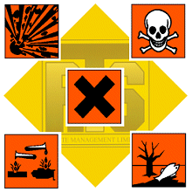

The Environment and Your Health
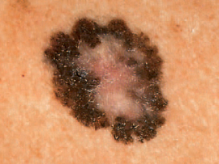
First day of class version

Course Schedule
Spring 2013

WEEK TOPIC ACTIVITIES
1/15 – 1/17 Course Outline Intro Buy your books!
Your Brain on Nature (YBN) Read: YBN Chapters 1&2 for next Tuesday
N O C L A S S T H U R S D A Y! (Dr. Gail has a seminar to lead) You guys: read!

1/22 – 1/24 Discuss YBN Chapters 1&2 Tues Quiz: YBN Chpts 1&2
Life Support (LS) Read: LS Chapters 1,13 &14 for Tues
Info Share: Past Health Disasters Info Share

1/29 – 1/31 Discuss LS Chapters 1,13&14 Tues Quiz: LS Chapters 1,13&14 for Tues
Enviro Health DVD Read: YBN Chapter 3 for Tues

2/5 – 2/7 Discuss YBN Chapter 3 Tues Quiz: YBN Chapter 3
Read: YBN Chapter 4 for Thurs
Discuss YBN Chapter 4 Thurs Quiz: YBN Chapter 4
Read: YBN Chapter 5 for Tues

2/12 – 2/14 Discuss YBN Chapter 5 Mon Quiz: YBN Chapter 5
Galapagos Read: YBN Chapter 6 for Tues
Info Share: Long-lived people Info Share

2/19 – 2/21 Discuss YBN Chapter 6 Tues Quiz: YBN Chapter 6
Read: YBN Chapter 7 for Thurs
Discuss YBN Chapter 7 Thurs Quiz: YBN Chapter 7
Read: YBN Chapter 8 for Tues

2/26 – 2/28 Discuss YBN Chapter 8 Tues Quiz: YBN Chapter 8
Read: YBN Chapter 9 for Thurs
Discuss YBN Chapter 9 Thurs Quiz: YBN Chapter 9
Read: LS Chapter 2 for Tues

3/5 – 3/7 Transition to Enviro Health Sci Tues Quiz: LS Chapter 2
Read: LS Chapter 3 for Tues
Info Share: Enviro Health Careers Info Share

3/12 – 3/14 Discuss LS Chapter 3 Tues Quiz: LS Chapter 3
Read: LS Chapter 4 for Thurs
Discuss LS Chapter 4 Thurs Quiz: LS Chapter 4
Read: LS Chapter 5 for Tues
3/19 – 3/21 Discuss LS Chapter 5 Tues Quiz: LS Chapter 5
Read: Discuss LS Chapter 7 for Thurs
Discuss LS Chapter 7 Thurs Quiz: LS Chapter 7
Read: LS Chapter 8&9 for Tues after Break

3/25 – 3/29 S P R I N G B R E A K (BIG CHANCE TO READ!!!!!) (Read on the beach)

4/2 – 4/4 Discuss LS Chapter 8 Tues Quiz: LS Chapter 8
Read: LS Chapter 9 for Thurs
Discuss LS Chapter 9 Thurs Quiz: LS Chapter 9
Read: LS Chapter 10 for Tues

4/9 – 4/11 Discuss LS Chapter 10 Tues Quiz: LS Chapter 10
Read: LS Chapter 11 for Tues
Info Share: Improving Enviro Health Info Share

4/16 – 4/18 Discuss LS Chapter 11 Tues Quiz: LS Chapter 11
Read: LS Chapter 16 for Tues
Discuss LS Chapter 11 (cont’d)

4/23 – 4/25 Discuss LS Chapter 16 Tues Quiz: LS Chapter 16 (Last Quiz!)
Enviro Health DVD/Movie

4/30 – 5/2 What have we learned?; Synthesis Discussion
Info Share: Future Env Health Issues Info Share





