Chaminade University of Honolulu

Math 100-20: Survey of Mathematics
Fall 2012

Mathematical thought is studied through interactions between the foundations of knowledge and the study of the nature of mathematics. Topics include the basis of sets and logic, numbers and operations, algebra, geometry, measurement, financial management, probability and statistics, graphs and functions. This course fulfills the Track A general education requirement in mathematics. The course is intended as a terminal course and is not a prerequisite for any other course in mathematics.

Instructor Information

Peter Anzalone, M.P.H.

Tel: 808-381-4513
Email: Primary email communications should be through eCollege.
Secondary email: peter.anzalone@adjunct.chaminade.edu

Class Meeting Information

Location: Kaneohe Marine Corps Hawaii, Building 22
Days: Mondays
Time: 1730-2140

Key Dates

Beginning Date: 1 October
No Class: 8 October (Columbus Day)
Last Day to Add/Drop: 9 October
No Class: 12 November (Veterans Day)
Last Day to Withdraw: 19 November
Ending Date: 13 December

Textbook

Thinking Mathematically-Fifth Edition, Blitzer, Robert 2011, Boston, MA: Prentice Hall.

Sending and Receiving email

The instructor will respond to all inquiries, questions, and other electronic correspondence within a timely, but not necessarily immediate, manner. Most electronic communications will be answered within 48 hours. All email messages from the instructor will be sent to the student’s eCollege email address. To avoid having your message mistakenly identified as SPAM, please identify the course in the subject line.

Learning Expectations and Course Objectives

At the end of this course, the student will gain knowledge of the following topics:

1. Inductive and Deductive Reasoning
2. Estimation
3. Problem Solving
4. Basic Set Concepts, Subsets, Venn Diagrams and Set Operations
5. Problem Solving using Logic and Truth Tables
6. Our Hindu-Arabic System and Positional Number Systems
7. Number Theory: Prime Numbers and Composite Numbers
8. The Integers: Order of Operations
9. Exponents and Scientific Notations
10. Algebraic Expressions, Formulas and Linear Equations
11. Percent, Sales Tax, and Income Tax
12. Mathematics and Finance
13. Geometry and Trigonometry
14. Euler Paths, Euler Circuits. Hamilton Paths and Hamilton Circuits
15. The Fundamental Counting Principle
16. Permutations and Combinations
17. Fundamentals of Probability

Grading

Assignment Weight
Quizzes: | 6 x 10 pts. each = 60 pts.
Homework: | 2 x 20 pts. each = 40 pts.
Mid-term Exam: | 1 x 100 pts. = 100 pts.
Final Exam: | 1 x 100 pts. = 100 pts.
Project: | 1 x 60 pts. = 60 pts.
Attendance/Class Part: | 1 x 40 pts. = 40 pts.

Final Grade
A= 360-400 pts.
B= 320-359 pts.
C= 280-319 pts.
D= 240-279 pts
F= 239 pts. & below

Homework

Math is not a spectator sport. In order to master the skills learned in this course, you need to practice them each week. Homework problems will be assigned weekly from each section and posted on eCollege. The answers to most of these practice problems will be in the back of the textbook. Weekly homework assignments should be completed but do not need to be submitted to the instructor, however, there will be two homework assignments that must be submitted and will be graded. Check eCollege and the calendar for more details.

Quizzes

There will be six 10 pt. weekly quizzes to test your understanding of the material from the previous week. Bonus questions will be assigned from the current week’s material. Quizzes will be held at the beginning of class. The quizzes are closed-book and no calculators are permitted.

Exams

There will be two exams: one mid-term exam and one final exam. The exams are closed-book and no calculators are permitted. Each is worth 100 pts. The final exam will be cumulative.

Project

As active participants in the learning experience, each class member is required research a significant mathematical topic to be shared with the rest of the class at the end of the term in the form of a 8-10 minute presentation. This will contribute 15% towards your final grade.

The topic you select may be anything related to mathematics must be one either one that demonstrates the significance mathematics has in an “every day” application like your job or a hobby or one that we have not covered in class. Your selection must be submitted and approved by your instructor in week 8. Some examples of topics are:

· Mathematics and Construction/Engineering · Mathematics and Personal Finances
· Pythagoras and Pythagorean Society · The Number Zero
· Mathematics and Art · Scuba Diving and Dive Tables
· Numerology · Probability and Gambling
· The Biography of a Mathematician
Your topic must be submitted two weeks prior to the due date using the form provided by your instructor on eCollege. Your submission will include your topic, a brief (one paragraph) summary, and a list of at least three references. Only one reference may be from the internet.

Navigating the Online Course Resources: Getting Started

The electronic classrooms for this course are located in eCollege and MyMathLab.

eCollege. To gain access to the course you need your Chaminade Student ID (username) and last 4 of your SS# (password).

1. Open your Internet browser to the Chaminade University eCollege page at chaminade.ecollege.com
2. Login with your Username and Password
3. Click on Course List to see your current courses
4. Click on the course link and then click on the syllabus link to begin your course.

MyMathLab. A subscription to MyMathLab is highly recommended and is included with the purchase of your textbook.

MyMathLab is an excellent resource that gives students access to excellent resources and practice questions that provide instructional assistance.
To enroll in the MyMathLab course, each student needs to have a:
- Student access code, a valid credit card, or a PayPal account– Students get an access code with a new book purchase or by buying the code separately in a student access kit/card at the campus bookstore. Students can also buy access to a course online with a credit card or PayPal account while they are enrolling.
Important: The student access code is nontransferable and can be used only once.
- Course ID: To Be Announced
- Course Name: To Be Announced
- Email address – The student's registration and enrollment confirmation will be sent to this email address.
- Multimedia library: MyMathLab has powerpoint presentations, video lectures, chapter test prep viedeos and textbook excerpts to help you master your skills.
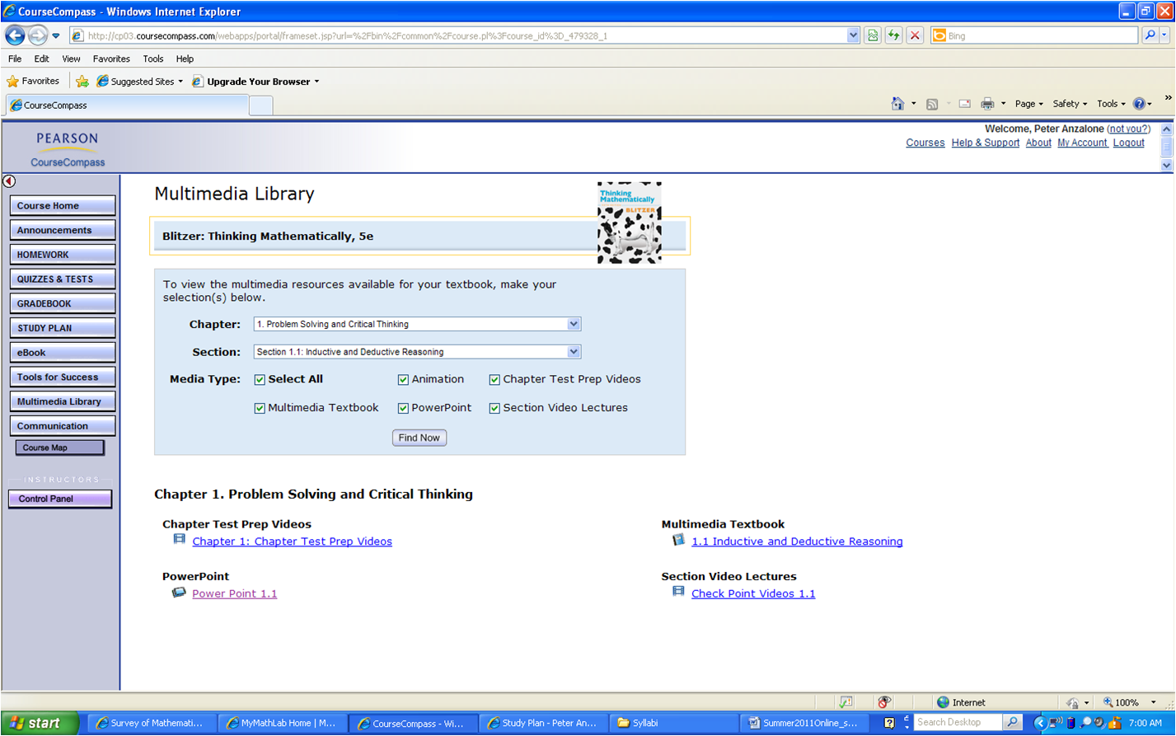
- Sample Tests and Quizzes: Sample tests and quizzes can be taken for practice or to build your study plan. Sample tests and quizzes do not affect your grade.

Makeup/Extra Credit Assignments

There will be no makeup assignments without prior approval from the instructor. There will be no extra credit assignments.

Academic Integrity Policy

As members of the Chaminade University community, we are all commitment to truthfulness, honor, and responsibility, without which we cannot earn the trust and respect of others. Furthermore, we recognize that academic dishonesty detracts from the value of a Chaminade degree. Therefore, we shall not tolerate lying, cheating, or stealing in any form.

ADA Accommodations

Students with special needs who meet criteria for the Americans with Disabilities Act (ADA) provisions must provide written documentation of the need for accommodations from the CUH Counseling Center (Dr. June Yasuhara; phone 735 4845) by the end of week three of the class, in order for the instructor to plan accordingly. Failure to provide written documentation will prevent your instructor from making the necessary accommodations. Please refer any questions to the Dean of Students and review the procedures at http://www.chaminade.edu/student_life/sss/counseling_services.php

Music Devices and Cell Phones

Use of music devices and cell phones is prohibited during all Natural Science and Mathematics classes at Chaminade, unless specifically permitted by your instructor. Use of cell phones and music devices in laboratories is a safety issue. In addition, use of cell phones and music devices in any class is discourteous and may lead to suspicion of academic misconduct. Students who cannot comply with this rule will be asked to leave class and may be subject to laboratory safety violation fines. Please refer any questions to the Dean of Natural Sciences and Mathematics.

Students with special needs who meet criteria for the Americans with Disabilities Act (ADA) provisions must provide written documentation of the need for accommodations from the CUH Counseling Center (Dr. June Yasuhara; phone 735 4845) by the end of week three of the class, in order for the instructor to plan accordingly. Failure to provide written documentation will prevent your instructor from making the necessary accommodations. Please refer any questions to the Dean of Students and review the procedures at http://www.chaminade.edu/student_life/sss/counseling_services.php

Distance Education Information and Technical Help
http://www.chaminade.edu/online
eCollege assistance is available by telephone (808-739-8327) or email (jnakason@chaminade.edu).

Library Services
http://www.chaminade.edu/library/about/index.php
The library web pages connect you to the many services and resources provided for Chaminade University students, including online databases, e-journals, electronic books, interlibrary loan, etc.

Registrar’s Office
http://www.chaminade.edu/academics/registrar/
The Registrar’s Office web site provides you with information about course schedules, registration, calendars, tuition fees, and grades.

Schedule and Calendar

1 October | Orientation and Introduction  Inductive and Deductive Reasoning  Estimation Problem Solving | 1.1  1.2  1.3
8 October | Columbus Day – No Class
15 October | Basic Set Concepts  Subsets  Venn Diagrams and Set Operations  Set operations and Venn Diagrams with Three Sets  Survey Problems  Quiz 1 | 2.1  2.2  2.3  2.4  2.5
22 October | Statements, Negations, and Quantified Statements  Compound Statements and Connectives  Truth Tables for Negation, Conjunction and Disjunction  Truth Tables for the Conditional and the Biconditional  Equivalent Statements and Variations of Conditional Statements Arguments and Truth Tables  Quiz 2 | 3.1  3.2  3.3  3.4  3.5  3.7
29 October | Our Hindu-Arabic System and Early Positional Systems  Number Bases in Positional Systems  Number Theory: Prime Numbers and Composite Numbers  The Integers: Order of Operations  Exponents and Scientific Notations  Quiz 3 | 4.1  4.2  5.1  5.2  5.6
5 November | Homework 1 Due / MID-TERM EXAM
12 November | Veterans Day – No Class
19 November | Percent, Sales Tax, and Income Tax  Simple Interest  Compound Interest  Annuities, Stocks and Bonds  Installment Loans, Amortization and Credit Cards | 8.1  8.2  8.3  8.4  8.5
26 November | Points, Lines, Planes, and Angles  Triangles  Right Triangle Trigonometry  Beyond Euclidean Geometry  Euler Paths and Euler Circuits  Hamilton Paths and Hamilton Circuits  Quiz 4, Project Submission Form Due | 10.1  10.2  10.6  10.7  15.2  15.3
3 December | The Fundamental Counting Principle  Permutations  Combinations  Fundamentals of Probability  Probability with the Fundamental Counting Principle, Permutations and Combinations  Quiz 5 | 11.1  11.2  11.3  11.4  11.5
10 December | Homework 2 Due, Class Presentations, Quiz 6
13 December | FINAL EXAM

