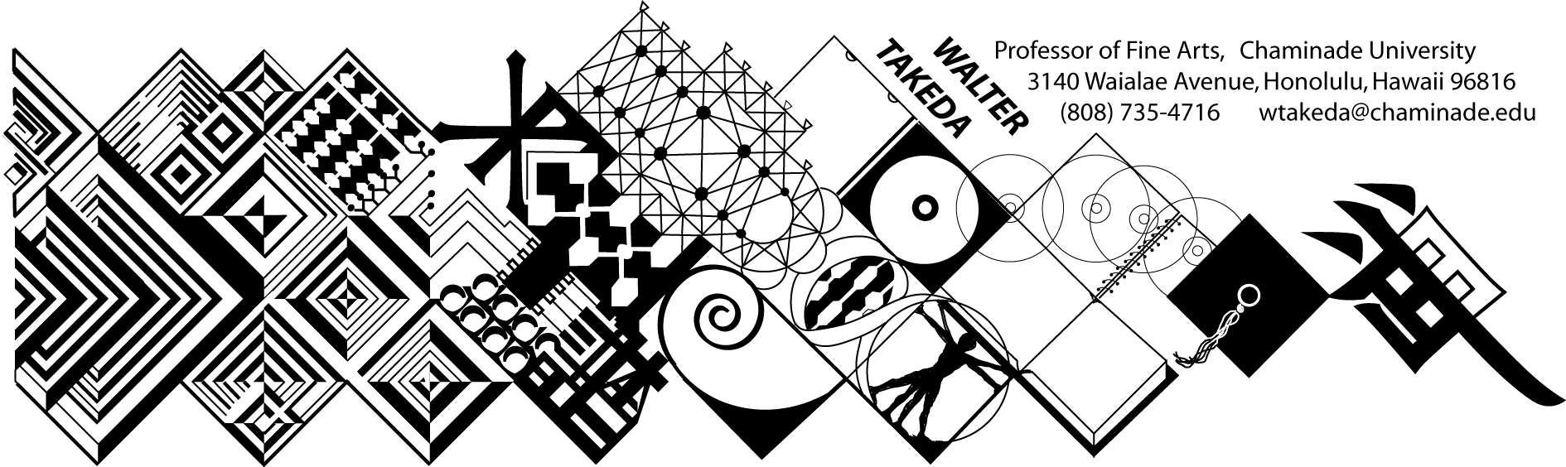
ART 202 Spr 2012
Survey of Art II
Tues/Thurs 8-9:20 am
Henry 227
Text: Art thru the Ages
Office Hrs: afternoons
or appointment E205

COURSE DESCRIPTION: Art 202 is a general survey course, with no prerequisites, that may be used to fulfill CUH's general education fine arts requirement or used as a liberal arts elective.

The material covers a survey of Western art, sculpture, and architecture from the Renaissance to present. In this age of frequent travel, you will undoubtedly have opportunity to visit many of the areas covered. Study of these cultures will result in a deeper understanding of this rich human legacy.

COURSE OUTCOMES: Student Learning Outcomes linked to Program Learning Outcomes:

Upon successful completion of this course, the student will demonstrate an:

- Understanding of the placement of art within its historical context;
- Ability to recognize important aspects of a style, country, or movement;
- Ability to use this understanding and ability to contextualize a given piece of art or artistic movement.

These outcomes are all linked to Program Learning Outcome #4.

This class presents material in chronological order; you are expected to do parallel reading in your text. At the beginning of each class, a pool of slides will be shown of previous critical material. As much as possible, these works will be from the text. After each class, keep a list of this pool of slides, correctly spelled as to artist, title of work and school or style. Use this "mini-review" to good advantage; cramming for THIS class is a poor idea.
Before each exam is a thorough review of the material. Audiotaping this review helps many students. Review slides will be placed on e-College for you to download well before the exam.

COURSE REQUIREMENTS:

Examinations will include objective questions (multiple choice, true/false), slide identification (artist, title, school), and a written comparative analysis (paper) between two works. Your ability to recognize artists and/or styles not in the review pool will take the test beyond mere rote memory; this will be an assessment tool to gauge important goals of this course. These goals include your ability to place art in historical context, recognize important aspects of a style or movement, and recognize individual styles of artists. As such, additional quizzes (which may not count to the grade) may be administered. A comparative analysis paper is also required; a handout to this effect will be distributed later.

MAKEUP EXAMS are a serious matter. Students will notify the instructor BEFORE the exam, then bring in a verifiable excuse, such as a service station invoice, doctor's slip, etc. It is the student's responsibility to abide by these two conditions and the instructor's prerogative to refuse a makeup. The makeup will be scheduled by the instructor, and if the student is again absent, he or she will be given a zero. In fairness to other students, a harder makeup exam will be administered; if it is at all possible to take the test on time, make every effort to do so rather than risk a more difficult exam. THERE IS ABSOLUTELY NO EXTRA CREDIT IN THIS COURSE! The instructor may extend to the entire class an alternative paper in lieu of a bad grade.

GRADING POLICY: A:100-90, B: 89-80, C: 79-70, D: 69-60. Please note that this scale may be different from other instructors. Each exam, including the final, will be equally weighted.

COURSE SCHEDULE:
The instructor reserves the right to adjust the schedule and contents of this syllabus, such as exam times or grading criteria or any other changes. Any announced change made in class is the student's responsibility.

The student is obligated to abide by the conditions of this syllabus, the Chaminade catalog, and the Chaminade student handbook, and cannot claim ignorance of these conditions as an excuse for noncompliance with the requirements herein set.

DATE | TUESDAY | DATE | THURSDAY
Jan17 | Historical overview; proto Renaissance | 19 | The triumph of the Renaissance
24 | Italian Renaissance artists of 15thC | 26 | Internat. Gothic to Early Flemish
31 | High Renaissance: Leonardo, Raphael | Feb2 | Michelangelo
7 | Mannerism, Venetian | 9 | German; Italian Baroque*
14 | Flemish Baroque*; REVIEW | 16 | FIRST EXAM
21 | 17th C Spanish art | 23 | Dutch Realism I
28 | Dutch Realism II | Mar1 | French 17th C art & Versailles
6 | Rococo | 8 | Neoclassicism
13 | Romanticism | 15 | Romanticism to Realism
20 | Impressionism**; REVIEW | 22 | SECOND EXAM
26 | SPRING BREAK | 29 | SPRING BREAK
Apr3 | Impressionism to Post Impressionism | 5 | Cezanne to Cubism
10 | Early American art | 12 | Fauve, Dada, Surrealism
17 | European Expressionism - Action ptg | 19 | Pop to Post Modern
24 | Ming/Qing | 26 | Muromachi
May1 | Edo art | 3 | FINAL EXAM REVIEW paper due
 | FINAL same room

