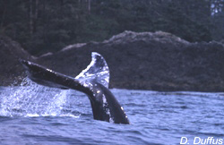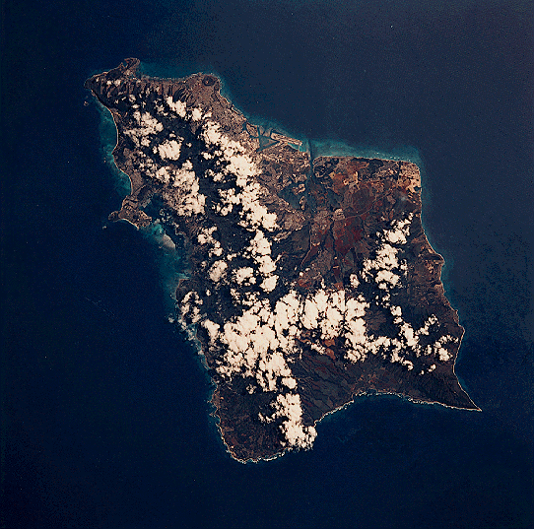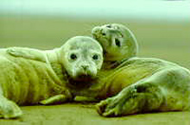
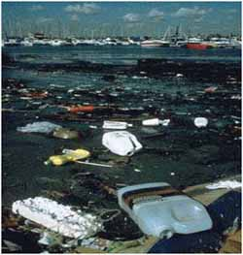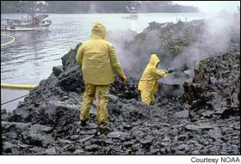

Marine Environmental Science Laboratory: ENV 115L

Laboratory Syllabus
Fall 2011

Human alteration of earth is substantial and growing.
Peter M. Vitousek et al.
Science 1997

Not unlike the lobster, we humans tend not to notice changes in our “water” so long as they happen gradually. For an American, dropping into the “hot pot” of Haiti or Burkina Faso creates a shock of realization: the entire planet is in the same pot, and while their are local spots hotter than others, our “pot” is warming worldwide.
Thom Hartmann
The Last Hours of Ancient Sunlight

Instructor: Dr. Gail Grabowsky (“Dr. Gail”)

Address: Behavioral Sciences Building, room 107
Environmental Studies
Chaminade University
3140 Waialae Ave
Honolulu, HI 96816

Phone: 735-4834 (ext. 834 if calling from on campus)

E-mail address: ggrabows@chaminade.edu

Office hours: TTh: 1:00 – 3:00; Or by appointment

Course Description: This course introduces students to the scientific methodologies used to determining and studying the current major marine environmental issues. Issues studied include: global warming, marine pollution, marine debris, oil spills, fisheries exploitation, fisheries by-catch, marine alien species, coastal development and coral reef degradation. Laboratory exercises are conducted in the field and on the Chaminade campus. Students taking this course will be engaged in field science activities.

Course Learning Outcomes: When you have completed this course you should:
Know what science is and how scientific research is conducted
Be familiar with and experienced at reading the primary scientific literature
Know the basic units used in making scientific measurements
Be able to competently collect, record, analyze, present and interpret scientific data
Be able to write up a scientific research report
Be able to properly collect, identify and preserve marine biological specimens
Be able to identify particular marine organisms and their behaviors in the field
Be comfortable conducting field measurements in a variety of types of marine habitats
Be able to document the physical effects of a number of the major marine environmental issues
Be able to document some of the detrimental effect(s) marine environmental issues have on marine ecosystems

Course Requirements: Your grade in this course will be based on the following. Each of the items/activities listed below will be described to you in writing or orally in class.

- Laboratory worksheets, quizzes, homework, etc. 50%
- Hawaiian Invertebrate/Vertebrate Organism Exposé 20%
- Marine environmental issue Journal Article Critique 20%
- Attendance 10%

Course Grading: The proportion that each of the above contributes to your grade in this course is as follows:

Lab worksheets, etc. 250 points
Hawaiian Invertebrate/Vertebrate Organism Exposé 100

Journal Article Critique 100
Attendance 50
500 points total

Laboratory worksheets and Journal Article Critique will be graded on effort, correctness (when there is a correct response etc.) thoughtfulness and organization. Effort in general manifests itself as neatness, completeness, thoroughness, calories expended per unit time(!), timeliness, correct spelling, any extra creative things you do above-and-beyond what is expected, etc. Correctness means do your statements jive with corresponding scientific knowledge, do your conclusions follow from the evidence before you, did you calculate an equation correctly, interpret a graph accurately, make a table that illustrates your data properly, etc. Thoughtfulness can show up in many ways, perhaps you really think things through, trying to consider all the variables or you worked hard to tie pieces of evidence together, maybe you consider something that may be important that everyone else ignores. By being “thoughtful” I don’t mean that you look out for other people (i.e. are kind) I mean that you have done some thinking, really reflected upon a topic, have given it some time, have analyzed it, etc. thoroughly. Organization pertains to the design of your presentation. Did you present the material, answers, ideas, etc. is a way that is understandable, efficient and follows existing protocol (if they exist and/or are explained prior to the assignment).

Issue homeworks are graded only on effort and thoughtfulness. In order to receive full credit you MUST SHOW ALL YOUR WORK on these lab assignments.

Texts:
Required: There is no required textbook for this lab. Dr. Gail will provide all handouts to you.

Supplemental Texts: We will do a number of laboratory activities that do not come from a specific lab book per se. These have been put together by Dr. Gail and/or her colleagues. You will be given handouts for these labs. There will also be some quantitative “dry labs” which will come out of the book below. You will be given handouts for these as well.

McConnell, Robert, L. and Daniel C. Abel. 2008. Environment Issues: An Introduction to Sustainability. Prentice Hall, Upper Saddle River, NJ.

Things You’ll Need for Class:
- Snorkel Gear: It is NOT a pre-requisite that you be able to snorkel/swim to take this class but you will have the opportunity to do so in lab if you are able. The University does own snorkel gear (mask, snorkel and fins) which each of you can check out from student services. If you want to check this equipment out you MUST do so a few days in advance. If you own your own gear that is great. If you check out the gear be sure and check that it is in working order – particularly that the snorkel valve is in place – on occasion students have checked out gear that is not in working order. Have me check it out if you’d like before you take it in the water to find out it isn’t working!
- Shoes that can get wet: Be sure you have something for your feet that you can cross wet basalt rocks in! These will get wet.
- Water Bottle: Bring this to all labs that occur in the field.
- Sunscreen/hat/etc.: To protect you when we are in the field.
- A love of the field and getting dirty, wet or cold: Guys this is a marine course so will will have/get to go outside! Be ready to be hot/cold, dirty etc. and prepare accordingly. Bring sunscreen if you need it, a towel, a wetsuit, etc. if you’d like and have a mind to be IN nature!

Attendance:
If you miss a lab your absence must be excused if it is not to formally effect your grade. Excused absences occur when you bring in a doctor’s note, a funeral announcement for a family member, notice of participation in athletic events, etc. Unexcused absences occur when you were working, surfing, sleeping, cramming for an exam in another class, etc.
ClassroomAtmosphere:
I value a very open, yet courteous class atmosphere. Express your ideas! Ask your questions! (The only dumb question is the one in which you ask yourself if you should ask your question.) Respect the thoughts and ideas and opinions of others – really think about what others say. Let them fully express their thoughts and ideas and then you do the same. The thing I value most from my college days are all the wonderful, valuable, diverse ways of looking at and understanding the world that I was exposed to. Be an open vessel – take ideas in! You will learn as much from each other as you do from me.

This syllabus and course schedule are living documents: they are free to change. I try to adhere as closely as possible to them for your convenience, but there will be times in which we will take longer on a particular topic or add or delete a topic to enhance the course. I like to be able to react to you as the course proceeds and go with the flow a bit in order to make the course experience sort of custom fit to you!

If you are handicapped under the Americans with Disabilities Act:
Chaminade will provide assistance for any student with documented disabilities. Any student who believes he/she may need accommodations in this class must contact Dr. June Yasuhara (735-4845), at the Counseling Center (office is next to security), in order to determine if you meet the requirements for a documented disability in accordance with the Americans with Disabilities Act. Please contact Dr. Yasuhara as soon as possible so that accommodations can be implemented in a timely fashion.

Reminders of Important University-Wide Policies:
The following policies are summarized from the Student Handbook. Please be sure that you have reviewed these and other policies that your Handbook contains.

Academic Honesty:
Students are responsible for promoting academic honesty at Chaminade by not participating in or facilitating others’ participation in any act of academic dishonesty, and by reporting incidences of academic dishonesty (such as theft of tests, records, and other confidential materials, altering grades, and/or plagiarism) to their instructors.

Freedom of Expression:
Students are free to take reasoned exception to the views offered in a particular course of study. They may be required to know thoroughly the specific bodies of knowledge or interpretations or theories set forth by the professor, but are free to reserve judgment as to the truth or falsity of them.

Students are expected to maintain the standards of academic performance articulated in course syllabi, supplemental readings, assignments and Academic and Student Affairs policies. The instructor is considered the normal and competent judge of academic work. Students have an appeals process in the rare case of unjust grading and evaluation by the procedure detailed in the Academic Grievance section of the Student Handbook.

You are responsible for all of the information in this document:
Losing it or not reading it, are not excuses for not knowing what’s in it!!!

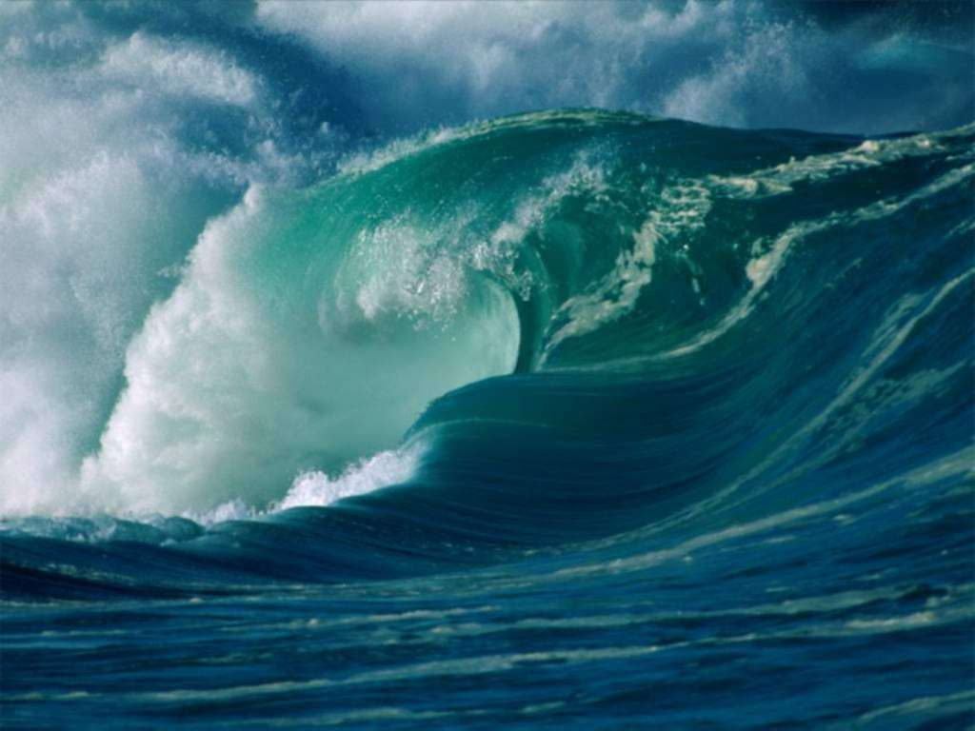

Marine Environmental Science Laboratory

Course Schedule
Fall 2011

DATE LAB TOPIC ACTIVITIES
8/24 Lab Intro; Lab Safety Review lab syllabus; Organisms to know

8/31 Ocean Issues Share a marine issue of concern

9/7 Introductory Video Blue Planet Opener; Critter Quiz: Corals

9/14 Ocean Ecosystems I Blue Planet: Coastal and Seasonal Seas
Critter Quiz: Coral species names

9/21 Hawaiian Organism Exposés Natural history presentations

9/28 Ocean Ecosystems II Blue Planet: Tidal Seas and Coral Seas
Critter Quiz: Invertebrates

10/5 Marine Animals; Animal Phyla Waikiki Aquarium; Lab handout & worksheet

10/12 Marine Plants Diamond Head; Need Field Gear!

10/19 Coral Reef Transects; An Unhealthy Reef Ala Moana; Need Field Gear!

10/26 A Healthy Reef Hanauma Bay; Lab handout & worksheet

11/2 Nutrient Pollution Lab Sand Island Waste Treatment Plant

11/9 Marine Debris Collection & Analysis Waimanalo then back to CUH

11/16 Choose Journal Articles for Critique Meet in the lobby of the library

11/23 Ocean Ecosystems III Blue Planet: Open Ocean and The Deep
Critter Quiz: Vertebrates

11/30 Real Issues in the Research Literature Journal Article Critiques
Critter Quiz: All – Fill in the blank

