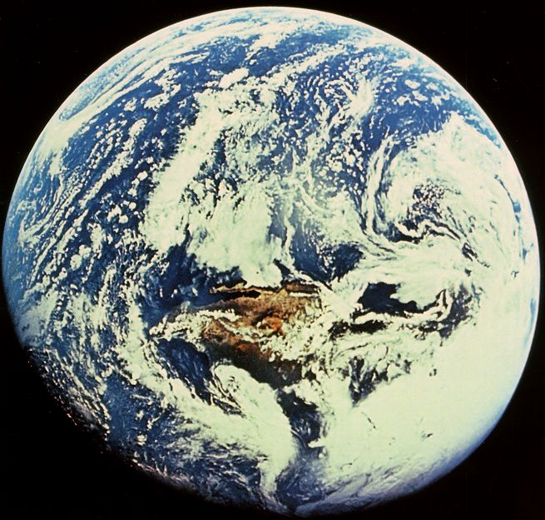

ENV 100: Introduction to Environmental Issues

Fall 2011
Dr. Gail

Syllabus

I find myself wrestling with such demons this early November morning, as my disconnected professional and personal roles clash with my desire for a more cohesive existence. Outside I hear the neighborhood stir with preparations for the new day, the busy pulse of work, school, and commerce projecting a hum of energy and purpose. What seems lacking in all this activity, though, is a sense of integrity – an integration of work and community, a harmony of place and environment.
Stephen R. Kellert
The Value of Life

With all beings and all things we shall be as relatives.
Black Elk

Wilderness remains because we allow it to exist.
Roderick Nash

The environment is too serious a business to be left to environmentalists.
J. William Futell

In the largest sense, humanity’s ultimate economic problem is to use Ultimate Means wisely in the service of the Ultimate End.
Herman E. Daly
Valuing the Earth:
Economics, Ecology, Ethics

The key idea is that we ought not to let the environmental organizations, business lobbyists or the media be alone in presenting truths and priorities. Rather, we should strive for a careful democratic check on the environmental debate, by knowing the real state of the world – having knowledge of the most important facts and connections in the essential areas of our world.
Bjorn Lomborg
The Skeptical Environmentalist

Instructor: Dr. Gail Grabowsky

Address: Environmental Studies, Rm 107 Behavioral Sciences (high-on-the-hill!)
Chaminade University
3140 Waialae Ave
Honolulu, HI 96816

Phone: 735-4834 (ext. 834 if calling from on campus); cell 387-9319 (please don’t call after 9:00 pm)

E-mail address: ggrabows@chaminade.edu

Office hours: TTh: 1:00 – 3:00; Or by appointment

Texts: Watersheds 4: Ten Cases in Environmental Ethics. 4th Edition. 2004. L.H. Newton, C.K. Dillingham, J.H. Choly. Wadsworth Publishing. [ISBN 0534521266]

Earth Insights: A Multicultural Survey of Ecological Ethics from the Mediterranean Basin to the Australian Outback. 1994. J.B. Callicott, University of California Press, Berkeley, CA. [ISBN 9780520085602]

50 Simple Things You Can Do To Save Hawaii. 2007. G.L. Grabowsky. Bess press, Hawaii. [ISBN 9781573062770]

Supplemental Texts: We may be reading articles from each of the following as. If so, copies will be provided to you.
Earth in Mind: On Education, Environment, and the Human Prospect. 1994. D. W. Orr. Island Press.

Ecological Ethics: An Introduction. 2006. P. Curry. Polity press, Malden, MA.

Environment 10/11 (29th edition). 2004. J. L. Allen editor, Dushkin/McGraw-Hill Publisher.

Environmental Ethics: An Introduction to Environmental Philosophy. (4th Edition) 2006. J.R. Des Jardins. Wadsworth Publishing Company.

The Skeptical Environmentalist: Measuring the Real State of the World. 2001. B. Lomborg. Cambridge University Press.

Valuing the Earth: Economics, Ecology and Ethics. 1993. H.E. Daly & K.N. Townsend eds. The MIT Press, London, England.

Watersheds 2: Ten Cases in Environmental Ethics. 1997. L.H. Newton & C.K. Dillingham, Wadsworth Publishing Company, Belmont, CA.

Watersheds 3: Ten Cases in Environmental Ethics. 2002. L.H. Newton & C.K. Dillingham, Wadsworth Publishing Company, Belmont, CA.

Watersheds: Classic Cases in Environmental Ethics. 1994. L.H. Newton & C.K. Dillingham, Wadsworth Publishing Company, Belmont, CA.

Environmental Studies Program Student Learning Outcomes:
This course is one of the required courses for a major, minor or certificate in Environmental Studies at Chaminade University. As such, it has been designed to help students achieve a number of the Learning Outcomes for the Environmental Studies Program. This course also counts as a “Social and Behavioral Science” towards your general education course requirements if you are not and Environmental Studies major or minor.
The learning outcomes for Chaminade’s Environmental Studies degrees were not “pulled out of the sky.” In establishing the Environmental Studies Program at Chaminade, over forty professionals with diverse careers in the environment were asked via a survey: “What do you need to know on the job?” And: “Based on your experience, what do you think anyone graduating with a degree in the environment should know today?” Eighty-five different kinds of responses, all suggestions for what you need to know to successfully work in the “environmental industry” today, were received from the professionals. These comprise the majority of the Program outcomes for a major in Environmental Studies. Dr. Gail will give you a listing of them; it is really important for you to know what these professionals believe you need to know.
A number of additional program learning outcomes were added to those of the professionals by the faculty and administration of Chaminade University. Our outcomes include very practical suggestions like: You need to know what kind of jobs there are in the environment. And some very deep, foundational goals which relate to what Chaminade’s educational mission is, like: You need to know how Catholic Marianist values support environmental efforts. You also need to know the spiritual importance of natural resources from a Catholic and diverse array of other spiritual traditions.
The Learning Outcomes for the Environmental Studies Program are the following:

The Environmental Studies student will demonstrate an understanding of:

- The central importance of spirituality, ethics and worldviews in the “environmental movement”
- The importance of the environment in our own health and well being
- The major environmental issues and their potential solutions
- Problem-solving skills from diverse disciplines for diverse populations
- Scientific reasoning and methodology
- The roles and importance of laws, politics and economics in environmental issues
- Career opportunities in the environment

Introduction to Environmental Issues:
This is the first course along the path to a degree (major or minor) in Environmental Studies at Chaminade. It is the most general, interdisciplinary and inclusive course that you’ll take as an Environmental Studies student. This course introduces you to a variety of careers in the environment and to real people with those careers. Through this course you will discover the complexity of environmental challenges and the diversity of environmental values, and you will begin to learn and use the tools and techniques required for successful environmental problem solving.
In this class you will be presented with real (International and Hawaiian) environmental issues which you will investigate, attempt to understand in entirety and devise a solution or solution-strategy for. Issues are organized into three "modules:” (1) WATER & AIR issues, (2) TERRESTRIAL ECOSYSTEM issues, and (3) HUMAN DEVELOPMENT issues. At the end of each module you will choose your own contemporary issue that pertains to the module and: gather information on that issue, pool information to gain a full understanding of the problem, network with one another and discuss the problem, devise possible solutions, negotiate, and finally reach a hypothetical solution which you will “advocate” in a presentation to the class. Solutions must be systems based: they must address the entire issue. Each subsequent module will be more complex than the previous one requiring you to draw upon the perspectives of a wider range of disciplines and manage more variables. This course is meant to introduce you to the sorts of multidisciplinary tasks you will be learning about in greater detail in later courses and performing in your future careers.
You will also have the opportunity throughout this course to participate in service learning activities aimed at ameliorating some of the environmental challenges discussed in the classroom. These hands-on, problem-solving approaches allow you to discover the many disciplines and techniques involved in ameliorating real environmental challenges.

ENV 100 Course Learning Outcomes:
The fifteen particular outcomes that this course should provide you with are:

- Knowledge of diverse environmental ethics and their implications for the treatment of nature.
- An understanding of the positive roles Judeo-Christian and Polynesian worldviews can play in environmental problem solving.
- Knowledge of the importance of natural resources for the holistic health of diverse peoples.
- A thorough understanding of some of the major historical environmental crises.
- An awareness of the complexity of environmental issues and the important role of ethics, science, education, economics, the media and politics in environmental problem solving.
- Knowledge of the diverse perspectives of stakeholders.
- The ability to take a balanced outlook to environmental problems.
- The ability to collaborate with others in developing a systems approach to creative environmental problem-solving.
- Knowledge of the major federal, state and non-governmental environmental agencies.
- Familiarity with a variety of careers in the environment.
- An understanding of the connections between academic work and real-life situations.
- Increased interest in being civically engaged due to your service learning experience.
- An understanding of human behavior relative to adapting to various changing environmental contexts.

Course Modules:
NOTE: Specific topics for each module are subject to change!
These are the Modules, in order, for the course:
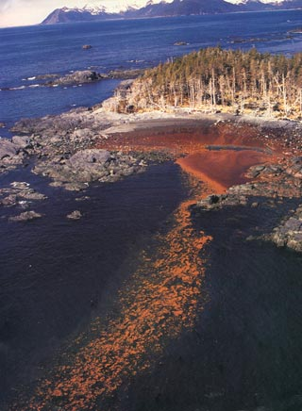

Module 1: WATER and AIR ISSUES (8/22-9/30)

Classic historic water/air issues: The Exxon Valdez
Decline of Atlantic Cod
The Ozone “Hole”

Contemporary water/air issues: Coral Reef Aquarium Fish Collection
Great Pacific Garbage Gyre
BP Oil Spill
Ocean Acidification
Global Warming…

Module 2: TERRESTRIAL ECOSYSTEM ISSUES (10/3-10/28)
Classic historic terrestrial eco issues: Old Growth Redwood Forests

Silverback Gorilla Decline

Contemporary terrestrial nature issues: Monk Seal Murders
Conversion of Ag.Land to Urban
Alien Swamp Rats in New Orleans…

Module 3: HUMAN DEVELOPMENT ISSUES (10/31-12/2)

Classic historic development issues: Love Canal

The Disaster at Bhopal Chemical Plant

Contemporary development issues: Mass Transit

Landfills on Oahu

New Incinerator on the Big Island…

Grading:
Your grade in this course will be based on your take-home exams, presentations, and cumulative quiz and assignment scores. There will be 3 take-home exams: one after the completion of each module. Exams I and II will be handed out to you on the last day of each module and will be due one week later. Exam III, covering the third module, will be due on the day scheduled for our final exam. Exams will cover topics, ideas and concepts addressed in each module.
Presentations will be prepared by groups of students and will be presented at the end of each module. Presentations will be based on a particular international or local environmental issue and will (1) demonstrate students’ understanding of the issue, (2) demonstrate the students’ awareness of each of the components AND “stakeholders” involved in the issue, (3) demonstrate the students’ understanding of all of the ethical aspects of the issue and (4) demonstrate the students’ ability to attempt to devise a solution to the problem, which may incorporate a number of compromises in the eyes of each of the stakeholders. There will be three presentations. The specific topic of each will be decided within each module by you! The final presentation will be given on the day our final exam is scheduled (Wednesday, December 7, from 8:30-10:30 AM). Because of Dr. Gail’s cancer surgery which will occur most likely in late November or early December you may be making one of your presentations to each other in a recorded session that Dr. Gail will watch and grade at home.
In addition to the take-home exams and presentations, there will quizzes following most, if not all, of the readings. The quizzes will be multiple choice and will be given on the day the reading assignment was to be finished. If you miss a quiz and you do not have an excused absence (see below for definition of an excused absence) you will receive a zero for that quiz score. You will be allowed to drop your lowest two quiz scores.
There will be a few additional assignments as well throughout the class. These will include, but are not limited to, an exposé on an environmental agency and an environmental career description. These will be explained in class before they are due.

Grading will be quantified as follows:

Exam I 20% (200 points)
Exam II 20% (200 points)
Exam III 20% (200 points)
Quizzes and Assignments 20% (200 points)
Presentations 20% (200 points)
100% (1000 points total)

Environmental Ethics:
Because an important part of this course entails imparting on you an awareness of the importance of ethics in environmental-problem solving, and because the professors in the Environmental Studies Program want you to be aware of the huge variety of kinds of environmental ethics in the real world, we will devote class time to discussions of the various environmental ethics of peoples from all over the world. We will use the books: Valuing the Earth and Earth Insights: A Multicultural Survey of Ecological Ethics and Environmental Ethics: An Introduction to Environmental Philosophy as sources of information for this topic. At the end of the course we will try and forge the ideal eco ethic….

Course Materials:
Most of the readings for the course will come from the books you had to buy for the course. I will provide a few of the readings in the course to you. These will come from diverse sources. You will need access to both a library and the worldwide web. You will also need to have DVD’s/USB’s etc. that can hold your Power Point presentations.

Attendance: Role will be taken every day in class (we need to do this in order to be able to retain a number of important federal grants the University receives). Attendance is required. You are all allowed two unexcused absences before your grade is effected. Excused absences are those in which you have a doctors official, signed note, and obituary/funeral notice, a letter from the Athletic Department or an invitation to a Family reunion/wedding and an airplane ticket stub. I am a scientist; I require hard evidence if an absence is to be excused. If you miss a quiz with an excused absence you can make up the quiz; if you miss a quiz due to tardiness or an unexcused absence you cannot make up the quiz and you will receive a zero for that quiz score.

Extra Credit Options:
Periodically throughout the course there will be talks and presentations you may attend that pertain to the course material. I will let you know when these opportunities arise OR you may discover them and bring them to the class’s attention. You can earn +2 extra credit points towards a lecture exam for each talk you attend. If you do any service activities that relate to the environment AND that require you work for 3-5 hours you can receive +3 extra credit points per outing towards a lecture exam. In order for all talks and service activities to count for extra credit you MUST have them approved by Dr. Gail PRIOR TO the event and you MUST document your presence with a photograph of yourself participating AND give Dr. Gail the name and phone number of the person in charge or speaker/presenter. If there are any handouts from the event bring them as evidence of your attendance as well. You may earn up to 30 extra credit points from service activities and 10 from attending talks/presentations.

Classroom Atmosphere:
Guys, I value a very open, yet courteous class atmosphere. Express your ideas! Ask your questions. Propose solutions. (The only dumb question is the one in which you ask yourself if you should ask your question.) Respect the thoughts and ideas and opinions of others – really think about what others say. You will learn as much from each other as you do from me.

If you are handicapped under the Americans with Disabilities Act:
Chaminade will provide assistance for any student with documented disabilities. Any student who believes he/she may need accommodations in this class must contact Dr. June Yasuhara (735-4845), at the Counseling Center (office is next to security), in order to determine if you meet the requirements for a documented disability in accordance with the Americans with Disabilities Act. Please contact Dr. Yasuhara as soon as possible so that accommodations can be implemented in a timely fashion.

Nothing is Certain but Change Itself Clause…
This syllabus and course schedule are living documents: they are free to change. I try to adhere as closely as possible to each, but there will be times in which we will take longer on a particular topic or add or delete a topic to enhance the course. I like to be able to react to you as the course proceeds and go with the flow a bit in order to make the course experience sort of custom fit to you!

You are responsible for all of the information in this document: losing it or not reading it are not excuses for not knowing what’s in it!
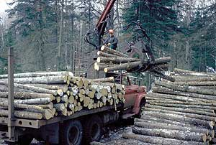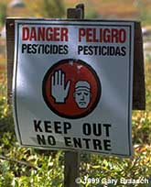
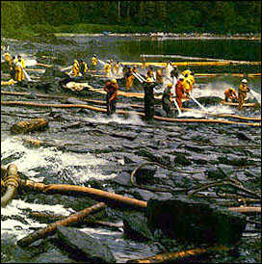

Introduction to Environmental Issues

Course Schedule

Week of: Readings & Activities

Module 1: WATER and AIR ISSUES

8/22-8/26 Course Introduction; Pre-Assessment
First Issue Reading
Environmental Ethics: Chapter 1 [“Sci, Ethics and the Enviro”] (handed out to you)

8/29-9/2 First Issue (continued); Discuss handout from Environmental Ethics

9/6-9/9 Second Issue Reading

9/12-9/16 Second Issue (continued)
Ethics Video; Choose Presentation Topics & Groups

9/19-9/23 Earth Insights: Chapter 2 [Western European enviro ethics];
Enviro Agency Exposé

9/26-9/30 Second Issue (continued)
Take-Home Exam handed out 9/29, DUE 10/6 by 11:35
Current Water/Air Issues Presentations on 9/29

Module 2: TERRESTRIAL ECOSYSTEM ISSUES

10/3-10/7 First Issue Reading

10/11-10/14 Earth Insights: Chapter 6 [Polynesian enviro ethics]
Enviro Careers Exposé; Ethics Video

10/17-10/21 Second Issue Reading; Reading on Steady-State Vs Growth Economies (handed out to you)

10/24-10/28 Second Issue (continued)
Take-Home Exam handed out 10/27, DUE 11/3 by 11:35
Current Terrestrial Ecosystem Issues Presentations on 10/27

Module 3: HUMAN DEVELOPMENT ISSUES

10/31-11/4 First Issue Reading

11/7-11/10 Earth Insights: Chapter 4 [East Asian Deep Ecology enviro ethics]

11/14-11/18 Second Issue Reading

11/21-11/25 Environmental Ethics: Chapter 4 [Responsibilities to Future Generations]

11/28-12/2 Earth Insights: Chapter 9 [Postmodern enviro ethics];
The Ideal Eco-Ethic?; Post-Assessment

Third take-Home Exam handed out 11/29, DUE on 12/7 by 8:30 AM

You will give your third presentations covering Current Human Development Issues on 12/7 from 8:30-10:30 AM.


