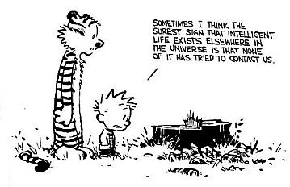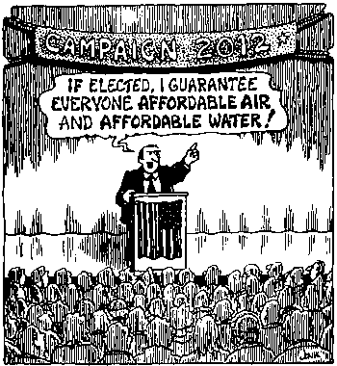

ENV 400: Current Global Environmental Issues

Course Syllabus
Spring 2011

Human alteration of earth is substantial and growing.
Peter M. Vitousek et al.
Science 1997

Beyond our genetic coding, we need to go to the earth, as the source whence we came, and ask for its guidance, for the earth carries the psychic structure as well as the physical form of every living being upon the planet. Our confusion is not only with ourselves; it concerns also our role in the planetary community.
Thomas Berry

Not unlike the lobster, we humans tend not to notice changes in our “water” so long as they happen gradually. For an American, dropping into the “hot pot” of Haiti or Burkina Faso creates a shock of realization: the entire planet is in the same pot, and while their are local spots hotter than others, our “pot” is warming worldwide.
Thom Hartmann
The Last Hours of Ancient Sunlight

Instructor: Dr. Gail Grabowsky

Address: Behavioral Sciences Building, room 107
Environmental Studies
Chaminade University
3140 Waialae Ave
Honolulu, HI 96816

Phone: 735-4834 (ext. 834 if calling from on campus)

E-mail address: ggrabows@chaminade.edu

Office hours: MTF: 2:00 – 5:00; Or by appointment

Texts:
Required: You should purchase these in the bookstore.

Worldwatch Institute. State of the World 2010: Transforming Cultures from Consumerism to Sustainability. W.W. Norton & Company. 2010.
Allen, John, L. ed., Annual Editions 10/11. 29th ed. Dushkin/McGraw-Hill. 2009.
Easton, Thomas, A. Taking Sides: Clashing Views on Controversial Environmental Issues. 13th ed. McGraw-Hill/Dushkin, 2010.
Worldwatch Institute. Vital Signs 2010. W.W. Norton & Company. 2010.

Selected Readings List: (Readings and handouts from these and others will be provided to you as copies throughout the course.)

Brown, Lester, P. The Worldwatch Reader on Global Environmental Issues. W.W. Norton & Company. 1998.
Brown, Lester, P. Eco-Economy: Building an Economy for the Earth. W.W. Norton & Company, 2001.
Dowie, Mark. Losing Ground: American Environmentalism at the Close of the Twentieth Century. The MIT Press, 1995.
Getis, Judith. You Can Make a Difference: Be Environmentally Responsible. WBC/McGraw Hill. 1999.
Goldfarb, Theodore, D., ed. Notable Selections in Environmental Studies, 10th ed. Dushkin/McGraw-Hill. 2004.
Goodwin, Neva, R., Frank Ackerman and David Kiron eds. The Consumer Society. Island Press. 1997.
Gore, Al. Earth in the Balance. Houghton Mifflin Company. 1992.
Harns, Valerie and others eds. The National Audubon Society Almanac of the Environment: The Ecology of Everyday Life. Grosset/Putnam Books. 1994.
Hartmann, Thom. The Last Hours of Ancient Sunlight. Mythical Books. 1998.
Honey, Martha. Ecotourism and Sustainable Development: Who Owns Paradise? Island Press, 1999.
Jackson, Robert, M., Annual Editions: Global Issues 00/01. 16th ed. Dushkin/McGraw-Hill. 2000.
Kennedy, Robert, F. Crimes Against Nature. HarperCollins Publishers, 2004.
LaRoe, Edward, T. and others eds. Our Living Resources: A Report to the nation on the Distribution, Abundance, and Health of U.S. Plants, Animals, and Ecosystems. U.S. Department of the Interior & U.S. Geological Survey Biological Resources Division. 1995.
Lomborg, Bjørn. The Skeptical Environmentalist: Measuring the Real State of the World. Cambridge University Press. 2001.
Mac, Michael, J and others eds. Status & Trends of the Nation’s Biological Resources. Vols 1 & 2. U.S. Department of the Interior & U.S. Geological Survey Biological Resources Division. 1998.
Makower, Joel. The Green Consumer. Penguin Books. 1993.
Underwood, Larry. Case Studies in Environmental Science, 2nd ed. Harcourt College Publishers. 2001.
Union of Concerned Scientists, eds. World Scientists’ Warning Briefing Book. Union of Concerned Scientists. 1993.
Wilson, Edward. O. ed. Biodiversity. National Academy Press. 1988.
Worldwatch Institute. State of the World 2002. W.W. Norton & Company. 2002.
Worldwatch Institute. State of the World 2003. W.W. Norton & Company. 2003.
Worldwatch Institute. State of the World 2004. W.W. Norton & Company. 2004.
Worldwatch Institute. State of the World 2005. W.W. Norton & Company. 2005.

(This list may not include all of the sources of our outside readings. I may choose additional sources as new articles become available throughout the semester.)
Course Description:
This course surveys the major environmental challenges facing the planet-at-large and those issues that are particularly poignant to island peoples today. Students will learn, discuss and debate the major proximal cause(s) and potential short-term and long-term consequences of each issue as far as they are currently known. Issues covered will include: population increase, global warming, fresh water consumption, fresh water pollution, waste management, species extinction, habitat depletion, coral reef bleaching, resource depletion, urban sprawl/development and more.

General Purpose of the Course:
This is an interdisciplinary course with the general goal of having us come to understand and be able to: explain, dialogue, intelligently argue-about, problem-solve and see the connections between, the major environmental issues facing the people and ecosystems of planet Earth today. This course does not exist solely in the classroom; it is a course aimed at helping us know, act and better live in our current world. You may take what you learn through this course with you when you graduate. You may share it with your friends and family or take it with you into your workplace to effect change there. You might spread the facts and actions you’ve learned around to those who are interested and lacking in the experience we will have in this course. Who really knows what you might do with what you learn and do in this course but I bet it will change your life and the lives of others through you!

Environmental Studies Learning Outcomes this course helps to meet:
Since this course is required for students seeking a certificate, minor or major in Environmental Studies it has been designed to partly teach some of the Environmental Studies Program Learning Outcomes. Specifically this course helps the Program to meet 5 of its seven Program Learning Outcomes. Those five are the following:

A student graduating with a bachelor of science in Environmental Studies will be able to…

- Demonstrate an understanding of the central importance of spirituality, ethics and worldview in the “environmental movement”
- Demonstrate problem-solving skills from diverse disciplines for diverse populations
- Demonstrate an understanding of science and scientific investigation
- Demonstrate and understanding of the roles and importance of laws, politics and economics in environmental issues
- Demonstrate an understanding of the major environmental issues and their potential solutions

Student Learning Outcomes for this particular course:

Students taking this course will demonstrate an understanding of:
- The major global and Pacific Island environmental issues
- The causal sequence of events that is believed to have resulted in/created each of the global issues discussed in class
- The general mechanism(s) by which each of the issues discussed is detrimental to people and/or ecosystems
- One or more potential solutions to each environmental issue and the pros and cons of each from a variety of stakeholder perspectives
- The role of diverse environmental ethics in contributing to the creation of and solutions to global environmental issues
- How to effectively argue for particular solutions to environmental issues
- The connections between environmental issues and real-life situations
- Their hands-on role in issues of public concern
- How service-learning increases student interest in being civically engaged

Course Requirements:
Your grade in this course will be based on the following. Each of the items/activities listed below will be described to you in writing or orally in class. The dates of each activity (or its parts) are indicated on the Schedule portion of this syllabus.

- One midterm and one final exam based on all our readings & discussions
- “Causes, Consequences and Solutions” Portfolios (2)
- Issue Exposés (You lead discussion)
- Environmental service and reflection

Course Grading: The proportion that each of the above contributes to your grade in this course is as follows:
Midterm & Final Exam 30%
“Causes, Consequences and Solutions” Portfolios 20%
Issue Paper Exposé & Discussion Leading 30%

Service Learning 20%
100%
The proportion that each of the above contributes to your grade in this course is as follows:

Midterm & Final Exam 300
“Causes, Consequences and Solutions” Portfolios 200
Issue Paper Exposé & Discussion Leading 300
Service Learning 200
1000

Midterm & Final Exam: Covers the readings. Multiple choice. Date and time of each noted in the Schedule portion of this syllabus. Your “Causes, Consequences and Solutions” portfolios, class notes, highlighted readings and discussion notes will be your best study aids for the exams!

“Causes, Consequences and Solutions” Portfolios: For Two of the global issues (of your choice) that we cover in class, you will be required to turn in a written explanation of the: (1) Causes, (2) Consequences and (3) potential Solutions for that issue. Portfolios will be due two weeks (to the day) after we finish each issue. There is no length requirement. Late papers will not be accepted. Plagiarism within your portfolios will result in you receiving an F for the course. Details describing the grading criteria for these explanation papers will be shared with the class in the form of a grading rubric handout prior to the due date of the first paper.

Global Environmental Issue Exposés: In past terms I have led the discussions for each of the global environmental issues that we cover. I have decided that this year I will have each of you lead one or two guided discussions (depending on the size of the class). In this course we read a number of contemporary articles about each of the issues. You will each lead a discussion about one or two of the articles. I’ll explain the grading parameters for this assignment in class. You will choose your issue(s) early in the course. I am going to let you choose the article(s) the class will read and that you’ll explain if you’d like to choose it. You must have the article approved by me. If you don’t want to choose it, I can choose one for you. Finally, you MUST get the paper to me so I can scan or copy it for the rest of the class ONE WEEK prior to the day you lead discussion or you will receive an F for your discussion.

Assessment: You will be given an assessment survey for this course on the first day of class. The assessment will be administered again on the last day of the course. The results will be analyzed so that I may learn what you think you learned and in so doing learn whether the course is helping to meet the Environmental Studies Program learning outcomes. The assessment has no effect on your course grade.

Attendance: Excused absences include being ill with a doctor’s note, missing for a work-related, family related emergency and/or missing for an athletic event/retreat/research paper presentation at a symposium. You’ll need to provide some kind of documentation or a phone number of someone responsible that I may call in order to verify the urgency of the reason for your absence. Otherwise you are all allowed FOUR, and only four, unexcused absences, after the fourth absence you will lose 25 points from your overall grade for each unexcused absence….

Course Atmosphere: This course is meant to be a seminar experience; it is not a lecture course. This means we will be discussing issues, the readings, our ideas and opinions, watching videos, debating each other and educating each other almost every day. So if you are shy you’ll have to try and shed that skin and be bold! Fake it if you have to – remember that everyone’s thoughts are valuable and if you don’t share yours the rest of us will be denied that “gold.”
In order to speak in class you do not have to raise your hand, but do please wait for people to finish what they are saying before you start to speak. We learn from each others often differing opinions…the point of this class is not to all agree on topics related to each of the issues. Be an “open vessel,” listen to what others say and think about their points and points of view. You will learn more from each other that from your professors as you go through college!!!

If you are handicapped under the Americans with Disabilities Act:
Chaminade will provide assistance for any student with documented disabilities. Any student who believes he/she may need accommodations in this class must contact Dr. June Yasuhara (735-4845), at the Counseling Center (office is next to security), in order to determine if you meet the requirements for a documented disability in accordance with the Americans with Disabilities Act. Please contact Dr. Yasuhara as soon as possible so that accommodations can be implemented in a timely fashion.

Nothing is Certain but Change Itself Clause…
This syllabus and course schedule are living documents: they are free to change. I try to adhere as closely as possible to each, but there will be times in which we will take longer on a particular topic or add or delete a topic to enhance the course. I like to be able to react to you as the course proceeds and go with the flow a bit in order to make the course experience sort of custom fit to you!

You are responsible for all of the information in this document: losing it or not reading it are not excuses for not knowing what’s in it!

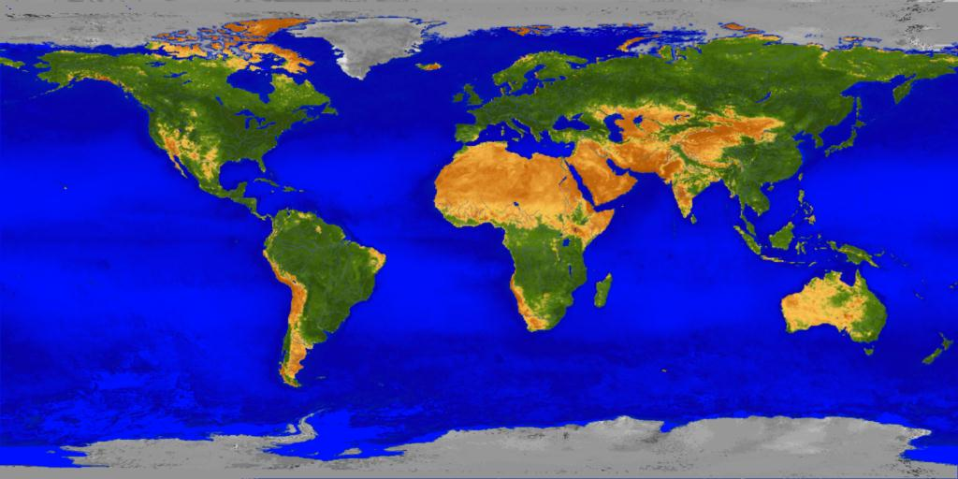
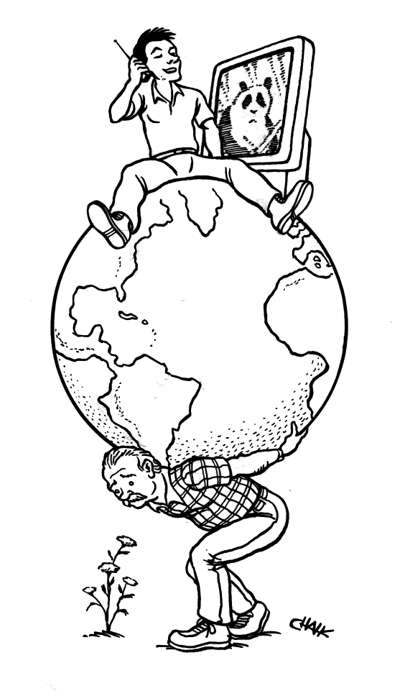

Current Global Environmental Issues
First day of class version

Course Schedule
Spring 2011

WEEK TOPIC PRESENTERS ACTIVITIES
1/11 – 1/15 Course Introduction & Mechanics Introductions; Course Assessment
Introduction to Global Enviro Issues Dr. Gail Reading/Discussion

1/10 – 1/14 Precautionary Principle/Pop Growth Dr. Gail Reading/Discussion

1/18 – 1/21 Consumerism ________________ Reading/Discussion

1/24 – 1/28 Solid Waste/Recycling ________________ Reading/Discussion

1/31 – 2/4 Food Availability ________________ Reading/Discussion

2/7 – 2/11 Water consumption ________________ Reading/Discussion

2/14 – 2/18 Water Pollution ________________ Reading/Discussion

2/22 – 2/25 Climate Change ________________ Reading/Discussion

2/28 – 3/4 Energy ________________ Reading/Discussion, Mid Term 3/4

By Monday 3/7: You MUST have at least ONE Portfolio turned in already

3/7 – 3/11 Species Extinction ________________ Reading/Discussion

3/14 – 3/18 Habitat Loss ________________ Reading/Discussion

3/21 – 3/25 S P R I N G B R E A K (Read on the beach!)

3/28 – 4/1 ________________ Reading/Discussion

4/4 – 4/8 ________________ Reading/Discussion

4/11 – 4/15 ________________ Reading/Discussion

4/18 – 4/21 _____________________________ ________________

4/25 – 4/29 Summary of Issues; Sustainability ________________ Reading/Discussion
Solutions roundtable

Important Dates You Should Know:
- You MUST turn in your SECOND and final portfolio by Tuesday, May 3rd at 10:35 AM
- Final Exam: Tuesday, May 3rd, from 10:30-12:30 PM in our regular classroom.



