
EDUC 652 Multicultural Education and Diversity
Semester/Year  Winter, 2011 | Instructor:  Bobbie Martel
Course# and Credits:  ED 652 3 credits | Email:  Roberta.martel@adjunct.chaminade.edu
Class Title:  Multicultural Education and Diversity | Telephone:  455-0632 (office) or cell: 777-8841
Course Format:  Online | Office Hours/When to Contact:  Office Hours by Appointment  Contact by phone/email
Class Location:  www | Office Location:  455-0632 or cell: 777-8841
Class Time/Day:  www | Other:  Leeward Community College, DA 205A
O&P/Service Requirement:
n/a

Catalog Description:
ED 652 Multicultural Education and Diversity (3) Diversity describes the wide range of racial, cultural, ethnic, linguistic, and religious variation that exists with and across societies. This course explores multicultural and diversity issues as they affect classroom and school cultures with a focus on developing sensitivity to all types of diversity for community building at local and global levels.

Conceptual Framework:

The Education Division’s Conceptual Framework is based upon a set of beliefs that flow from the University’s vision and mission statements, the Division’s vision and mission statements, and the core academic beliefs of Chaminade University. These values and beliefs are based on the Catholic Marianist principles; a commitment to mentor teacher and educational leader candidates to their fullest potential; a commitment to teaching, scholarship and research; and a commitment to serve the university and the larger community. This alignment is designed to prepare education professionals who meet the National Council for Accreditation of Teacher Education (NCATE) standards for effective teaching by demonstrating professional dispositions and empathy, content knowledge, and the pedagogical/leadership skills to work effectively work with a diverse community of learners.

Marianist Values, Multicultural Education and Diversity

At Chaminade we embrace the Marianist value of “Education and the Family Spirit, ” similar to the Hawaiian value of Ohana. We view our students as participants in a community of learners, and encourage the personal development of each member of the community. According to Bro. James Wisecaver, today the hallmark of American Catholicism is diversity – in ethnic heritage, social class, family structure, educational level, spiritual formation, and theological orientation. In this regard at Chaminade we take the responsibility of knowing our students and their backgrounds as central to our educational goals, but we also embrace the personal history and rich heritage that our students bring as a resource.

Therefore, the underlying ethos of ED 652 is to engage you first in an examination of your own background, identity, and characteristics, and then to ask you to analyze how these factors play out in teaching and learning. In today’s world diversity is a multi-dimensional construct. While the multicultural component (race and ethnicity) is central to an understanding of diversity, in today’s world diversity is a multi-dimensional construct as illustrated in the figure below. This course is designed to help you understand how this complex set of variables impact both you and your students.

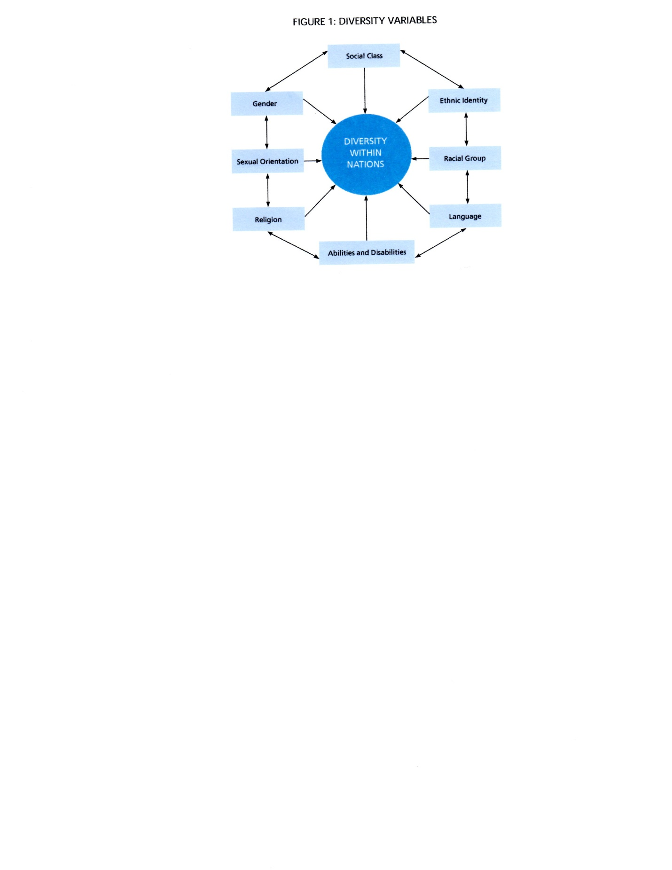
Adapted from Banks, J. (2001). Cultural Diversity and Education: Foundations Curriculum, and Teaching , p. 76 (4th Edition). Boston: Allyn & Bacon.

Program Learning Outcomes (PLOs):
Successful teacher candidates in Chaminade initial teacher licensure programs will demonstrate knowledge, skills, and dispositions in the following areas:

PLO1 | Content Knowledge (Knowledge of subject matter)
PLO2 | Developmentally Appropriate Practice (Knowledge of how students develop and learn, and engagement of students in developmentally appropriate experiences that support learning )
PLO3 | Pedagogical Content Knowledge (Knowledge of how to teach subject matter to students and application of a variety of instructional strategies that are rigorous, differentiated, focused on the active involvement of the learner)
PLO4 | Educational Technology (Knowledge of and application of appropriate technology for student learning)
PLO5 | Assessment for Learning (Knowledge of and use of appropriate assessment strategies that enhance the knowledge of learners and their responsibility for their own learning)
PLO6 | Diversity (Skills for adapting learning activities for individual differences and the needs of diverse learners and for maintaining safe positive, caring, and inclusive learning environments)
PLO7 | Focus on Student Learning (Skills in the planning and design of meaningful learning activities that support and have positive impact on student learning based upon knowledge of subject matter, students, the community, curriculum standards, and integration of appropriate technology)
PLO8 | Professional & Ethical Dispositions and Communication (Professional dispositions, professionalism in teaching, and ethical standards of conduct consistent with Marianist values, and positive and constructive relationships with parents, the school community and professional colleagues)

Course Learning Objectives:
At the end of this course, the students will:
CLO 1  (HTSB 2,3,4,9,10)) | Describe and identify cultural factors and other dimensions of diversity (e.g., social class, gender, sexual orientation, language, ability) that have significant impact on their own and their students’ lifestyles, attitudes and behaviors
CLO 2  (HTSB 1,3,5) | Define and describe the major theoretical concepts and issues in multicultural education and diversity
CLO 3  (HTSB 1,2,3,4,5) | Identify, discuss and analyze the impact of culture on learning, focusing especially in connecting knowledge of content areas to students’ prior experiences, personal interests and real life situations
CLO 4  (HTSB 1,2,3,4,5,7,8,10) | Demonstrate knowledge of appropriate teaching strategies for productive learning environments in a multicultural school setting, focusing especially on the use of appropriate assessment strategies and culturally responsive teaching

Linkages between Course Learning Objectives (CLOs) and Program Learning Objectives
 | PLO 1 | PLO 2 | PLO 3 | PLO 4 | PLO 5 | PLO 6 | PLO 7 | PLO 8
CLO 1 | X |  |  |  |  |  |  | X
CLO 2 | X |  |  |  |  | X
CLO 3 |  |  | X |  |  |  | X | X
CLO 4 |  |  | X |  | X | X |  | X

Essential Questions Addressed in This Course
Essential Questions | Related CLOs | Related PLOs
What are the key dimensions of cultural and ethnic identity as well as other dimensions of diversity that define my own identity and behavior as well as the identity and behavior of my students? | 1 | 3,6,8
Why multicultural education and education for diversity? | 1 - 2 | 1,6,7,8
How does the diversity in the classroom influence teaching and learning? | 1, 2, 3, 4 | 3, 6, 8

Key Teaching-Learning Strategies
This is an on-line course. The learning strategies include:
- Online discussions
- Written assignments
- Written and “visual” presentations via powerpoint
- Self-reflection
- Individual research
- Interviews
Course Requirements
Assignment | Pts | Assignment Description | Due Date
Assigned Questions | 70 | These will be assigned from your readings. Answers should be based on content from the texts (citations included) and include a reflective statement/response to the question as to how this topic has impacted your thinking as a teacher/guide for children. This assignment is designed to help you integrate content from the readings. Write 1-2 double-spaced, page(s) for each question. **Your first assignment will be your “I am” poem due in week 1. ***Weeks 2 &3 you will work on your case study due 1/31. | - 1/17  - 1/31  - 2/7  - 2/14  - 2/21  - 2/28  - 3/14
Personal Cultural Identity | 45 | As educators we bring our culture, ethnicity and identity into the classroom. This assignment is designed to support you in becoming more aware of the impact of your own family history and values on the expectations you have for yourself as a teacher and for the children you teach. An important part of this assignment is an interview with one of your elders.  The following subtopics should be included:  *Information on your own cultural, ethnic and socio-economic background as well as any other important identity markers.  *How the knowledge gained from the interview reflects on your own cultural values.  *How this knowledge is important in teaching students from different and similar backgrounds, ethnic groups, and genders. | 2/14
Student Presentation |  | You will create a visual presentation of your Personal Cultural Identity assignment. Using a power point you will present an identity “map” celebrating YOU! Please include pictures, family traditions, family history, etc. | 2/14
Signature Assignment | 75 | Research Paper and Power-point Presentation: The research paper should focus on a particular culture or sub-culture. Choose a group that does or will appear in your classroom or that you wish to learn more about and is different from your own background. In your paper be sure to include the following as SPECIFIC subtopics within your paper:  1 The history and percentage of the group in the state as well as in public school settings.  2 Use of language, time and space in the group  3 Barriers to learning in the traditional American mainstream school setting.  4 Traditional learning styles of the group  5 Teaching styles and pedagogy that show promise in working with the group, as well as some practices that do not appear useful, especially with reference to assessment practices.  6 Personal experiences with the group  Paper must be written in APA style for the title page, body and references section, including use of 12 point font, double spacing throughout, correct use of citations in the body of the paper, and correct form for the references section. Minimum of 10 pages. The power-point slide show should be prepared for a community audience of parents and other teachers. It should have a minimum of 7-10 slides. Due the 9th class session | 3/20
Participation | 30 | Participation and Punctuality:  Full points will be awarded to those who participate on-line with enthusiasm and demonstrate interest in discussions and activities, as well as turn in assignments on time. | Ongoing

Assessment:
Your performance in this course will be assessed on the following:
- Personal Identity Paper: Full points will be awarded to papers that include all factors identified in the assignment, and include transcript “snippets” from the elder interview to enhance the reader’s understanding of the cultural background being described. The paper should be 5 - 7 pages including the interview.
- Personal Identity presentation: Full points will be awarded to those who create a visual display of their cultural heritage. The power point should be presented including pictures, dates and family history.
- Answers to Assigned Questions: Answers to the question related to the reading should be posted by the dates stated above. Full points will be awarded to papers that are submitted on time, are thorough in their response, include a reflective section, and are written to graduate standards of writing. Points will be deducted for late submissions.
- Research Paper: Research paper is to be written in formal academic style. Full points will be awarded to papers that are turned in on time, typed, use correct APA format, use correct grammar, syntax and spelling, use at least 7 references, and either synthesize or analyze information, rather than providing only a simple reporting of facts. For full points the accompanying Power-point presentation must include a minimum of 7 – 10 slides and explain the paper succinctly and clearly in a manner that parents and/or other teachers could understand and enjoy.
- Attendance/Participation: Full points will be awarded to those who turn in assignments on time, and who participate with enthusiasm, flexibility and respect, in discussions and activities.

Grading Scale:
A = 225-250 points
B = 200-225 points
Anything under 200 points is not a passing grade and the class will have to be re-taken
All written course assignments must follow American Psychological Association (APA) standards for writing student papers (See chapter six of APA manual).
Signature Assignment:
To document candidates’ progress toward the mastery of the requisite knowledge, skills and dispositions for teacher licensure, all required courses have a signature assignment. Signature assignments are assessed via a rubric linked to the relevant program learning outcome(s). All signature assignments must be submitted on LiveText, where candidates may view their assessment results and any comments from the instructor. The signature assignments for this course are the development of:
- A Research Paper
- A Power point Presentation
Course Schedule/Calendar by Session:
No. | Date | Topics/What to Do
1 | 1/10 | Introductions / Syllabus  Expectations and Goals for the course  The Risks of First Assumptions: Activity  Everyone Has a Culture - Everyone is Different  Assignment:  Read: Message for week 1  Read: Ch One Bennett  Read: Ch 4 / 5 Bridging  Post an on-line Introduction of yourself
2 | 1/17 | Defining Similarities and Differences  Race Relations and the Nature of Prejudice  Educating Children in our Unique Multi-culture  Assignments:  Read: Ch Two/Three Bennett  Read: Ch 6 Bridging  Assigned question response
3 | 1/24 | The "Bumpy Road" to Human Rights  Creating an Inclusive Classroom  Organizing for Learning.  Assignments:  Read: Message for week 3  Read: Ch / Four / Five Bennett  Assigned question response
4 | 1/31 | Effective Multicultural teaching  Language and Culture  Culture of Home and Culture of School  Assignments:  Read: Message for week 4  Read: Ch. 6 Bennett  Read: Ch. 7 Bridging  Assigned question response
5 | 2/7 | Presentations of “Personal Identity Maps” on-line  Gender, Class, Ethnicity and Special Needs  Assignments:  Read: Ch. 7 Bennett ( 6th edition) Ch. 9 (7th edition)  Read: Ch. 10 Bridging  Assigned question response
6 | 2/14 | Teaching about Prejudice and Racism  Contrasting Values Between Cultures  Developing positive classroom climates  Assignments:  Read: Message for week 6  Read: Ch. 8 Bennett  Read: Ch. 8 Bridging  Assigned question response
7  8 | 2/21  2/28 | Strengthening Multicultural perspectives in curriculum and instruction  Read: Message for week 7  Read: Ch. 9 Bennett (6th edition) Ch. 11 (7th edition)  Read: Ch. 9 Bridging  Assigned question response  Stereotypes in Children’s Literature  Assignments:  Designing lesson plans for gender equity (Topic for your consideration)  Read: Message for week 8
9 | 3/7 | Teaching Tolerance  Assignments:  Assigned question response.  Finalize your Signature Assignment:
10 | 3/14 | Celebrate Great Learning  Post your reflections and “aloha” to your classmates. Post your Signature Assignment in Doc Sharing and in Livetext.

Text:
Taylor, L. S. & Whittaker, C. R. (2008) Bridging Multiple Worlds. (2nd ed.) Boston: Pearson. ISBN 0205582516
Bennett, C. I. (2011). Comprehensive Multicultural Education: Theory and Practice (7thed.) Boston: Pearson ISBN 0-13-704261-2
Other Readings:
Richards, H., Brown, A., & Forde, T. (2006). Addressing diversity in schools: Culturally responsive pedagogy. Tempe, Arizona: National Center for Culturally Responsive Educational Systems. Retrieved from http://www.nccrest.org/Briefs/Diversity_Brief.pdf
White, K., Zion, S., & Kozleski. E. (2005, October). Cultural Identity and Teaching. Tempe, Arizona: National Institute for Urban School Improvement. Retrieved from http://www.urbanschools.org/pdf/cultural.identity.LETTER.pdf
University Policies:
Attendance: As stated in the Chaminade University Catalog, students are expected to attend all classes for courses in which they are registered. Students must follow the attendance policy of the Division as appropriate for the course format (on-ground, hybrid, or online). Penalties for not meeting the attendance requirements may result in lowering of the grade, withdrawal from the course, or failing the course.
A summary of the Education Division’s attendance policy is attached at the end of this syllabus.
Writing Standards: All work submitted by Chaminade University students must meet the following writing standards. Written assignments should:
- Use correctly the grammar, spelling, punctuation, and sentence structure of Standard Written English.
- Develop ideas, themes, and main points coherently and concisely.
- Adopt modes and styles appropriate to their purpose and audience.
- Be clear, complete, and effective.
- Carefully analyze and synthesize material and ideas borrowed from sources. In addition, the sources of the borrowed material should be correctly acknowledged to avoid plagiarism.

Plagiarism: “Plagiarism is the offering of work of another as one’s own. Plagiarism is a serious offense and may include, but is not limited to, the following:
- Complete or partial copying directly from a published or unpublished source without proper acknowledgement to the author. Minor changes in wording or syntax are not sufficient to avoid charges of plagiarism. Proper acknowledgement of the source of a text is always mandatory.
- Paraphrasing the work of another without proper author acknowledgement.
- Submitting as one’s own original work (however freely given or purchased) the original exam, research paper, manuscript, report, computer file, or other assignment that has been prepared by another individual.

Please refer to your Student Handbook and the Graduate Catalog for other important institutional and academic policies including more detailed information regarding Grading, Plagiarism, Classroom Deportment, Freedom of Expression, Add/Drop, Disabilities, and others.

Diversity/Full Inclusion: Chaminade University of Honolulu is committed to a policy of non-discrimination and recognizes the obligation to provide equal access to its programs, services, and activities to students with disabilities. If a student is in need of accommodation due to a documented disability, he/she should contact the Counseling Center at 735-4845 or 739-4603. A determination will be made if the student meets the requirements for documented disability in accordance with the Americans with Disabilities Act. It is important to contact them as soon as possible so that accommodations are implemented in a timely fashion.
Beyond the legal requirements Chaminade’s Education Division is committed to an integral, quality education that begins with respect for the complexity and diversity of each person. Subsequently, faculty members attempt to engage the whole person with quality courses and activities that challenge the intellectual, emotional, aesthetic, physical, and ethical dimensions that make up each student's life experience.

Education Division Attendance Policy
(Revised 3/8/10)
As stated in the Chaminade University Catalog, students are expected to attend all classes for courses in which they are registered.
Students must follow the attendance policy as stipulated in the syllabus of Education Division courses. Penalties for not meeting the attendance requirements may result in lowering of the grade, withdrawal from the course, or failing the course.
- Excused Absences.
  - Since it is expected that students will participate in all class sessions, excused absences are only granted in exceptional situations where evidence is provided by the student to the instructor. Examples would include illness (with verification by a doctor) or the death of a close family member. Students should notify their instructors when a situation prevents them from attending class and make arrangements to complete missed assignments. While notification of the instructor by a student that he/she will be absent is courteous, it does not necessarily mean the absence will be excused.
  - In cases where excused absences constitute a significant portion of a course’s meetings (e.g., more than 20% of on-ground course meetings, or a significant portion of online or hybrid courses), the instructor should refer the case to the Dean with a recommendation on how the case should be handled (e.g., withdrawal or incomplete).

- Unexcused Absences. Chaminade University policy states that in cases where unexcused absences are equivalent to more than a week of classes the instructor has the option of lowering the grade. In the Education Division we have added detailed guidelines to cover different types of courses and class schedules:
  - On-ground courses. When unexcused absences total more than 10% of the number of classes will result in a lowering of the overall grade by one letter grade. A student who misses 20% or more should withdraw or be administratively withdrawn.
    - Accelerated Semester Classes (10 classes): More than one absence lowers grade one letter. Missing more than two classes results in failure or withdrawal.
    - Undergraduate Day Courses TTh (30 classes): More than 3 absences lowers grade one letter. Missing more than six classes results in failure or withdrawal.
    - Undergraduate Day Courses MWF (45 classes): More than 4 absences lowers grade one letter. Missing more than nine classes results in failure or withdrawal.
  - Hybrid courses (online combined with 3 or more on-ground meetings) One absence from on-ground classes lowers grade one letter. Two or more absences from on-ground meetings results in failure or withdrawal. For the online portion of the course the instructor will specify and enforce expectations for online participation and receipt of assignments appropriate to the design of the course.
  - Online courses and online portion of hybrid courses. The instructor will specify and enforce expectations for online participation and receipt of assignments appropriate to the design of the course.
- Additional Notes
  - If a student does not logon to an online or hybrid course for the first two weeks, the instructor should notify the Dean and the student will be withdrawn from the course.
  - Any student who stops attending an on-ground course or stops participating in an online course without officially withdrawing may receive a failing grade.

