Chaminade University of Honolulu
AR 201: Survey of Art 1
Instructor: Ms. Suzette Scotti
Friday evenings, 17:30-21:40, Kaneohe Marine Base
Fall ’10 term: Oct. 8 – Dec. 10, 2010
Email: suzette.scotti@adjunct.chaminade.edu
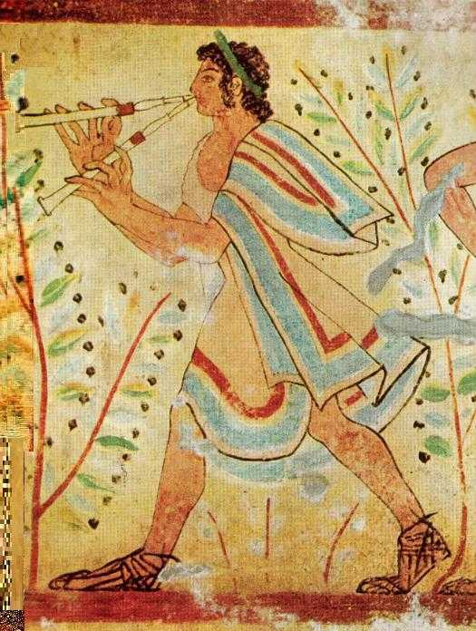

BRIEF COURSE DECRIPTION: Since the beginning of time, humankind has felt the impulse to create art. This course will examine some of the greatest works of art and architecture from the prehistoric era to the Gothic period. Through lecture, discussion, Powerpoint presentations, and film, we will study these works not only in terms of their stylistic and formal development, but by placing them in their cultural, historical, political, and religious contexts. We will seek answers to key questions, such as “What inspires humans to create Art?” “What can Art teach us about the past?” “How does Art reflect the values and ideas of the society that produces it?” “How can a knowledge of Art History help us appreciate and understand our own cultural heritage more fully?”
This course fulfills the Fine Arts General Education requirement.

STUDENT LEARNING OUTCOMES:

- : Acquire a solid knowledge of the most significant works of Western art and architecture from prehistory to late medieval Europe, with some discussion of Eastern/non-Western artistic traditions
- Understand the social, political, historical, and religious contexts in which this art was produced
- Develop an awareness of the power of the visual arts as a means of communicating a society’s values, ideas, and beliefs
- Describe the significance of important movements or themes which have shaped the world’s diverse cultures and impacted its art
- Learn and apply the critical vocabulary of Art History
- Demonstrate an understanding of style and iconography in the Arts

- Develop an appreciation of skills involved in artistic expression including sculpture, painting, print making, ceramics and architecture
- Appreciate the relevance of the visual arts in our own world and make insightful connections between past and present artistic traditions

COURSE REQUIREMENTS:
3 exams: 25% each (1 in class, 2 take-home)
Short research paper (5 pages) on a work of art of your choice in the Honolulu Academy of Art or the Bishop Museum: 25%.
GRADING:
A = 90-100%: reserved for outstanding work showing insight, excellent understanding of subject matter, and exceptional effort
B = 80-89%: reserved for above-average work showing sound grasp of concepts, solid knowledge of subject matter, and very good effort
C = 70-79%: reserved for average work that reflects satisfactory preparation and good overall grasp of subject matter
D = 60-69%: reserved for poor quality work, showing a weak understanding of subject matter and little effort
F = 59 % or below is failing

REQUIRED TEXT: Fred S. Kleiner, Gardner’s Art Through the Ages: The Western Perspective (13th edition), Vol. 1, Wadsworth
READING: Please read the assigned chapters before each class so you can follow the lecture more easily and formulate possible questions in advance.
ATTENDANCE: Of course, any absences are discouraged. Since the bulk of the course will be visual, you will miss valuable material if you are not present. However, I do try to be flexible and make allowances for unforeseen and/or unavoidable circumstances (military duties, deployments, etc.) If you are absent, you are responsible for the material you have missed, so please make arrangements to borrow a classmate’s notes and come talk to me or email me about any questions you may have.
ACADEMIC HONESTY: It goes without saying that I expect you to do your own work. If you borrow information from another source for a take-home exam or research paper, you must cite that source according to MLA guidelines. Plagiarism will not be tolerated and may lead to a failing grade for the course. We will discuss proper academic citation procedures to help you avoid the pitfalls. That said, I strongly encourage you to discuss ideas generated by our class with your friends and colleagues, in the true spirit of the scholarly quest for knowledge!

CLASS SCHEDULE and ASSIGNED READINGS:
Before your first class, please read Kleiner, Chapters 1 & 2.
Oct. 8: Introduction; Prehistoric art; Ancient Near Eastern art
Oct. 15: Ancient Egyptian art. Kleiner, Chapter 3
Oct. 22: Prehistoric Aegean and Ancient Greek art. Kleiner, Chapters 4 & 5
FIRST TAKE-HOME EXAM. Due in class on Oct. 29.
Oct. 29: Etruscan and Ancient Roman art. Kleiner, Chapters 6 & 7
Nov. 5: Early Christian and Byzantine art. Kleiner, Chapters 8 & 9
Nov. 12: Islamic and Early Medieval art. Kleiner, Chapter s 10 & 11
SECOND TAKE-HOME EXAM. Due in class on Nov. 19.
Nov. 19: Romanesque art. Kleiner, Chapter 12
Nov. 26: Gothic art. Kleiner, Chapter 13
Dec. 3: Early Renaissance art. Kleiner, Chapter 14
Dec. 10: Early Renaissance continued; synthesis and conclusion
FINAL EXAM WILL BE GIVEN IN CLASS on Dec. 10.
Museum paper due in class.

Just a final note: I am so excited you are taking my class! Together in our time machine we will travel back to fascinating civilizations, starting with the dawn of time. Like savvy detectives, we will use Art as a key to unlock the mysteries of the past, a past whose artistic and cultural legacy continues to impact and inspire us today. I sincerely hope that by the end of the term, you’ll be as hooked on Art as I am!

