Chaminade University of Honolulu
AR 101: INTRODUCTION TO THE VISUAL ARTS
Instructor: Suzette Scotti
Tuesday evenings, 17:30-21:40 at Schofield Army Base
Dates: Oct. 5 - Dec. 7, 2010
Email : suzette.scotti@adjunct.chaminade.edu
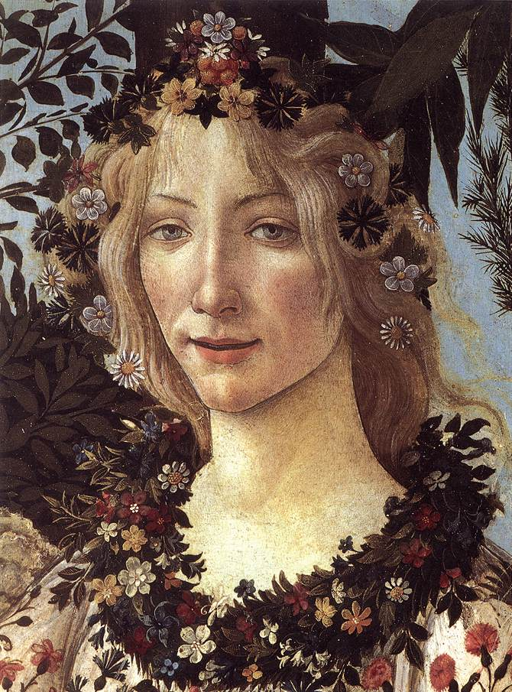

Brief Course Description: Since the beginning of time, humankind has felt the impulse to create art. This course will examine some of the greatest works of art and architecture from the prehistoric era to the twentieth century, with some discussion of non-Western traditions. Through lecture, discussion, Powerpoint presentations, and film, we will study these works not only in terms of their stylistic and formal development, but by placing them in their cultural, historical, political, and religious contexts. We will seek answers to key questions, such as “What inspires humans to create Art?” “What can Art teach us about the past?” “How does Art reflect the values and ideas of the society that produces it?” “How can a knowledge of Art History help us appreciate and understand our own cultural heritage more fully?”

STUDENT LEARNING OUTCOMES:
- Acquire a basic understanding of the development of forms of art and architecture with emphasis on (but not limited to) the Western tradition
- Understand the social, political, historical, and religious contexts in which the art was produced
- Develop an awareness of the power of the visual arts as a means of communicating a society’s values, ideas, and beliefs
- Learn and apply the critical vocabulary of Art History
- Appreciate the relevance of the visual arts in our own world and make insightful connections between past and present artistic traditions

COURSE REQUIREMENTS:
3 exams: 25% each (1 in class, 2 take-home)
Short research paper (5 pages) on a work of art of your choice in the Honolulu Academy of Art: 25%
GRADING:
A = 90-100%: reserved for outstanding work showing insight, excellent understanding of subject matter, and exceptional effort
B = 80-89%: reserved for above-average work showing sound grasp of concepts, solid knowledge of subject matter, and very good effort
C = 70-79%: reserved for average work that reflects satisfactory preparation and good overall grasp of subject matter
D = 60-69%: reserved for poor quality work, showing a weak understanding of subject matter and little effort
F = 59 % or below is failing

REQUIRED TEXT: Patrick Frank, Prebles’ Art Forms (9th edition), Pearson.
READING: Please read the assigned chapters before each class so you can follow the lecture more easily and formulate possible questions in advance.
ATTENDANCE: Of course, any absences are discouraged. Since the bulk of the course will be visual, you will miss much valuable material if you are not present. However, I do try to be flexible and make allowances for unforeseen and/or unavoidable circumstances (military duties, deployments, etc.) If you are absent, you are responsible for the material you have missed, so please make arrangements to borrow a classmate’s notes and come talk to me or email me about any questions you may have.
ACADEMIC HONESTY: It goes without saying that I expect you to do your own work. If you borrow information from another source for a take-home exam or research paper, you must cite that source according to standard MLA procedure. Plagiarism will not be tolerated and may lead to a failing grade for the course. We will discuss proper academic citation procedures to help you avoid the pitfalls. That said, I strongly encourage you to discuss ideas generated by our class with your friends and colleagues, in the true spirit of the scholarly quest for knowledge!

COURSE CONTENT: (flexible and subject to modifications)
Oct. 5: Introduction; Prehistoric and ancient Mesopotamian Art.
Reading: Chapter 1; Chapter 2 (pp. 17-21 and 29-34); Chapter 14

Oct. 12: Ancient Egyptian and Greek Art
Reading: Chapter 15 (pp. 244-249).

Oct. 19: Etruscan and Ancient Roman Art
Reading: Chapter 15 (pp. 249-255); pp. 215-216 (on Roman architecture). Take-home exam #1 given out. Due Oct. 26 at the beginning of class.

Oct. 26: Byzantine Art
Reading: Chapter 15 (pp. 257-259)

Nov. 2: Romanesque and Gothic Art
Reading: pp. 261-265; p. 217 (on Gothic architecture). Research topics due in class.

Nov. 9: The Renaissance in Italy and Northern Europe
Reading: Chapter 16 (pp. 266-282). Take-home exam #2 given out. Due Nov. 16 at the beginning of class.
Nov. 16: Baroque, Rococo, and Neoclassical Art
Reading: Chapter 16 (pp. 282-289); Ch. 20 (pp. 350-352)

Nov. 23: Nineteenth-Century European and American Art
Reading: Chapter 20 (pp. 352-380); pp. 218-219 (on architecture)

Nov. 30: Early Twentieth-Century European and American Art
Reading: Chapter 21; pp. 220-227 (on architecture). Take-home exam # 3 Part 1. Due at the beginning of Class # 10. Final Exam Part 1 given out. Due Dec. 7 at the beginning of class.

Dec. 7: Art Between the World Wars, Post-War Art
Reading: Chapter 22; Chapter 23 (pp. 422-439). In-class final exam (Part 2). Honolulu Academy of Art research paper due in class.
REMEMBER: FINAL EXAM WILL BE GIVEN IN THE LAST CLASS ON DECEMBER 7.

Just a final note: I am so excited you are taking my class! Together in our time machine we will travel back to fascinating periods of history, starting with the mysterious cave paintings of prehistoric Europe and ending with the artistic revolution of the twentieth century. Like savvy detectives, we will use Art as a key to unlock the hidden meanings of the past, a past whose artistic and cultural legacy continues to impact and inspire us today. I sincerely hope that by the end of the term, you’ll be as hooked on Art as I am!

