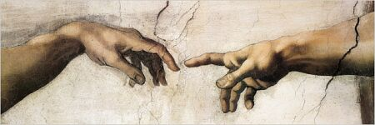
Art 101 - Introduction to the Visual Arts
Fall 2009
Chaminade University of Honolulu

Instructor: Tammy Cotton-Jennings
Email: tammy.cotton-jennings@adjunct.chaminade.edu

Course Description

This course is about the world of visual art. It is about the ideas, feelings and experiences that art can reveal and create. Students will be encouraged to develop an awareness and appreciation of the visual arts in contemporary society as well as an understanding of the relationship to philosophy, religion, politics and history. This will be a general survey course that will include not only the history of art but also the methods, materials and practice of art making.
The course is divided into three parts:

Visual Theory - representation, creativity and meaning in art
Visual Language - the formal elements that comprise all visual works
Contextual Studies - ideas and issues associated with the visual arts

You will be asked to discuss, debate, draw, paint, write and participate in an exploration of the meaning, value and role of art in your life and the lives of others. You will also be exposed to various media and the methods by which art is produced in order to explore on a practical level many of the concepts presented in the class.

Course Content
The content is derived from text, lectures, demonstrations, slides, and videos.

Course Objectives & Competencies
By the end of the course students should be able to:
- Demonstrate a knowledge and understanding of the elements of at, principles of design and the creative process.
- Demonstrate a familiarity with major historical and contemporary movements in art and be able to understand how and why a work of art reflects it’s time.
- Demonstrate an understanding of the various media.
- Appreciate the visual art’s influence on the quality of life.
- Incorporating writing as a tool for analyzing art forms.

Attendance
Attendance is required because presentations will not be repeated. If you miss a class it is your responsibility to get the class notes from another student. Repeated tardiness or absences will be reflected in your overall grade.

Grading
Grading is based on a series of projects, exams, and quizzes. Artwork is graded not on talent but on effort and a demonstration of your understanding of the concepts.
In order to do well in this class you will need to take notes from both the class lectures and the reading assignments. All notes are to be done in your sketchbook
All reading assignments for a particular topic are to be completed before the scheduled class.
Each Quiz = possible 75 points (8 quizzes= 600 pts)
Midterm = Possible 150 pts
Final = Possible 150 pts
Projects= Possible 100 pts

