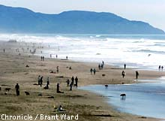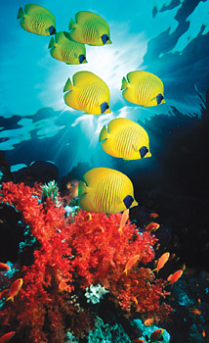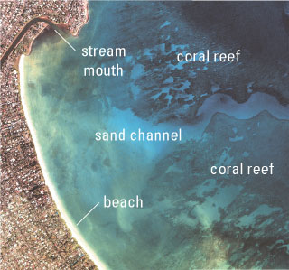

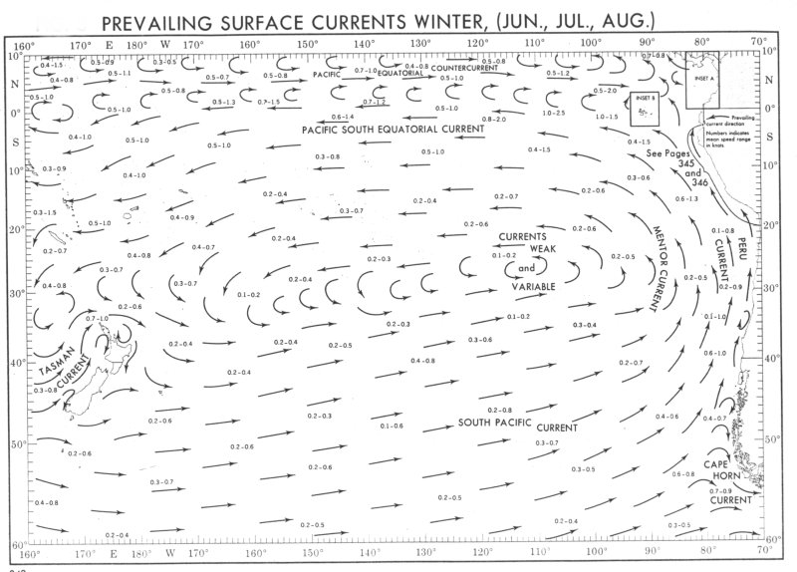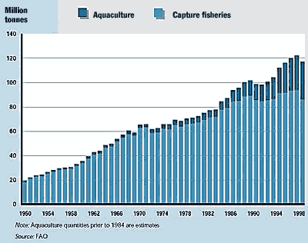

Marine Environmental Science: ENV 115

Lecture Syllabus
Fall 2009

An Oceanographers Dream

I built my soul a stately treasure house
Beside the rolling ocean’s swell,
With cunning apparatus to disclose

The gems below that dwell, --

Those living gems ‘of purest ray serene,’
Oft frail, fantastic, strange and rare,
Whose lives sheer mysteries have ever been,
But need not be – with care.

‘Twas not in marbled luxury it grew,
With spacious courts and colonnades;
A boat and cooling tanks were most in view,
And tackle of all grades.

An isolated pinnacle I chose,
Five hundred miles from every shore:
Sheer from th’ Atlantic’s deep abyss it rose,
Three miles in depth or more.

Around it limpid dark blue waters flows
From distant equatorial seas:
It feels, above the pulse of melting snows,
The Gulf Stream’s vagrancies.

A sturdy, broad beamed, fishing boat I planned,
Equipped with motor, winch and screw,
For quick excursions out and back to land –
A man and boy for crew.

The zone of waters which concerns us most,
Where mighty currents change their beat,
Can here be sampled three miles off the coast
To full 3,000 feet.

Bermuda, watch-tower of the Sargasso Sea!
Its coral cap twelve miles across,
On this one spot my treasure-house would be, --
Its absence the world’s loss.

Walter Garstang, 1943

The scientific community is no private club. In principle, and in its best and broadest sense of the words, scientific inquiry can be undertaken by anyone on almost any subject matter.
W. Quine and J. Ullian

Instructor: Dr. Gail Grabowsky (“Dr. Gail”)

Address: Behavioral Sciences Building, room 107
Environmental Studies
Chaminade University
3140 Waialae Ave
Honolulu, HI 96816

Phone: 735-4834 (ext. 834 if calling from on campus)

E-mail address: ggrabows@chaminade.edu

Office hours: MThF: 2:00 – 5:00; Or by appointment

Course Description: This course introduces students to the scientific causes and consequences of the current major marine environmental issues. Topics include: effects of global warming on ocean ecosystems, marine pollution, marine debris, oil spills, fisheries exploitation, fisheries by-catch, marine alien species, coastal development and coral reef degradation. The course focuses on making students aware of the material causes and consequences of each issue as well as the role of science in devising solutions to each issue.

Course Learning Outcomes: When you have completed this course you should:
Know what science is and how scientific research is conducted
Understand the basic concepts in oceanography and marine biology
Know the characteristics of the major marine zones
Know the names and ecological roles of a number of marine organisms that occur in Hawaiian waters
Know the physical causes of each of the major marine environmental issues
Understand the causal network of events that lead to the occurrence of each issue
Know the actual and projected physical consequences of each issue
Understand the detrimental effect(s) of each issue on marine ecosystems and human welfare
Be familiar with some of the specific mechanisms diverse indigenous people of the Pacific employ(ed) in gathering ocean resources that may be considered sustainable practices
Demonstrate an understanding of the connections between academic work and real-life situations

Course Requirements: Your grade in this course will be based on the following. Each of the items/activities listed below will be described to you in writing or orally in class.

Course Grading: Based solely on the following in the following proportions:
- Two Lecture Exams 40% (20% each)
- Final Exam 20%
- Service Learning & Reflection 20%
- Marine Zone Presentation 10%
- Notable Marine Places and Issues Presentation 10%

The points that each contributes to your grade in this course is as follows:
Lecture Exams 200 points (100 points each)
Final Exam 100
Service Learning & Reflection 100

Marine Zone Presentation 50
Notable Marine Places and Issues Presentation 50
500 points total
Grading Procedures:
Grades will be assigned to written exams using a curve with the mean score for the class being a B- and the score immediately below the mean being a C+. This will be explained in detail in class. The first two lecture exams will cover the material from the start of class up until the first exam and the material after the first exam up until the second exam, respectively. These exams will have a variety of types of questions on them. The final exam is cumulative, multiple choice and covers the lecture material for the entire semester. A review sheet will be handed out before every exam.

Texts:
Required: You should purchase these in the bookstore.

Castro, P. & M. E. Huber. Marine Biology. 6th Edition. McGraw Hill. 2007. [ISBN 0072852909]
Sheppard, C. Coral Reefs: Ecology, Threats and Conservation. World Life Library, Voyaguer press. 2007. [ISBN 0896582205]

Supplemental Texts: A number of readings in this course will come from the documents and publications listed below. Still other readings may come from documents not on the list below which become known to me or relevant during the course. I will provide hard copies or e-copies of all non-textbook readings to you.

Boesch, D. F. et al. “Marine Pollution in the United States.” 2001. Pew Oceans Commission.
Carlton, J.T. “Introduced Species in U.S. Coastal Waters.” 2001. Pew Oceans Commission.
Dayton, P. K., S. Thrush and F.C. Coleman. “Ecological Effects of Fishing in Marine Ecosystems of the United States.” 2002. Pew Oceans Commission.
Mallin, M.A. 2006. “Wading is Waste.” Scientific American.
Mora, C., Andrefouet, S., Costello, M.J. et al. 2006. “Coral reefs and the global network of marine protected areas.” Ecology: 312: 1750-1751.
Poepoe, K.K., P.K. Bartram and A. M. Friedlander. 2003(?). “The use of traditional Hawaiian knowledge in the contemporary management of marine fisheries.” Putting Fishers’ Knowledge to Work: Conference Proceedings, pp. 328-339.
“U.S. Ocean Action Plan: The Bush Administrations Response to the U.S. Commission on Ocean Policy.” 2005.

Marine Zone Presentation:
This presentation will count towards your lecture grade. The particular protocols, requirements and grading criteria for it will be described in class by Dr. Gail. The date of the presentations is indicated on the syllabus.

Service Learning Option:
In this course you will have the opportunity to work in the community and/or in the field and do a variety of environmentally-related service-learning activities. These activities may involve gathering information about environmental issues for community publications, coming up with ideas for environmental public service announcements, helping out at environmentally-related events, designing an environmental research project or helping out “in the field” as we try to restore native ecosystems, document the state of particular ecosystems, clean-up beaches, etc. These activities are all “Service Learning” opportunities. They are all fun – experience has taught me this, my students always get a lot out of them, and they are all educational in a way that pertains to the course. You all need to do four service activities (20 hours total; 4 hours each) and write a short reflection as a part of this course. This counts for 20% of your lecture grade. This semester you are all going to be involved in making public service announcements (PSA’s) for the Ocean Network (Cable 349). The details of this assignment will be explained in class.

Extra Credit Options:
Periodically throughout the course there will be talks you may attend that pertain to the course material. I will let you know when these opportunities arise. If you choose to attend you will earn +2 extra credit points towards a lecture exam. If you do more than the four required service activities then you’ll receive extra credit for those outings you do after your fourth (+3 per trip).

Attendance:
While I dearly hope that you can make every class…, since you are adults now, you are free to miss any lecture class you choose… but KNOW that there may be some consequences should you choose to exercise this option: your grade could (and most likely WILL) suffer. I believe that students who have missed a lot of classes ALWAYS would have done better if they had not missed classes. There simply is no substitute for being in class when it comes to understanding the material. I can give you a fishing pole, but I cannot make you fish.
If you miss a lecture exam your absence must be excused if it is not to formally effect your grade. Excused absences occur when you bring in a doctor’s note, a funeral announcement for a family member, notice of participation in athletic events, etc. Unexcused absences occur when you were working, surfing, sleeping, cramming for an exam in another class, etc.

ClassroomAtmosphere:
I value a very open, yet courteous class atmosphere. Express your ideas! Ask your questions! (The only dumb question is the one in which you ask yourself if you should ask your question.) Respect the thoughts and ideas and opinions of others – really think about what others say. Let them fully express their thoughts and ideas and then you do the same. The thing I value most from my college days are all the wonderful, valuable, diverse ways of looking at and understanding the world that I was exposed to. Be an open vessel – take ideas in! You will learn as much from each other as you do from me.

This syllabus and course schedule are living documents: they are free to change. I try to adhere as closely as possible to them for your convenience, but there will be times in which we will take longer on a particular topic or add or delete a topic to enhance the course. I like to be able to react to you as the course proceeds and go with the flow a bit in order to make the course experience sort of custom fit to you!

If you are handicapped under the Americans with Disabilities Act:
Chaminade will provide assistance for any student with documented disabilities. Any student who believes he/she may need accommodations in this class must contact Dr. June Yasuhara (735-4845), at the Counseling Center (office is next to security), in order to determine if you meet the requirements for a documented disability in accordance with the Americans with Disabilities Act. Please contact Dr. Yasuhara as soon as possible so that accommodations can be implemented in a timely fashion.

Reminders of Important University-Wide Policies:
The following policies are summarized from the Student Handbook. Please be sure that you have reviewed these and other policies that your Handbook contains.

Academic Honesty:
Students are responsible for promoting academic honesty at Chaminade by not participating in or facilitating others’ participation in any act of academic dishonesty, and by reporting incidences of academic dishonesty (such as theft of tests, records, and other confidential materials, altering grades, and/or plagiarism) to their instructors.

Freedom of Expression:
Students are free to take reasoned exception to the views offered in a particular course of study. They may be required to know thoroughly the specific bodies of knowledge or interpretations or theories set forth by the professor, but are free to reserve judgment as to the truth or falsity of them.

Students are expected to maintain the standards of academic performance articulated in course syllabi, supplemental readings, assignments and Academic and Student Affairs policies. The instructor is considered the normal and competent judge of academic work. Students have an appeals process in the rare case of unjust grading and evaluation by the procedure detailed in the Academic Grievance section of the Student Handbook.

You are responsible for all of the information in this document:
losing it or not reading it, are not excuses for not knowing what’s in it!!!

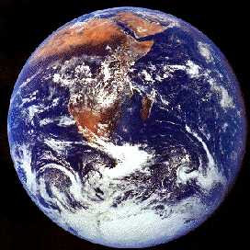

Marine Environmental Science

Course Schedule
Fall 2009

Part I

Ocean Inhabitants & Environments

WEEK TOPIC ACTIVITIES
8/24 – 8/28 Course Intro; Marianist Values; Science Chapter 1 in textbook
8/31 – 9/4 Marine Geology Chapter 2 in the textbook
9/9 – 9/11 Special Properties of Water; Seawater Chemistry Chapter 3 in the textbook
9/14 – 9/18 Oceanography
9/21 – 9/25 History of Life; Marine Biodiversity Chpts 4 & 6 in the textbook
9/28 – 10/2 Introduction to Ecology Chpts 7, 8 & 9 in the textbook
9/30, 10/2: Marine Zone Presentations
10/5 – 10/9 Marine Ecosystems; Healthy Oceans Wrap-Up Chapter 10 in the textbook
10/9: Exam I 10/9: Exam I

Part II

Threats to Our Oceans

WEEK TOPIC ACTIVITIES
10/14 – 10/16 Coral Reef Threats Coral Reefs book
10/19 – 10/23 Coastal Development Outside Readings
10/26 – 10/30 Marine Pollution; Marine Debris Outside Readings
11/2 – 11/6 Eutrophication and Non-Point Source Pollution Outside Readings
11/9 – 11/13 Fisheries: Recreational Near Shore Outside Readings
11/16 – 11/20 Fisheries: Commercial Outside Readings
11/20: Exam II 11/20: Exam II
11/23 – 12/27 Aquaculture; Introduced Species Outside Readings
11/30 – 12/4 Issues Summary; Solutions to Marine Threats Chapter 18 in the textbook

Service Learning Reflections are due on the last day of class, no later than 5 PM.

Important Dates You Should Know:

- 9/1 Drop/Add ends
- 11/6 Last day to drop classes
- Final Exam: Tuesday, December 8th from 10:30 – 12:30 PM in our classroom.

