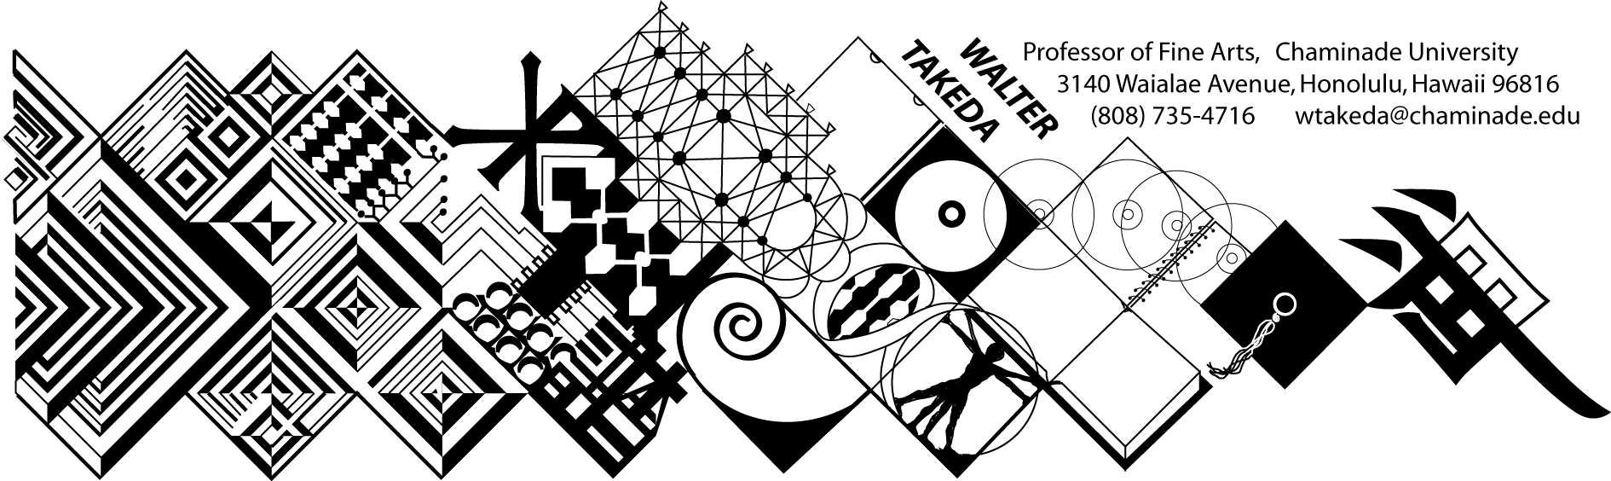
ART 201 – Fall 2009
Survey of Art I
Tues/Thurs 8-9:20 am
Eiben 207
Text: Art thru the Ages
Office Hrs: afternoons
or appointment: E205

COURSE DESCRIPTION: Art 201 is a general survey course that may be used to fulfill Chaminade's fine arts requirement of the general education core; it is also a requirement for the BFA major. There is no prerequisite for this course.
The material covered in this course includes a survey of Western art from paleolithic to the gothic period, as well as Asian art. Art 202, for which this course is not a prerequisite, continues from the Renaissance to contemporary art.
In this age of frequent travel, you will undoubtedly have some opportunity to visit areas where there are considerable works of art. It is hoped that this course would make these trips more meaningful and life-enhancing. Involvement in the rich endowment of human artistic endeavors is a vital part of one's college and life experience.

GOAL AND ASSESSMENT: The goal of this course is to acquaint the student with different artistic expressions of many cultures over time. The students’ ability to distinguish to distinguish expressions and styles can be partially assessed as the course progresses. The class will be given a pre-test of slides from different cultures, and during the course of the semester, be tested either separately or with slides imbedded in the exams.
COURSE OUTCOMES: Student Learning Outcomes linked to Program Learning Outcomes:
Upon successful completion of this course, the student will demonstrate an:
- Understanding of the placement of art within its historical context;
- Ability to recognize important aspects of a style, country, or movement;
- Appreciation of the spiritual and physical nature of works of art
- Ability to articulate refined distinctions and similarities between artists and styles

These outcomes are all linked to Program Learning Outcome #4.

ATTENDANCE will be taken for administrative purposes but will not affect your grade, which is based solely on your test performance and the paper. Attendance is ABSOLUTELY MANDATORY on scheduled exam days. Attendance is particularly crucial in this class; it is categorically impossible to do well just be relying on the text.

HOW TO STUDY FOR THIS COURSE: Each day material will be presented with slides. At the beginning of each class, the instructor will show accumulating slides from previous lectures for which you will be responsible. Whenever possible, these mandatory slides will come from the textbook. Hence, be on time and take meaningful advantage of these "mini-reviews" at the beginning of class. Keep an ongoing list of these works. Do parallel reading in the text. Note how the instructor wants the periods broken down. Familiarize yourself with the general characteristics of each style or sub-style; part of the exam will test this knowledge with slides other than from the mandatory pool. If you have difficulty taking notes, bring a tape recorder to class; it is particularly helpful to tape the thorough, full-period review before examinations.

EXAMINATIONS, as stated above, will not be based exclusively on the obligatory pool of slides, but will also test your ability to recognize styles from other examples. In addition to slide questions, there will be other objective questions of a multiple choice, true/false nature. There will also be a comparative analysis written on differences between two given works of art. Handouts may be given describing the strict format with which this analysis is to be written. In keeping with Chaminade's writing standards, the analysis will be written in proper grammar, spelling and clarity of thought. The following grading criteria will apply to all exams: A = 100-90%, B = 89-80%, C = 79-70%, D = 69-60%, F = 59% or lower. Although all exams are equally weighted, consideration may be given on a good Final Exam result in borderline cases.

MAKEUP EXAMS will necessarily be more challenging in fairness to other students. Questions may be restructured in a more difficult way, and there may be additional questions increasing the points that could be deducted. Students will notify the instructor BEFORE the scheduled exam if they are to miss a scheduled exam for reasons beyond their control, e.g. flat tire, illness, etc. Leave a message at the instructor's office number above. Subsequently, you must present verifiable evidence to this effect, i.e. service station invoice, doctor's slip, etc., to be eligible for a makeup. The time of the makeup exam will be at the instructor's convenience, not the student's . Failure to appear a second time will result in a zero. There is no other extra credit opportunity in this class. Vacations extending into regularly scheduled exam days will not be considered an excuse for makeups or early exams.

COMPARATIVE ANALYSIS PAPER: You will submit a paper by the due date on the course schedule at the beginning of class (anything later will be graduated downward in letter grade. A handout on the specifics of this paper will be distributed well before its due date. It will be due on December 3 at the beginning of class. It will be of equal weight to the exams (25%). You may submit MS Word drafts to my e-mail address no later than November 24.

By enrolling in this class, the student understands and agrees to the conditions of this syllabus, and cannot claim ignorance of it as an excuse for noncompliance.

COURSE SCHEDULE: The instructor reserves the right to make adjustments to the following schedule verbally in class, for which the student is responsible.

Lect# Date Subject (may vary)
- Aug 25 Paleolithic art
- Aug 27 Theories of art
- Sept 1 Neolithic art
- Sept 3 Mesopotamia
- Sept 8 Mesoptamia; Egypt
- Sept 10 Egypt
- Sept 15 Aegean
- Sept 17 Greek
- Sept 22 Greek; REVIEW 1ST EXAM
- Sept 24 FIRST EXAM
- Sept 29 Roman art
- Oct 1 Roman – Late Antique
- Oct 6 Dark Ages to Byzantine
- Oct 8 Romanesque
- Oct 13 Romanesque to Gothic
- Oct 15 Gothic
- Oct 20 Gothic; REVIEW 2ND EXAM
- Oct 22 2ND EXAM
- Oct 27 India
- Oct 29 India continued; Southeast Asia
- Nov 3 China
- Nov 5 China
- Nov 10 China
- Nov 12 China
- Nov 17 Japan
- Nov 19 Japan
- Nov 24 Japan
Nov 26 Thanksgiving – no class
- Dec 1 Japan
- Dec 3 REVIEW FOR FINAL; paper due
FINAL: Dec 8 (Tuesday) 8-10 am same room

